ASHA N – Daily Progress Report on 05/12/2020

**Updated Code of the GUI (Configurator)**

import tkinter as tk

root = tk.Tk()

'''

def take_input():

    ac_data=ac_choices.get()

    dc_data=dc_choices.get()

    print("numbers = {}, {}".format(ac_data, dc_data))

'''

def decide(option):

    if option=="Voltage - AC":

        dc_range.configure(state="disabled")

    else:

        ac_range.configure(state="disabled")

root.title("Configurator")

root.geometry("400x200")

measurement_choices = tk.StringVar()

ac_choices = tk.IntVar()

dc_choices = tk.IntVar()

measurement_type = {"Voltage - AC", "Voltage - DC",}

AC_range = {1, 50, 100, 200,300,400,500}

DC_range = {1, 6, 12, 18,24,30,36,42,48}

measurement_choices.set("Measurement Type")

ac_choices.set("AC range")

dc_choices.set("DC range")

label=tk.Label(root,text="Select the Type and range")

label.place(x=130, y=10)

measur_type = tk.OptionMenu(root,measurement_choices, *measurement_type)

measur_type.configure(width=15)

measur_type.place(x=50, y=35)

AC_range=sorted(AC_range)

ac_range = tk.OptionMenu(root,ac_choices, *AC_range)

ac_range.configure(width=10)

ac_range.place(x=230, y=35)

DC_range=sorted(DC_range)

dc_range = tk.OptionMenu(root,dc_choices, *DC_range)

dc_range.place(x=230, y=75)

dc_range.configure(width=10)

option1=measur_type.cget()

next_button = tk.Button(root,text="Next", bg="gray",command = decide(option1))

next_button.place(x=150, y=150)

root.mainloop()

This is the GUI for Data Acquisition System, in this GUI we have three dropdown menus namely measurement type, AC and DC ranges.

* In Measurement Type Option Menu, if we select one of the option then option menu of the other option will be disabled.
* If we click the Next button, then the control goes to source method.

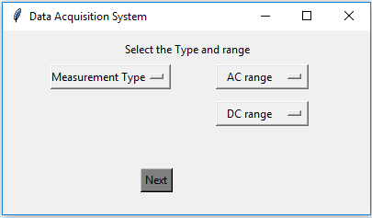

Unable to take the screenshot of dropdown button in snippet tool.

**Code of GUI (Display)**

import tkinter as tk

root = tk.Tk()

def clear_widget_text(type_label,unit_label):

    type_label['text'] = ""

    unit_label['text'] = ""

def close_window():

    root.destroy()

root.title("Calculation display")

root.geometry("270x150")

label=tk.Label(root,text="Selected measurement type and range")

label.place(x=25, y=10)

type_label=tk.Label(root,text="Measurement type",borderwidth=2, relief="groove")

type_label.place(x=40, y=50)

type_label.configure(width=15)

unit_label=tk.Label(root,text="Range",borderwidth=2, relief="groove")

unit_label.place(x=160, y=50)

unit_label.configure(width=8)

clear_button = tk.Button(root,text="Clear", bg="gray",command=lambda : clear_widget_text(type_label,unit_label))

clear_button.place(x=50, y=90)

clear_button.configure(width=8)

exit_button = tk.Button(root,text="Exit", bg="gray",command = close_window)

exit_button.place(x=150, y=90)

exit_button.configure(width=8)

root.mainloop()

This is the GUI for Display to display the result of measurement calculations.

In this GUI we have following,

* One Label
* Two Labels for displaying the selected Measurement type and Range in the Configurator.
* Two buttons namely Clear and Exit
* Clear button to empty the label.
* Exit button to exit the user interface.

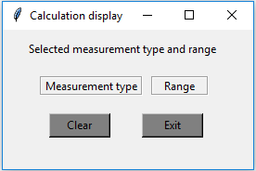

When the Clear button is clicked, label will be cleared.

