ASHA N – Daily Progress Report on 04/12/2020

**Code of the GUI**

import tkinter as tk

root = tk.Tk()

root.title("Data Acquisition System")

root.geometry("400x200")

measurement_choices = tk.StringVar()

ac_choices = tk.IntVar()

dc_choices = tk.IntVar()

measurement_type = {"Voltage - AC", "Voltage - DC",}

AC_range = {1, 50, 100, 200,300,400,500}

DC_range = {1, 6, 12, 18,24,30,36,42,48}

measurement_choices.set("Measurement Type")

ac_choices.set("AC range")

dc_choices.set("DC range")

label=tk.Label(root,text="Select the Type and range")

label.place(x=130, y=10)

measur_type = tk.OptionMenu(root,measurement_choices, *measurement_type)

measur_type.configure(width=15)

measur_type.place(x=50, y=35)

ac_range = tk.OptionMenu(root,ac_choices, *AC_range)

AC_range=sorted(AC_range)

ac_range.configure(width=10)

ac_range.place(x=230, y=35)

dc_range = tk.OptionMenu(root,dc_choices, *DC_range)

DC_range=sorted(DC_range)

dc_range.place(x=230, y=75)

dc_range.configure(width=10)

btn = tk.Button(root,text="Next", bg="gray")

btn.place(x=150, y=150)

root.mainloop()

This is the GUI for Data Acquisition System, in this GUI we have three dropdown menus namely measurement type, AC and DC ranges.

* Measurement type dropdown includes Voltage-AC and Voltage-DC.
* AC range dropdown includes various ranges of selected measurement type.
* DC range dropdown includes various ranges of selected measurement type.

Next button for further process

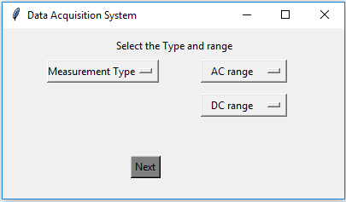

Unable to take the screenshot of dropdown button in snippet tool.