./

**Design of Analog & Digital Data Acquisition System**

Details

|  |  |  |
| --- | --- | --- |
| Name | PS No. | Email Id |
| Lakshmisha Gowda B | 99002625 | lakshmisha.gowdab@ltts.com |
| Asha N | 99002646 | Asha.n@ltts.com |
| Unmesh | 99002485 | Unmesh.deshpande@ltts.com |
| Lakshmi Narayana S | 9900 | Lakshmi.narayanas@ltts.com |

Table of Contents

Design of Analog and Digital data acquisition system 4

Introduction: 4

SOFTWARE REQUIREMENTS: - 4

Anaconda 4

Visual Studio Code 4

GUI for Configurator 4

Input Signal 5

GUI for Display 5

Output Signal 6

Libraries used 6

Block diagram 7

Source generator (sine wave) 7

Amplitude(A) 7

Frequency () 7

Requirement specification to generate sine wave 8

Adding 2 Harmonic to the signal 8

DC wave generator 8

Attenuator 9

Analog to Digital converter[N=16-bit] 9

Flow chart 10

Filter 11

AC Voltage Signal 11

DC Voltage Signal: 11

Serializations and sockets 13

Block Diagram: 13

Flowchart: 13

Measurement Calculations 14

DC Voltage: 15

AC RMS Voltage Calculation 15

# Design of Analog and Digital data acquisition system

## Introduction:

Data acquisition (DAQ) is the process of measuring an electrical or physical phenomenon such as voltage, current, temperature, pressure, vibration or sound with a computer. A DAQ system consists of sensors, DAQ measurement hardware, and a computer with application software.

## SOFTWARE REQUIREMENTS: -

### Anaconda



Anaconda is an open-source distribution of the Python and R programming languages for scientific computing, that aims to simplify package management and deployment. The distribution includes data-science packages suitable for Windows, Linux, and macOS.

### Visual Studio Code



Visual Studio Code is a free source-code editor made by Microsoft for Windows, Linux and macOS. Features include support for debugging, syntax highlighting, intelligent code completion, snippets, code refactoring, and embedded Git.

### GUI for Configurator

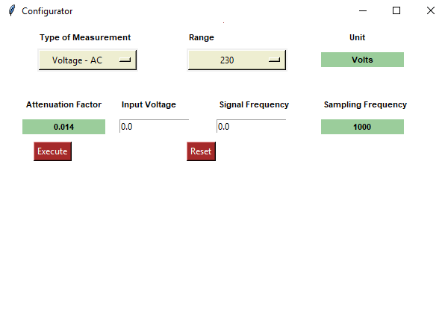

### Input Signal

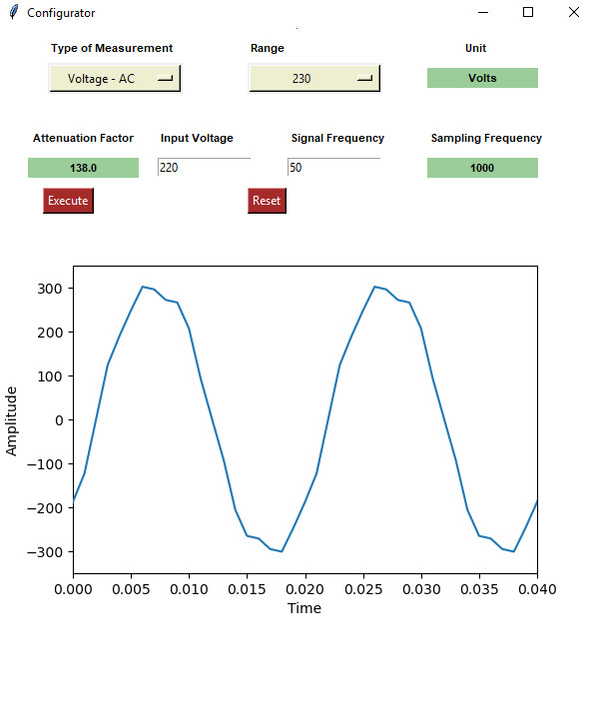

### GUI for Display

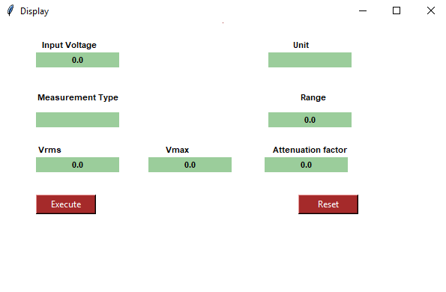

### Output Signal

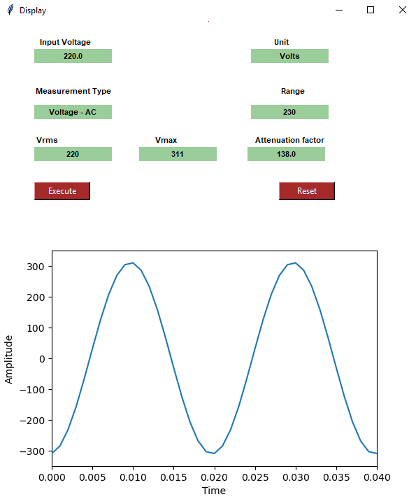

### Libraries used

1. **Tkinter**

Tkinter is the most commonly used method for developing GUI. Python with Tkinter is the fastest and easiest way to create GUI applications.

Tkinter widgets used for developing GUI:

* Label
* Entry
* Canvas
* Option menu
* Frame
* Button

1. **Matplotlib**

* **Matplotlib** is a [plotting](https://en.wikipedia.org/wiki/Plotter) [library](https://en.wikipedia.org/wiki/Library_(computer_science)) for the [Python](https://en.wikipedia.org/wiki/Python_(programming_language)) programming language and its numerical mathematics extension [NumPy](https://en.wikipedia.org/wiki/NumPy).
* It is mainly used for plotting graph.

1. **Animation**

* Animations make even more sense when depicting time series data
* Matplotlib’s animation base class deals with the animation part.
* It provides a framework around which the animation functionality is built.
* [FuncAnimation](https://matplotlib.org/api/_as_gen/matplotlib.animation.FuncAnimation.html#matplotlib.animation.FuncAnimation) is the main object that makes an animation by repeatedly calling a function func.

Block diagram

Attenuator

Analog to digital converter

Source Generator

(AC Wave/Dc wave)

## Source generator (sine wave)

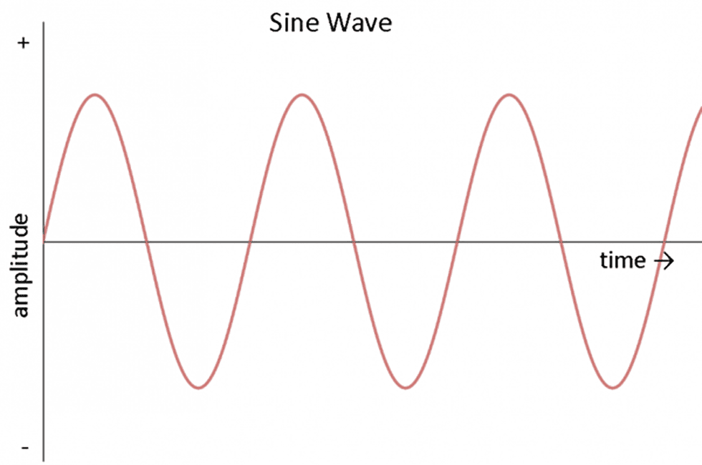

### Amplitude(A)

The amplitude of a sine wave is the maximum distance it ever reaches from zero. Since the sine function varies from +1 to -1, the amplitude is one. In general, a sine wave is given by the formula

### Frequency ()

The frequency is the number of oscillation per unit time. It is used for defining the cyclic process like rotation, oscillation, wave etc. The completion of the cyclic process at particular interval of time is known as the frequency.

Output of sinewave:

Where,

is the amplitude of the signal.

is the signal frequency.

is the sampling time.

### Requirement specification to generate sine wave

|  |  |
| --- | --- |
| **Parameters** | **value** |
| Frequency(F) | Variable |
| Time period (T) | 1/F |
| Sampling frequency (Fs) | Variable |
| Sampling interval (Ts) | 1/Fs |
| No. of samples (N=T/Ts) | N=T/Ts |
| Input Voltage | 0-440Vrms |
| Amplitude(A) | 1.414*rmsValue |

### Adding 2 Harmonic to the signal

A harmonic is a signal or wave with a frequency that is a ratio of another reference wave or signal. Depending upon the integer multiple of the frequency to the original frequency, the respective harmonic wave can be termed as 2f, 3f and so on where f stands for the fundamental frequency wave.

1st harmonic signal:

2nd harmonic signal:

Output of sine wave generator:

## DC wave generator

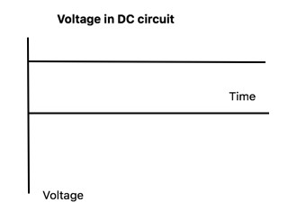

Direct current (DC) is an [electric current](https://energyeducation.ca/encyclopedia/Electric_current) that is uni-directional, so the flow of [charge](https://energyeducation.ca/encyclopedia/Charge) is always in the same direction. As opposed to [alternating current](https://energyeducation.ca/encyclopedia/Alternating_current), the direction and amperage of direct currents do not change. It is used in many [household electronics](javascript:%20void(0)) and in all devices, that use [batteries](https://energyeducation.ca/encyclopedia/Battery).

## Attenuator

An attenuator is an [electronic device](https://en.wikipedia.org/wiki/Electronic_device) that reduces the [power](https://en.wikipedia.org/wiki/Electric_power) of a [signal](https://en.wikipedia.org/wiki/Signal_(information_theory)) without appreciably [distorting](https://en.wikipedia.org/wiki/Distortion) its [waveform](https://en.wikipedia.org/wiki/Waveform).

To find the attenuation factor:

Output of attenuator:

## Analog to Digital converter[N=16-bit]

Since computers only process [digital](https://techterms.com/definition/digital) information, they require digital [input](https://techterms.com/definition/input). Therefore, if an analog input is sent to a computer, an analog-to-digital converter (ADC) is required. This device can take an analog signal, such as an electrical current, and [digitize](https://techterms.com/definition/digitize) it into a [binary](https://techterms.com/definition/binary) format that the computer can understand.

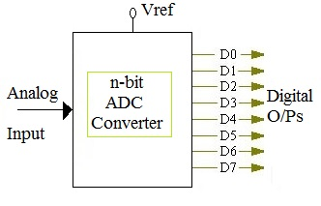

Resolution: The resolution of the ADC is the number of bits it uses to digitize the input samples. For an n bit ADC, the number of discrete digital levels that can be produced is 2^n.

Output of ADC:

…………………Unipolar ADC

### Flow chart

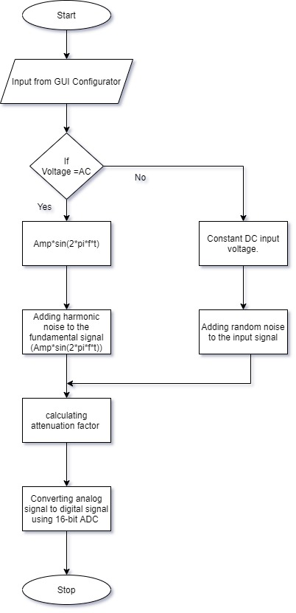

## Filter

### AC Voltage Signal

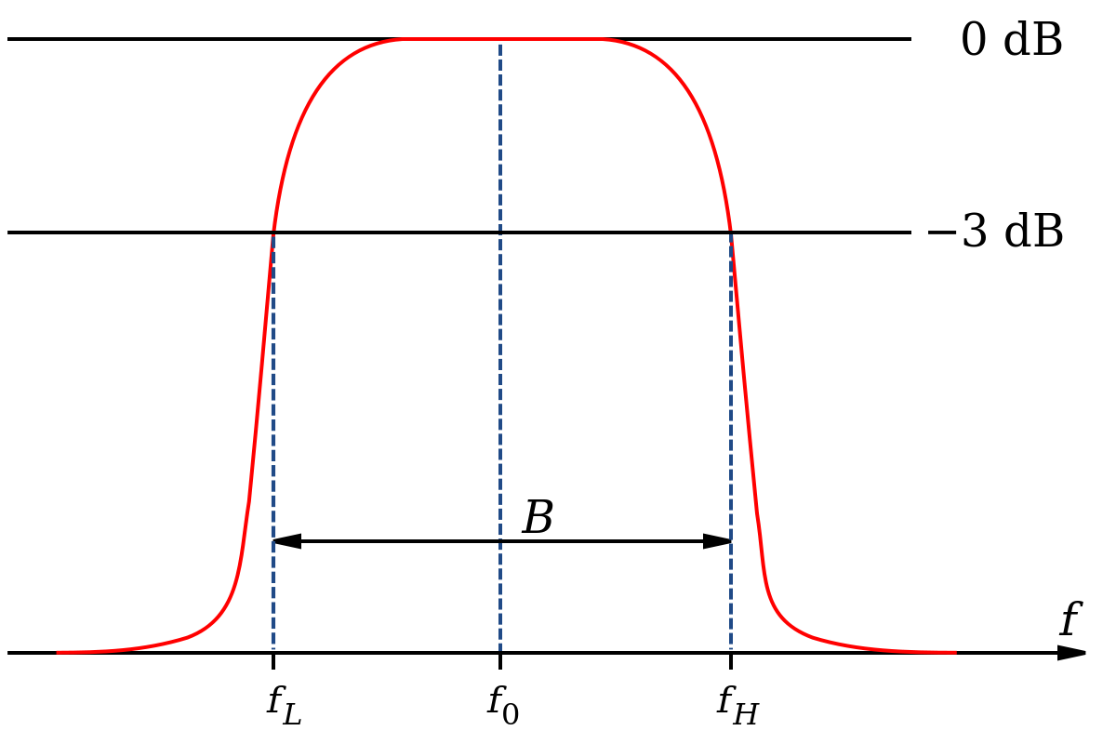

The AC signal is expected to contain Harmonic Noise, Gaussian Noise and Random Noise in a 16bit format. These noises are all to be tackled by a combination of digital filters comprising of a Butterworth Band Pass filter and a Gaussian Filter. The specifications of the filters are as below:

* Sampling Rate: 5kHz
* Pass Band: 40Hz to 70 Hz
* Order of Butterworth Filter: 3rd
* Order of Gaussian Filter: 1st
* Sigma for Gaussian Filter: 4
* No. of Samples: 400

### DC Voltage Signal:

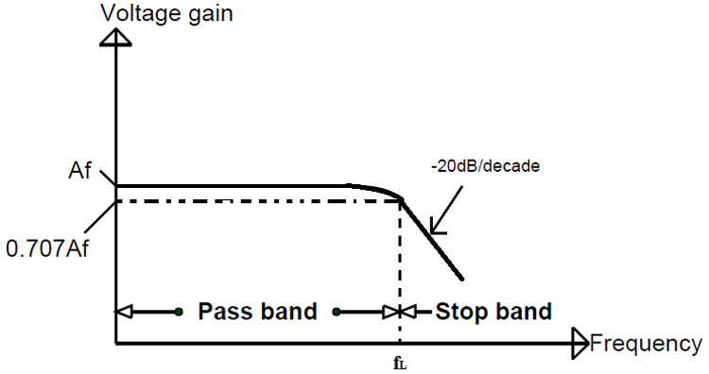

The DC signal is expected to contain Gaussian Noise and Random Noise in a 16bit format. These noises are all to be tackled by a combination of digital filter comprising of a Gaussian Filter and a Butterworth Low-Pass Filter. The specifications are as below:

* Sampling Rate: 5kHz
* Cutoff Frequency: 25Hz
* Order of Butterworth Filter: 2
* Order of Gaussian Filter: 1st
* Sigma of Gaussian Filter: 7
* No. of Samples: 400

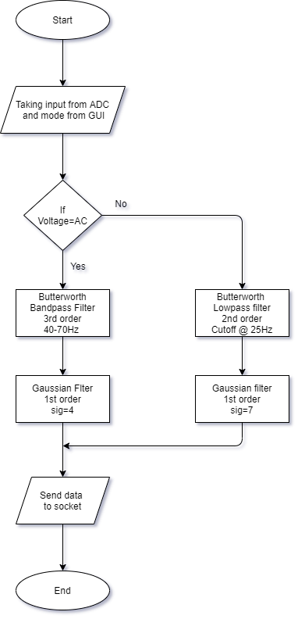

## Serializations and sockets

### Block Diagram:

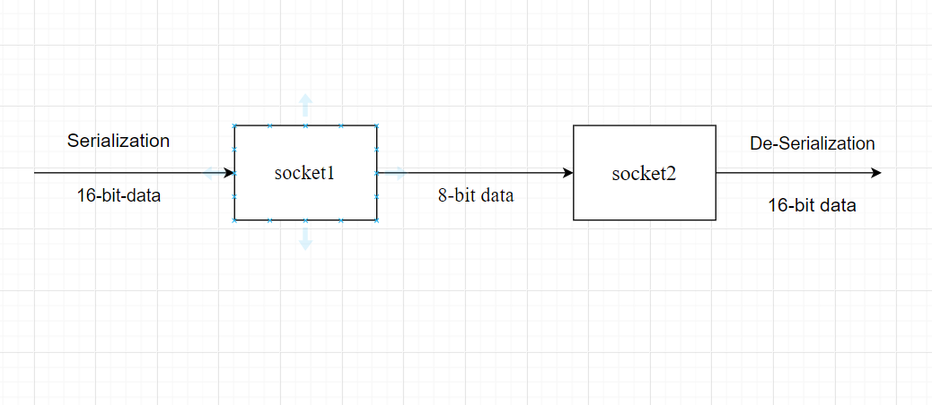

* The data from the filter which is of 16 bits or 2 bytes is converted into 8bits(serialization).
* The 16-bit data is converted into 8 bit using right shift operations and store the data into a tuple.
* The converted data is sent over the socket serially.
* We have created two sockets. The list of tuples is sent from first socket to next.
* The receiver socket accepts the input and converts back the 8 bits data into 16bits(De-serialization).
* The data received is converted back into 16bit using left shift operation.
* The data is further fed for calculations.

### Flowchart:

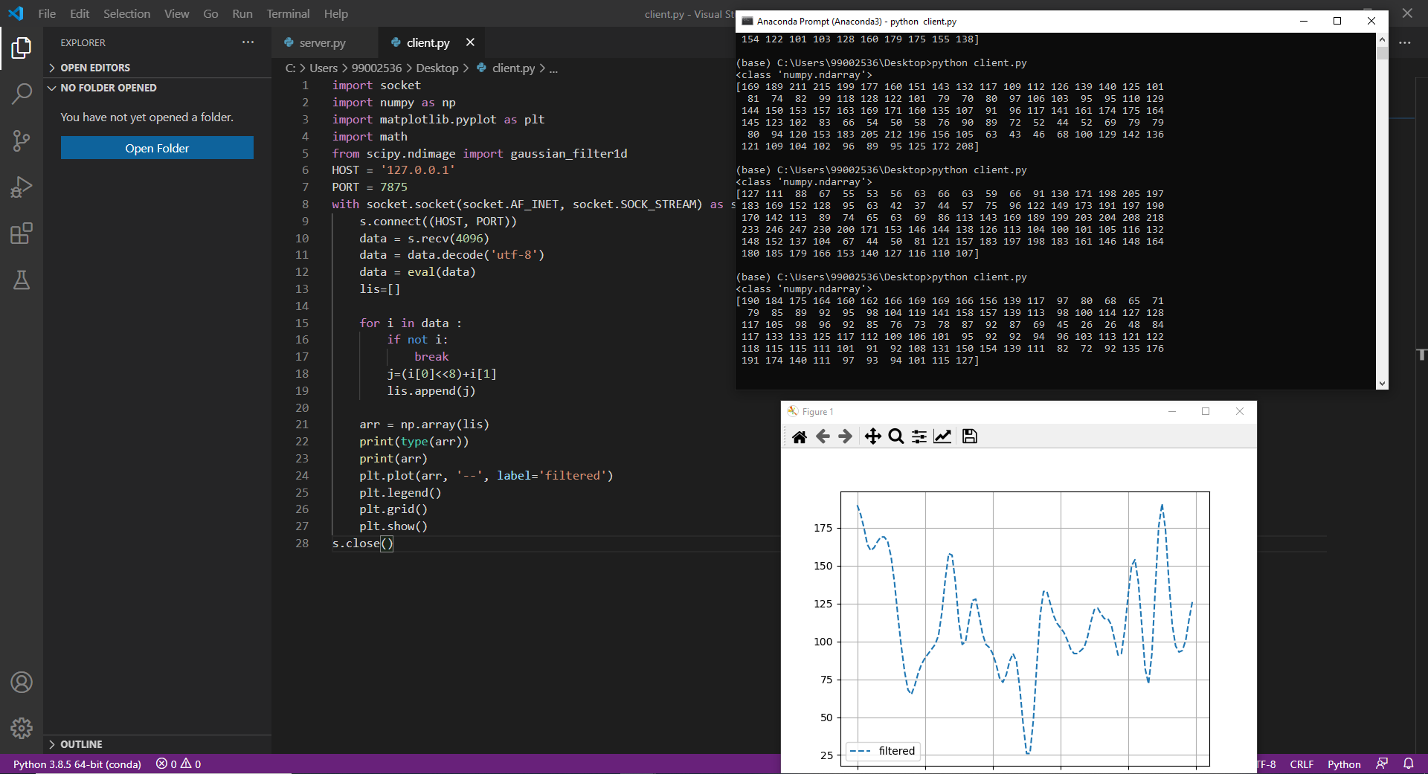

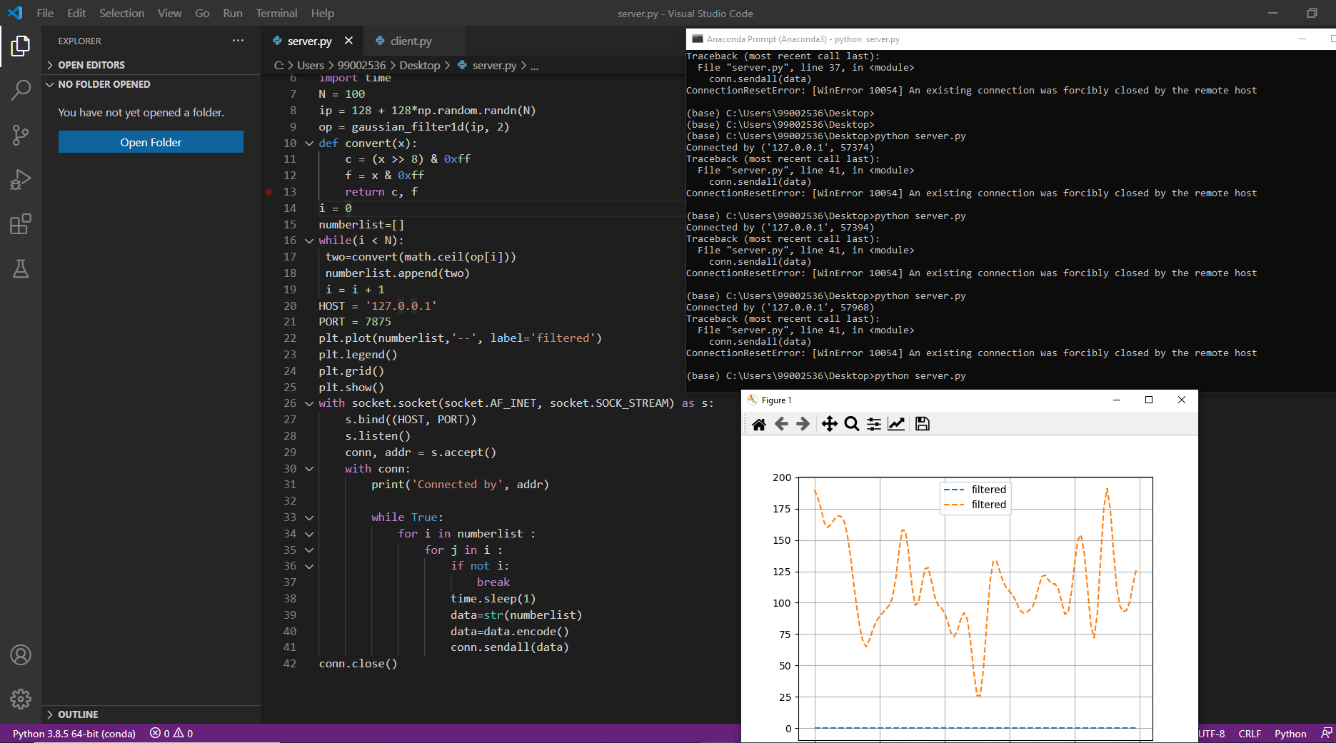

## Measurement Calculations

The digital signals once obtained from the De-serialize need to be converted to a numerical physical quantity to be measured. The 16bit data needs to be converted to a measurement of a physical quantity. This conversion is to be done here.

* The range and mode of measurement is obtained from the configurator/GUI.
* The input from De-serialize is taken in 16bit format.
* The 16bit data is linearly mapped to the selected range for said mode of measurement.
* The measured data is then sent to the display GUI.

### DC Voltage:

The DC voltage is directly displayed to the GUI output window

### AC RMS Voltage Calculation

The RMS voltage needs to be calculated to be recorded as per requirements. The RMS value of a certain set of voltage is calculated as follows:

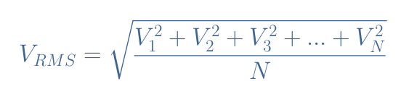

The RMS value is calculated similarly in the code and output in the GUI:

1. Break down the complete output into small sets of samples (covering one whole period).
2. Calculate the RMS value for the set of samples.
3. Repeat the process for entire set of data to get RMS values for complete output.

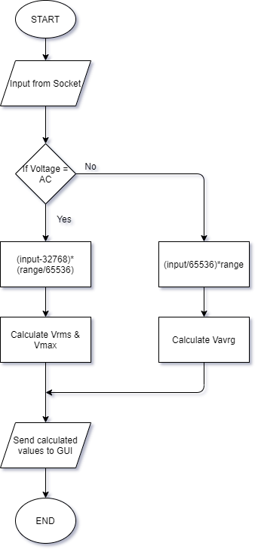

**Flow chart for Display GUI**

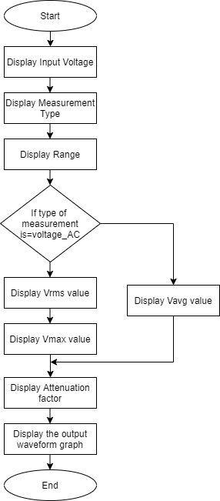

**Use Case Diagram**

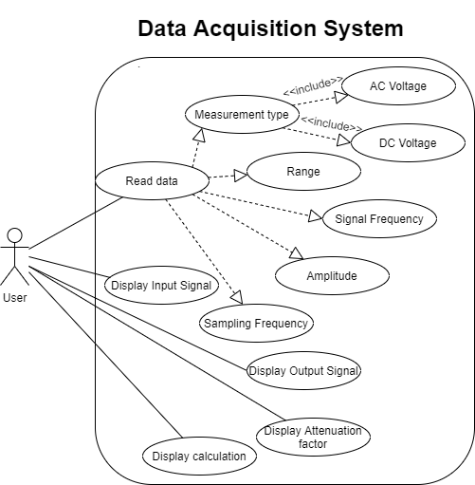

### Test Plan

|  |  |  |  |  |  |
| --- | --- | --- | --- | --- | --- |
| Test Id | Description | Expected input | Expected Output | Actual output | Tested and working |
| TI_01 | Selecting type of measurement | AC Voltage | Range for AC, Frequency and Amplitude selection | Range for AC, Frequency and Amplitude selection | Yes |
| TI_02 | Selecting type of measurement | DC Voltage | Range for AC,  Deactivated frequency selection and Magnitude selection | Range for AC,  Deactivated frequency selection and Magnitude selection | Yes |
| TI_03 | Value Exceeding Range error | Amplitude/Magnitude exceeding the range selection | Error and Notification to keep the amplitude/magnitude within range | Error and Notification to keep the amplitude/magnitude within range | Yes |
| TI_04 | Sinewave Generation | Give Sinewave with frequency 50-60Hz | Sinewave with harmonic noise generated at input | Sinewave with harmonic noise generated at input | Yes |
| TI_05 | Sinewave Regeneration | Sinewave generated at 50-60Hz from input for said RMS value | Sinewave regenerated at display side without noise with same RMS frequency as input wave | Sinewave regenerated at display side without noise with same RMS frequency as input wave. Vmax value is also displayed. | Yes |
| TI_06 | DC signal generation | DC mode selected and magnitude value given within selected range | DC signal generated for said frequency with random noise added to the signal | DC signal generated for said frequency with random noise added to the signal | Yes |
| TI_07 | DC signal Regeneration | DC input generated for selected magnitude. | Denoised DC signal displayed at output side with Vavrg equal to selected magnitude | Denoised DC signal displayed at output side with Vavrg lesser than selected magnitude due to transient period of filter. | Yes |