./



Learning Report – Applied System Development Life Cycle and Software Testing

|  |  |  |
| --- | --- | --- |
| **Name** | **PS Number** | **Email ID** |
| NISHANT RAJ | 99002652 | nishant.raj@ltts.com |

**Details**

Table of Contents

ACTIVITY 1 4

**Topic:** 4

**Introduction:** 4

**Research – Aging and Costing:** 4

**Product Features:** 5

**Specifications:** 5

**SWOT Analysis:** 5

**High Level Requirements:** 6

**Design Analysis:** 7

Behavioral diagram 7

**Use case diagram:** 8

**Structural diagram** 9

**Unit level Payment Chart** 10

**Testing** 11

Unit testing: 11

Integration testing: 11

ACTIVITY 2 12

ACTIVITY 3 14

# ACTIVITY 1

## **Topic:**

Cookies vending Machine

## **Introduction:**

A cookie vending machine is an automated machine which disposes packets of different types of cookies to the consumers when the payment is done successfully through cards, wallets and UPI. This vending machine can give service 24*7 without any additional manpower required other than refilling and maintenance.

## **Research – Aging and Costing:**

* The first recorded example of the vending machine came from Greek mathematician Hero of Alexandria, who invented a device that dispensed holy water inside Egyptian temples.
* Other early examples included small brass machines that dispensed tobacco, found in taverns in England around 1615. In 1822, English publisher and bookshop owner Richard Carlile built a newspaper dispensing machine that allowed patrons to purchase banned works. The first fully automatic vending machine, which dispensed stamps, appeared in 1867.
* During the early 1880s, the first commercial coin-operated vending machines were introduced in London, England.
* The first beverage vending machine was in Paris, France, and allowed people to buy beer, wine, and liquor. In the early 1920s, vending machines started dispensing [sodas](https://www.thoughtco.com/introduction-to-soda-pop-1992433) into cups.
* The industry took a big jump around 2006 when credit card scanners became common on vending machines.
* After 2006 specialized vending machines like cookies and snacks vending machine became popular.

**Costing:** The average cost of cookies vending machine is 75000rs to 100000rs.

## **Product Features:**

1. A wide range of Products available for selection.
2. A QR code for scanning and doing the payment.
3. Breakage sensing alarm
4. Cookie label and price is user settable
5. Toughened glass
6. Credit and Debit Card acceptance
7. LED Touch screen panel
8. Bill printer
9. Mobile application synchronization
10. Fast Product Refilling
11. Powder coated metal cabinet with tamper proof secure locks

## **Specifications:**

Dimensions: H * D * W = 2000* 1000 * 800 (in mm)

Weight: 250Kg

Electrical Supply: 230V,50Hz ,0.15A

Styling: Metal Casing with Glass Back

Display: LED

Vending Mechanism achieved using 24V DC Motor.

## **SWOT Analysis:**

|  |  |  |  |
| --- | --- | --- | --- |
| STRENGTH | WEAKNESS | OPPORTUNITY | THREATS |
| The Vending Machine can be operated anywhere where there is 230V AC supply | The initial set-up cost is high | As there is Mobile app integration it can be operated even remotely. | As it runs on AC power so in case of power failure operation is disturbed |
| The time taken to complete one transaction is less | There can be problems due to Power Failure |  | There is a possibility of mechanical damage to the machine. |
| The Manpower is required for very less time which reduces the overall cost. |  |  |  |
| The transactions done can be viewed through the Mobile Application as Mobile app integration is there |  |  |  |
| The machine can run whole day with reduced cost |  |  |  |

## **High Level Requirements:**

|  |  |
| --- | --- |
| **ID** | **Description** |
| HL_01 | Different types of Cookies. |
| HL_02 | Displaying the Total available Cookies. |
| HL_03 | Different dispensing methods for different Cookies. |
| HL_04 | Mobile application integration with the Machine. |

Table: High Level Requirements

**Low Level Requirements:**

|  |  |
| --- | --- |
| **ID** | **Description** |
| LL_01 | To check the efficiency of Code for the Machine |
| LL_02 | Continuous update on Quality of Cookies |
| LL_03 | Implementation of Different Sensors |
| LL_04 | Meeting the Power requirement |

Table: Low Level Requirements

## 

## **Design Analysis:**

## Behavioral diagram

Sequence diagram:

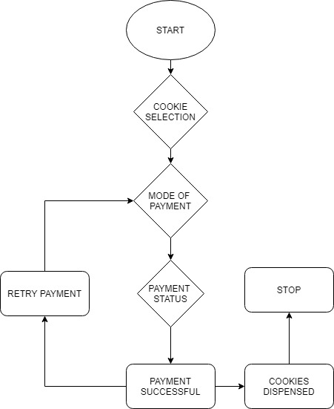

## **Use case diagram:**

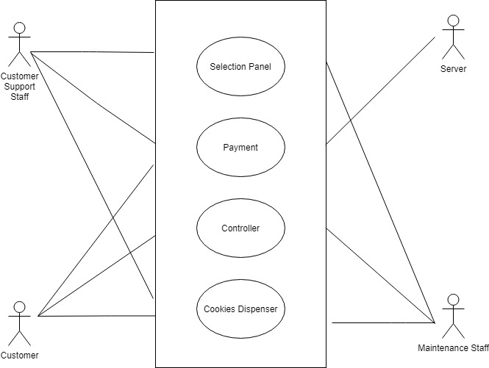

## **Structural diagram**

Class Diagram:

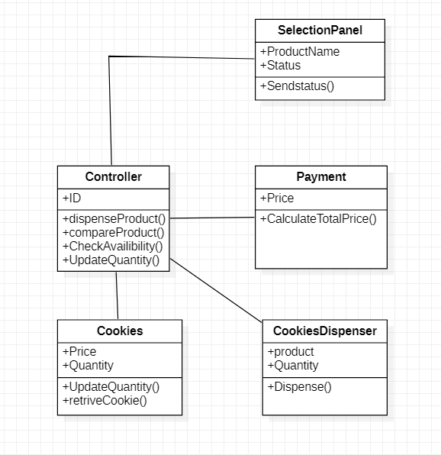

## **Unit level Payment Chart**

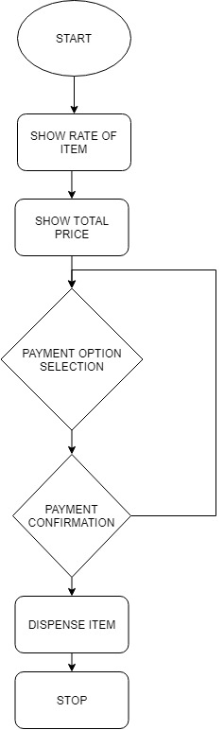

## **Testing**

## Unit testing:

|  |  |  |  |  |
| --- | --- | --- | --- | --- |
| **Test id** | **Description** | **Expected input** | **Expected output** | **Actual output** |
| HH_01 | On add option | Cookies Selection | The selected item should be added | Cookies are added |
| HH_03 | On view option | - | List of available cookies | List of Cookies available is shown |
| HH_04 | On update option | Available Quantity changed | The number of available quantities should change | Quantity Updated |
| HH_02 | On delete option | The selected item deleted | The selected item removed | Cookie Removed |

Table: Unit Testing

## Integration testing:

|  |  |  |  |  |
| --- | --- | --- | --- | --- |
| **Test id** | **Description** | **Expected input** | **Expected output** | **Actual output** |
| LL_01 | Program runs or not | Console screen should display | Home screen should display | Home screen should display |
| LL_02 | Add, update, delete function are available | Selection of option number | List of option available | List of option available |
| LL_03 | Selected option is directed to the specified function | Option number | Display of option function | Display of option function |
| LL_04 | On selection of exit | Exit option | Exit program | Exit program |

Table: Integration testing

# ACTIVITY 2

TOPIC: IMPACT OF FAILURE OF MOBILE PHONES

[Link to the File](https://www.yammer.com/lnttsgroup.onmicrosoft.com/#/uploaded_files/770528387072?threadId=900852725047296)

|  |  |  |  |  |
| --- | --- | --- | --- | --- |
| PRODUCT | CAUSE | IMPACT | OUTCOME | REFERENCE |
| BlackBerry | The main reason to BlackBerry’s failure was their ignorance and choosing to stick with the Query keyboard whilst leaders like Apple provided a full touchscreen interface to which consumers preferred | In 2018 blackberry announced that they will stop making Phones | The sale of Blackberry phones dropped rapidly. | <https://medium.com/@edwardmuldrew/what-happened-to-blackberry-7f5f37623873#:~:text=A%20key%20reason%20to%20BlackBerry%27s,interface%20to%20which%20consumers%20preferred> |
| Samsung Galaxy Fold (2019) | Expensive - close to $2,000, alarmingly fragile-potential for dust to ruin the display | Samsung had to stop production once because of breaks. | The sales went down and the model was declared a failure | <https://9to5google.com/2019/04/24/galaxy-fold-screen-failures/> |
| Palm Pre | There are two major reasons behind Palm Pre’s failure. First, without a real App Store of its own, it couldn’t compete with the likes of Apple and Google. Secondly, and more important, the physical build quality of the phone was spotty at best. | In July 2010, Palm was purchased by Hewlett-Packard (HP) and in 2011 announced a new range of webOS products. | Overall sales were modest from the outset. The sales were not enough to keep the company afloat, leading to its acquisition by HP. | <https://www.goliath.com/tech/13-revolutionary-cell-phones-that-failed-miserably/> |
| Microsoft Windows Phone | At the heart of Windows Mobile’s failure was Windows itself, an OS designed for a big screen, crammed into a little screen product. The Windows Mobile effort then became an effort to throw good money after bad. Microsoft continued to increase budget, up until the point where they bought most of Nokia, but behind where it needed to be to counter a strengthening Apple and Google. Windows Mobile was crippled because it was too tightly connected to Windows, and Microsoft executed a too-little, too-late, strategy regarding funding. | The impact was not a severe one that could hurt the parent company MICROSOFT in a higher marginally manner but a large amount of efforts, Development, Marketing and sales went in vain and acquiring NOKIA amidst all this hurt the wound deeper as the ample organization was also to blame for and Latter affected the sales of the upcoming NOKIA Phones (Android). | Windows Mobile had a lot of potential but was terminally plagued by a series of unforced and often repeated errors. These ranged from not assuring the success of Danger, which became foundational to Android, to not executing on an historic Microsoft strategy, to not funding timely…and some of the most horrid execution seen. The Reputation Microsoft had thought out, took a deeper impact when Nokia was acclaimed and Lumia was introduced only made the IMPACT worse. | <https://www.computerworld.com/article/3336057/how-microsoft-failed-with-windows-10-mobile.html#:~:text=At%20the%20heart%20of%20Windows,into%20a%20little%20screen%20product.&text=So%2C%20Windows%20Mobile%20was%20crippled,%2Dlate%2C%20strategy%20regarding%20funding.> |
| Amazon's Fire Phone | Too Expensive  Small App Store  Features of Limited Interest  Poor Battery Life | Customers gave the smartphone a lackluster rating of 2.6 out of 5 stars. Reviewers called the device “forgettable” and “mediocre.” | The Phone's Price was dropped from $199 to 99 Cents. | <https://time.com/3536969/amazon-fire-phone-bust/#:~:text=4%20Reasons%20Amazon's%20Fire%20Phone%20Was%20a%20Flop,-A%20man%20holds&text=But%20consumers%20apparently%20didn't,Phones%20still%20in%20its%20inventory.> |
| HTC First | The hardware for HTC First was unremarkable. Too much competition. The phone was too expensive. | The price of HTC First dropped from $99 to $0.99 in a month. | HTC First was scrapped a year later. | <https://www.goliath.com/tech/13-revolutionary-cell-phones-that-failed-miserably/> |

# ACTIVITY 3

TOPIC: UML VS SysML

|  |  |
| --- | --- |
| UML | SysML |
| UML is a standardized language for specifying software systems | SysML uses a subset of the diagrams defined by UML and has extensions. It is a UML-profile. |
| UML is software-centric | SysML is more engineering systems oriented. Used in system level design on SoC |
| Composite structures, which are seldom used in UML. | Composite structures take a central role in SysML as “Blocks”. |
| UML is used to represent software semantics (interpretations of notations). | SysML expresses systems engineering semantics (interpretations of notations) better than UML. |
| Bigger than SysML and difficult to learn | SysML is smaller and easier to learn than UML. |
| UML projects have set of elements, diagrams, and profiles. | SysML has a set of elements, diagrams and profiles along with additional capabilities for requirements management. |

# INDIVIDUAL ACTIVITY 1:

**Themes:**

Cookie Vending Machine is a machine which dispenses Packets of Cookies upon payment acceptance done successfully through cards, wallets and UPI. It is very useful for vending small size Biscuit Packets and cookies. This vending machine can give service 24*7 without any additional manpower which is required only for refilling and maintenance.

**Epics:**

* Adding new cookies to the menu
* Updating the quantity of the Cookies.
* Dispensing the Cookies.
* Updating the total available Quantity.
* Updating the Price of the Cookies.
* Display all available Cookies with quantity and type.

**User stories:**

|  |  |  |
| --- | --- | --- |
| USER TYPE | EPIC | USER STORY |
| Maintenance Staff | Adding new Cookies to the Menu | Through this method new products can be added to the menu |
| Customer Support Staff | Updating the quantity of the Cookies | The Quantities of the existing Cookies can be updated through this. |
| Customer | Dispensing the Cookies | The dispensing machine will dispense the required cookies after it receives input from the Customer |
| Maintenance Staff | Updating the Price of Cookies | Whenever there is Change in Price its needs to be updated in the Vending Machine |
| Customer, Maintenance Staff, Customer Support Staff | Display all available type and Quantity of Cookies | Whenever any user goes for order or wants the available Cookies it gets displayed. |

# INDIVIDUAL ACTIVITY 2: