./

Learning Report –

**Embedded Software Design, Development processes & standards**



|  |  |  |  |  |  |
| --- | --- | --- | --- | --- | --- |
| **Ver. Rel. No.** | **Release Date** | **Prepared. By** | **Reviewed By** | **To be Approved By** | **Remarks/Revision Details** |
| 1 | 12-10-20 | S P Bala Sirisha |  | Bhargav N |  |
|  |  |  |  |  |  |
|  |  |  |  |  |  |
|  |  |  |  |  |  |
|  |  |  |  |  |  |

**Document History**

# 

Table of Contents

Activity-1: 4

**White box testing:** 4

Applications: 4

White Box Testing Tools 5

**Black Box Testing:** 5

Steps of black box testing: 5

Types of Black Box Testing 6

Applications of Black box testing: 6

**Gray Box Testing | Software Testing:** 6

Objective of Gray Box Testing: 6

Activity 2: Various Standards 7

Aerospace Industry Standards 7

Various Standards of Rail Industry 8

Various standards of Automobile Industry 9

Activity 3: Overview of the diagrams used in SysML 10

• Block definition diagram 10

• Internal block diagram 11

• Package diagram 11

• Use case diagram 12

• Activity diagram 12

• Sequence diagram 13

• State machine diagram 14

• Requirement Diagram 14

References: 15

**List of Figures:**

Figure 1:Block definition diagram of a vehicle 11

Figure 2: Internal block diagram 12

Figure 3:Package Diagram of a Bank 12

Figure 4:Use case diagram of a Bnak 13

Figure 5: Activity Diagram of a Bank System 13

Figure 6:Server and Client Chart 14

Figure 7:State machine diagram of opening a door 15

Figure 8: Requirement diagram of a Car 15

# Activity-1:

## **White box testing:**

White box testing techniques analyze the internal structures the used data structures, internal design, code structure and the working of the software rather than just the functionality as in black box testing. It is also called glass box testing or clear box testing or structural testing.

**Working process of white box testing:**

* **Input:** Requirements, Functional specifications, design documents, source code.
* **Processing:** Performing risk analysis for guiding through the entire process.
* **Proper test planning:** Designing test cases so as to cover entire code. Execute rinse-repeat until error-free software is reached. Also, the results are communicated.
* **Output:** Preparing final report of the entire testing process.

Knowledge of internal working structure (Code) is not required for this type of testing. Only GUI (Graphical User Interface) is required for test cases.

The term "White Box" was used because of the see-through box concept. The clear box or White Box name symbolizes the ability to see through the software's outer shell (or "box") into its inner workings. Likewise, the "black box" in "Black Box Testing" symbolizes not being able to see the inner workings of the software so that only the end-user experience can be tested.

White box testing involves the testing of the software code for the following:

* Internal security holes
* Broken or poorly structured paths in the coding processes
* The flow of specific inputs through the code
* Expected output
* The functionality of conditional loops
* Testing of each statement, object, and function on an individual basis

The testing can be done at system, integration and unit levels of software development. One of the basic goals of white box testing is to verify a working flow for an application. It involves testing a series of predefined inputs against expected or desired outputs so that when a specific input does not result in the expected output, you have encountered a bug.

### Applications:

White box testing encompasses several testing types used to evaluate the usability of an application, block of code or specific software package. There are listed below --

* **Unit Testing:**It is often the first type of testing done on an application.[Unit Testing](https://www.guru99.com/unit-testing-guide.html) is performed on each unit or block of code as it is developed. Unit Testing is essentially done by the programmer. As a software developer, you develop a few lines of code, a single function or an object and test it to make sure it works before continuing Unit Testing helps identify a majority of bugs, early in the software development lifecycle. Bugs identified in this stage are cheaper and easy to fix.
* **Testing for Memory Leaks**: Memory leaks are leading causes of slower running applications. A QA specialist who is experienced at detecting memory leaks is essential in cases where you have a slow running software application.

### White Box Testing Tools

Below is a list of top white box testing tools.

* Parasoft Jtest
* EclEmma
* N Unit
* PyUnit
* HTML Unit
* Cpp Unit

## **Black Box Testing:**

Black Box Testing is a software testing method in which the functionalities of software applications are tested without having knowledge of internal code structure, implementation details and internal paths. Black Box Testing mainly focuses on input and output of software applications and it is entirely based on software requirements and specifications. It is also known as Behavioral Testing.

### Steps of black box testing:

* Initially, the requirements and specifications of the system are examined.
* Tester chooses valid inputs (positive test scenario) to check whether SUT processes them correctly. Also, some invalid inputs (negative test scenario) are chosen to verify that the SUT is able to detect them.
* Tester determines expected outputs for all those inputs.
* Software tester constructs test cases with the selected inputs.
* The test cases are executed.
* Software tester compares the actual outputs with the expected outputs.
* Defects if any are fixed and re-tested.

### Types of Black Box Testing

There are many types of Black Box Testing but the following are the prominent ones -

* **Functional testing** - This black box testing type is related to the functional requirements of a system; it is done by software testers.
* **Non-functional testing**- This type of black box testing is not related to testing of specific functionality, but non-functional requirements such as performance, scalability, usability.
* **Regression testing**- Regression Testing is done after code fixes, upgrades or any other system maintenance to check the new code has not affected the existing code.

### ****Applications of Black box testing****:

Example, an operating system like Windows, a website like Google, a database like Oracle or even your own custom application. Under Black Box Testing.

## **Gray Box Testing | Software Testing:**

**Gray Box Testing** is a software testing technique which is a combination of Black Box Testing technique and White Box Testing technique. In Black Box Testing technique, tester is unknown to the internal structure of the item being tested and in White Box Testing the internal structure is known to tester. The internal structure is partially known in Gray Box Testing. This includes access to internal data structures and algorithms for purpose of designing the test cases.

Gray Box Testing is named so because the software program is like a semitransparent or grey box inside which tester can partially see. It commonly focuses on context-specific errors related to web systems.

### Objective of Gray Box Testing:

The objective of Gray Box Testing is:

1. To provide combined advantages of both black box testing and white box testing.
2. To combine the input of developers as well as testers.
3. To improve overall product quality.
4. To reduce the overhead of long process of functional and non-functional testing.
5. To provide enough free time to developers to fix defects.
6. To test from the user point of view rather than a designer point of view.

# Activity 2: Various Standards

### Aerospace Industry Standards

* [**AS9100**](https://www.nqa.com/en-in/certification/standards/as9100)**:** If your company provides or manufactures aerospace machines and parts, the AS9100 standard lays out specific quality system management requirements that will ensure you provide the highest quality service to customers and clients. This set of streamlined policies helps increase cost-effectiveness, work speed and performance for organizations all around the globe. All departments and teams within a given organization can adopt these practices.
* [**AS9110**](https://www.nqa.com/en-in/certification/standards/as9110)**:** The AS9110 standard is a set of requirements for aerospace repair stations. While it includes much of the same content as AS9100, it offers a variety of specific standards for the repair and maintenance of aircraft machines. As a result, businesses that provide aerospace equipment preventative maintenance and address system malfunctions usually seek out AS9110 standard compliance certification.
* [**AS9120**](https://www.nqa.com/en-in/certification/standards/as9120)**:**The AS9120 standard is an updated version of AS9100, designed and developed for organizations in the aviation, military and space industries. This is the ideal set of standardized requirements that will allow companies to perform more effectively and safely. The goal of AS9120 is to create a simpler, more efficient experience for both organizations and clients.
* [**AS6081**](https://www.nqa.com/en-in/certification/standards/as6081)**:**In the aerospace industry, there is a significant risk to organizations from providers who sell fraudulent or counterfeit parts and equipment. AS6081 standards reduce these risks with requirements that streamline buying, inspection and management processes. With an AS6081 certification, businesses can discover and take steps to solve situations relating to counterfeit purchases before they cause major financial or productivity losses.
* **[ARP4761:](http://en.sae.org/standards/aerospace/arp4761/" \o "<div class=\"libitm-code\">ARP4761</div><div class=\"libitm-title\">Guidelines and Methods for Conducting the Safety Assessment Process on Civil Airborne Systems and Equipment</div>)** [Guidelines and Methods for Conducting the Safety Assessment Process on Civil Airborne Systems and Equipment](http://en.sae.org/standards/aerospace/arp4761/" \o "<div class=\"libitm-code\">ARP4761</div><div class=\"libitm-title\">Guidelines and Methods for Conducting the Safety Assessment Process on Civil Airborne Systems and Equipment</div>)
* **[AMS2750E:](http://en.sae.org/standards/aerospace/ams2750e/" \o "<div class=\"libitm-code\">AMS2750E</div><div class=\"libitm-title\">Pyrometry</div>)** [Pyrometer](http://en.sae.org/standards/aerospace/ams2750e/" \o "<div class=\"libitm-code\">AMS2750E</div><div class=\"libitm-title\">Pyrometry</div>)
* **[AS9102B:](http://en.sae.org/standards/aerospace/as9102b/" \o "<div class=\"libitm-code\">AS9102B</div><div class=\"libitm-title\">Aerospace First Article Inspection Requirement</div>)** [Aerospace First Article Inspection Requirement](http://en.sae.org/standards/aerospace/as9102b/" \o "<div class=\"libitm-code\">AS9102B</div><div class=\"libitm-title\">Aerospace First Article Inspection Requirement</div>)
* **[AS9101E:](http://en.sae.org/standards/aerospace/as9101e/" \o "<div class=\"libitm-code\">AS9101E</div><div class=\"libitm-title\">Quality Management Systems Audit Requirements for Aviation, Space, and Defense Organizations</div>)** [Quality Management Systems Audit Requirements for Aviation, Space, and Defence Organizations](http://en.sae.org/standards/aerospace/as9101e/" \o "<div class=\"libitm-code\">AS9101E</div><div class=\"libitm-title\">Quality Management Systems Audit Requirements for Aviation, Space, and Defense Organizations</div>)
* **[ARD9000:](http://en.sae.org/standards/aerospace/ard9000/" \o "<div class=\"libitm-code\">ARD9000</div><div class=\"libitm-title\">Aerospace Basic Quality System Standard</div>)** [Aerospace Basic Quality System Standard](http://en.sae.org/standards/aerospace/ard9000/" \o "<div class=\"libitm-code\">ARD9000</div><div class=\"libitm-title\">Aerospace Basic Quality System Standard</div>)
* **[ARP4754A:](http://en.sae.org/standards/aerospace/arp4754a/" \o "<div class=\"libitm-code\">ARP4754A</div><div class=\"libitm-title\">Guidelines and Methods for Conducting the Safety Assessment Process on Civil Airborne Systems and Equipment</div>)** [Guidelines for Development of Civil Aircraft and Systems](http://en.sae.org/standards/aerospace/arp4754a/" \o "<div class=\"libitm-code\">ARP4754A</div><div class=\"libitm-title\">Guidelines and Methods for Conducting the Safety Assessment Process on Civil Airborne Systems and Equipment</div>)
* **[AS478N](http://en.sae.org/standards/aerospace/as478n/" \o "<div class=\"libitm-code\">AS478N</div><div class=\"libitm-title\">Identification Marking Methods</div>)**[: Identification Marking Methods](http://en.sae.org/standards/aerospace/as478n/" \o "<div class=\"libitm-code\">AS478N</div><div class=\"libitm-title\">Identification Marking Methods</div>)
* **[AMS5643T](http://en.sae.org/standards/aerospace/ams5643t/" \o "<div class=\"libitm-code\">AMS5643T</div><div class=\"libitm-title\">Steel, Corrosion-Resistant, Bars, Wire, Forgings, Tubing, and Rings, 16Cr - 4.0Ni - 0.30Cb - 4.0Cu, Solution Heat Treated, Precipitation Hardenable</div>)**[: Steel, Corrosion-Resistant, Bars, Wire, Forgings, Tubing, and Rings, 16Cr - 4.0Ni - 0.30Cb - 4.0Cu, Solution Heat Treated, Precipitation Hard enable](http://en.sae.org/standards/aerospace/ams5643t/" \o "<div class=\"libitm-code\">AMS5643T</div><div class=\"libitm-title\">Steel, Corrosion-Resistant, Bars, Wire, Forgings, Tubing, and Rings, 16Cr - 4.0Ni - 0.30Cb - 4.0Cu, Solution Heat Treated, Precipitation Hardenable</div>)
* **[AMSH6875B:](http://en.sae.org/standards/aerospace/amsh6875b/" \o "<div class='libitm-code'>AMSH6875B</div><div class='libitm-title'>Heat Treatment of Steel Raw Materials</div>)** [Heat Treatment of Steel Raw Materials](http://en.sae.org/standards/aerospace/amsh6875b/" \o "<div class='libitm-code'>AMSH6875B</div><div class='libitm-title'>Heat Treatment of Steel Raw Materials</div>)
* **[AS9006A](http://en.sae.org/standards/aerospace/as9006a/" \o "<div class=\"libitm-code\">AS9006A</div><div class=\"libitm-title\">Deliverable Aerospace Software Supplement for AS9100A, Quality Management Systems - Aerospace - Requirements for Software (based on AS9100A)</div>)**[: Deliverable Aerospace Software Supplement for AS9100A, Quality Management Systems - Aerospace - Requirements for Software (based on AS9100A)](http://en.sae.org/standards/aerospace/as9006a/" \o "<div class=\"libitm-code\">AS9006A</div><div class=\"libitm-title\">Deliverable Aerospace Software Supplement for AS9100A, Quality Management Systems - Aerospace - Requirements for Software (based on AS9100A)</div>)
* **[AS5553A](http://en.sae.org/standards/aerospace/as5553a/" \o "<div class=\"libitm-code\">AS5553A</div><div class=\"libitm-title\">Fraudulent/Counterfeit Electronic Parts; Avoidance, Detection, Mitigation, and Disposition</div>)**[: Fraudulent/Counterfeit Electronic Parts; Avoidance, Detection, Mitigation, and Disposition](http://en.sae.org/standards/aerospace/as5553a/" \o "<div class=\"libitm-code\">AS5553A</div><div class=\"libitm-title\">Fraudulent/Counterfeit Electronic Parts; Avoidance, Detection, Mitigation, and Disposition</div>)
* **[AS6174A](http://en.sae.org/standards/aerospace/as6174a/" \o "<div class=\"libitm-code\">AS6174A</div><div class=\"libitm-title\">Counterfeit Materiel; Assuring Acquisition of Authentic and Conforming Materiel</div>)**[: Counterfeit Materiel; Assuring Acquisition of Authentic and Conforming Materiel.](http://en.sae.org/standards/aerospace/as6174a/" \o "<div class=\"libitm-code\">AS6174A</div><div class=\"libitm-title\">Counterfeit Materiel; Assuring Acquisition of Authentic and Conforming Materiel</div>)

### [Various Standards of Rail Industry](http://en.sae.org/standards/aerospace/as6174a/" \o "<div class=\"libitm-code\">AS6174A</div><div class=\"libitm-title\">Counterfeit Materiel; Assuring Acquisition of Authentic and Conforming Materiel</div>)

[The following codes, standards and specifications applies to all systems and equipment’s, as the case maybe, forming part of the project:](http://en.sae.org/standards/aerospace/as6174a/" \o "<div class=\"libitm-code\">AS6174A</div><div class=\"libitm-title\">Counterfeit Materiel; Assuring Acquisition of Authentic and Conforming Materiel</div>)

[• NFPA 130: Standard for Fixed Guideway Transit and Passenger Rail Systems: This standard specifies fire protection and life safety requirements for underground, surface, and elevated fixed guideway transit and passenger rail systems. Read more](http://en.sae.org/standards/aerospace/as6174a/" \o "<div class=\"libitm-code\">AS6174A</div><div class=\"libitm-title\">Counterfeit Materiel; Assuring Acquisition of Authentic and Conforming Materiel</div>)

[• BS EN 50126: Railway applications-The specification demonstrate reliability, availability, maintainability and safety (RAMS). This is a multi-part standards divided into many parts such as:](http://en.sae.org/standards/aerospace/as6174a/" \o "<div class=\"libitm-code\">AS6174A</div><div class=\"libitm-title\">Counterfeit Materiel; Assuring Acquisition of Authentic and Conforming Materiel</div>)

* + [BS EN 50126-1: Railway applications. The specification and demonstration of reliability, availability, maintainability and safety (RAMS). Basic requirements and generic process.](http://en.sae.org/standards/aerospace/as6174a/" \o "<div class=\"libitm-code\">AS6174A</div><div class=\"libitm-title\">Counterfeit Materiel; Assuring Acquisition of Authentic and Conforming Materiel</div>)
  + EN 50119 Railway applications - Fixed installations - Electric traction overhead contact lines
  + EN 50121: Railway applications- Electromagnetic compatibility: This is a multi-part document divided into the following parts:
  + EN 50121-1: Railway applications. Electromagnetic compatibility. General o EN 50121-2: Railway applications. Electromagnetic compatibility. Emission of the whole railway system to the outside world
  + EN 50121-3-1: Railway applications. Electromagnetic compatibility. Rolling stock. Train and complete vehicle
  + EN 50121-3-2: Railway applications. Electromagnetic compatibility. Rolling stock. Apparatus
  + EN 50121-4: Railway applications. Electromagnetic compatibility. Emission and immunity of the signalling and telecommunications apparatus o EN 50121-5: Railway applications. Electromagnetic compatibility. Emission and immunity of fixed power supply installations and apparatus
  + BS EN 50122-1 Railway applications. Fixed installations. Protective provisions relating to electrical safety and earthing
  + BS EN 50122-2 Railway applications. Fixed installations. Protective provisions against the effects of stray currents caused by d.c. traction systems
  + BS EN 50122-3 Railway applications. Fixed installations. Electrical safety, earthing and the return circuit. Mutual Interaction of a.c. and d.c. traction systems
  + IEC 60364 (4-41): Electric installation of Buildings - Electric Shocks having following as applicable releases.
  + IEC 60364-4-41 Amd.1 Ed. 5.0 b:2017 (Amendment 1 - Low voltage electrical installations - Part 4-41: Protection for safety - Protection against electric shock)
  + IEC 60364-4-41 Ed. 5.0 b:2005
  + IEC 60364-4-41 Ed. 5.1 b:2017
  + IEEE 80-2013: Guide for Safety in AC Substation Grounding: This guide is primarily concerned with outdoor ac substations, either conventional or gas-insulated. These include distribution, transmission, and generating plant substations.

### Various standards of Automobile Industry

The most common standards related to the automotive industry include:

* [**IATF 16949**](https://www.nqa.com/en-in/certification/standards/iatf-16949)**:**We work with the automotive industry to support the manufacturing of safe and reliable products, which are produced and continually improved to meet or exceed customer and regulatory authority requirements. Most organizations manufacturing for the automotive industry are required to be certificated to IATF 16949, which was developed by the International Automotive Task Force ([IATF](https://www.nqa.com/en-gb/certification/standards/iatf-16949)).
* [**ISO 9001**](https://www.nqa.com/en-in/certification/standards/iso-9001)**:**Since IATF 16949 isn’t designed to be a self-sufficient quality standard but instead works best in conjunction with a comprehensive QMS, ISO 9001 certification makes a great deal of sense for automotive companies looking to demonstrate improvement in customer satisfaction, operating costs, stakeholder relationships, legal compliance, risk management, business credentials and attracting new business.
* [**ISO 14001**](https://www.nqa.com/en-in/certification/standards/iso-14001)**:**As the international standard for environmental management systems — or EMS — ISO 14001 is the primary EMS certification for more than 250,000 organizations around the world. As the global standard for any business that wants to manage and positively control all aspects of its environmental impact, ISO 14001 certification is a proven way to demonstrate that you’re serious about your business’s environmental and economic sustainability.
* [**ISO 45001**](https://www.nqa.com/en-in/certification/standards/iso-45001)**:** Along with offering reliable products and services, automotive manufacturers must constantly strive to provide their workers and visitors with a safe and healthy business environment. With the ultimate goal of providing businesses with a framework for controlling and eliminating factors that can lead to illness, injuries and — in worst-case scenarios — death, obtaining ISO 45001 Health and Safety certification is a prudent move for any organization’s senior management to support.
* **AIS-098:** Offset frontal crash
* **AIS-100:** Pedestrian protection
* **AIS-99:** Side mobile deformable offset

# Activity 3: Overview of the diagrams used in SysML

SysML is a graphical modelling language developed in response to the UML for Systems Engineering RFP developed by the OMG, INCOSE, and AP233a. It supports the specification, analysis, design, verification, and validation of systems that include hardware, software, data, personnel, procedures, and facilities.

Is a visual modeling language that provides :

* Semantics - meaning, connected to a meta model (rules governing the creation and the structure of models)
* Notation - representation of meaning, graphical or textual

SysML includes 9 types of diagram, some of which are taken from [UML](https://en.wikipedia.org/wiki/Unified_Modelling_Language):

* [Block definition diagram](https://en.wikipedia.org/w/index.php?title=Block_definition_diagram&action=edit&redlink=1): The Block Definition Diagram in SysML defines features of a Block and relationships between Blocks such as Associations, Generalizations, and Dependencies. It captures the definition of Blocks in terms of properties and operations, and relationships such as a system hierarchy or a system classification tree. In addition, you can use a Block Definition Diagram to apply Constraint Blocks to Blocks.

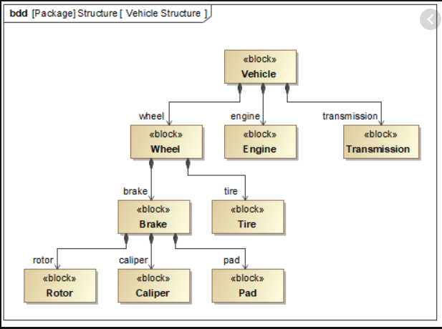

Figure 1:Block definition diagram of a vehicle

* [Internal block diagram](https://en.wikipedia.org/w/index.php?title=Internal_block_diagram&action=edit&redlink=1): An Internal Block Diagram is a static structural diagram owned by a particular block that shows its encapsulated structural contents: Parts, Properties, Connectors, Ports, and Interfaces. Stated otherwise, an IBD is a "white-box" perspective of an encapsulated ("black-box") block.

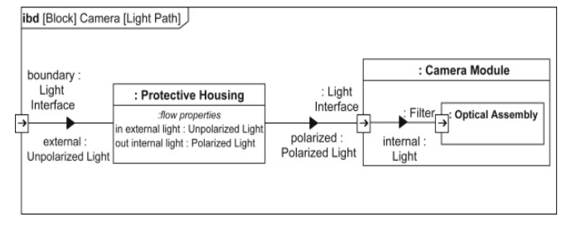

Figure 2: Internal block diagram

* [Package diagram](https://en.wikipedia.org/wiki/Package_diagram): A package diagram provides a means of visualizing the organization of a complex model into recognizable containers, which helps you to group the structures of the model and define high level relationships between these groupings. The structures can include name-spaces and their sub-packages, and other less formally defined groups of elements. The basis of allocating structures to packages could be, for example, access control, configuration management, ease of navigation, or dependency level.

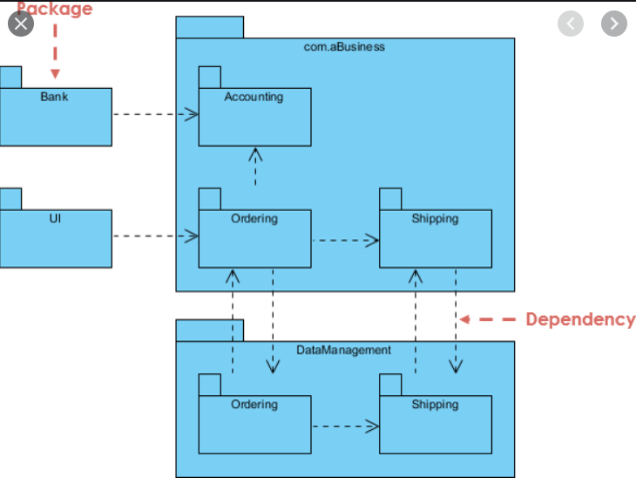

Figure 3:Package Diagram of a Bank

* [Use case diagram](https://en.wikipedia.org/wiki/Use_case_diagram): A Use Case diagram is used to define and view Use Cases and the Actors that derive value from the system. The Use Case diagram describes the relationship between the Actors and the Use Cases. Enclosing the Use Case within a Boundary defines the border of the system; the Actors by definition lie outside the boundary.

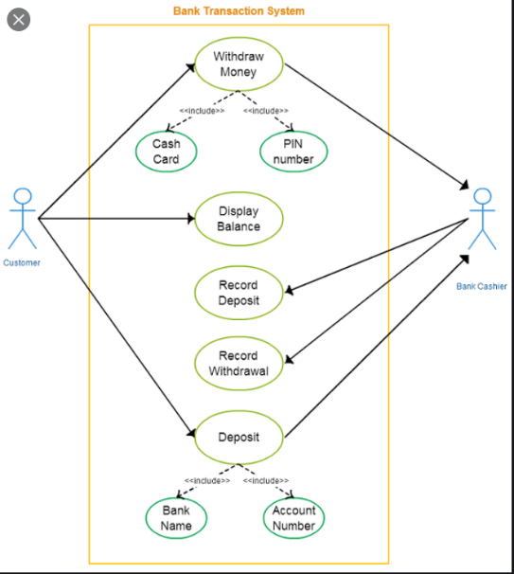

Figure 4:Use case diagram of a Bnak

* [Activity diagram](https://en.wikipedia.org/wiki/Activity_diagram): Activity Diagrams can be used to define situations where parallel processing occurs in the execution of some activities. Activity diagrams are useful for engineering modeling, where they detail the processes involved in system activities.

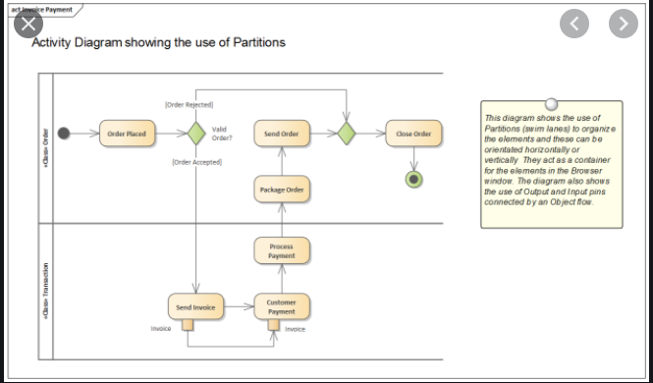

Figure 5: Activity Diagram of a Bank System

* [Sequence diagram](https://en.wikipedia.org/wiki/Sequence_diagram): A Sequence diagram is a dynamic behavioral diagram that shows interactions (collaborations) among distributed objects or services via sequences of messages exchanged, along with corresponding (optional) events.

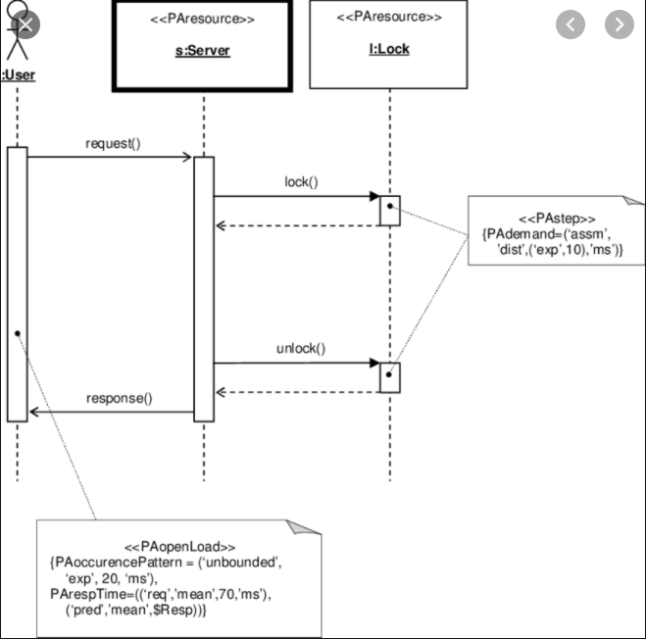

Figure 6:Server and Client Chart

* [State machine diagram](https://en.wikipedia.org/wiki/State_machine_diagram): A State Machine diagram is a powerful vehicle for presenting information about the lifetime of a system element such as a Block, which might have complex behavior and might have life cycles that are difficult to understand. The diagram can be used to describe the important conditions (States) that an entity might pass through during its lifetime or life cycles.

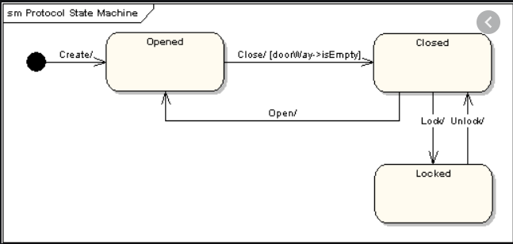

Figure 7:State machine diagram of opening a door

* [Requirement Diagram](https://en.wikipedia.org/wiki/Requirement_Diagram): The purpose of Requirement diagrams is to specify both functional and non-functional requirements within the model so that they can be traced to other model elements that satisfy them and test cases that verify them.

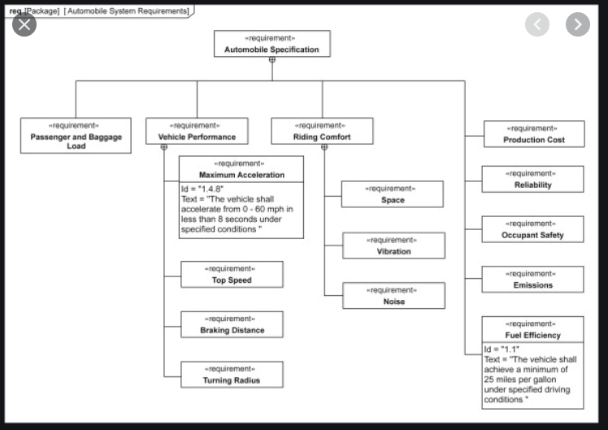

Figure 8:Requirement diagram of a Car

# References:

* + 1. <https://www.geeksforgeeks.org/gray-box-testing-software-testing/>
    2. <https://www.astm.org/Standards/aerospace-material-standards.html>
    3. <https://www.guru99.com/black-box-testing.html>
    4. <https://www.guru99.com/white-box-testing.html>
    5. <https://pediaa.com/what-is-the-difference-between-blackbox-and-whitebox-testing/#:~:text=Blackbox%20and%20whitebox%20are%20two%20testing%20types.%20The,of%20the%20system%20such%20as%20the%20program%20code.>