./



Learning Report – Applied SDLC

Course Code: <CODE>

|  |  |  |  |  |  |
| --- | --- | --- | --- | --- | --- |
| **Ver. Rel. No.** | **Release Date** | **Prepared. By** | **Reviewed By** | **Approved By** | **Remarks/Revision Details** |
| 1.0 | 17.09.2020 | Neeraja A | Deeksha P & Harsheet Dubey | Srinivas K & Prithvi Sekhar |  |
| 1.1 | 18.09.2020 | Neeraja A | Deeksha P & Harsheet Dubey | Srinivas K & Prithvi Sekhar |  |
| 1.2 | 19.09.2020 | Neeraja A | Deeksha P & Harsheet Dubey | Srinivas K & Prithvi Sekhar |  |
|  |  |  |  |  |  |
|  |  |  |  |  |  |

**Document History**

# 

Contents

List of Figures 3

Chocolate Vending Machine 4

**Design**: 4

# List of Figures

Figure 1 Use case diagram for Chocolate vending machine 4

Figure 2 Class diagram for Chocolate vending machine 5

# Chocolate Vending Machine

## Design:

**Use case Diagram:**

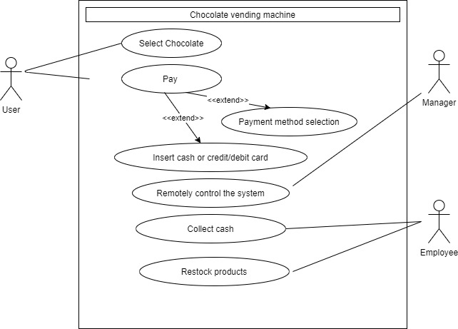

Figure 1 Use case diagram for Chocolate vending machine

**Class Diagram:**

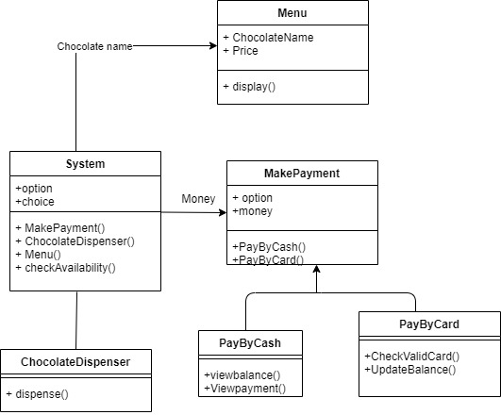

Figure 2 Class diagram for Chocolate vending machine