**Design**

**Project Name:** Hopping Numbers

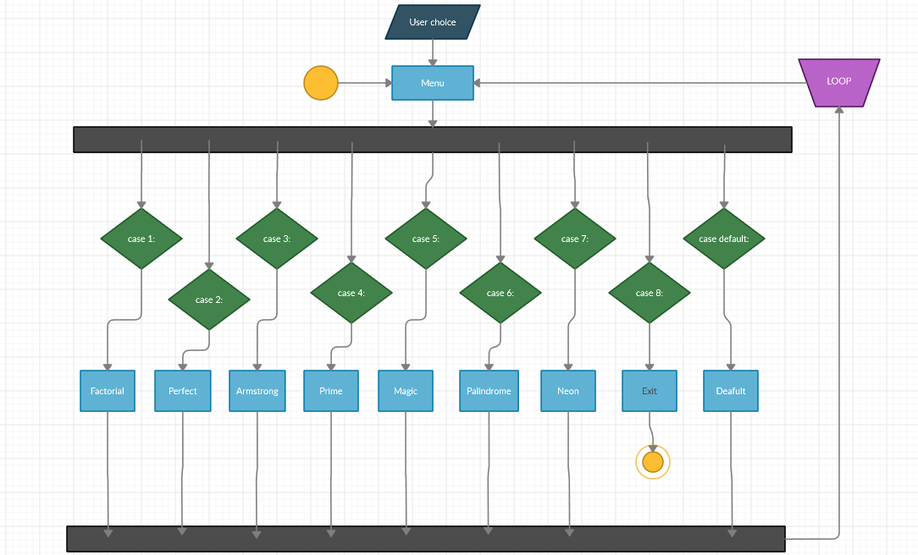

Activity Diagram