./

Learning Report – Automatic Street Lamp

Course Code: <CODE>



|  |  |  |  |  |  |
| --- | --- | --- | --- | --- | --- |
| **Ver. Rel. No.** | **Release Date** | **Prepared. By** | **Reviewed By** | **Approved By** | **Remarks/Revision Details** |
| 1 | 18/09/20 | Milind Mohapatra |  |  |  |
|  |  |  |  |  |  |
|  |  |  |  |  |  |
|  |  |  |  |  |  |
|  |  |  |  |  |  |

**Document History**

# 

Contents

Checklist 3

Activity and Tasks 4

**Activity 1**– System/Software Development 4

**Activity 2** –CI Workflow for C Programming 10

**Activity 3** – Agile Aspects 14

# Checklist

* Installation of SW on Phone and Desktop
* Additional Aspects …

# Activity and Tasks

## **Activity 1**– System/Software Development

* Requirements:
* High level requirements:

|  |  |
| --- | --- |
| **ID** | **Description** |
| HL_01 | Lamp must turn ON when ambient light is below threshold |
| HL_02 | Lamp must turn OFF when ambient light is above threshold |
| HL_03 | System must function regardless of weather conditions |
| HL_04 | Battery life must be long |

* Low level requirements:

|  |  |
| --- | --- |
| **ID** | **Description** |
| LL_01 | Ambient light above threshold must result in HIGH signal from amplifier |
| LL_02 | Below threshold ambient light must result in a LOW signal from amplifier |
| LL_03_1 | Lamp must turn ON during rain |
| LL_03_2 | Lamp must turn ON during fog |
| LL_04 | Operating voltage must be low |

* Test plan:

|  |  |  |  |  |  |
| --- | --- | --- | --- | --- | --- |
| **ID** | **Description** | **Precondition** | **Expected I/P** | **Expected O/P** | **Actual O/P** |
| HL_01 | Check lamp status when ambient light is LOW | System has power supply | Ambient light | Lamp turns ON |  |
| HL_02 | Check lamp status when ambient light is HIGH | System has power supply | Ambient light | Lamp turns OFF |  |
| HL_03_1 | Lamp status on a rainy/foggy day | System has power | Ambient light | Lamp turns ON |  |
| HL_03_2 | Lamp status at night with many vehicles | System has power; night/cloudy | Ambient light | Lamp turns ON |  |
| LL_01 | Check amplifier output when ambient light is LOW | Amplifier has power supply | Signal from LDR | Lamp turns ON |  |
| LL_02 | Check amplifier output when ambient light is HIGH | Amplifier has power supply | Signal from LDR | Lamp turns OFF |  |
| LL_03 | Operating voltage | System has power supply | Supply from battery | Power consumption is low |  |

* Design
  + High level UML design
    - Structural diagram:

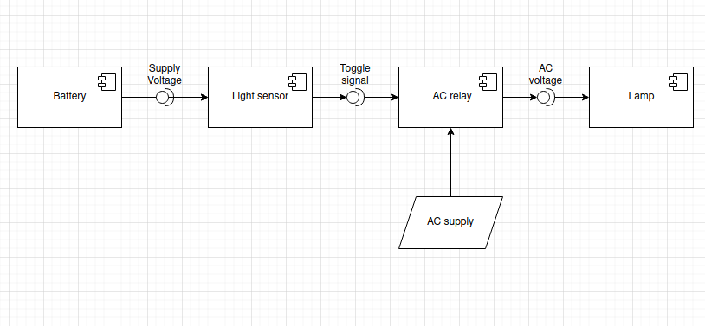

Component diagram

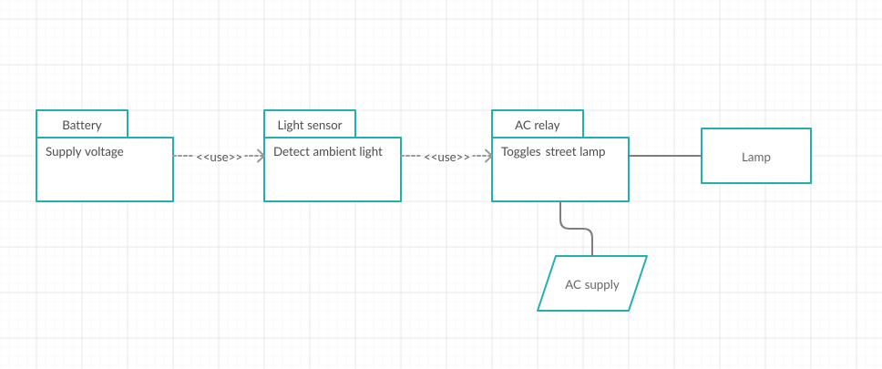

Package diagram

* + - Behavioral diagram:

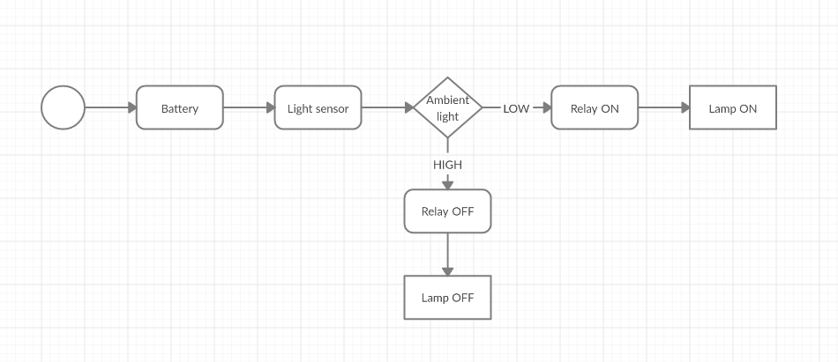

Activity diagram

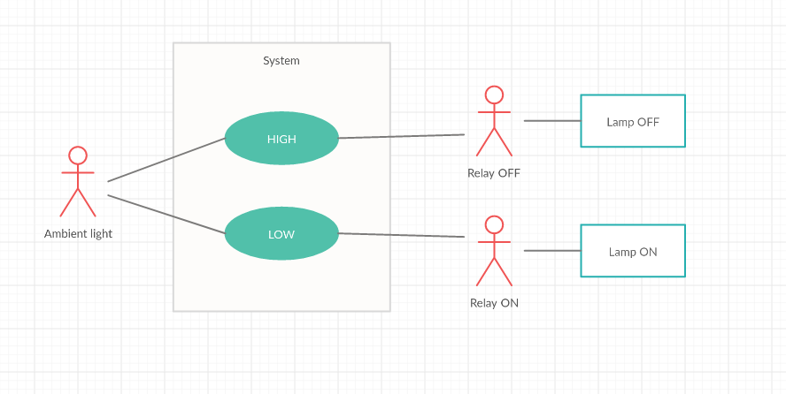

Use case diagram

* + Low level UML diagram
    - Structural diagram:

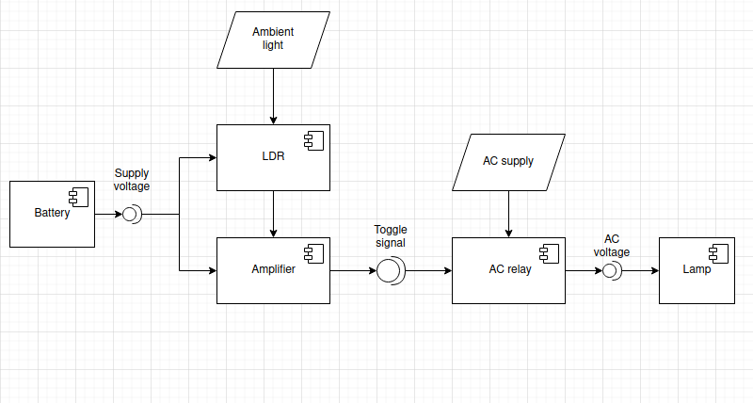

Component diagram

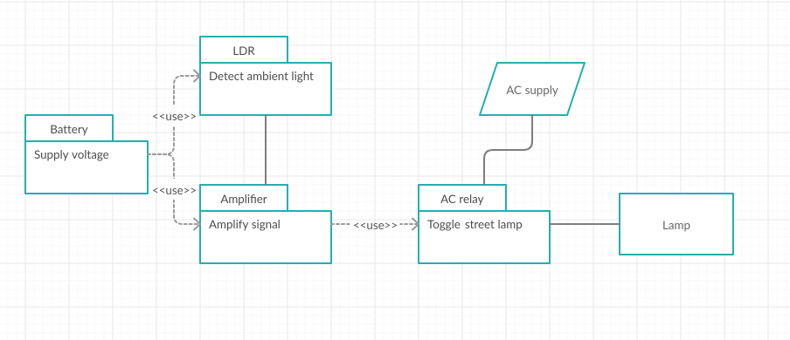

Package diagram

* + Behavioral diagram:

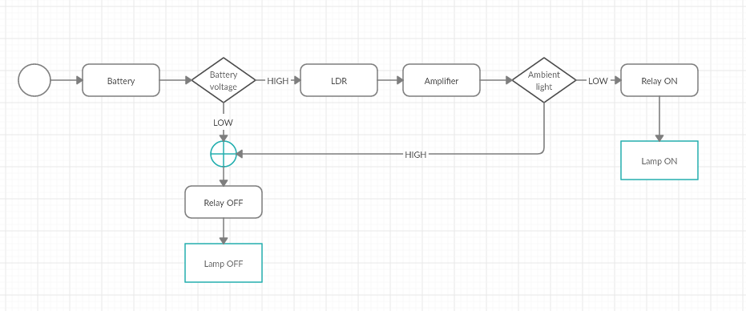

Activity diagram

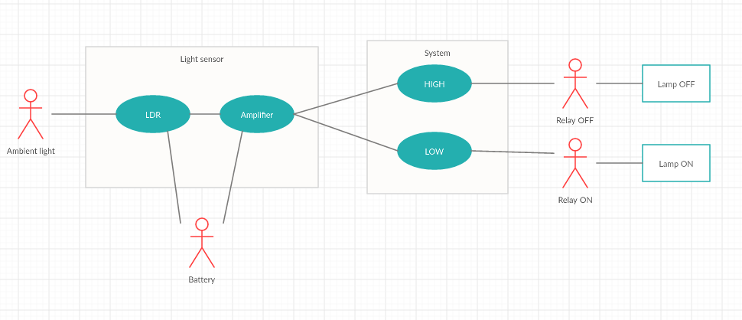

Use case diagram

## **Activity 2** –CI Workflow for C Programming

[Github repo](https://github.com/stepin105343/stepin-practice)

* **Commit log:**

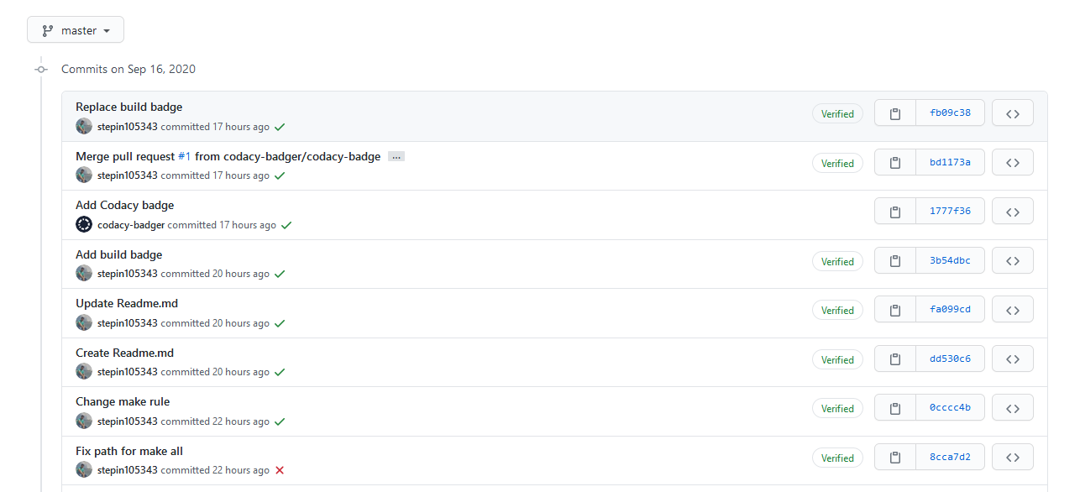

* **Actions:**

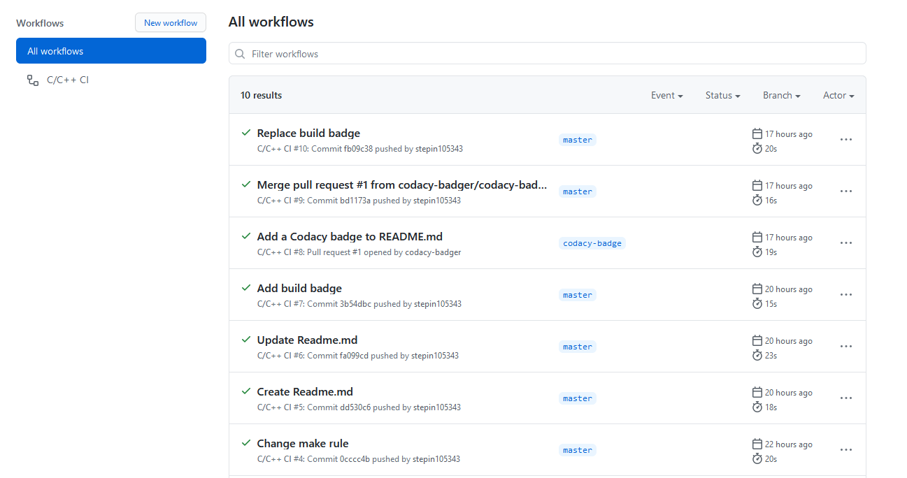

* **Build:**

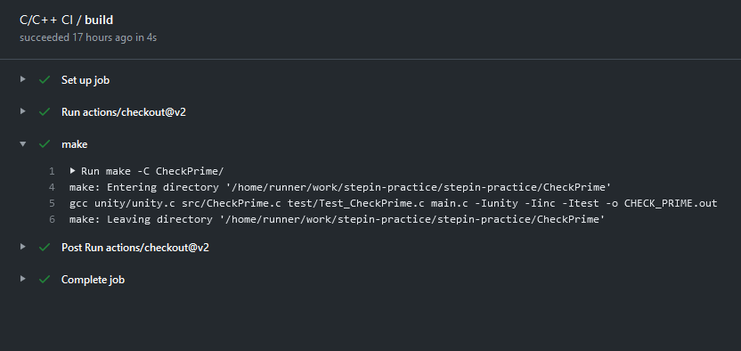

* **Codacy issues:**

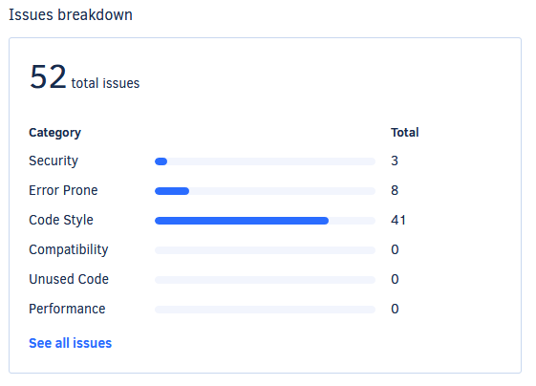

* **Badges:**

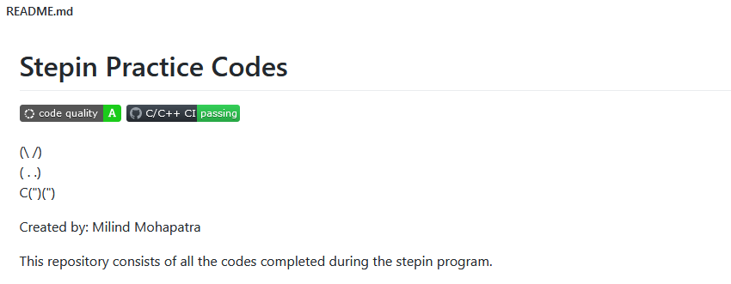

* **Makefile:**

|  |
| --- |
| SRC = unity/unity.c\ |
|  |

|  |
| --- |
| src/CheckPrime.c\ |
|  |

|  |
| --- |
| test/Test_CheckPrime.c\ |
|  |

|  |
| --- |
| main.c |
|  |

|  |
| --- |
|  |
|  |

|  |
| --- |
| INC = -Iunity\ |
|  |

|  |
| --- |
| -Iinc\ |
|  |

|  |
| --- |
| -Itest |
|  |

|  |
| --- |
|  |
|  |

|  |
| --- |
| PROJECT_NAME = CHECK_PRIME.out |
|  |

|  |
| --- |
|  |
|  |

|  |
| --- |
| $(PROJECT_NAME): $(SRC) |
|  |

|  |
| --- |
| gcc $(SRC) $(INC) -o $(PROJECT_NAME) |
|  |

|  |
| --- |
|  |
|  |

|  |
| --- |
| run:$(PROJECT_NAME) |
|  |

|  |
| --- |
| ./${PROJECT_NAME} |
|  |

|  |
| --- |
|  |
|  |

|  |
| --- |
| doc: |
|  |

|  |
| --- |
| make -C documentation |
|  |

|  |
| --- |
|  |
|  |

|  |
| --- |
| clean: |
|  |

rm -rf $(PROJECT_NAME) documentation/html

## **Activity 3** – Agile Aspects

* User story 1:

As a responsible citizen, I want to conserve energy so that the systems are more sustainable and work for longer periods of time.

* User story 2:

As a daily commuter, I want the street lamps to turn ON whenever it is dark so that the roads are always visible.

* User story 3:

As a daily commuter, I want the street lamps to work appropriately in all weather conditions so that roads are visible.