Import data
Script for importing data from the following spreadsheet:
Worksheet: D:\Matlab\Genesis-Matlab\database\log.csv
@author : Milind Mohapatra
@PS no. : 99002670
Import the data 1
Create output variable 1
Create table 1
Allocate imported array to column variable names 1
Clear temporary variables 2
Assign independent variables for all the sensors 2
Time Normalization 2
Linear acceleration data analysis 2
Clear no longer required variables 3
Gravity sensor data analysis 3
Sensor Fusion 4
Clear no longer required variables 5
Accessing ride quality 5
Putting together all data 6
Write all the data to a csv file named "ALL_DATA_LOGS" 6

Import the data
[acc] = xlsread('D:\MATLAB\Genesis-Matlab\database\log.csv','G2:I4457');
[gravity] = xlsread('D:\MATLAB\Genesis-Matlab\database\log.csv','D2:F4457');
[time] = xlsread('D:\MATLAB\Genesis-Matlab\database\log.csv','AD2:AD4457');
raw = [acc,gravity,time];

Create output variable
data = raw;

Create table
bus_data = table;

Allocate imported array to column variable names
bus_data.ACCNx = data(:,1);
bus_data.ACCNy = data(:,2);
bus_data.ACCNz = data(:,3);
bus_data.GRAVITYx = data(:,4);
bus_data.GRAVITYy = data(:,5);
bus_data.GRAVITYz = data(:,6);
bus_data.TIME = data(:,7);

Clear temporary variables
clearvars raw acc gravity time;

Assign independent variables for all the sensors
%Linear Acceleration on all three axes
ax = bus_data.ACCNx;
ay = bus_data.ACCNy;
az = bus_data.ACCNz;
%Gravity changes on all three axes
gx = bus_data.GRAVITYx;
gy = bus_data.GRAVITYy;
gz = bus_data.GRAVITYz;
%Time
t_temp = bus_data.TIME;
iteration = 4455;

Time Normalization
for i = 1:iteration
t(i,:) = t_temp(i+1,1) - t_temp(i,1);
end
t_real(1,1) = 0;
for i = 1:iteration
t_real(i+1,:) = t_real(i,:) + t(i,:);
end
%Time elapsed in seconds
t_real = t_real.*0.001;
%Clear no longer required variables
clearvars t_temp;
clearvars t;

Linear acceleration data analysis
%Change in acceleration every 0.1s on each axis
for i = 1:iteration
axt(i,:) = ax(i+1,1)-ax(i,1);
end
for i = 1:iteration
ayt(i,:) = ay(i+1,1)-ay(i,1);
end
for i = 1:iteration
azt(i,:) = az(i+1,1)-az(i,1);
end
%Combining the acceleration change over all axis
acc_temp = sum(axt.^2 + ayt.^2 + azt.^2, 2);
acc_change = sqrt(acc_temp);
%Plot overall acceleration changes throughout journey
subplot(3,1,1);
plot(acc_change, 'm');
xlabel('Time in secs');
ylabel('Accleration in m/s^2');
title('RATE OF CHANGE OF ACCELERATION');
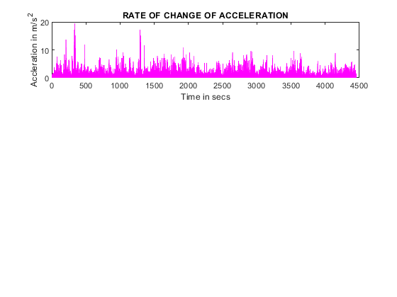

Clear no longer required variables
clearvars acc_temp ax ay az;
clearvars axt ayt azt;

Gravity sensor data analysis
for i = 1:iteration
gxt(i,:) = gx(i+1,1)-gx(i,1);
end
for i = 1:iteration
gyt(i,:) = gy(i+1,1)-gy(i,1);
end
for i = 1:iteration
gzt(i,:) = gz(i+1,1)-gz(i,1);
end
gvt_change = sum(gxt.^2 + gyt.^2 + gzt.^2, 2);
%Plot overall gravity changes throughout journey
subplot(3,1,2);
plot(gvt_change);
xlabel('Time');
ylabel('Gravity in m/s^2');
title('RATE OF CHANGE OF PERCIEVED GRAVITY');
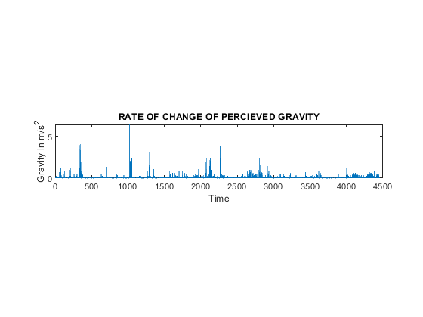

Sensor Fusion
%Use of custom function : fuse(arg1,arg2S)
final_data = fuse(acc_change, gvt_change);
subplot(3,1,3);
plot(final_data);
xlabel('Time');
ylabel('Bumps');
title('BUMPS ON THE ROAD');
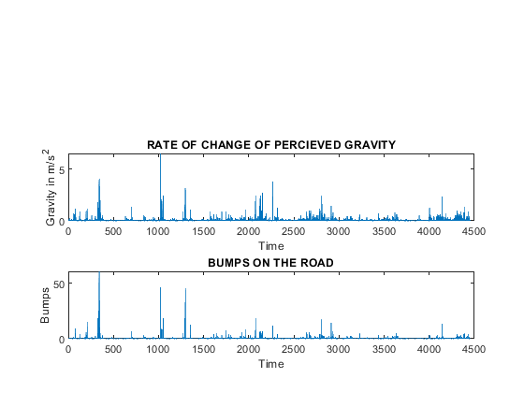

Clear no longer required variables
clearvars gx gy gx;
clearvars gxt gyt gzt;

Accessing ride quality
bump = 0;
smooth = 0;
threshold = 2;
for i = 1: iteration
if final_data(i,:) > threshold
bump = bump + 1;
else
smooth = smooth + 1;
end
end
total_counter = bump+smooth;
percent_good_ride = (smooth/total_counter)*100;
percent_bad_ride = (bump/total_counter)*100;
percent_bad_ride = round(percent_bad_ride);
DISPLAY = sprintf('%d percent of the total ride was bad', percent_bad_ride);
disp(DISPLAY);
3 percent of the total ride was bad

Putting together all data
for i = i:size(final_data)
null_matrix(i,:) = 0000;
end
alldata = horzcat(data(2:end,1),data(2:end,2),data(2:end,3),data(2:end,4),data(2:end,5),data(2:end,6),data(2:end,7),null_matrix, acc_change,gvt_change,final_data);

Write all the data to a csv file named "ALL_DATA_LOGS"
csvwrite('ALL_DATA_LOGS.csv', alldata);
Published with MATLAB® R2020b

