./

Learning Report –

Embedded C

Course Code: <CODE>



|  |  |  |  |  |  |
| --- | --- | --- | --- | --- | --- |
| **Ver. Rel. No.** | **Release Date** | **Prepared. By** | **Reviewed By** | **Approved By** | **Remarks/Revision Details** |
| 1 | 30th Sept 2020 | Amit Das |  |  | MCU specific header files for GPIO and RCC |
|  |  |  |  |  |  |
|  |  |  |  |  |  |
|  |  |  |  |  |  |
|  |  |  |  |  |  |

**Document History**

# 

CONTENTS

Activity 1: Linker Script 4

Activity 2: Semi Hosting 5

Activity 3: Changing bit state of SPI1 SPE 6

Activity 4: Debugging techniques 7

Serial wire viewer and data tracing 7

Single stepping, stepping over and stepping out 7

Breakpoints 8

Call stack (Static stack analyzer) 8

Expression and Variable window 9

Memory browser 10

Data watch points 10

Disassembly 11

Activity 5: MCU specific header file 12

Link to repository: Link 12

**TABLE OF FIGURES**

Figure 1: Linker section 5

Figure 2: Code Snippet for semi hosting 6

Figure 3: Semi hosting enabled 6

Figure 4: Bit modification of SPI1 SSI 7

Figure 5: Bit modification of SPI1 SPE 7

Figure 6: Enable serial wire viewer 8

Figure 7: Breakpoint stepping 8

Figure 8: Multiple breakpoints 9

Figure 9: Static stack analyzer 9

Figure 10: Variable window 10

Figure 11: Expression window 10

Figure 12: Memory browser 11

Figure 13: Assigning watch-point 11

Figure 14: Disassembly window 12

# Activity 1: Linker Script

[Link](https://github.com/99002591/GENESIS_WEEK3/blob/master/STM32_Linker_example.txt)

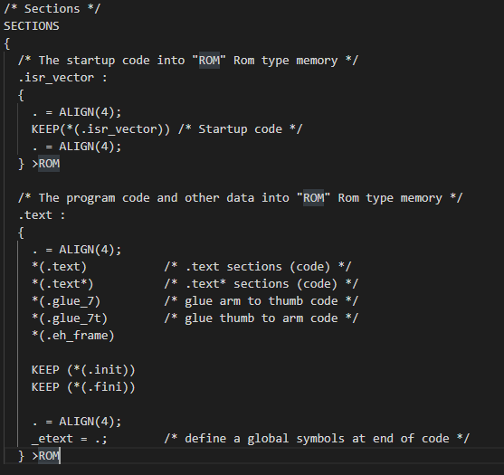

Figure : Linker section

# Activity 2: Semi Hosting

[Link](https://github.com/99002591/GENESIS_WEEK3/tree/master/Learn01)

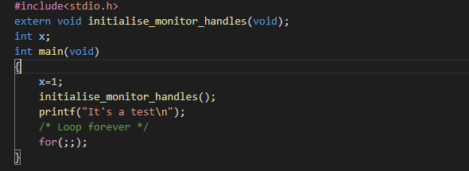

Figure : Code Snippet for semi hosting

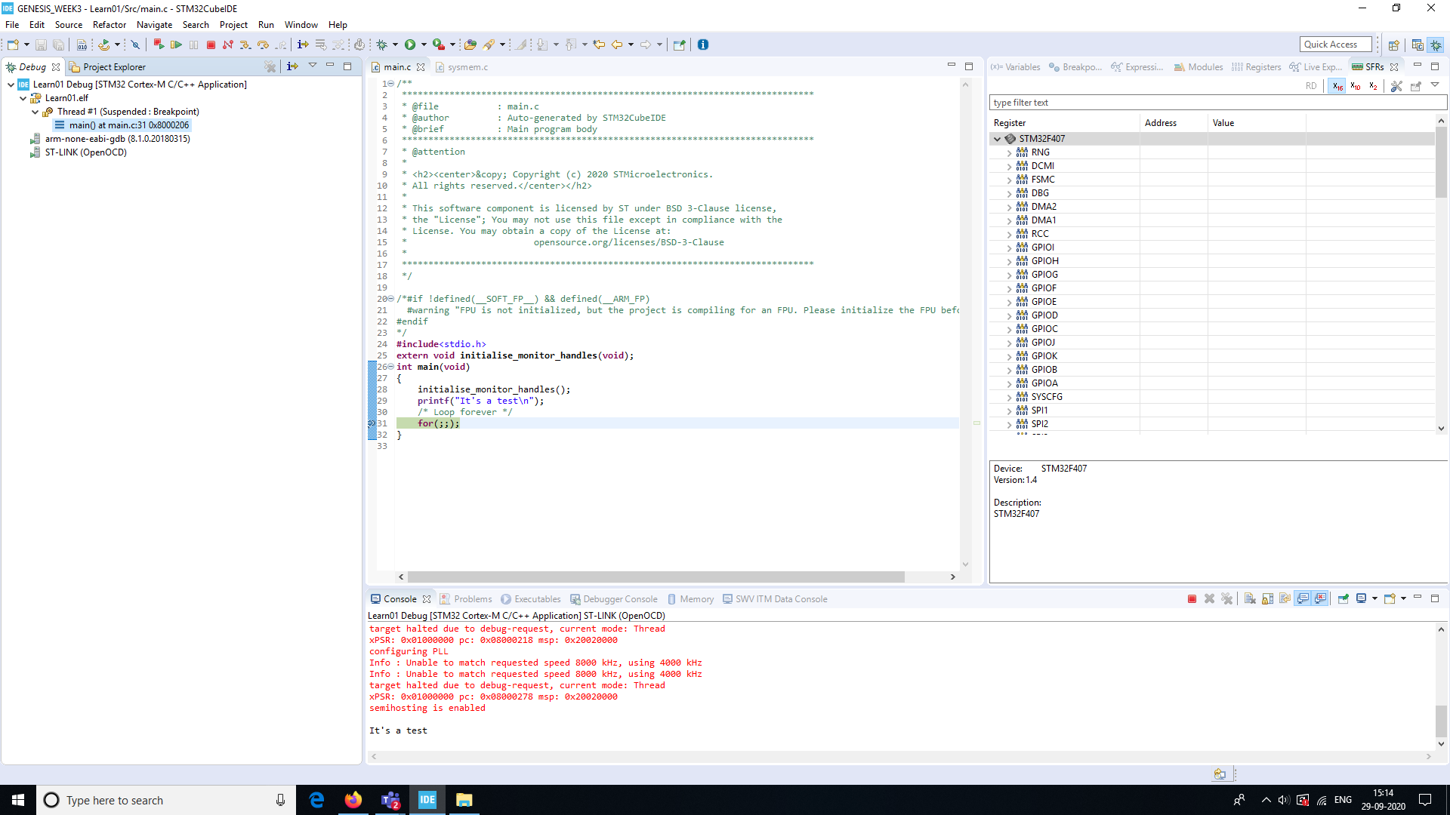

Figure : Semi hosting enabled

# Activity 3: Changing bit state of SPI1 SPE

[Link](https://github.com/99002591/GENESIS_WEEK3/tree/master/Activity001)

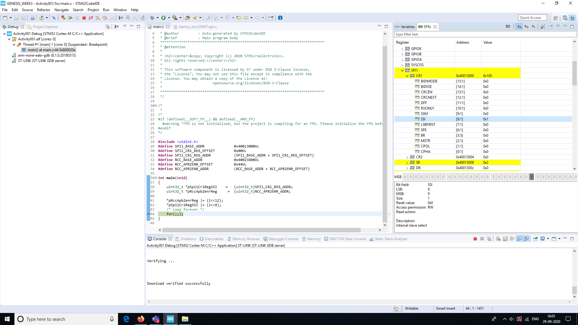

Figure : Bit modification of SPI1 SSI

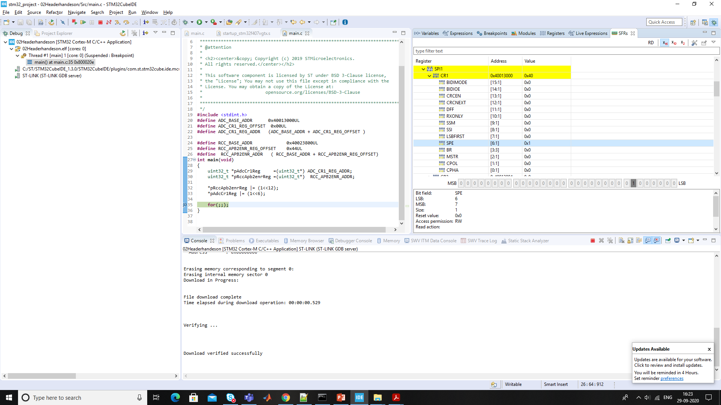

Figure : Bit modification of SPI1 SPE

# Activity 4: Debugging techniques

## Serial wire viewer and data tracing

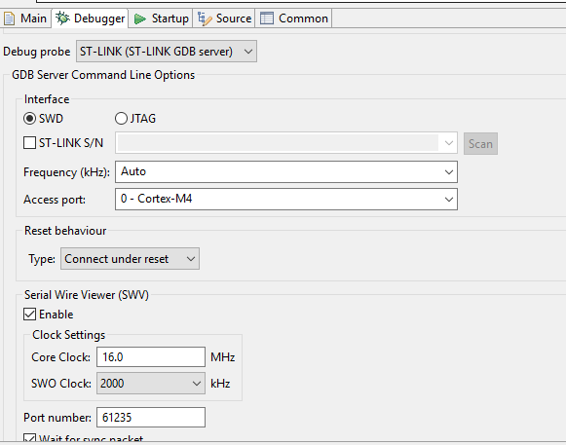

Figure : Enable serial wire viewer

## Single stepping, stepping over and stepping out

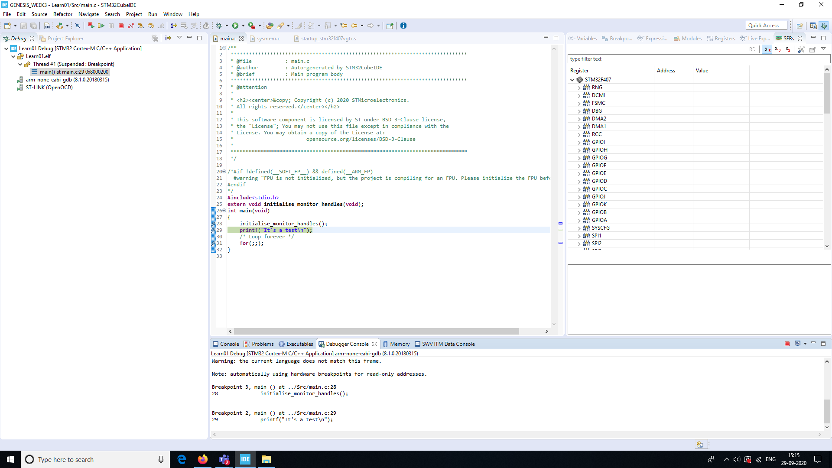

Figure : Breakpoint stepping

## Breakpoints

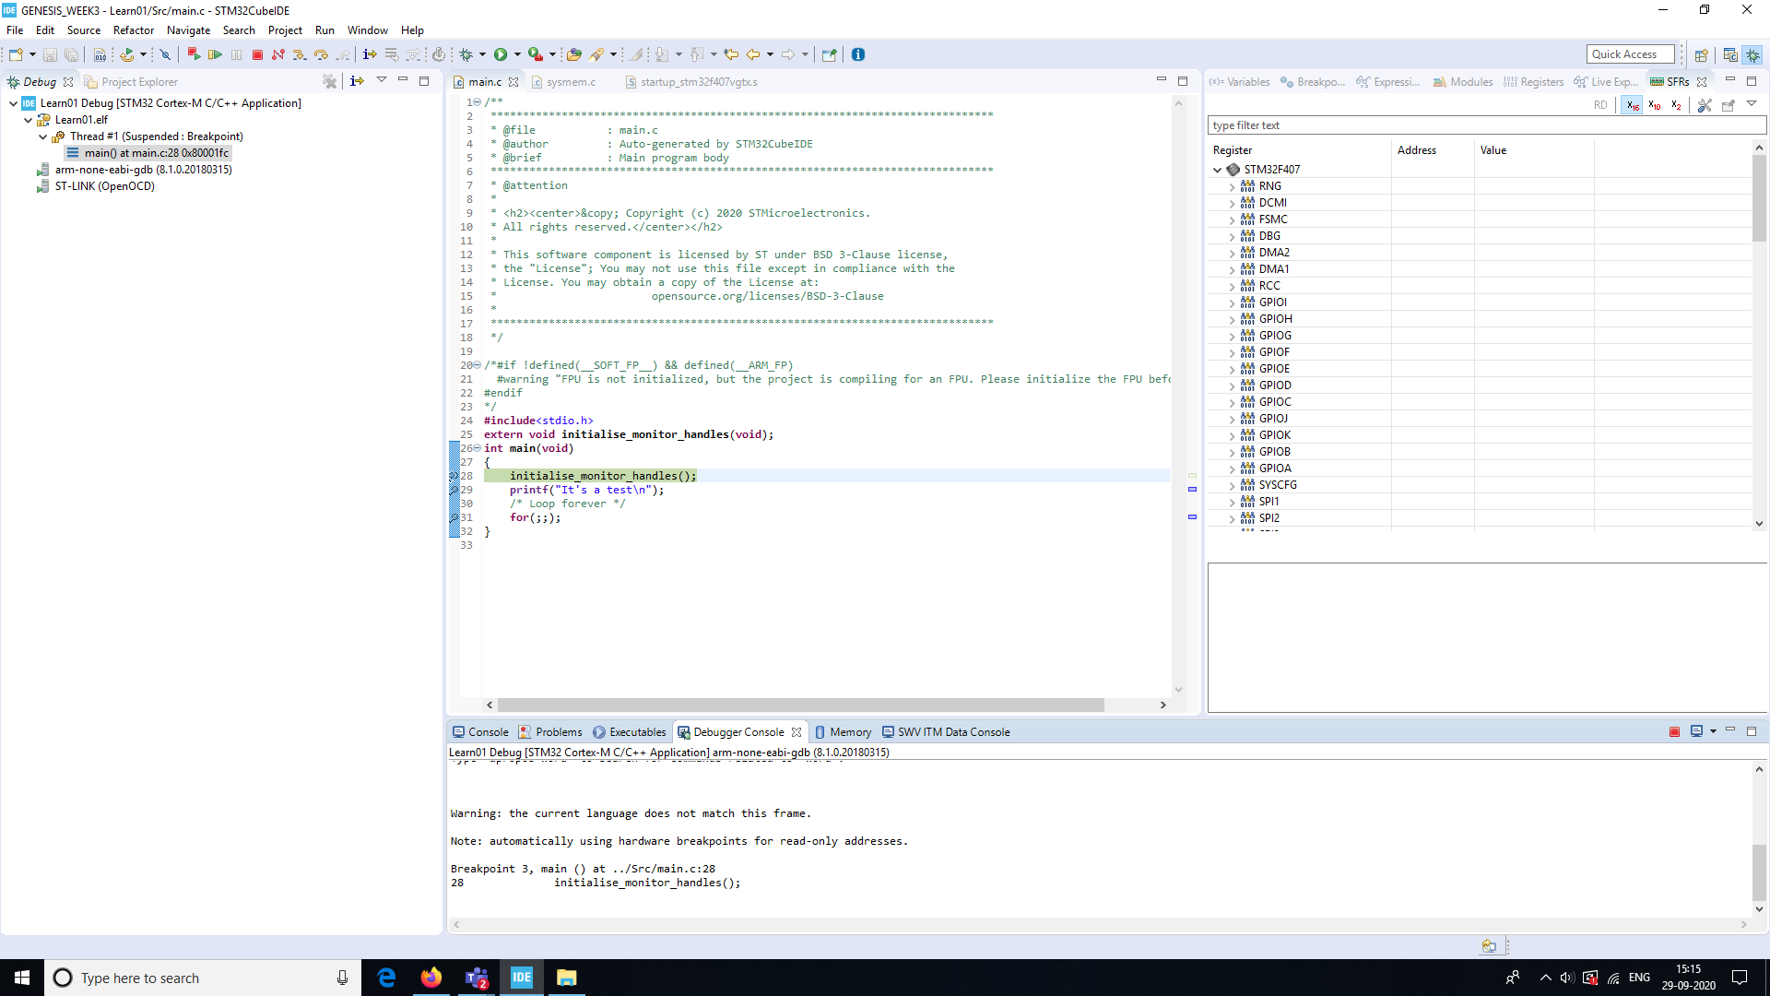

Figure : Multiple breakpoints

## Call stack (Static stack analyzer)

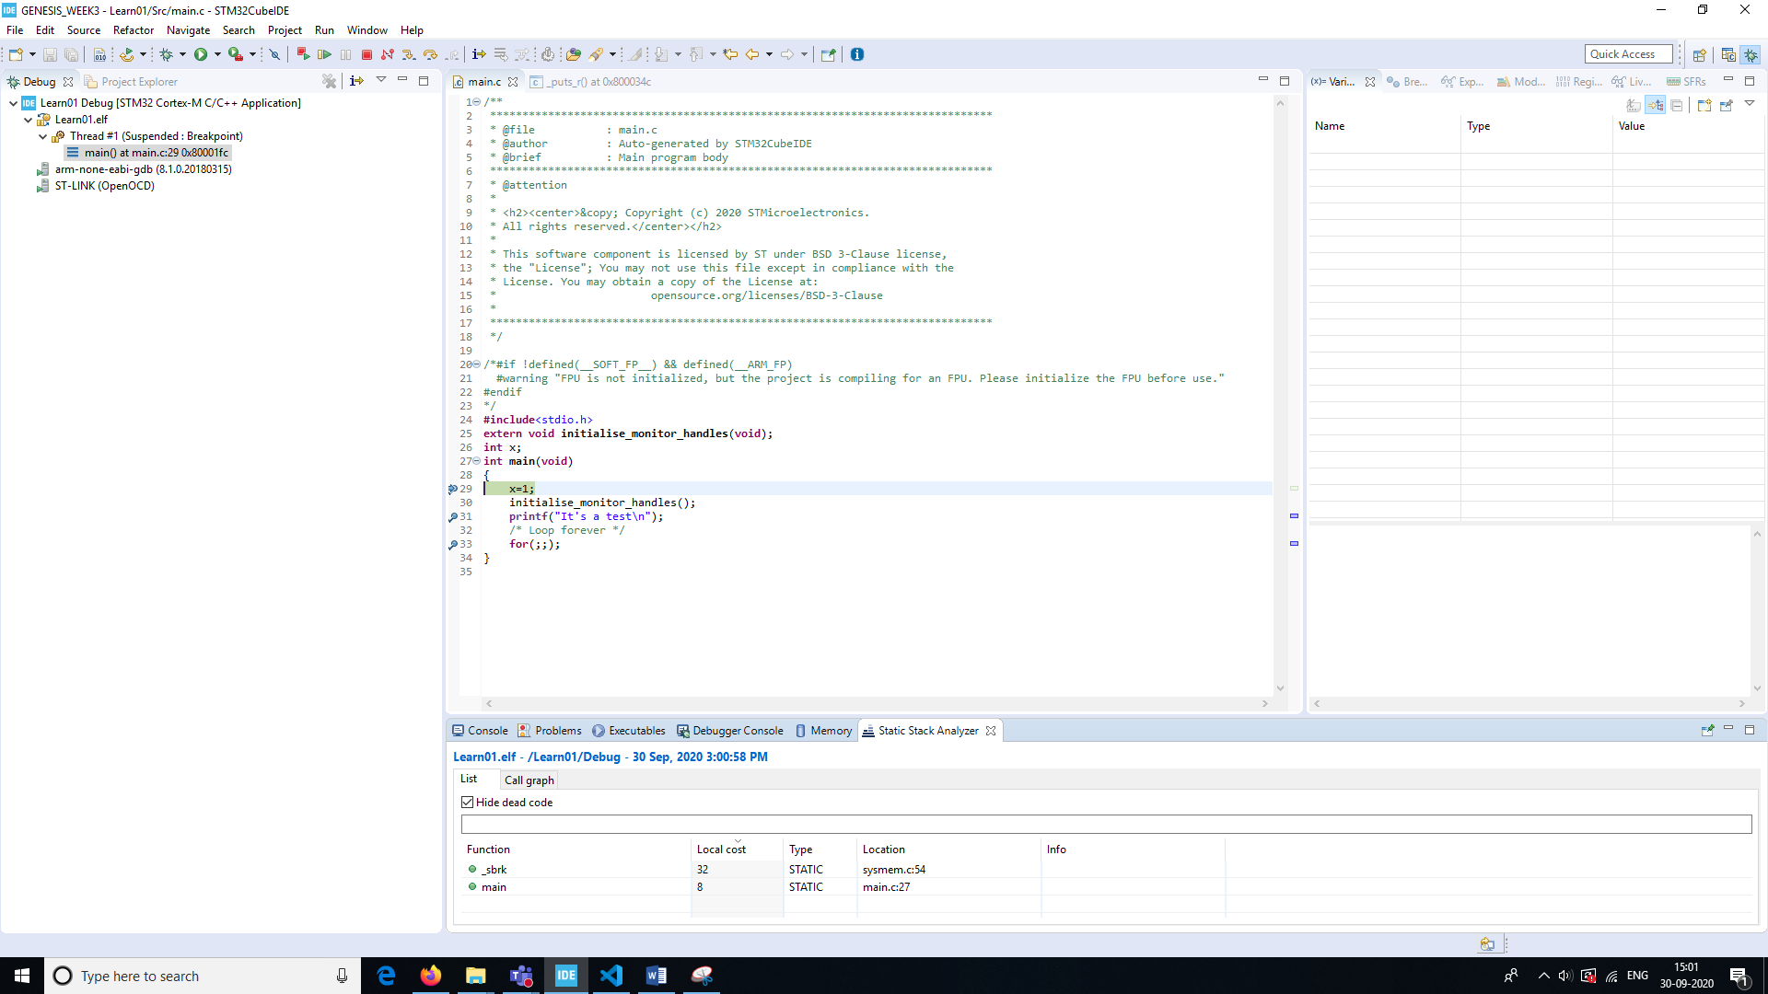

Figure : Static stack analyzer

## Expression and Variable window

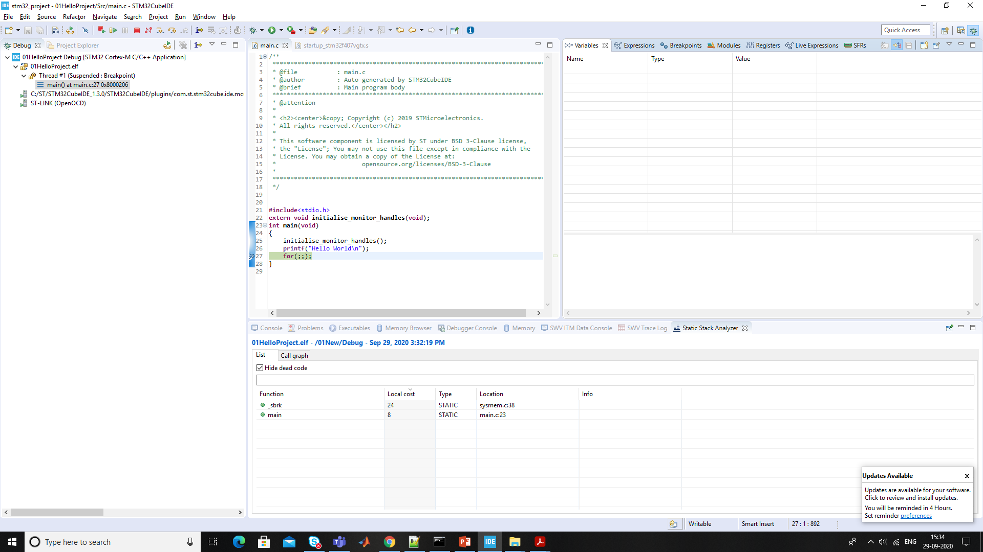

Figure : Variable window

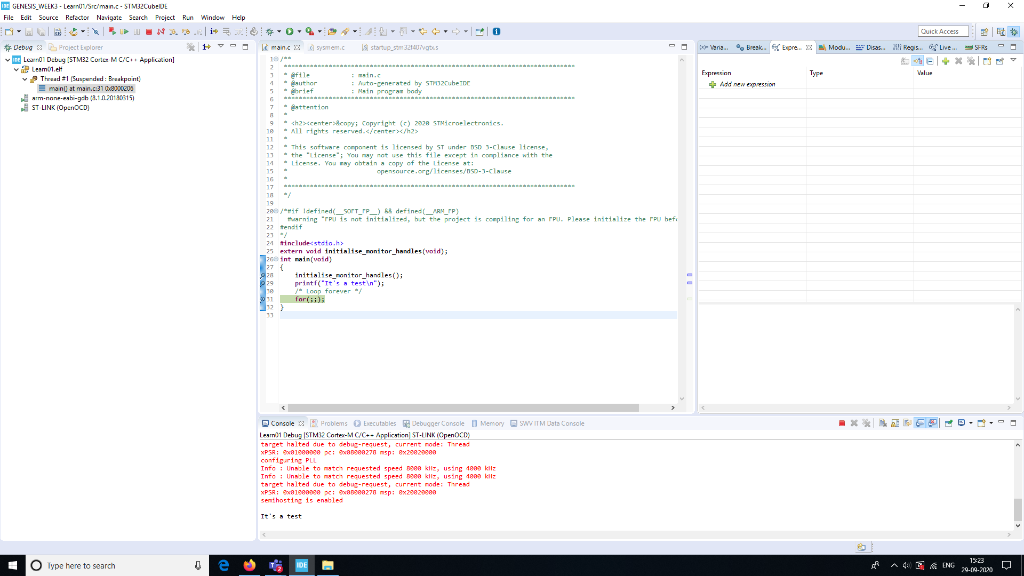

Figure : Expression window

## Memory browser

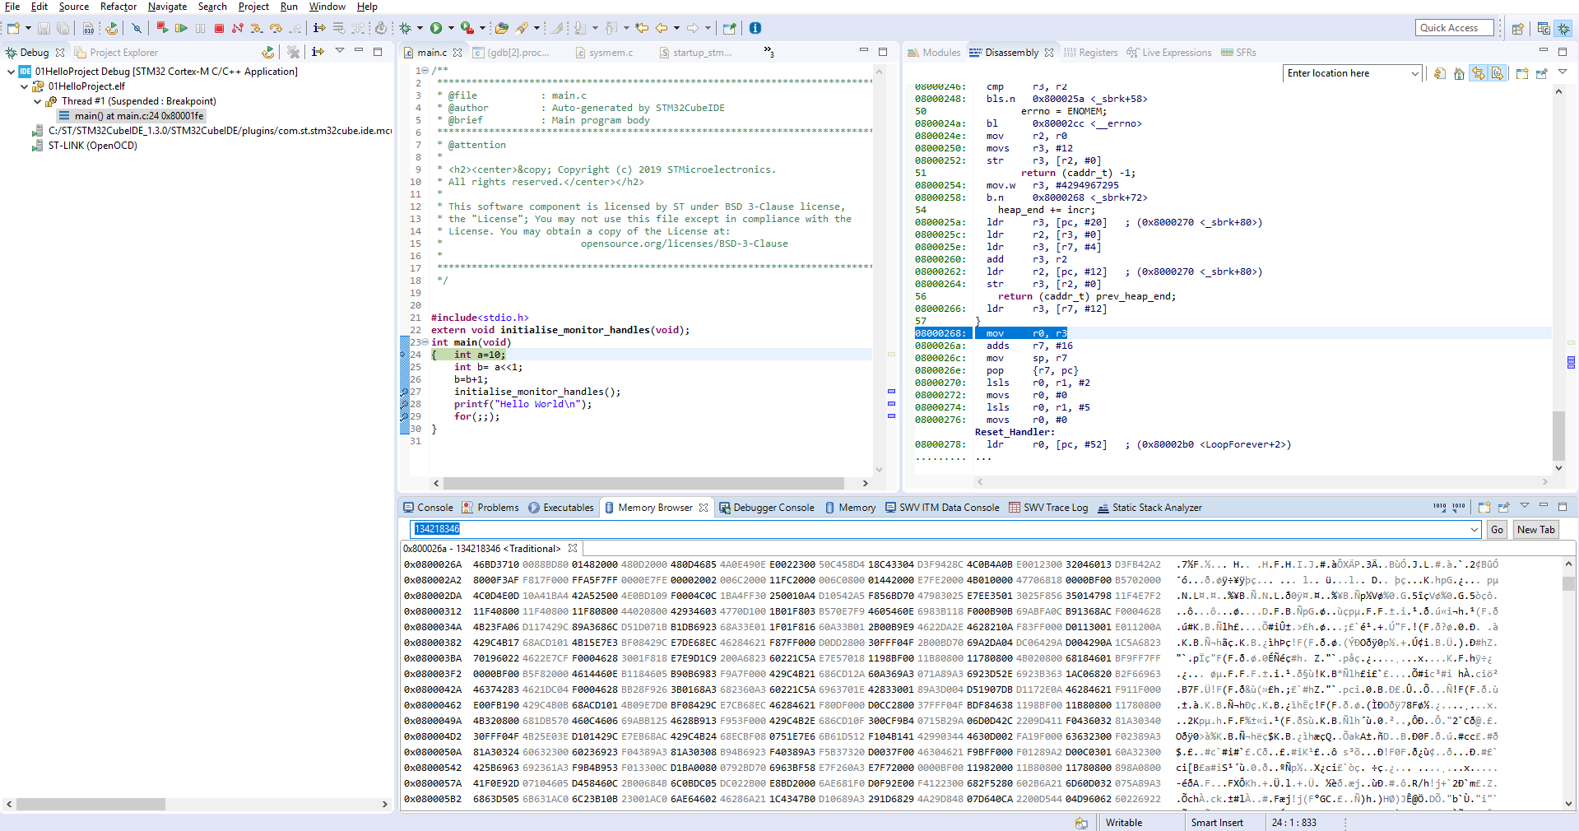

Figure : Memory browser

## Data watch points

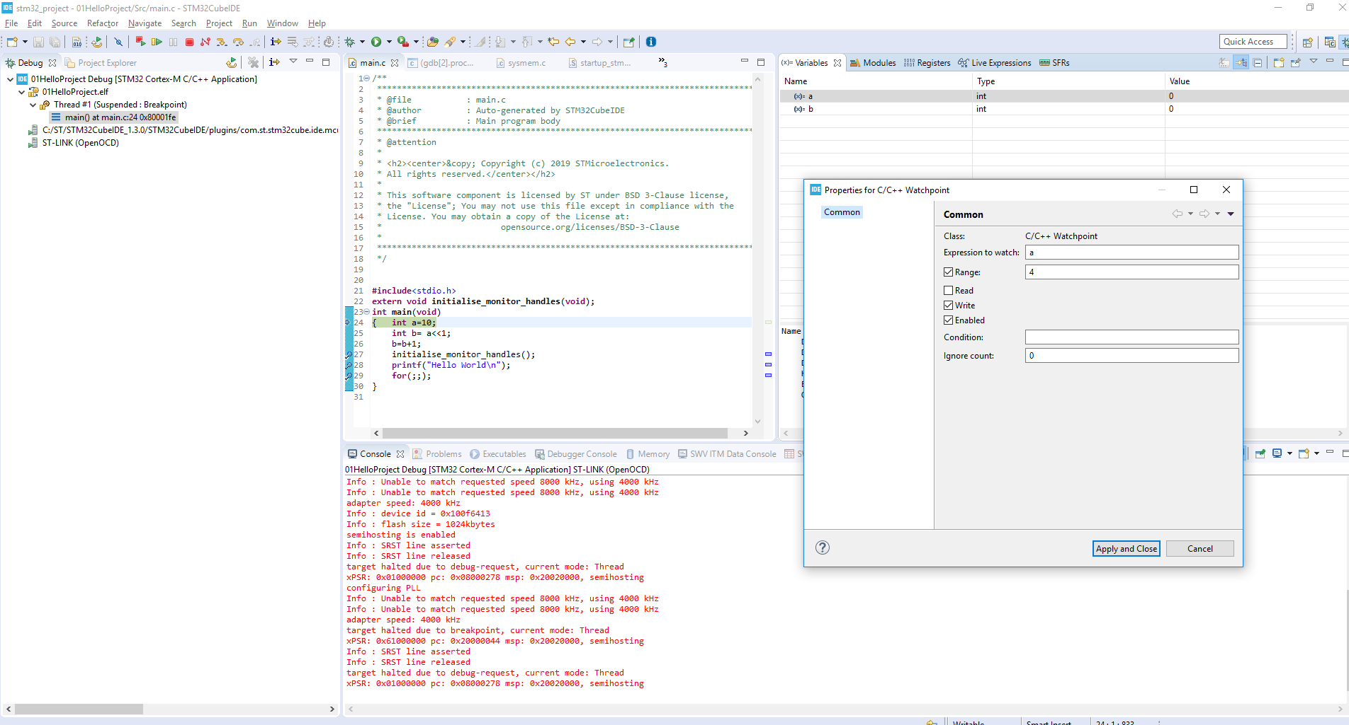

Figure : Assigning watch-point

## Disassembly

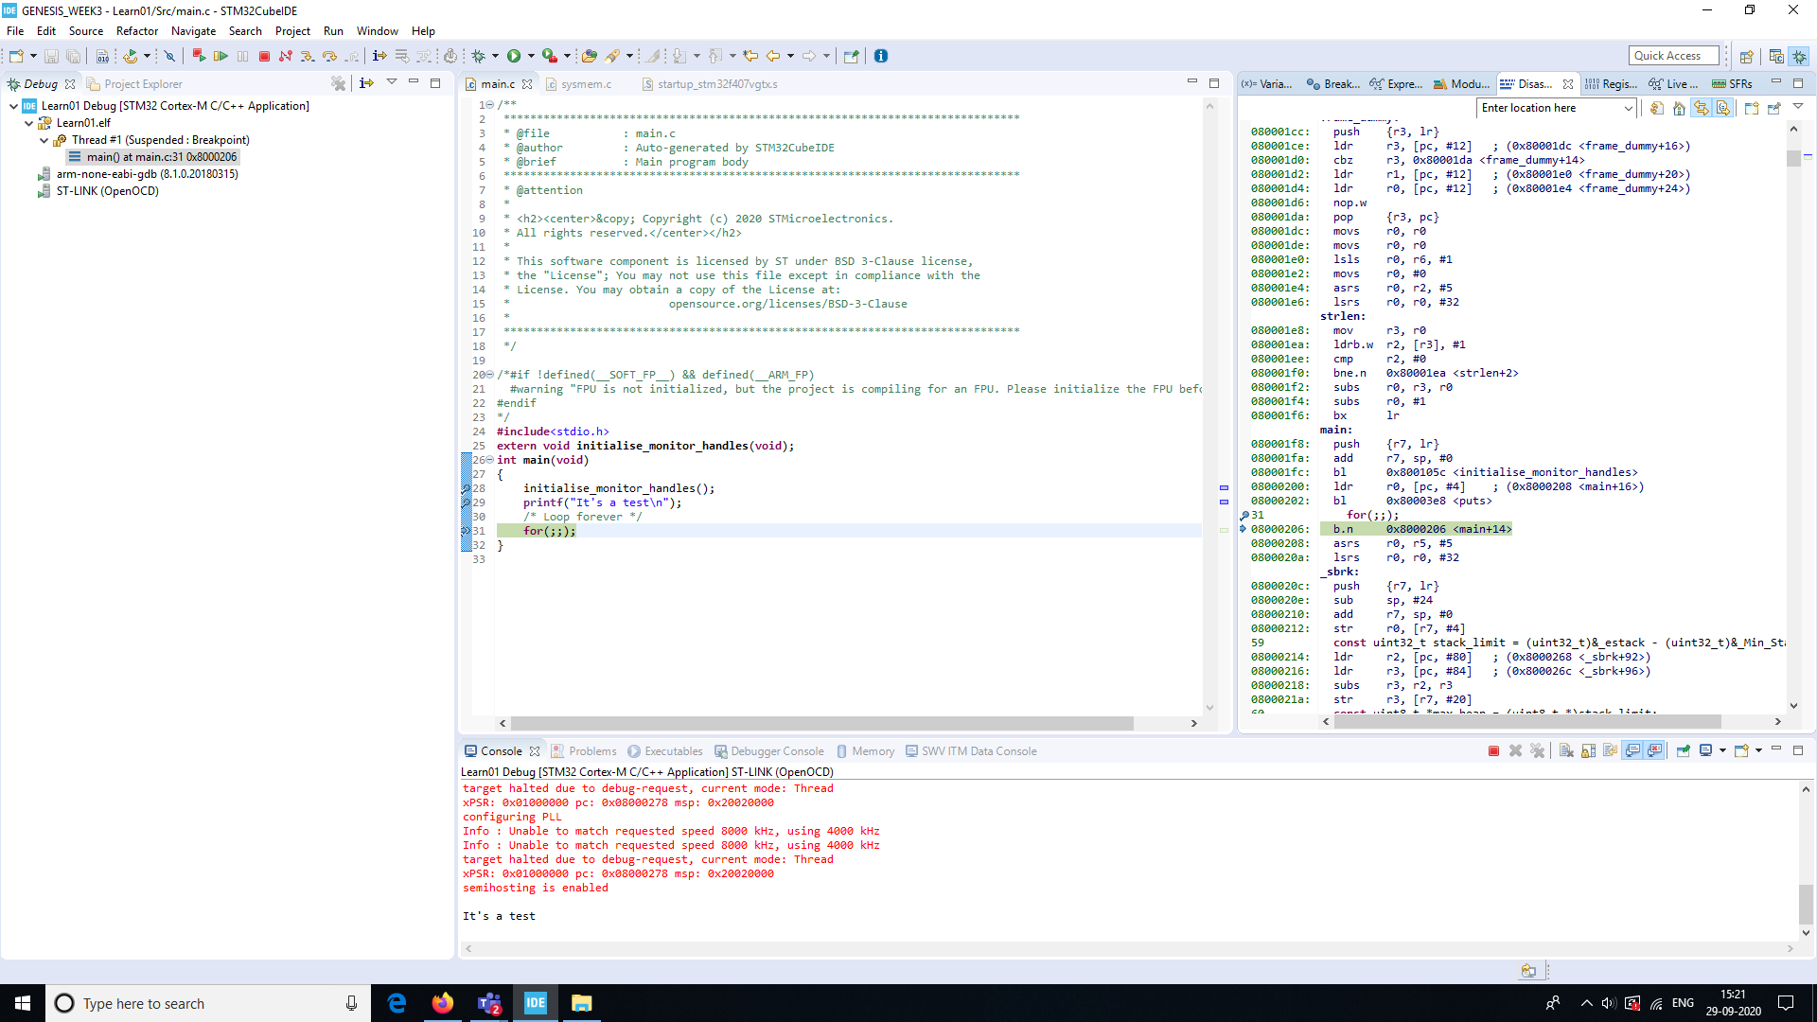

Figure : Disassembly window

# Activity 5: MCU specific header file

## Link to repository: [Link](https://github.com/99002591/GENESIS_WEEK3/tree/master/Learn03)