Remember:

* WatchFaceAdvancedCopy:

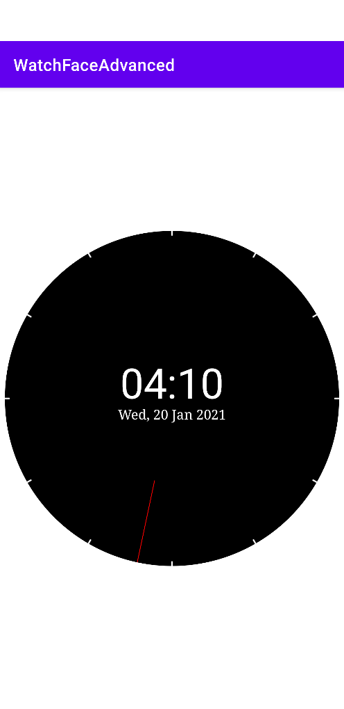

* FirstDigitalWatchCanvas:

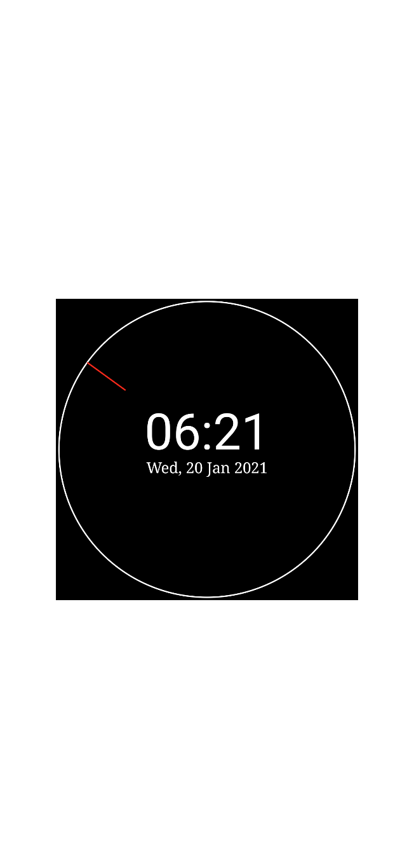

* SecondDigitalWatchFaceCanvas

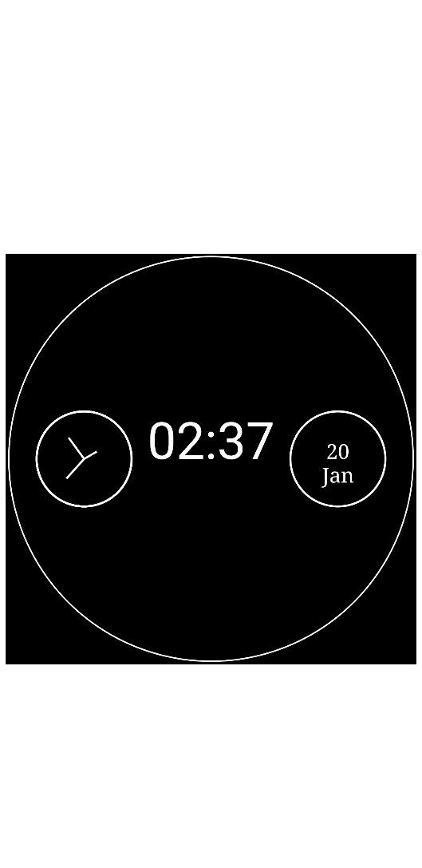

* WearOsExample: (for WearOs)

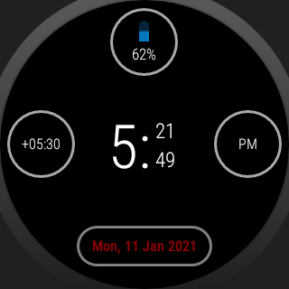

* SecondDigitalWatchFace (for WearOs)

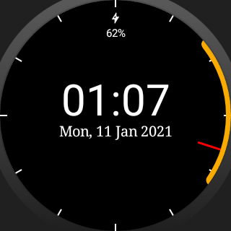

AnalogCanvasClock: (Without bitmaps)

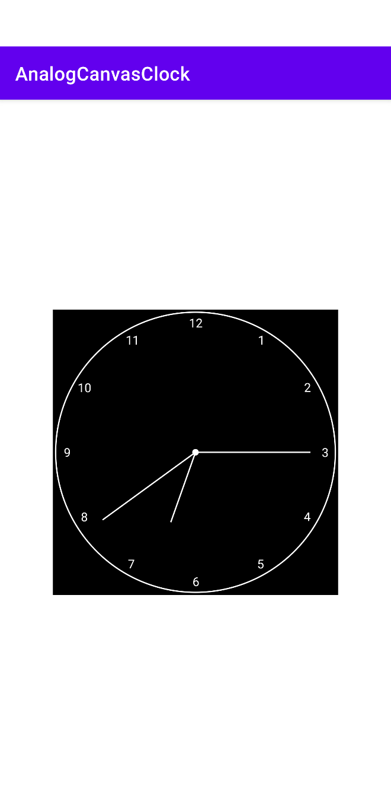

AnalogWatchFaceCanvas2

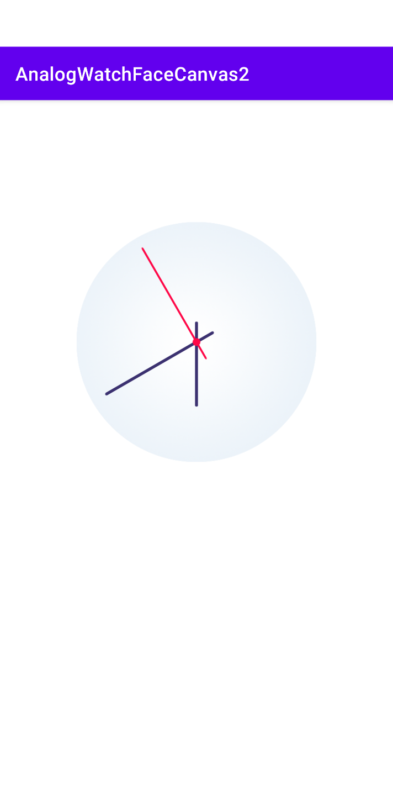

WatchFaceAdvanced

