./

Learning Report – Web Development Mini Project



|  |  |  |  |  |
| --- | --- | --- | --- | --- |
| **Date** | **PS No** | **Name** | **Email ID** | **To be Reviewed By** |
| 12/11/2020 | 99002652 | Nishant Raj | nishant.raj@ltts.com |  |
| 12/11/2020 | 99002683 | Pooja Pol | pooja.pol@ltts.com |  |
| 12/11/2020 | 99002658 | Subhrosil Maiti | subhrosil.maiti@ltts.com |  |
| 12/11/2020 | 99002681 | Hasika Chelladurai | hasika.chelladurai@ltts.com |  |

**Details**

Table of Contents

Quote Site 5

1. Introduction 6

2. Research 6

**2.1** **Aging** 6

4. SWOT Analysis 6

5. Detailed Requirements 7

**5.1** **High level requirements** 7

**5.2** **Low level requirements** 7

6. Design Analysis 8

**6.1** **Behavioral Diagram** 8

5.1.1 Use Case Diagram 8

5.1.2 Activity Diagram 8

**6.2** **Structural Diagram** 9

6.2.1 Component Diagram 10

6.2.2 Class Diagram 11

7. Testing 11

**7.1** **Unit testing** 12

**7.2** **Integration testing** 12

8. Reference 12

List of Tables

Table 1: SWOT Analysis 5

Table 2: High Level Requirements 5

Table 3: Low Level Requirements 6

Table 4: Unit Testing 10

Table 5: Integration Testing 10

List of Figures

Figure 1: Use Case Diagram 6

Figure 2: Activity Diagram 7

Figure 3: Component Diagram 8

Figure 4: Class Diagram 9

# Quote Site

# Introduction

The objective of this website is to generate Quotes. The Quote generating website is a Web based website that can be accessed by anyone who has an internet connection. This website can generate the quotes all at a time and it can also be generated and searched on different criteria. The search criteria are based on Author and Category. There are other buttons also to clear the quote that is displayed. Using the Menu, we can also access the contributors of the project.

# Research

## **Aging**

Existing methodologies are

* Brainyquote
* Quotery
* Goodreads
* Great-Quotes
* Quotesdaddy
  1. **Costing**

As its developed on an Open source platform using HTML, CSS, BOOTSTRAP, JavaScript, the cost in inexpensive. Later, nominal charges for hosting it on internet will be charge.

1. **My Product**

* Show all Quotes
* Show Quotes by Author
* Show Quotes by category
* Clear the loaded Quotes
* Show the contributors Page
* Landing to home Page from the Menu

# SWOT Analysis

|  |  |
| --- | --- |
| **Strengths** | **Weaknesses** |
| * Convenient and easy to use * Faster loading * New quotes can be updated * Compatible with all browsers | * Local storage used for images and media which can make the loading difficult sometimes |
| **Opportunities** | **Threats** |
| * More effects and transitions can be added in the quotes | * Indentation and format may not be correct sometimes |

Table : SWOT Analysis

# Detailed Requirements

## **High level requirements**

|  |  |
| --- | --- |
| **ID** | **Description** |
| HL_01 | Compatible with all devices |
| HL_02 | Compatible with all browsers |
| HL_03 | Maintain flow throughout |
| HL_04 | Interaction and synchronization with database |

Table : High Level Requirements

## **Low level requirements**

|  |  |
| --- | --- |
| **ID** | **Description** |
| LL_01 | Updating new quotes in database |
| LL_02 | Searching by Author |
| LL_03 | Search by category |
| LL_04 | Support and Contributors |
| LL_05 | Clearing the quotes using clear button |
| LL_06 | Show all quotes using Show button |
| LL_07 | Home Page landing using Home button |

Table : Low Level Requirements

# Design Analysis

## **Behavioral Diagram**

### 5.1.1 Use Case Diagram

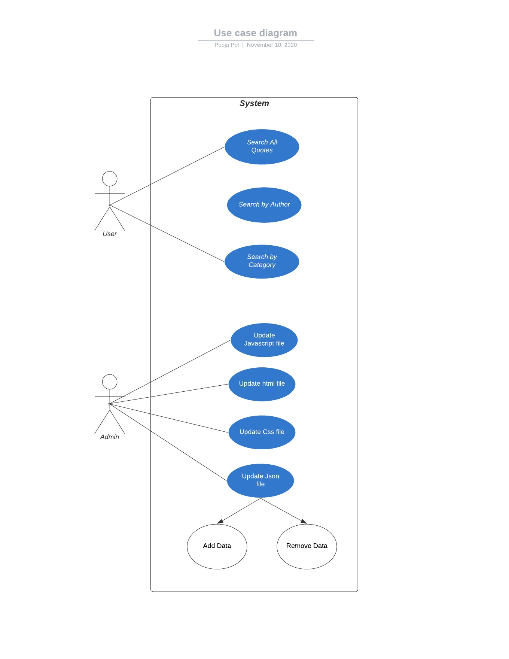

Figure : Use Case Diagram

### 5.1.2 Activity Diagram

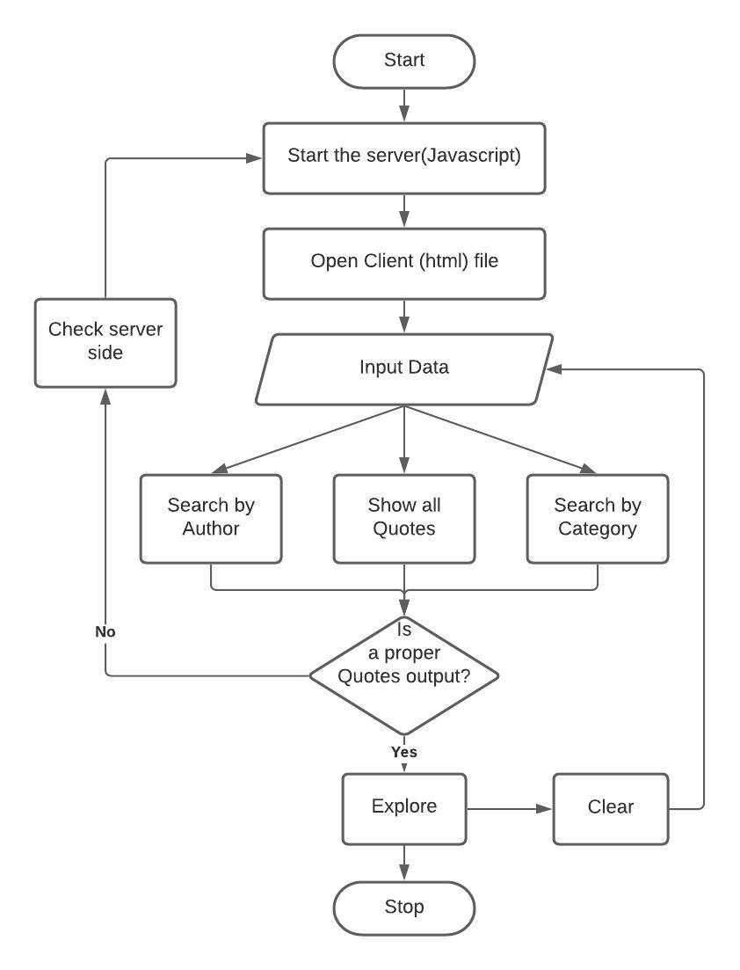

Figure : Activity Diagram

## **Structural Diagram**

### 6.2.1 Component Diagram

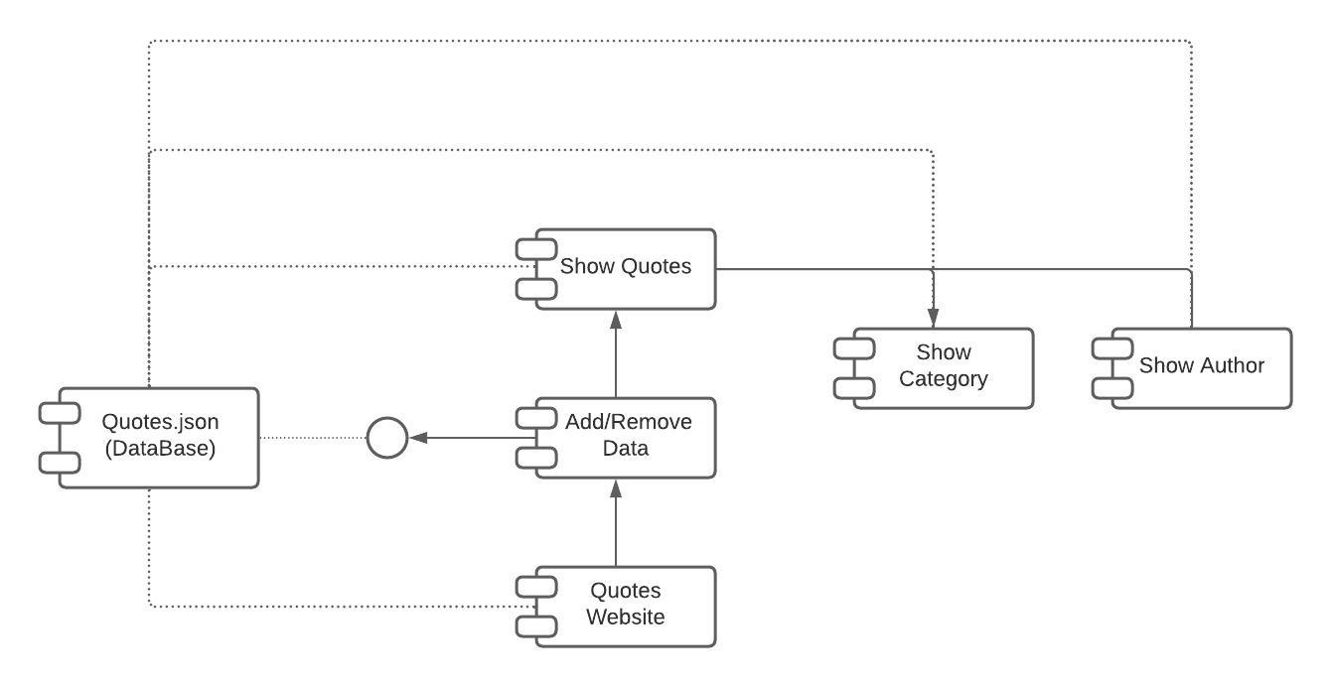

Figure : Component Diagram

### 6.2.2 Class Diagram

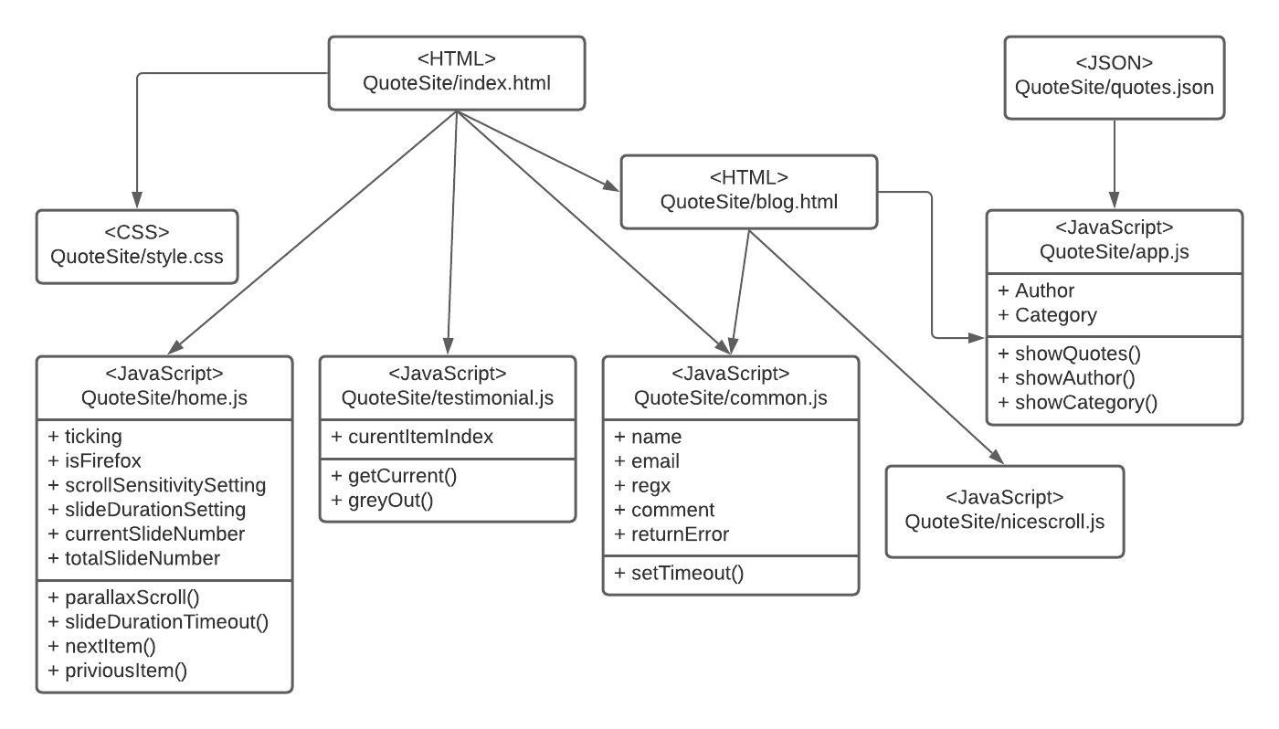

Figure : Class Diagram

# Testing

## **Unit testing**

|  |  |  |  |
| --- | --- | --- | --- |
| **ID** | **Description** | **Expected input** | **Expected output** |
| HH_01 | Compatible with all devices | View on desktop, tablet and mobile phones | Compatibility to view on all devices |
| HH_02 | Compatible with all browsers | View on different browsers | Successful loading on all browsers |
| HH_03 | Maintain flow throughout | Loading, Selecting one option viewing quotes | Quotes successfully loaded |
| HH_04 | Interaction and synchronization with database | Request quotes from the database | View the requested quotes |

Table : Unit Testing

## **Integration testing**

|  |  |  |  |
| --- | --- | --- | --- |
| **ID** | **Description** | **Expected input** | **Expected output** |
| LL_01 | Updating the new quotes in database | New Quote | New Quote added |
| LL_01 | Search by Author | Author Name | Quotes by the searched author |
| LL_03 | Search by Category | Category Name | Quotes by the searched author |
| LL_04 | Support and contributors Button | Clicking Contributors from menu | Contributors details displayed. |
| LL_05 | Clear button | Clicking clear button | The loaded quotes gets cleared |
| LL_06 | Show all button | Clicking Show all button | Displays all quotes |
| LL_07 | Home button | Clicking home button | Takes to home Page |

Table : Integration Testing

# Reference

[1] https://www.w3schools.com

[2] https://www.geeksforgeeks.org