**UML DIAGRAMS:**

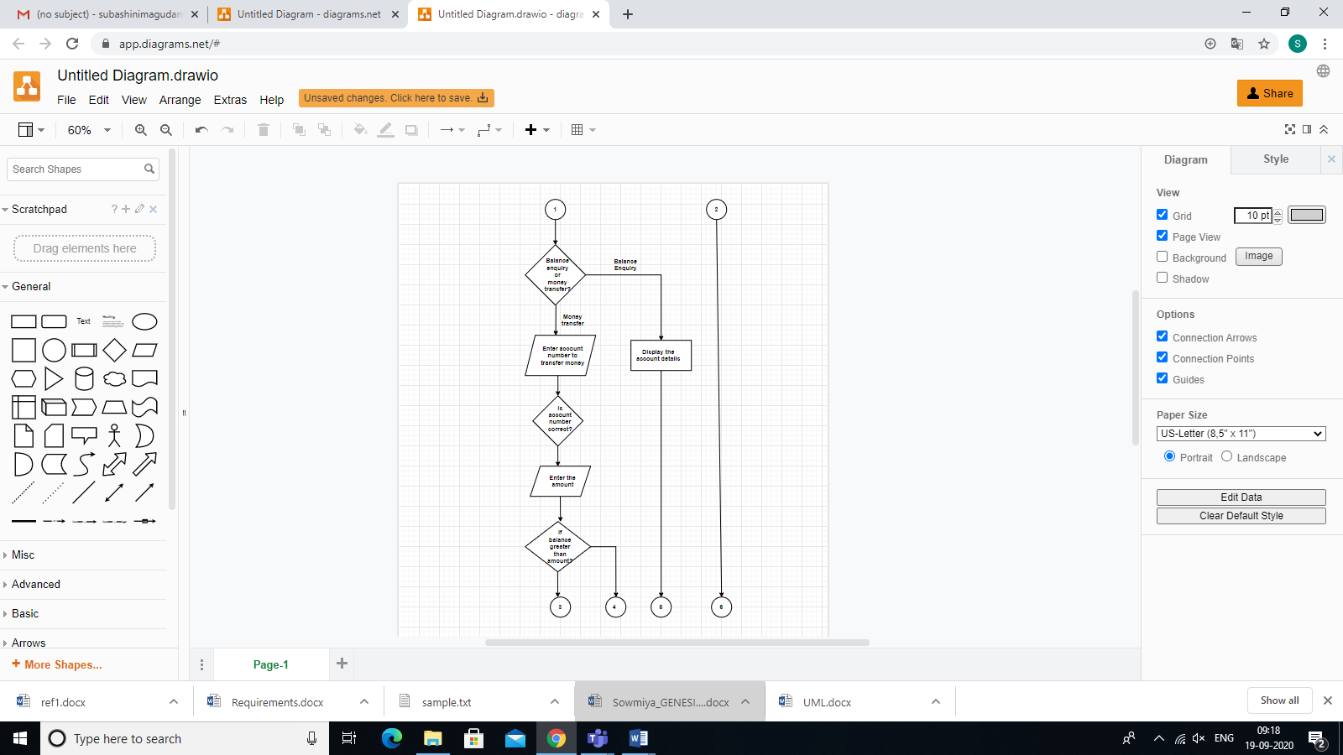

***Figure 1.1: Flow chart of Bank management system***

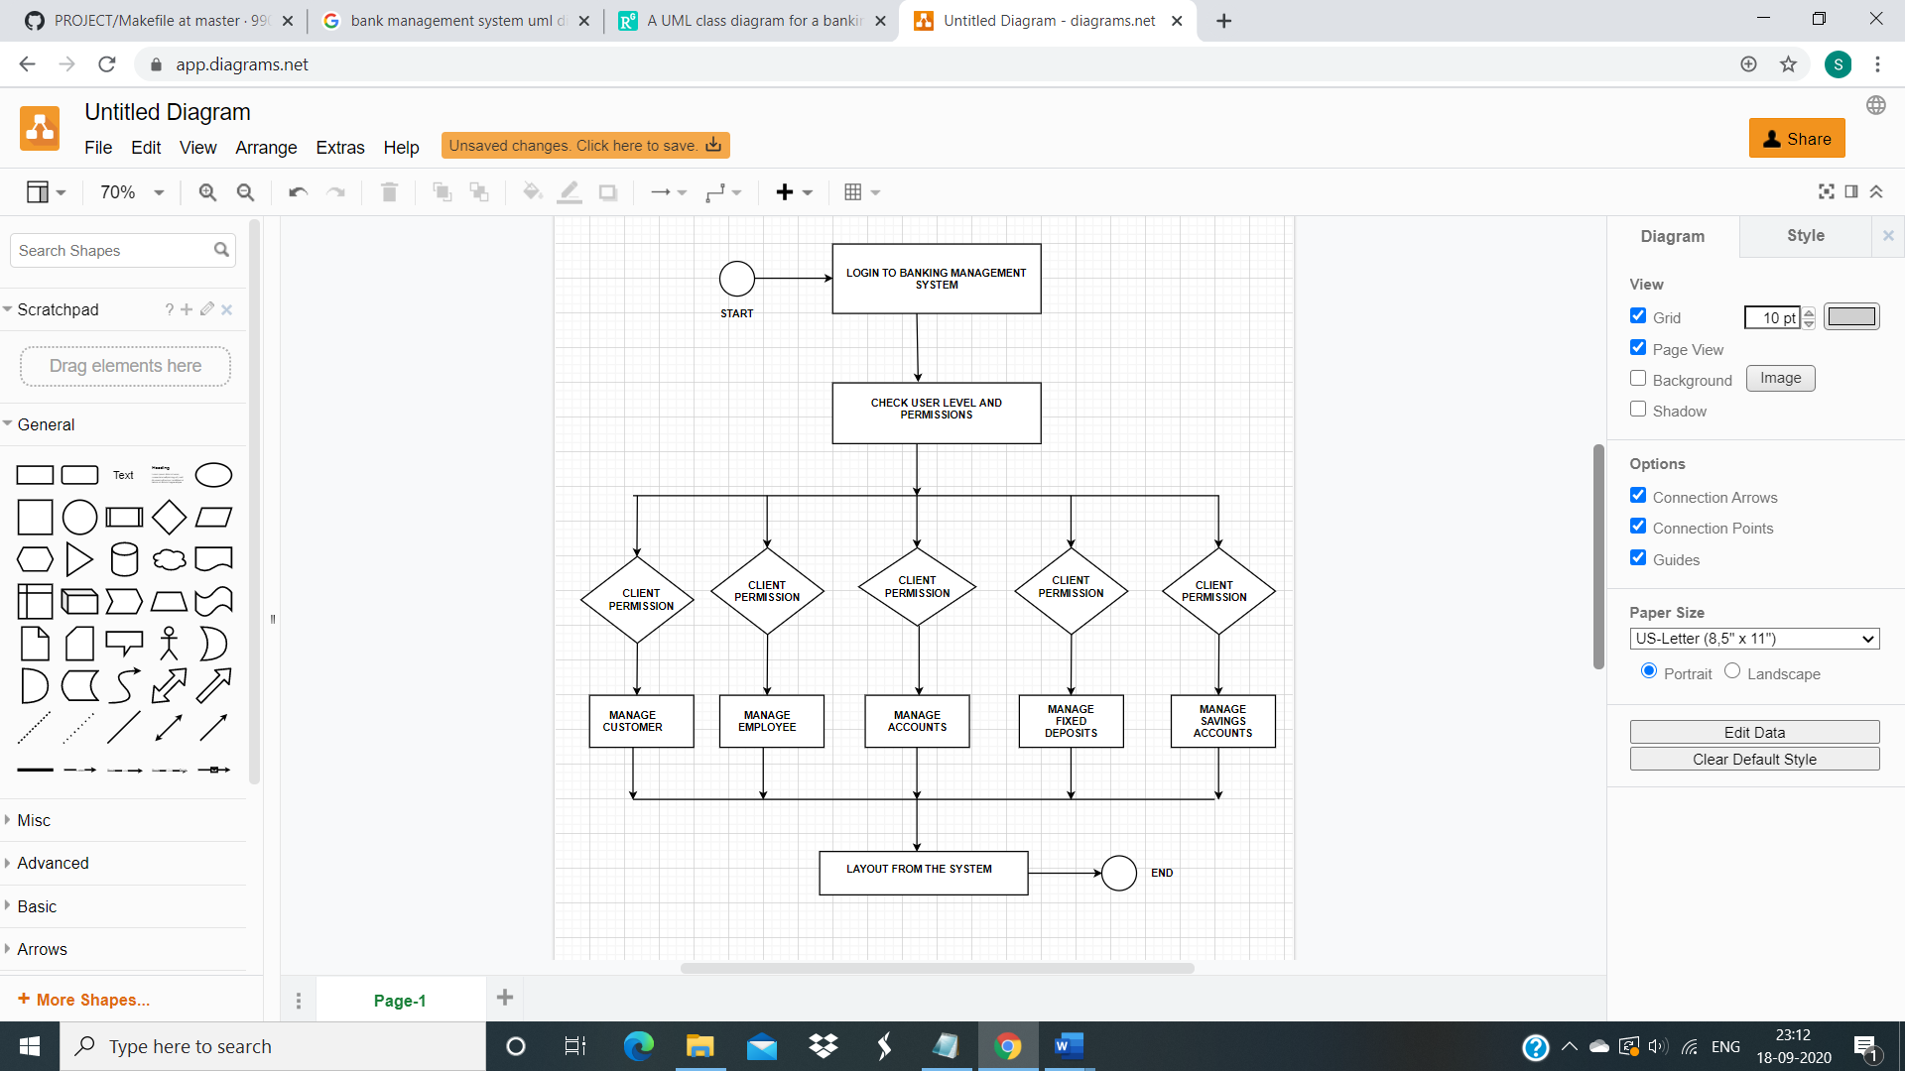

***Figure 1.2: Activity diagram of Bank management system***

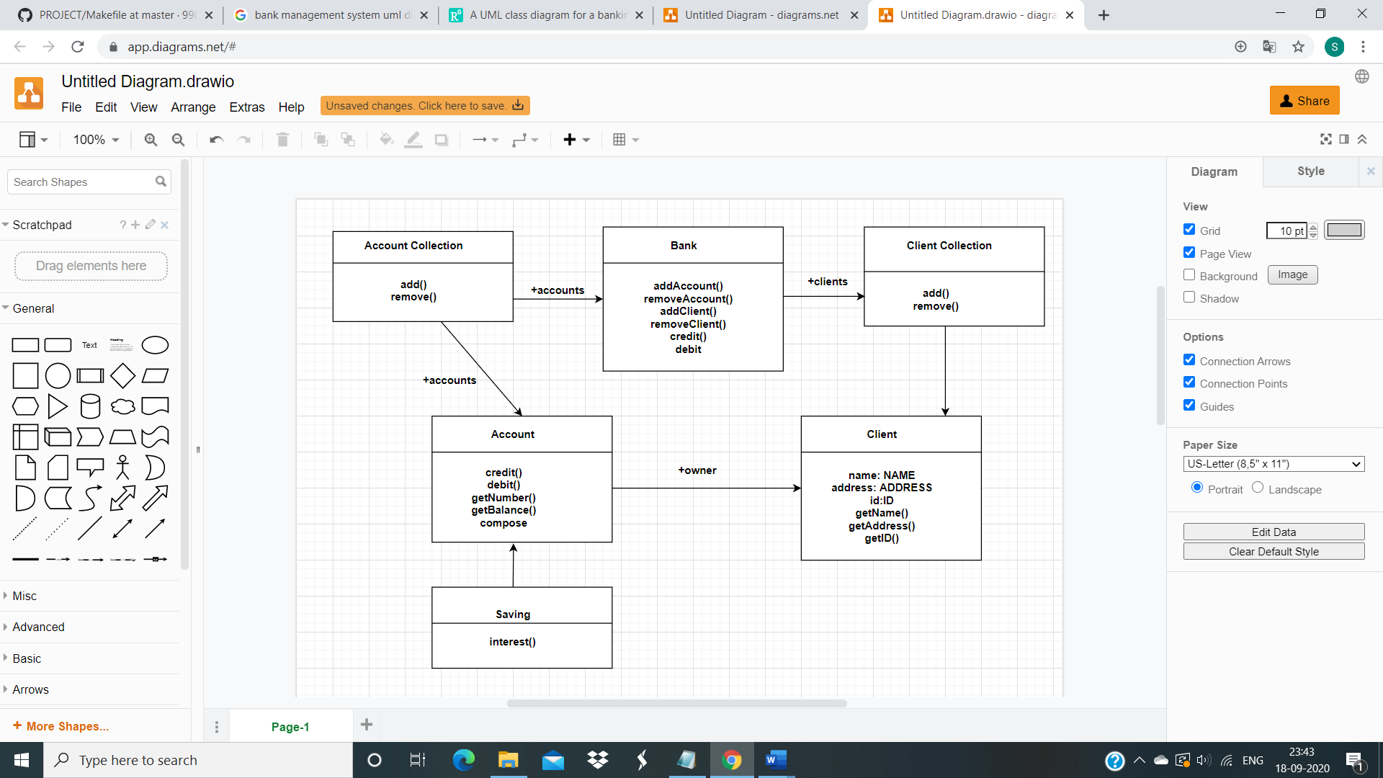

***Figure 1.3: UML class diagram of Bank management system***

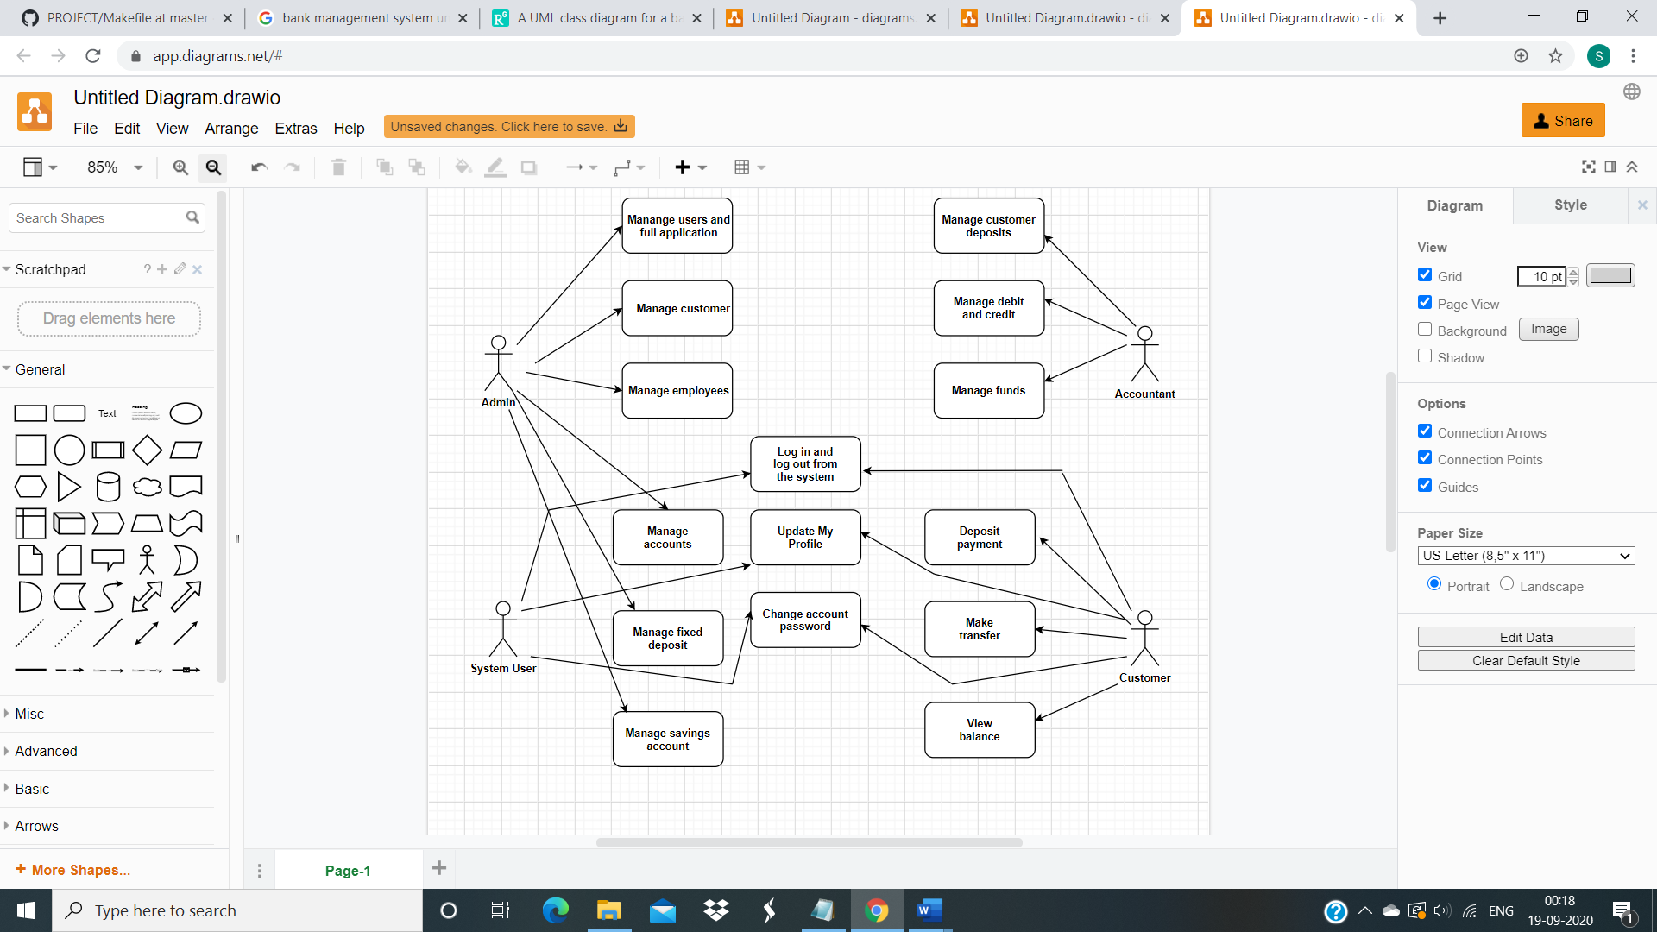

***Figure 1.3: UML user case diagram of Bank management system***