# Mini Project – Insurance Policy Generation

## System Definition

THE GANPATH INSURANCE POLICY CONSULTATION, aims to generate right policy for every customer, where several parameters were measures before selection of exact policy required. The policy generation will gather Personnel data, here policy credit score is evaluated by several parameters

1. BMI evaluation
2. Smoking evaluation
3. Alcohol evaluation
4. Drugs evaluation
5. Exercise evaluation
6. Diet evaluation
7. Stress evaluation
8. Insomniac evaluation
9. Health Issues
10. Accident evaluation
11. Policy selection
12. Monthly payment

The workflow was developed in C,

# 3.1 REQUIREMENT:

## 3.1.1 HIGH LEVEL REQUIREMENT

TABLE 3.1 HIGH LEVEL REQUIREMENT

|  |  |
| --- | --- |
| **ID** | **DESCRIPTION** |
| **H01** | Policy Declaration and standardization with Software VScode and GCC |
| **H02** | Memory Allocation for Applicants and libraries |
| **H03** | Standard structure Declaration |
| **H04** | Control flow execution |
| **H05** | Sub function declaration |
| **H06** | Permission to Data modification (Secondary) in policy |
| **H07** | Rough draft Policy generation |
| **H08** | Fair draft Policy Generation |

## 

## 3.1.2 LOW LEVEL REQUIREMENTS

TABLE 3.2 LOW LEVEL REQUIREMENTS

|  |  |
| --- | --- |
| **ID** | **DESCRIPTION** |
| **H01_L01** | Insurance Policy Enrollment Digital form standarization |
| **H01_L02** | Policy Coverage and functionality |
| **H01_L03** | Number of Applicant to be enrolled |
| **H02_L01** | Structure declaration in Variable Header before memory allocation |
| **H02_L02** | Memory allocation to number of people getting enrolled |
| **H02_L03** | Automatic Unique ID generation and structure mapping |
| **H03_LO1** | Personnel Data entry, Policy point initialization |
| **H03_L02** | Policy credit score based on BMI calculation |
| **H04_L01** | BMI evaluated policy credit |
| **H04_LO2** | Smoking, Alcohol and Drug evaluation evaluation |
| **H04_L03** | Splitting of Functions in various sub function |
| **H04_L04** | Store user input for Policy credit evaluation |
| **H05_L01** | Header file setup and Policy design |
| **H05_L02** | Declaration of sub function |
| **H05_L03** | Definition and error handling mechanism |
| **H06_L01** | Permission for Data modification with Creditials |
| **H06_L02** | Avoid memory to get truncated the stored data |
| **H06_L03** | Data Verification with rough draft generated and Data stored |
| **H07_L01** | Rough Policy draft generation which to allow modification |
| **H07_L02** | Fair Policy draft generation as Final |
| **H07_L03** | Stay Online to check wheter there is an thread to start over new policy evaluation |

# 

# 3.2 UML FLOW

## 3.2.1 ACTIVITY FLOW

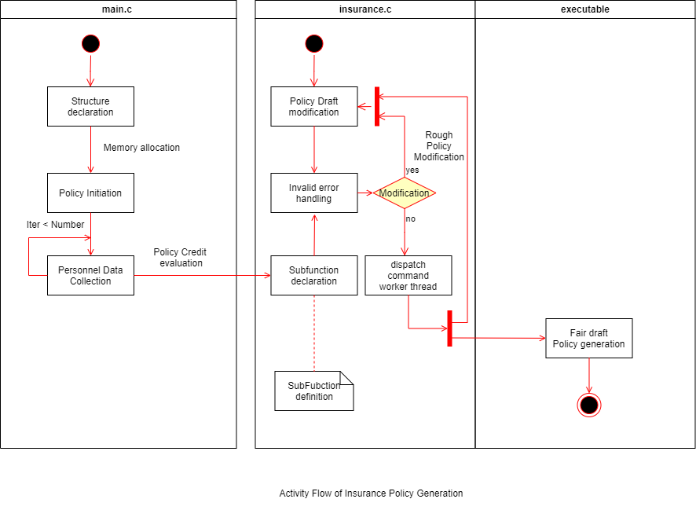

FIG 3.1 HIGH LEVEL ACTIVITY FLOW

# 3.3 TEST PLAN:

## 3.3.1 REQUIREMENT BASED

# TABLE 3.3 REQUIREMENT BASED TEST PLAN

|  |  |  |  |  |  |
| --- | --- | --- | --- | --- | --- |
| **ID** | **DESCRIPTION** | **PRE-CONDITION** | **EXPECTED INPUT** | **EXPECTED OUTPUT** | **ACTUAL OUTPUT** |
| **H01_T01** | Policy Framework/ Template ready | Insurance policies must be pre-planned | Availability of Activity flow of the system | The template should be clear with applicant | Policy generation |
| **H01_L02_T01** | Policy Coverage and Functionality of credit evaluation | The Policy Credit must be assigned to maximum at Initial | Credit score initiation | Credit score must be high so explore wiser policies | Policy generated |
| **H02_T01** | The requirement of structure holding the template of Customer data | Structure declaration for Applicant Input | Structure definition and instance creation | The Structure memory to be dynamically allocated without any truncation | Policy  generation |
| **H02_L01_T01** | The Structure must be declared with Proper template to load value of the applicant | The structure template ready | Structure instantiation must be declared as a header and used by most of the function. | The Memory must be declared dynamically based on no. of applicants | The standard information blog is created for end customer  Details. |
| **H04_L01_T01** | The BMI should be calculated | The BMI must determine the credit score modification | The BMI level initiation  BMI = 32 | The BMI classify the reduction in level of Credits Obese | Obese |

|  |  |  |  |  |  |
| --- | --- | --- | --- | --- | --- |
| **H02_L02_T01** | The memory allocation for the applicant can go truncated | Enter age = 19 -75, Policy Term = 14-30Y Sum assured = 2Min - 5L | The truncation must be handled with perror | The Truncation of memory must be handled with handling mechanism | Policy generation |
| **H03_L01_T01** | The Data entry in string format, So the NULL value accumulation on next memory | The Buffer must be maintained to prevent the NULL value being occupied next memory | The Buffer must be initiated  (Name, ) | The Buffer must be regularly handles when two strings called alternatively | Policy generation |
| **H04_L02_T01** | The Sub function must be called to evaluated, if it in un authorized memory | The headers must be called before function calling | The handling mechanism of should take Unauthorized memory accessing | The Handling mechanism must flow smoothly and load the value to memory location | Memory Structure |
| **H07_T01** | Rough policy modification can also go invalid inputs loaded | The Insurance policy will intelligently. | The Generated policy adopts error | The Fair Policy copy shouldn’t have any wrong loaded data. | A txt file gets generted |

|  |  |  |  |  |  |
| --- | --- | --- | --- | --- | --- |
| **H05_L02_T01** | Age of policy can be 5 – 60 years | Date of Birth and Present date must be valid | The Month loaded with number of days must be pre-assigned | The Age calculation must undergo perror handling mechanism | Date validation (1900-2050) |
| **H05_L02_T02** | Amount of consumption of alcohol must be in months | Option to answer must be loaded | The Amount of alcohol if consumed by the applicant, necessary ICS should be reduced | The ICS scored must reduce to lower the possibility of better Policy generation | Alcohol condamination in body. |

# Design and Flow:

1) A quick introduction about insurance policies, and available policy and its terms and conditions.

2) Data Gathering, the multiple data are gathered from applicant, to frame or suggest him/her an optimum policy.

3) The Personnel gathering data include all 12 inputs with personnel data analyse and manipulate the ICS.

4) The Data entered by the applicant gets dynamically stored and ICS get analysed.

5) The modification of data option is been provided if the applicant need to update to data in future.

6) Recovery and Retrieval of data takes more time, and need data structure to store the data in structured manner.

7) Age and date violation will automatically spotted and the data will recall itself to enter the corent one.