./

Learning Report – SDLC

Course Code: <CODE>



|  |  |  |  |  |  |
| --- | --- | --- | --- | --- | --- |
| **Ver. Rel. No.** | **Release Date** | **Prepared. By** | **Reviewed By** | **Approved By** | **Remarks/Revision Details** |
|  |  |  |  |  |  |
|  |  |  |  |  |  |
|  |  |  |  |  |  |
|  |  |  |  |  |  |
|  |  |  |  |  |  |

**Document History**

21

# 

Contents

Activity 1 – System/Software Development Life Cycle 4

VAAYU SENTRY - AIR QUALITY MONITOR 4

1.1 INTRODUCTION: 5

1.1.1 ENVIRONMNET PROTECTION ACT AQI CALCULATION: 5

1.1.2 AGEING, GRADATION AND COSTING: 5

1.1.3 EVOLUTION OF AQI MONITORS, 5

1.2 What’s VAAYU SENTRY 7

1.3 SWOT ANALYSIS: 8

1.4 REQUIREMENT OF IAQ MONITORS: 9

1.4.1 HIGH-LEVEL REQUIREMENT: 9

1.4.2 LOW LEVEL REQUIREMENT 10

1.5 TEST PLAN: 13

1.5.1 UNIT TESTING 13

1.5.2 INTEGRATION TESTING & SYSTEM TESTING 14

Activity 2 – Agile Aspects 15

2.1 THEME: 16

2.2 EPIC AND USER STORY: 16

EPIC 01: SENSOR INTEGRATION AND INITIATION 16

USER STORY 1 16

USER STORY 2: 16

USER STORY 3 16

EPIC 02: AQI ALERT SYSTEM 16

USER STORY 1: 16

USER STORY 2: 16

USER STORY 3 16

EPIC 03: INTERRUPT AND WEEKLY REPORT 16

USER STORY 01: 16

USER STORY 02: 16

USER STORY 03: 16

2.3 ACCEPTANCE CRITERIA: 16

Activity 3 – Mini Project – Insurance Policy Generation 17

3.1 REQUIREMENT: 18

3.1.1 HIGH LEVEL REQUIREMENT 18

3.1.2 LOW LEVEL REQUIREMENTS 18

3.2 UML FLOW 20

3.2.1 ACTIVITY FLOW 20

FIG 3.1 HIGH LEVEL ACTIVITY FLOW 20

3.3 TEST PLAN: 20

3.3.1 REQUIREMENT BASED 20

TABLE 3.3 REQUIREMENT BASED TEST PLAN 20

3.3.2 SCENARIO BASED TEST PLAN 21

TABLE 3.4 SCENARIO BASED TEST PLAN 21

3.3.3 BOUNDARY LEVEL TEST PLAN: 22

TABLE 3.5 BOUNDARY BASED TEST 22

GITHUB REPOSITORY LINK [PS]: 22

https://github.com/99002686/InsurancePolicyGeneraion 22

References: 22

Appendix - CI Workflow for C Programming 23

GITHUB REPOSITORY LINK [StepIN]: 23

Repository homepage 23

GITHUB WORKFLOW (UNIT-TEST, CPPCHECK, C/C++ CI) 23

UNIT TEST COMPILATION STATUS 24

CPP CHECK COMPILATION STATUS 24

CONTINUOUS INTEGRATION STATUS 25

BUILD STATUS 26

COMMIT STATUS 26

CODACY STATUS 27

## **Activity 1 – System/Software Development Life Cycle**

## **VAAYU SENTRY - AIR QUALITY MONITOR**

# 1.1 INTRODUCTION:

Air Quality monitoring for the environment is necessary in the cognitive era, (AQI)Air Quality Index is used by Government Agencies to communicate to the public about the air we breathe.

**Integration Sensors and Software for Real-Time AQI monitoring**

VAAYU SENTRY – An Air Quality monitor use to measure the AQI in Indoor and Outdoor environments, (NAAQS) National Ambient Air Quality Standards were launched and declared some gaseous compounds and particulate pollutants and Eight Major elements.

## 1.1.1 ENVIRONMNET PROTECTION ACT AQI CALCULATION:

**I = ((Ihigh - Ilow) / (Chigh – Clow)) * (C - Clow) + Ilow**

**I ->** Air Quality Index

**C** -> Pollution Concentration

**Clow** -> Concentration Breakpoint <= C

**Chigh** -> Concentration Breakpoint >= C

**Ilow** -> Index breakpoint with respect to Clow

**Ihigh** -> Index breakpoint with respect to Chigh

An application Responsive UI will provide the data measured from the device(s), without hassle, cost and risk associated,

## 1.1.2 AGEING, GRADATION AND COSTING:

* Personal air pollution monitoring is becoming more popular in highly developed communities.
* New low-cost sensors, which are both cheaper and smaller, but which propose challenges in terms of accuracy, reliability and performance were evaluated.

Fig 1.1 &1.2 describe about the evolution and Cost gradation of the AQI system.

## 1.1.3 EVOLUTION OF AQI MONITORS,

1. **Outdoor AQI Monitors:**

AQI monitors in outdoors can be mitigating the impact of air pollution on communities. The purpose of AQI monitors is to operate accurately, measure ambient air pollutants, remediation and control in urban environments, smart cities. Table 1.1 describe about the Outdoor AQI Monitor.

TABLE 1.1 OUTDOOR AQI MONITORS

|  |  |  |  |
| --- | --- | --- | --- |
| **S.no** | **Particles in AQI measurement** | **Discoveries (Y.O.R)** | **Technology used** |
|  | PM10, PM2.5, O3, NO2, Organic compounds | **Air Quality Dust Monitors (2012 - Present)** | External AC power source, Solar Powered. Wi-Fi, AQI (24/7/365), GAS sensors |
|  | PM10, PM2.5, O3, NO2, SO2, SF, Weather, Temperature, & Humidity | **Mini Air Quality stations (2014 - 2016)** | Battery powered, Wi-Fi, AQI (24/7/365), Mesh Network, Rail Corridor, Community track. |
|  | TSP, PM10, PM2.5, NO2, ppb particulates, VOC O3, DHT sensing | **Construction and Urban Air Quality Monitors (2015- Present)** | FTP, IP65, IP67, Intelligent BMS, ADC, 100-260Vac CAN, LIN connectivity. |
|  | TSP, PM10, PM2.5, DHT, NO2, SO2, CO, CO2 and O3 | **Portable outdoor Air Quality monitors (2015 - Present)** | Personal Exposure Analysis, AQI Mobile survey, Span Calibration, UFS 2.0, Wi-Fi and Li-ion battery |

1. **Indoor AQI Monitors:**

IAQ, monitoring System are useful in Industrial and Consumer based products. Unlike outdoor air, indoor air is recycled continuously causing it to trap and build up pollutants. IAQ characteristics include the concentrations of pollutants in indoor air, as well as air temperature and humidity. Table 1.2 describe about the device evolution and specification of AQI monitor.

TABLE 1.2 INDOOR AQI MONITORS

|  |  |  |  |
| --- | --- | --- | --- |
| **S.no** | **Particles in AQI measurement** | **Discoveries (Y.O.R)** | **Technology used** |
|  | TSP, PM10, PM2.5, DHT, NO2, SO2, CO, CO2 and O3, CH4, VOC, H2 & CH3-CHO | **Portable outdoor Air Quality monitors (2016 - Present)** | Personal Exposure Analysis, AQI Mobile survey, Span Calibration, UFS 2.0, Wi-Fi and Li-ion battery |
| 2. | PM10, PM2.5, O3, NO2, SO2, SF, Weather, Temperature, Humidity & Hazardous Gas detection | **Fixed Indoor Monitors (2013 - present)** | ADC, Wireless card, Dedicated Microcontroller, Alarm based alert system, Gas leak detection, Plug and Play. |

FIG 1.1 EVOLUTION OF AQI MONITORS

FIG 1.2 COST GRADATION OF INDOOR AQI MONITORS

FIG 1.3 AQI PARTICLE POLLUTION

# 1.2 What’s VAAYU SENTRY

* VAAYU Sentry, AQI monitors are simple tools/kit use for AQ assessors and individuals to gather real-time AQ information on the indoor environment.
* This device can also be portable as well as fixed in a place to analyze the Air Quality in the Indoor Environment.
* Each device will inhouse AQI monitor system inside shell with is IP65 & IP67 certified. Each shell will have sensor heads to measure the environment parameters. A Capacitive Touch O-LED display to interact with Customers.
* Calibration and recalibration is not required. Portable version will have 1400mAh battery can have standby of 7 days, have dynamic charging modes for better usability.
* It can communicate on LIN/USB with Master-Slave operations. Also, Wi-Fi 5 with 2.4GHz for Mesh networking.
* It can measure CO2, NO2, CO, NH4, Cl, and Organic compounds, PM2.5, PM10, O3, H2, HF/SF/SO2, VOC, Temperature, Humidity and Noise.
* An app with responsive UI to display Real-time AQI pollutants and Particulates.

# 1.3 SWOT ANALYSIS:

The IAQ monitors grows in the opportunity of customer consumer product in recent years, IAQ monitors evolve from Industrial requirement to consumer requirement in competing with real time 3m and EPA certification along with sustain product. To provide Real time monitoring data and forecasts of air quality that are color-coded in terms of the air quality index

1. **STRENGTH:**

**Performance:** Indoor Air Quality Monitors ports from Industrial usage to consumer product for Personal protection and alerts on Hazardous Gas detection.

**Range and Quality:** Indoor AQI monitoring ranges on kind of environment and usability

**Communication**: Usage of LIN and Wi-Fi technology for multi-mode communication.

**Customer Base:** Also comes in Portable Version with responsive UI and security Alerts.

**Safety and Security:** This device will have delivered in EPA and NAAQs standards. Standard WPA2-PSK encryption.

**Marketing**: As a consumer product, in 2020, IAQ monitor amounted to sell 23 lakhs devices as well as high demanding product for portability in 2019.

1. **WEAKNESS:**

**Environment:** It must be tested in Real time environment, to approve IP65, IP67 can cause failure in calamities

**Maintenance:** Some fixed IAQ must undergo regular maintenance in monitoring the environment.

**Connectivity:** It must stay connected online to notice real time update.

**Noise:** The measurement of volatile gaseous particle, Temperature & Humidity. The resolution of detecting the gaseous molecules beyond the threshold. The accuracy varies with the resolution of detection.

1. **OPPORTUNITY:**

**Consumer need:** Portable IAQ is one of the high demanding product in the market.

**Industrial standard:** Industrial environment is being install with IAQ in the workstation for regular monitoring and maintenance.

**Safety:** AQI will analyze the environment and alerts us if there any hazardous PPM particles, gases get emitted from industry.

**Portability:** It can also easily get ported to identify different gas and particles in environment. Can have high standby by adding Battery management system and dynamic charging.

**Toxicity leveling:** IAQ can also use in maintaining toxicity levels of indoor environment.

**Polymorphic modes:** IAQ will be implemented in different environment (Industries/Home). The number of Gas/Particles in air can varies, so intelligent modes of operation can be assigned to detect effectively.

1. **THREATS:**

**Competition:** IAQ installation and requirement in industrial environment will become mandatory for ISO certification. Investment for production will need expansion.

**Pricing & Power:** Selection of sensors to detect particles in IAQ will require precise measurement. Power management for portability or also plug and play mechanism.

# 1.4 REQUIREMENT OF IAQ MONITORS:

* **Performance**: The IAQ (P) monitors work in any environment, with 7 days of minimum standby, should detect 28 different gaseous molecules.
* **Efficiency:** The detection phase of gaseous molecules with higher accuracy in detection > 90%
* **Reliability:** IAQ should be carried in any environment, should be install in open area, indoor or in room temperature.
* **Robustness:** The Lifetime of IAQ should be maintained at regular intervals. The durability of IAQ should produce high connectivity with low power and better bug free detection.
* **Safety**: The portability of the product should include installation in dynamic environment.
* **Security:** The API to synchronizing the RT-data to push to the cloud should be done in encrypted manner to avoid breaching.
* **Hardware design:** The IAQ with limited sensor, should have MIPS controller, Wi-Fi 5, BLE for MESH networking, should have 1400mAh battery with 7 days standby.
* **Powe**r: Intelligent Power management, with different modes of powering. Plug in input AC powered. DC powered with 5-7V/2A.
* **Usability**: AQI measurement, 28 different gas/particle detection. Alert system, Master-slave multimode communication M2M/IoT data reliability in both Indoor and outdoor environment.

## HIGH-LEVEL REQUIREMENT:

Sequential Flow:

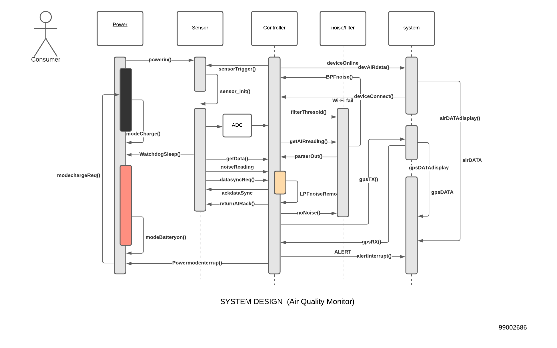

FIG 1.4 SYSTEM DESIGN

Activity Flow:

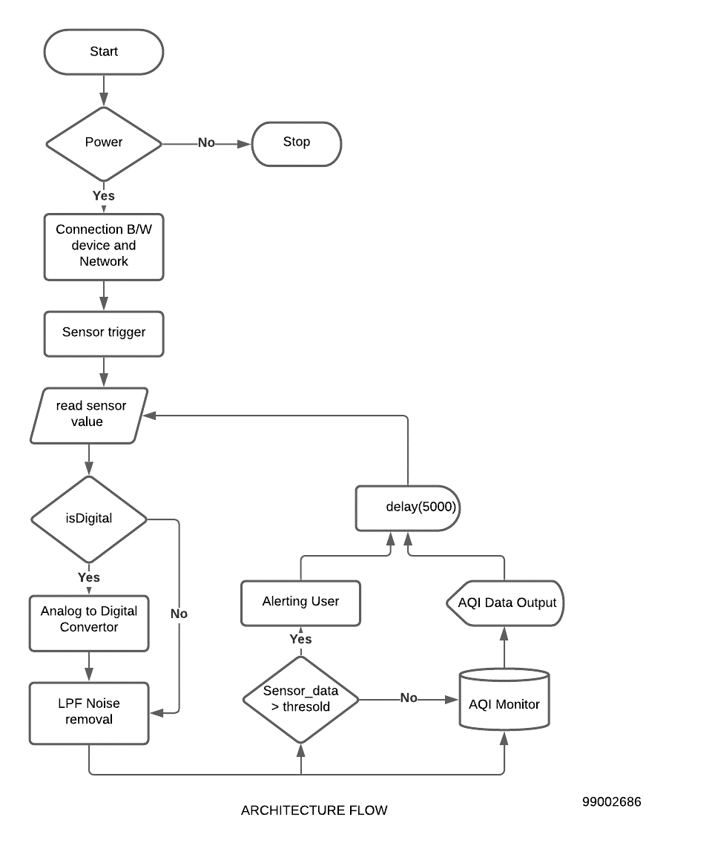

FIG 1.5 ARCHITECTURE DESIGN

## LOW LEVEL REQUIREMENT

Component Flow:

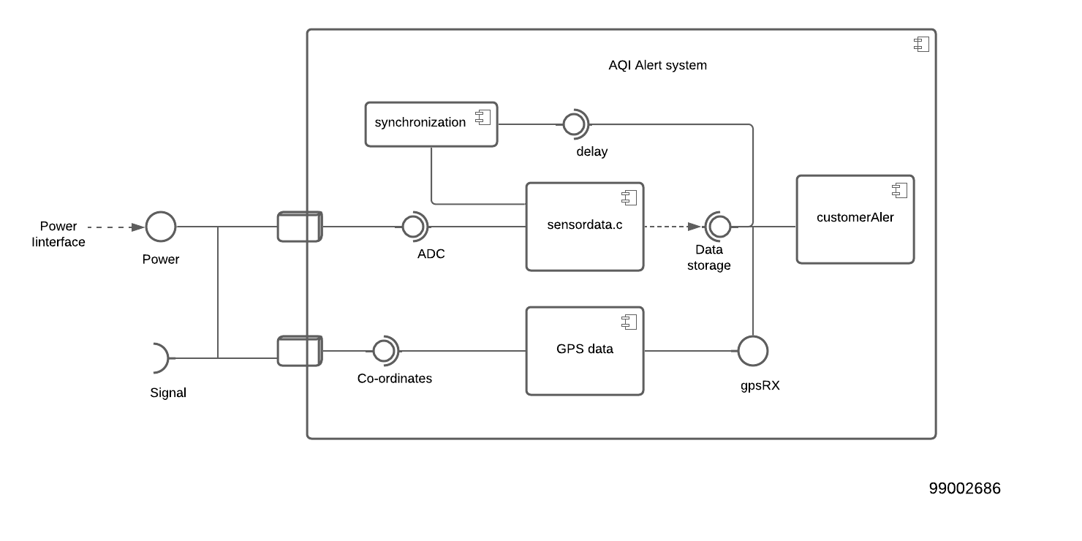

FIG 1.6 ALERT MECHANISM

State machine

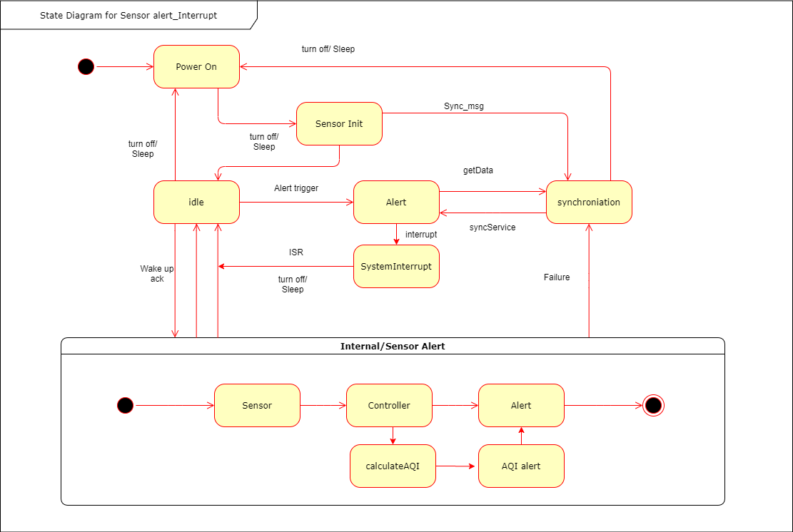

FIG 1.7 SENSOR ALERT INTERRUPT MODEL

TABLE 1.3 HIGH LEVEL REQUIREMENT

|  |  |
| --- | --- |
| **ID** | **DESCRIPTION** |
| **H01** | Sensor Integration and Initiation |
| **H02** | AQI calculation |
| **H03** | GPS Tracking |
| **H04** | Alert Interrupt |
| **H05** | Mesh Networking/IoT Client – Server Communication |
| **H06** | Week Polllution Report Generation |

TABLE 1.4 LOW LEVEL REQUIREMENTS

|  |  |
| --- | --- |
| **ID** | **DESCRIPTION** |
| **H01_L01** | Sensor Powering and Device Battery management Setup |
| **H01_L02** | Sensor Calibration (Controller – Sensor) Comunicaion establishment and Hardware setup |
| **H01_L03** | Sensor Triggering and Thresold Initialization |
| **H02_L01** | Gathering sensor Data and High resolution inputs |
| **H02_L02** | Noise Cancellation by appling functionl Lowpass filter |
| **H02_L03** | Sensor data synchronization and display |
| **H03_LO1** | GPS input availability |
| **H03_L02** | GPS Latitude and Longitude Analysis to alter the thresold from data |
| **H04_L01** | Idle state Interrupt selection |
| **H04_LO2** | AQI Hazardous Alert Interrupt, ISR Handling |
| **H04_L03** | Post ISR handling Sensor Data Gathering mechanism |
| **H05_L01** | API to keep device and database online |
| **H05_L02** | Device offline – Network Interrupt mechanism |
| **H05_L03** | Device Mesh Networking Mechanism |
| **H06_L01** | Data analysis of Pollution level and Intelligent Report generation |

# 1.5 TEST PLAN:

## 1.5.1 UNIT TESTING

TABLE 1.5 UNIT TEST PLAN

|  |  |  |  |  |  |
| --- | --- | --- | --- | --- | --- |
| **ID** | **DESCRIPTION** | **PRE-CONDITION** | **EXPECTED INPUT** | **EXPECTED OUTPUT** | **ACTUAL OUTPUT** |
| **H01_L01_T01** | Power input AC test | Device with Power mode operation must be connected to AC input | Device should be turned on, Dynamically charge the battery, Idle Model switch | Dynamic Charge in background. |  |
| **H01_L01_T02** | Power input DC test | Device with portability can be taken to any of the environment with Batteries powered | Device should standby for at least 3 days, with efficient Power management system | Device should stay awake and current flow in the sensor remain to be stable. |  |
| **H01_L01_T03** | Battery drained failure and No AC input test | Device with low battery, stay online, Data gathered | Sensor Data gathering, Data sync interrupt execution before Device go offline | Sensor low battery alert, data sync cycle execution. |  |
| **H01_L02_T01** | Sensor calibration and Initiation test | Sensors to calibrate with Analog read at output. | Sensor data sampling and quantization | Reference voltage to calculate threshold value |  |
| **H01_L02_T02** | Device – Sensor communication test | Sensors to connected in LIN/I2C with the controller | Device should be loaded with read mode to get sensor data | Sensor data with Analog/Digital values with better resolution |  |
| **H01_L03_T01** | Threshold initiation test | Sensor to initialized the threshold with varying the reference voltage | Sensor Input data | Data classify below or above threshold |  |
| **H02_L01_T01** | PM2.5, PM10, Organic gas estimation | Device to gather data from the gaseous sensor to estimate amount of gas in the environment | Good resolution analog voltage input | Data with analog input with accurate amount of particulates in the environment. |  |
| **H02_L01_T02** | Estimation of O3 and Sulphuric gases | Device with sensor to estimate Sulphuric gases | The reference threshold voltage to classify the Sulphuric gases | The Sulphuric gases in the environment get resolved |  |
| **H04_L02_T01** | Post ISR stack pointer override test | Device recovery after the alert interrupt/system interrupt | The Stack pointer should loaded with address on next task of firmware execution | Successful interrupt handling mechanism |  |

## 1.5.2 INTEGRATION TESTING & SYSTEM TESTING

TABLE 1.6 INTEGRITY & SYSTEM TESTPLAN

|  |  |  |  |  |  |
| --- | --- | --- | --- | --- | --- |
| **ID** | **DESCRIPTION** | **PRE-CONDITION** | **EXPECTED INPUT** | **EXPECTED OUTPUT** | **ACTUAL OUTPUT** |
| **H01_T01** | Sensor Integration and communication establishment wire shorted | H01_L02_T01  H01_LO2_T02 | Sensor data sampling and quantization, device should stay online | Device to stay online, gathering data at regular interval of time. Device will Expired |  |
| **H01_T02** | Sensor output resolution failure | Sensor potentiometer calibration | Sensor data input | High resolution of analog reference voltage to classify the gas detected |  |
| **H02_T01** | AQI Calculation Index threshold not initialized | Data gathering and secure storage mechanism | Senor Data input | Data with analog input with accurate amount of particulates in the environment |  |
| **H03_T01** | GPS data RX buffer overload without delay in transmission | Availability of serial data in buffer | GPS on state, with data receive | >80%Accuracy in latitude and longitude |  |
| **H04_T01** | H01_L03_T01  H01_L03_T02  Noise cancellation process | Estimation of AQI with data input. Noise cancellation mechanism | Alert interrupt execution | Post alert interrupt handling mechanism |  |
| **H05_T01** | Mesh Networking, Master slave mechanism | AQI monitors to connect multiple sensors with I2C | Sensor data input | Classify from which sensor which data is gathering |  |
| **H06_T01** | Pollution Report Generation | Pollution report generation of the environment to be encrypted and shared. | Data analytics and track on alert exposure mechanism | The detailed report on pollutants in the environment |  |

# Activity 2 – Agile Aspects

# 2.1 THEME:

Air Quality monitoring for the environment is necessary in the cognitive era, (AQI) Air Quality Index is used by Government Agencies to communicate to the public about the air we breathe. An Air Quality monitor use to measure the AQI in Indoor and Outdoor environments, (NAAQS) National Ambient Air Quality Standards were launched and declared some gaseous compounds and particulate pollutants and Eight Major elements.

AQI monitors in outdoors can be mitigating the impact of air pollution on communities. The purpose of AQI monitors is to operate accurately, measure ambient air pollutants, remediation and control in urban environments, smart cities. IAQ, monitoring System are useful in Industrial and Consumer based products. Unlike outdoor air, indoor air is recycled continuously causing it to trap and build up pollutants. IAQ characteristics include the concentrations of pollutants in indoor air, as well as air temperature and humidity. The consumer will be get alert if they are exposed by hazardous gases. The weekly pollution report will be generated on remedies to be taken to avoid or reduce pollutants.

# 2.2 EPIC AND USER STORY:

## **EPIC 01: SENSOR INTEGRATION AND INITIATION**

USER STORY 1: As a Product owner, The device to be compact enough with less weight carry, sensor integration should be compact and reliable and accommodate sensors and batteries management circuits.

USER STORY 2: As a service engineer, The device must connect with sensors and powered such that adequate amount of current is been passing.

USER STORY 3: As a Product owner, The device should be plug and play with different mode of operation based on the environment.

## **EPIC 02: AQI ALERT SYSTEM**

USER STORY 1: As a Product owner, the data from the sensor must be displayed in app also the system need to alert when customer exposed into hazardous region.

USER STORY 2: As a Developer, The reliability of data from the sensor must be of low noise, or must undergo LP,BP filter mechanism to quantize the voltage before gathering the data.

USER STORY 3: As a Product owner, The alert system must intimate the alert in two modes to increase the importance of exposure.

## **EPIC 03: INTERRUPT AND WEEKLY REPORT**

USER STORY 01: As a service manager, The failure percentage of the product due to improper interrupt handlers must be monitored and rectified.

USER STORY 02: as a product owner, The Weekly report generation must mention the type of pollutants present in environment with Humidity, Temperature and location of the device.

USER STORY 03: As a market manager, the specification of the device must meet the product owner expectation, by generating weekly reports of the environment and also about the device by troubleshooting.

# 2.3 ACCEPTANCE CRITERIA:

**Performance**: The IAQ (P) monitors work in any environment, with 7 days of minimum standby, should detect 28 different gaseous molecules.

**Efficiency:** The detection phase of gaseous molecules with higher accuracy in detection > 90%

**Reliability:** IAQ should be carried in any environment, should be install in open area, indoor or in room temperature.

**Robustness:** The Lifetime of IAQ should be maintained at regular intervals. The durability of IAQ should produce high connectivity with low power and better bug free detection.

**Safety**: The portability of the product should include installation in dynamic environment.

**Security:** The API to synchronizing the RT-data to push to the cloud should be done in encrypted manner to avoid breaching.

**Hardware design:** The IAQ with limited sensor, should have MIPS controller, Wi-Fi 5, BLE for MESH networking, should have 1400mAh battery with 7 days standby.

**Powe**r: Intelligent Power management, with different modes of powering. Plug in input AC powered. DC powered with 5-7V/2A.

**Usability**: AQI measurement, 28 different gas/particle detection. Alert system, Master-slave multimode communication M2M/IoT data reliability in both Indoor and outdoor environment.

# Activity 3 – Mini Project – Insurance Policy Generation

THE GANPATH INSURANCE POLICY CONSULTATION, aims to generate right policy for every customer, where several parameters were measures before selection of exact policy required. The policy generation will gather Personnel data, here policy credit score is evaluated by several parameters

1. BMI evaluation
2. Smoking evaluation
3. Alcohol evaluation
4. Drugs evaluation
5. Exercise evaluation
6. Diet evaluation
7. Stress evaluation
8. Insomniac evaluation
9. Health Issues
10. Accident evaluation
11. Policy selection
12. Monthly payment

# 3.1 REQUIREMENT:

## 3.1.1 HIGH LEVEL REQUIREMENT

TABLE 3.1 HIGH LEVEL REQUIREMENT

|  |  |
| --- | --- |
| **ID** | **DESCRIPTION** |
| **H01** | Policy Declaration and standardization |
| **H02** | Memory Allocation for Applicants |
| **H03** | Standard structure Declaration |
| **H04** | Control flow execution |
| **H05** | Sub function declaration |
| **H06** | Permission to Data modification (Secondary) |
| **H07** | Rough draft Policy generation |
| **H08** | Fair draft Policy Generation |

## 3.1.2 LOW LEVEL REQUIREMENTS

TABLE 3.2 LOW LEVEL REQUIREMENTS

|  |  |
| --- | --- |
| **ID** | **DESCRIPTION** |
| **H01_L01** | Insurance Policy Enrollment Digital form standarization |
| **H01_L02** | Policy Coverage and functionality |
| **H01_L03** | Number of Applicant to be enrolled |
| **H02_L01** | Structure declaration in Variable Header before memory allocation |
| **H02_L02** | Memory allocation to number of people getting enrolled |
| **H02_L03** | Automatic Unique ID generation and structure mapping |
| **H03_LO1** | Personnel Data entry, Policy point initialization |
| **H03_L02** | Policy credit score based on BMI calculation |
| **H04_L01** | BMI evaluated policy credit |
| **H04_LO2** | Smoking, Alcohol and Drug evaluation evaluation |
| **H04_L03** | Splitting of Functions in various sub function |
| **H04_L04** | Store user input for Policy credit evaluation |
| **H05_L01** | Header file setup |
| **H05_L02** | Declaration of sub function |
| **H05_L03** | Definition and error handling mechanism |
| **H06_L01** | Permission for Data modification with Creditials |
| **H06_L02** | Avoid memory to get truncated the stored data |
| **H06_L03** | Data Verification with rough draft generated and Data stored |
| **H07_L01** | Rough Policy draft generation which to allow modification |
| **H07_L02** | Fair Policy draft generation as Final |
| **H07_L03** | Stay Online to check wheter there is an thread to start over new policy evaluation |

# 3.2 UML FLOW

## 3.2.1 ACTIVITY FLOW

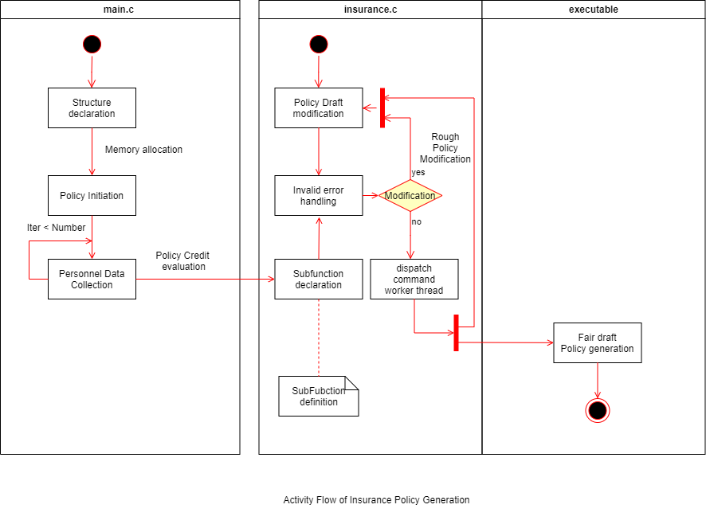

FIG 3.1 HIGH LEVEL ACTIVITY FLOW

# 3.3 TEST PLAN:

## 3.3.1 REQUIREMENT BASED

# TABLE 3.3 REQUIREMENT BASED TEST PLAN

|  |  |  |  |  |  |
| --- | --- | --- | --- | --- | --- |
| **ID** | **DESCRIPTION** | **PRE-CONDITION** | **EXPECTED INPUT** | **EXPECTED OUTPUT** | **ACTUAL OUTPUT** |
| **H01_T01** | Policy Framework/ Template ready | Insurance policies must be pre-planned | Availability of Activity flow of the system | The template should be clear with applicant |  |
| **H01_L02_T01** | Policy Coverage and Functionality of credit evaluation | The Policy Credit must be assigned to maximum at Initial | Credit score initiation | Credit score must be high so explore wiser policies |  |
| **H02_T01** | The requirement of structure holding the template of Customer data | Structure declaration for Applicant Input | Structure definition and instance creation | The Structure memory to be dynamically allocated without any truncation |  |
| **H02_L01_T01** | The Structure must be declared with Proper template to load value of the applicant | The structure template ready | Structure instantiation must be declared as a header and used by most of the function. | The Memory must be declared dynamically based on no. of applicants |  |
| **H04_L01_T01** | The BMI should be calculated | The BMI must determine the credit score modification | The BMI level initiation | The BMI classify the reduction in level of Credits |  |

## 3.3.2 SCENARIO BASED TEST PLAN

TABLE 3.4 SCENARIO BASED TEST PLAN

|  |  |  |  |  |  |
| --- | --- | --- | --- | --- | --- |
| **ID** | **DESCRIPTION** | **PRE-CONDITION** | **EXPECTED INPUT** | **EXPECTED OUTPUT** | **ACTUAL OUTPUT** |
| **H02_L02_T01** | The memory allocation for the applicant can go truncated | The memory allocated for strings based on conditional flow | The truncation must be handled with perror | The Truncation of memory must be handled with handling mechanism |  |
| **H03_L01_T01** | The Data entry in string format, So the NULL value accumulation on next memory | The Buffer must be maintained to prevent the NULL value being occupied next memory | The Buffer must be initiated | The Buffer must be regularly handles when two strings called alternatively |  |
| **H04_L02_T01** | The Sub function must be called to evaluated, if it in un authorized memory | The headers must be called before function calling | The handling mechanism of should take Unauthorized memory accessing | The Handling mechanism must flow smoothly and load the value to memory location |  |
| **H07_T01** | Rough policy modification can also go invalid inputs loaded | The Insurance policy will intelligently generate the test plan | The Generated policy adopts error | The Fair Policy copy shouldn’t have any wrong or invalid inputs loaded. |  |

## 3.3.3 BOUNDARY LEVEL TEST PLAN:

TABLE 3.5 BOUNDARY BASED TEST

|  |  |  |  |  |  |
| --- | --- | --- | --- | --- | --- |
| **ID** | **DESCRIPTION** | **PRE-CONDITION** | **EXPECTED INPUT** | **EXPECTED OUTPUT** | **ACTUAL OUTPUT** |
| **H05_L02_T01** | **Age of policy can be 5 – 60 years** | **Date of Birth and Present date must be valid** | **The Month loaded with number of days must be pre-assigned** | **The Age calculation must undergo perror handling mechanism** |  |
| **H05_L02_T02** | **Amount of consumption of alcohol must be in months** | **Option to answer must be loaded** | **The Amount of alcohol if consumed by the applicant, necessary ICS should be reduced** | **The ICS scored must reduce to lower the possibility of better Policy generation** |  |

## GITHUB REPOSITORY LINK [PS]:

## <https://github.com/99002686/InsurancePolicyGeneraion>

# References:

<https://www.aeroqual.com/indoor-air-quality-monitors>

<https://www.amazon.in/Airveda-PM2-5-Accuracy-Quality-Monitor/dp/B01MEE4363>

<https://en.wikipedia.org/wiki/Air_quality_index>

<https://en.wikipedia.org/wiki/Air_pollution_sensor>

<https://www.transportpolicy.net/standard/india-air-quality-standards/>

<https://www.conserve-energy-future.com/air-quality-index.php>

<https://www.airnow.gov/aqi/aqi-basics/>

<https://www.aqi.in/dashboard>

<https://ace.electronicsforu.com/buzz/new-products/misc/new-series-of-air-quality-pocket-monitors-launched-by-purelogic-labs-india/>

# Appendix - CI Workflow for C Programming

GITHUB REPOSITORY LINK [StepIN]:

<https://github.com/stepin105519/Time-to-code>

## Repository homepage

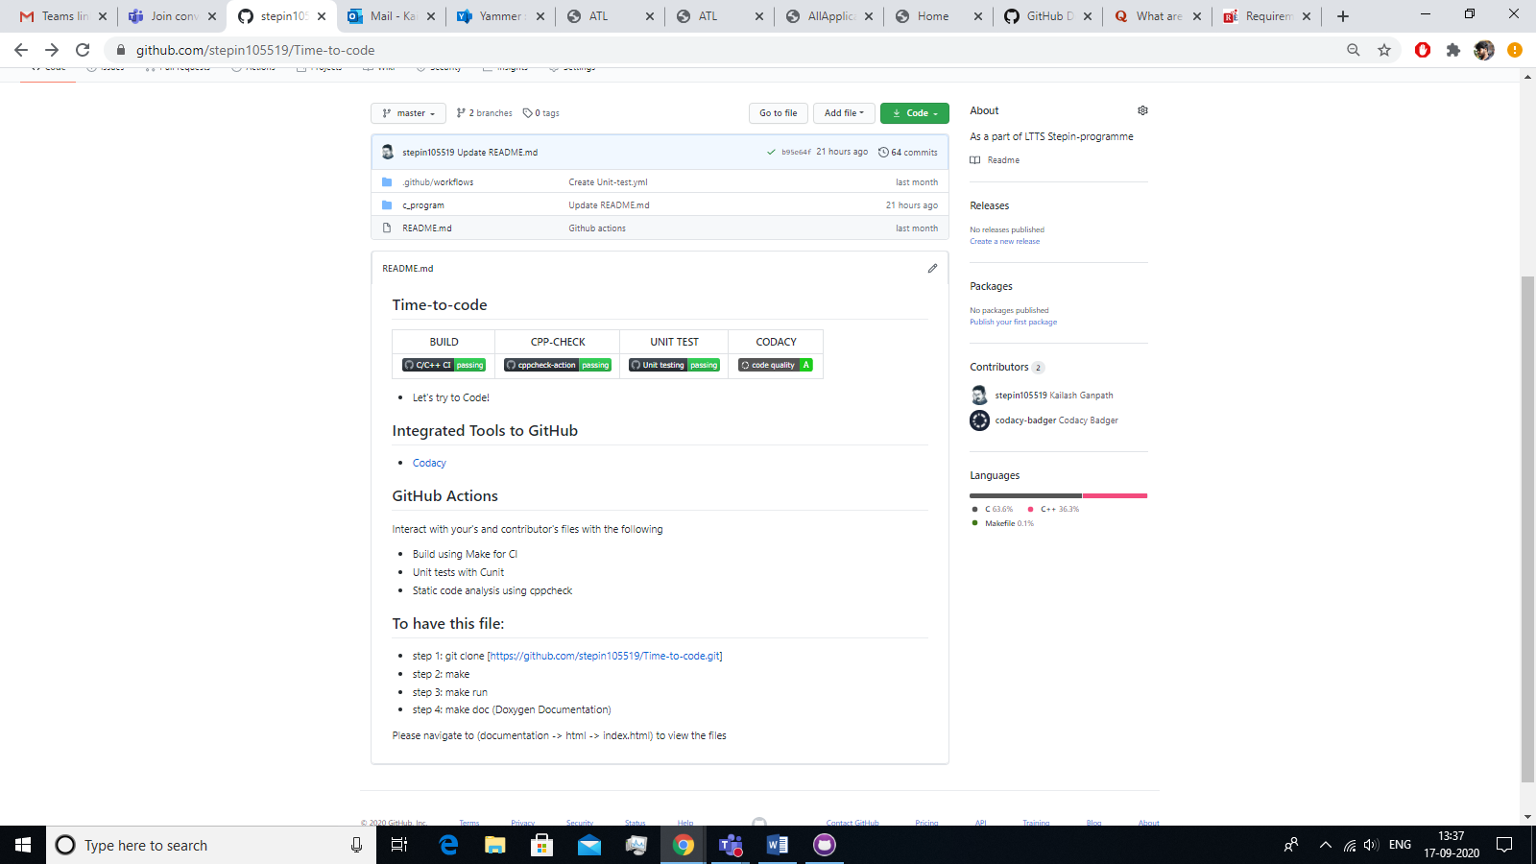

**Fig1 Repository Front Page**

GITHUB WORKFLOW (UNIT-TEST, CPPCHECK, C/C++ CI)

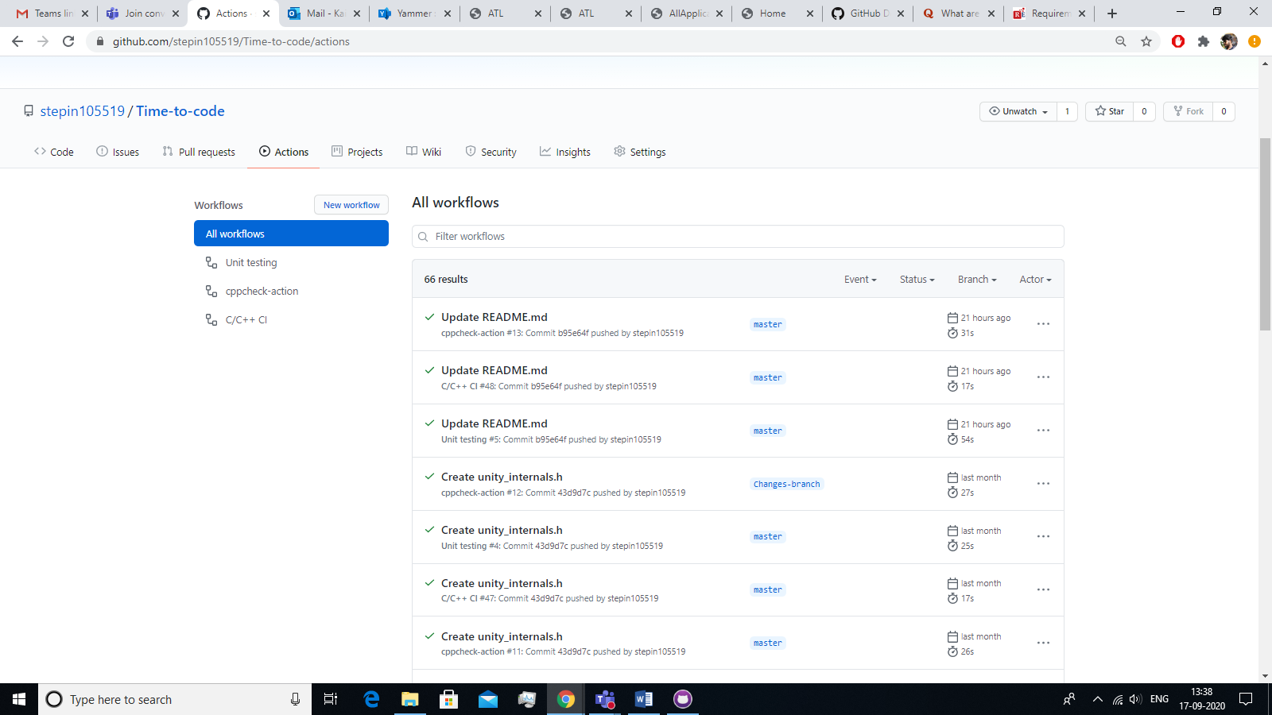

**Fig 2 GitHub workflow (Unit-test, Cppcheck, C/C++ CI)**

UNIT TEST COMPILATION STATUS

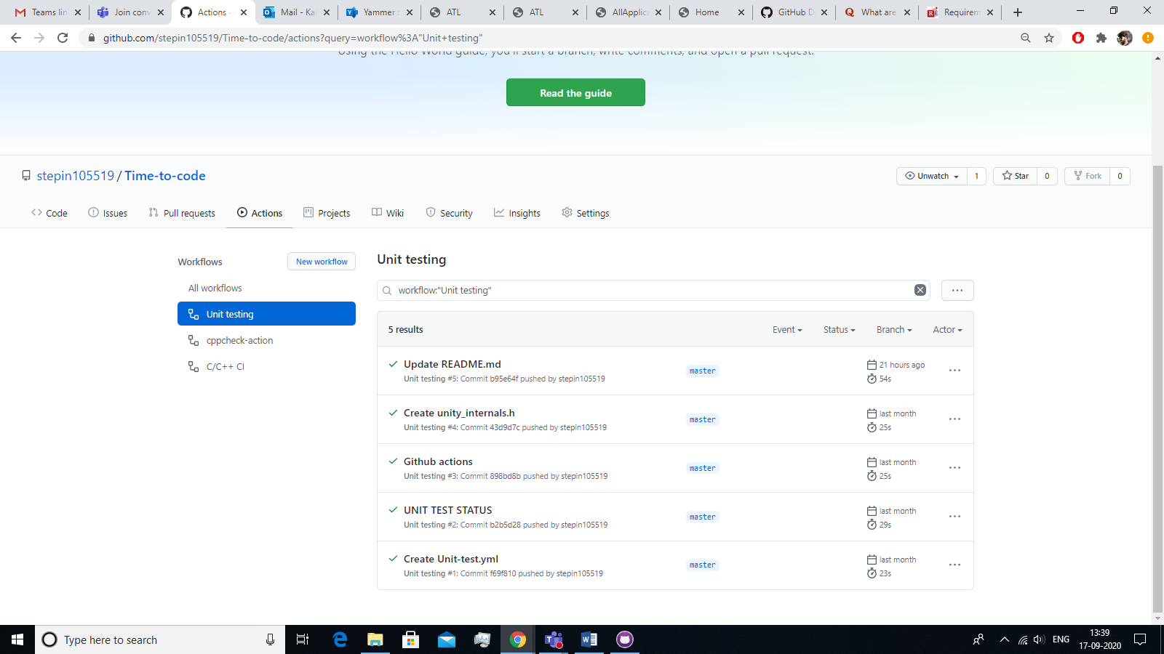

**Fig 3 Unit Test Compilation Status**

CPP CHECK COMPILATION STATUS

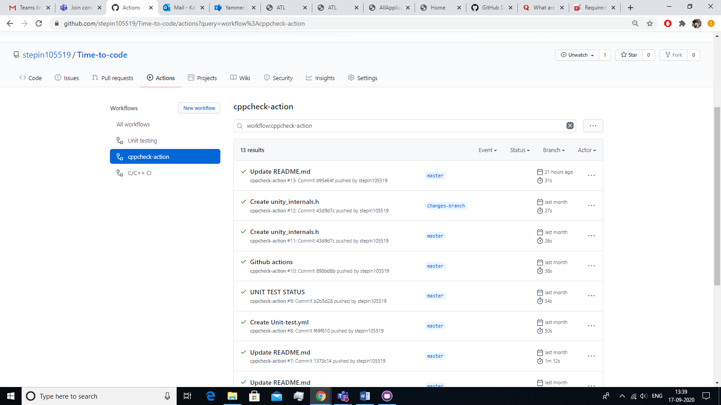

**Fig 4 CPP check Compilation Status**

CONTINUOUS INTEGRATION STATUS

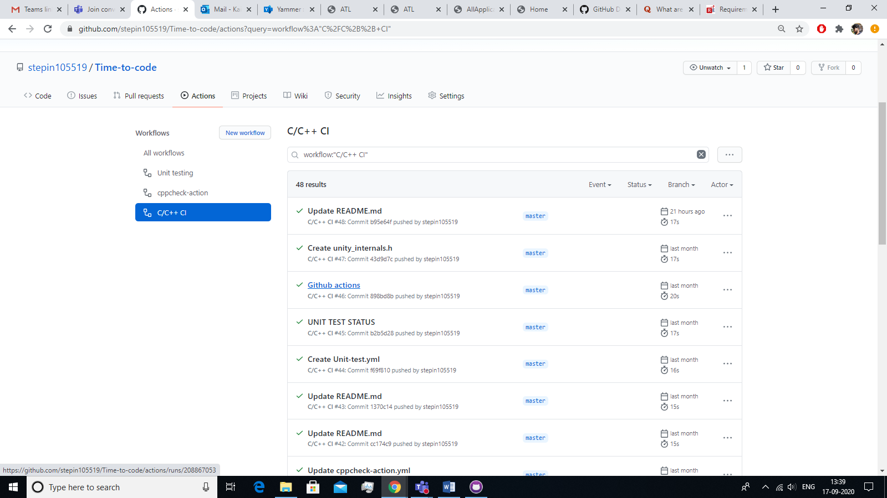

**Fig 5 C/C++ CI status**

## BUILD STATUS

**Fig 6 C/C++ CI Build status**

COMMIT STATUS

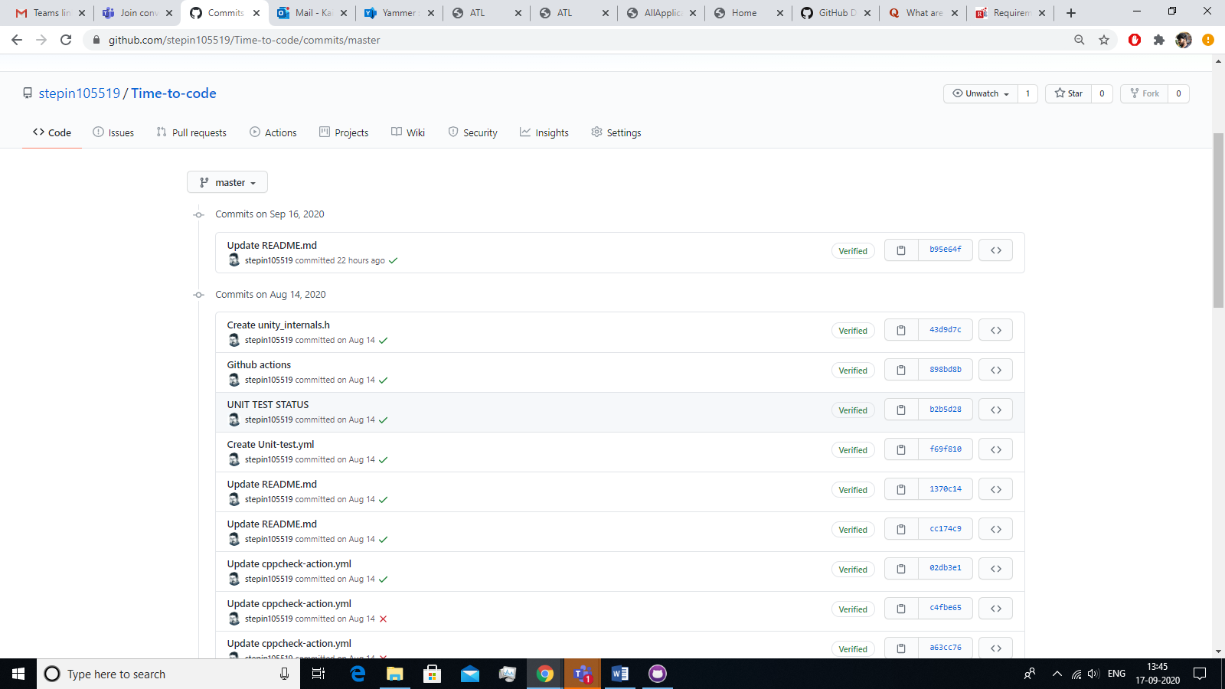

Fig 7 Commit status

CODACY STATUS

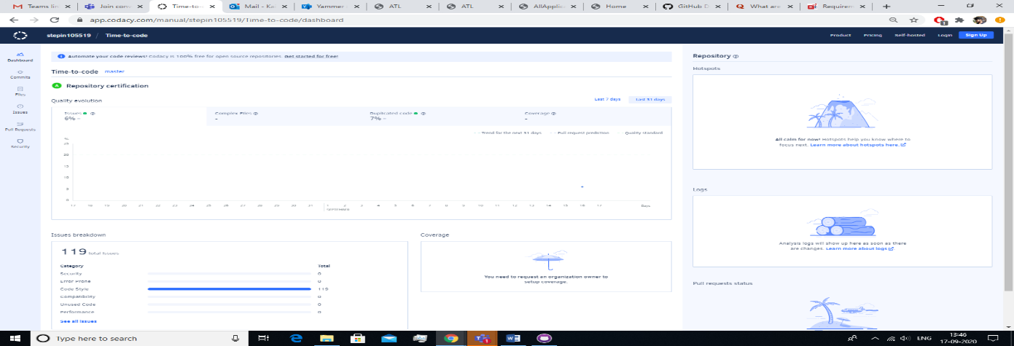

Fig 8 Codacy status