## DESIGN PLAN

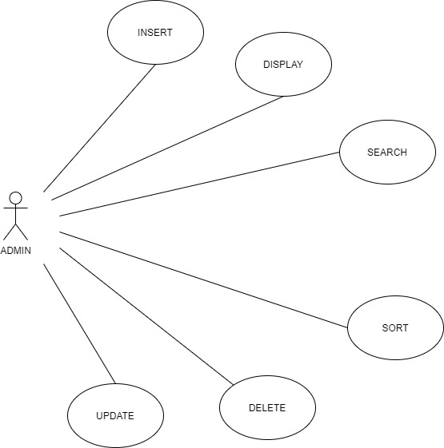

Figure 1 User Diagram of the System

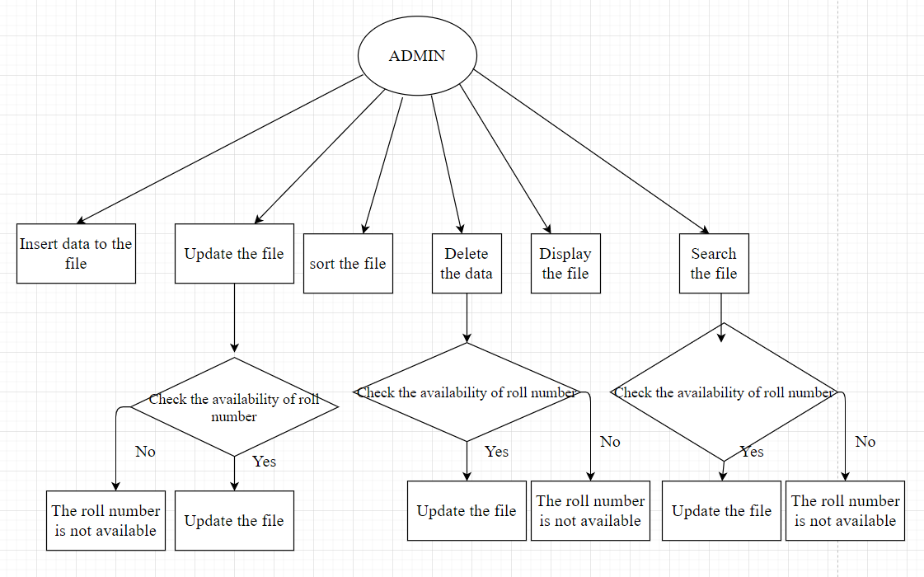

**Figure 2 Activity Diagram of the System**