./

Learning Report – MOBILE PHONE

Course Code: <CODE>



|  |  |  |  |  |  |
| --- | --- | --- | --- | --- | --- |
| **Ver. Rel. No.** | **Release Date** | **Prepared. By** | **Reviewed By** | **Approved By** | **Remarks/Revision Details** |
| 1 | 18/09/2020 | Vijay Kumar m |  |  |  |
|  |  |  |  |  |  |
|  |  |  |  |  |  |
|  |  |  |  |  |  |
|  |  |  |  |  |  |

**Document History**

Contents

Checklist 3

Activity and Tasks 4

Activity 1– System/Software Development 4

Activity 2 –CI Workflow for C Programming 4

Activity 3 – Agile Aspects 4

About the product: 5

Timeline of Mobile phone: 5

Costing: 5

SWOT ANALYSIS: 5

STRENGTH: 5

⮚ Excellent customer service 5

WEAKNESS: 5

OPPORTUNITIES: 6

THREATS: 6

Requirements: 6

High level requirements: 6

Low level requirements: 6

UML DIAGRAMS: 7

phone uml activity diagram 7

Use case diagram for calling: 7

Use case diagram for call history: 8

Use case diagram for Camera application: 8

sequence diagram for making a phone call: 9

Class diagram for camera application: 9

TEST PLAN: 10

User stories: 11

REFERENECES: 12

# Checklist

* Installation of SW on Phone and Desktop
* Additional Aspects …

# Activity and Tasks

## **Activity 1**– System/Software Development

* Sub Tasks
* Complete and Evolve

## **Activity 2** –CI Workflow for C Programming

* Sub Tasks
* Complete and Evolve

## **Activity 3** – Agile Aspects

* …..

# About the product:

A mobile is a handheld device that used for making calls and receive calls in the earlier generation, nowadays mobile phones are used for many purpose like browsing, gaming, shopping, capturing images, Videos etc.,

## Timeline of Mobile phone:

1. 1G (first generation -1983) - the first analog cellular system. It is a system designed to send sound signals of varying frequencies to transmit information
2. 2G (mid 1990’s) – first digitally phone system emerges. The new digital system is faster than 1G and instead of using varying sound frequencies it translates everything into string and sends it.
3. 3G (mid 2000’s) – the next generation of cellular system introduced. The launch 3G is the turning point for the potential of what cellular data system supports and it is improvised to carry information fast and have more capacity.
4. 4G (Recent 2000’s) – it pronounced development in terms of speed and volume of data for cellular network.
5. 5G – upcoming development

## Costing:

1. 1G mobiles – Rs. 1000-1500
2. 2G mobiles – Rs. 1500 and above
3. 3G mobiles – Rs. 2500 and above
4. 4G mobiles – Rs.4000 and above
5. 5G mobiles – Expected rs.35000 and above

# SWOT ANALYSIS:

|  |  |
| --- | --- |
| STRENGTH:Excellent customer service  * Competitive price on the market * Good brand reputation * Product versatility | WEAKNESS:  * Problem of switching cell phones from previous carrier * Insurance price higher than competitor * Limited growth * Small company |
| OPPORTUNITIES:  * Increase wireless towers * Increase sale by opening more retail stores * Buy out competition * Setup in features | THREATS:  * Slow economy * Strong competition * Technology problems * Increase in taxes |

# Requirements:

## High level requirements:

1. Application processor
2. Flash memory
3. Cellular modem
4. Phone camera image sensor
5. Display driver
6. Two slim card slots
7. Wireless communication(Bluetooth/WIFI)
8. Sound chip
9. Power management integrated circuit. (Battery)
10. Data communication

## Low level requirements:

* Reliability
* Performance
* Speed
* 4/6 GB Ram
* Qualcomm Snapdragon 665/ Qualcomm Snapdragon 662
* 4000mah battery
* Bluetooth version 4.0
* Display size: 5 inches
* Storage 32GB/64GB
* Front camera 12 MP and rear camera 20 MP

# UML DIAGRAMS:

## phone uml activity diagram

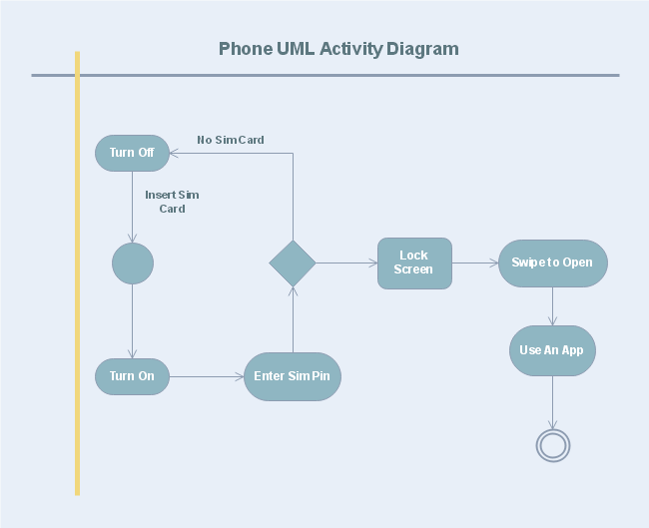

FIG 1: PHONE UML ACTIVITY DIAGRAM(ref.1)

## Use case diagram for calling:

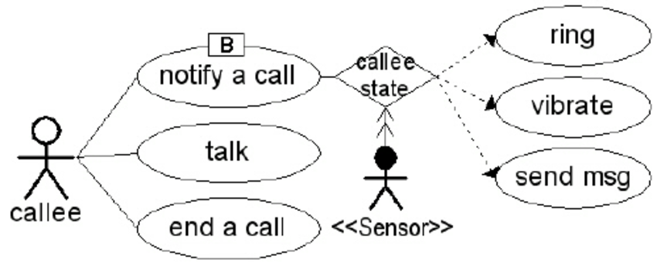

Fig 2: Use case diagram for calling. (ref.2)

## Use case diagram for call history:

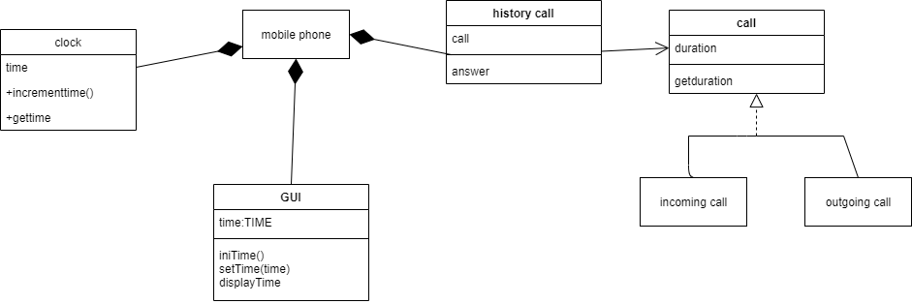

Fig 3: use case diagram for call history

## Use case diagram for Camera application:

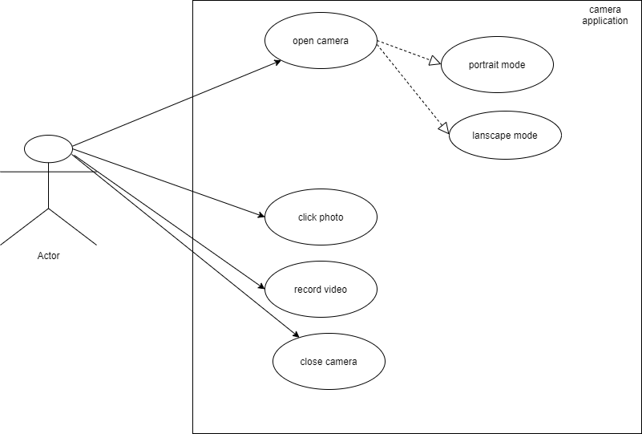

Fig 5: use case diagram for camera application

## sequence diagram for making a phone call:

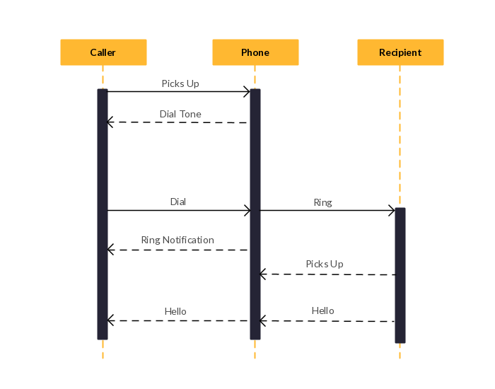

Fig 4: make a phone call sequence diagram(ref.3)

## Class diagram for camera application:

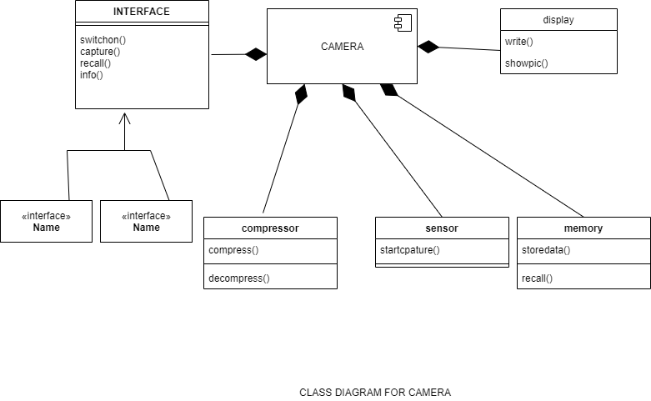

# TEST PLAN:

|  |  |  |  |  |  |
| --- | --- | --- | --- | --- | --- |
| ID | DESCRIPTION | PRE-CONDITION | EXPECTED INPUT | EXPECTED OUTPUT | ACTUAL OUTPUT |
| 1 | Check whether the keyboard works while tying message | Should have keyboard application installed | Text, numbers, special characters, symbols | Message can be typed used keyboard | Message can be typed used keyboard |
| 2 | Check whether microphone is working properly | Should have working microphone in the system | Call from the other person | Able to listen to the receiver | Able to listen to the receiver |
| 3 | Check whether keyboard works while listening to audio | Should have keyboard application and other audio apps | Text, numbers, special characters, symbols | Able to type message while listening to audio | Able to type message while listening to audio |
| 4 | Check alarm and phone timing working synchronous | Setting alarm from phone | Setting up an alarm | time and alarm works  synchronous way | synchronized |
| 5 | Check while charging user can perform all functional operation on phone | Connect to charging point | Function needs to perform in the system | Should be able use all the functions | Can access phone while charging |
| 6 | Check can connect to wireless network | Open wireless network connection | Available wireless connections | Should be able to connect another network | Can connect to the network |
| 7 | Check can make call | Should have call application | Calling number | Should be able to make calls | Can make calls |
| 8 | Check phones connects to internet | Have network connection | Available network | Should be able to connect to internet | Can connect to internet |
| 9 | Check can be able to use other apps while browsing | Have other apps in the system | Open other apps while browsing | Should be able to use other apps | Can use other apps while browsing |
| 10 | Check media player is working | Should have media player app | Videos | Should be able to play videos | Can play videos |
| 11 | Check camera is working | Should camera application | Capturing images | Should be able to capture images /videos | Can capture photos/videos |
| 12 | Check whether phones works in varying network signals | Should have sim cards in it | Network available | Phone should be able to work in varying signals | Works well |
| 13 | Check the USB port is working | Need shave usb port in the system | Other devices connect through usb port | Should be able to connect to other devices using USB | Working well |
| 14 | Check the image viewer working | Should have images viewer application | Images  /photos | Should open images | Can view images |
| 15 | Check can able to watch videos when connecting to WIFI | WIFI connection | videos | Should be able to watch videos | Can watch videos on WIFI connection |
| 16 | Check can message can be send while calling | On the call and opened message application | Typed message | Able to send message while on the call | Can send message while speaking |

# User stories:

* “I need a mobile with 4GB RAM and 64GB ROM, so that I can access applications faster and don’t need to complete other tasks to complete then open-up the other application and store more images videos, images and documents so that I can easily access/have my data whenever it required”
* “I need a mobile phone which have battery capacity above 4000mah, front camera of 20MP and rear camera of 48MP, so that I can use mobile phones to capture images/videos with clarity and with long lasting battery life”
* “I need to have face unlock and fingerprint unlock along with the pattern and pin unlocking method. So that I can unlock phone with much faster way”

# CI/WORKFLOW:

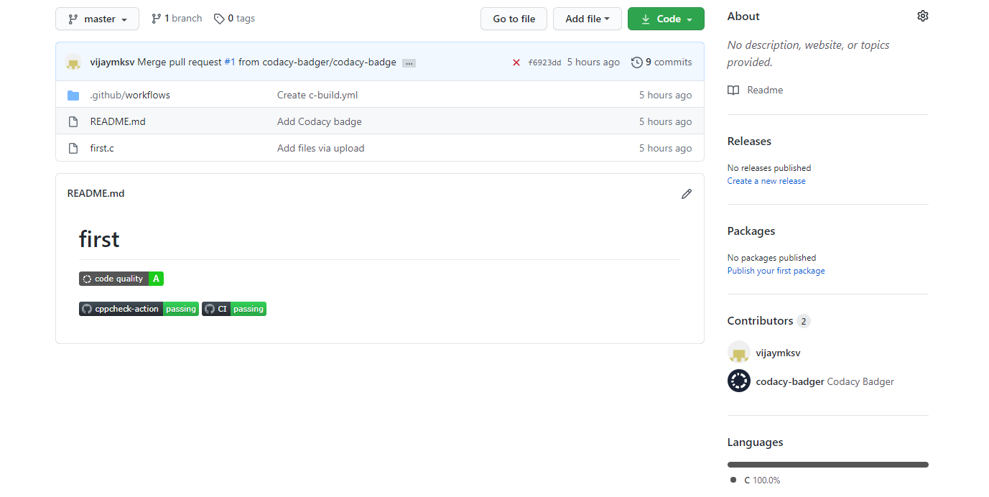

Fig 6: README.md file uploaded contents

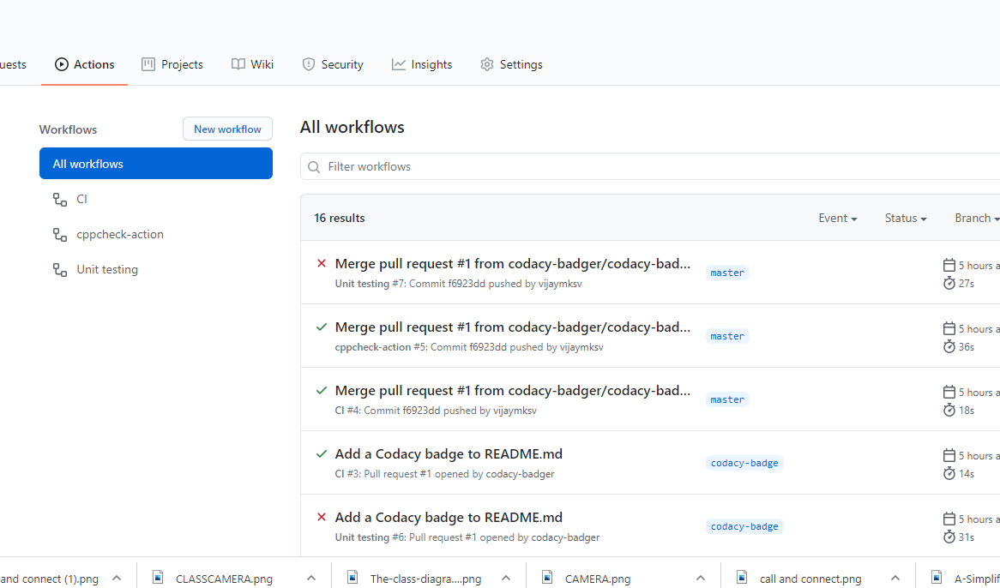

Fig 7: update on commit lists

# REFERENECES:

1. <https://www.edrawsoft.com/template-phone-uml-activity-diagram.html>
2. <https://www.researchgate.net/figure/Use-Case-Diagram-for-Mobile-Phone_fig3_221435440>
3. <https://www.pinterest.com/pin/464011567842577368/>
4. <https://github.com/vijaymksv/first/blob/master/first.c>

./

Learning Report – Calculator

Course Code: <CODE>



|  |  |  |  |  |  |
| --- | --- | --- | --- | --- | --- |
| **Ver. Rel. No.** | **Release Date** | **Prepared. By** | **Reviewed By** | **Approved By** | **Remarks/Revision Details** |
| 1 | 19/09/2020 | Vijay Kumar M |  |  |  |
|  |  |  |  |  |  |
|  |  |  |  |  |  |
|  |  |  |  |  |  |
|  |  |  |  |  |  |

**Document History**

Contents

About the product: 4

Timeline of Calculator: 4

Costing: 4

SWOT ANALYSIS: 4

STRENGTH: 4

WEAKNESS: 4

OPPORTUNITIES: 5

THREATS: 5

Requirements: 5

High level requirements: 5

Low level requirements: 5

UML DIAGRAMS: 6

Calculator use case Diagram: 6

Calculator Activity Diagram: 7

Use case diagram for calling mathematical operation: 7

Sequence diagram for computing 8

TEST PLAN: 9

CI workflow for C programming: 10

Updated workflows: 10

Agile aspects: 12

User stories: 12

REFERENECES: 12

# About the product:

It is calculator that performs the arithmetic operations on numbers. This calculator can only do addition, subtraction, multiplication, division, modulus, finding the greater number in the given two numbers and finding the lesser number in the given number.

## Timeline of Calculator:

1. Abacus: it is the basic and simple tool used to perform arithmetic problems quickly during the earlier days. Now it is mainly used in brain development programs. Studies proved that that abacus learners used both sides of the brain.
2. Basic Calculator: this are the mostly used in almost every office and homes to perform arithmetic operations. This type of calculator usually has 8-12 digits display.
3. Scientific calculator. This calculator mainly designed to solve problems in science, engineering and mathematics and some extend to perform computer algebra.
4. Graphing calculator: Scientific calculator n=have been replaced by graphing calculator, they can plot graph solve simultaneous equations and carry out tasks with variables.
5. Printing calculator: printing calculator is pretty much common computer where present at every home. Printing calculator performs basic operations that prints on the paper along with display it on the LCD screen.
6. Online calculator/mobile calculator: Nowadays, we can use calculator online, and mobile application. It is pretty much simple to use and can get result faster than other mode of calculations

## Costing:

1. Abacus Calculator: Rs. 100 and above
2. Basic calculator: Rs. 150 and above
3. Scientific calculator: Rs.500 and above
4. Graphing calculator’ Rs.10000 and above
5. Printing calculator: Rs. 1500 and above
6. Online calculator/mobile calculator: it comes with the mobile device like pre-installed or need to install it from another source or can access online.

# SWOT ANALYSIS:

|  |  |
| --- | --- |
| STRENGTH:  * Excellent customer service * Competitive price on the market * Good brand reputation * Product versatility | WEAKNESS:  * Have limited functions * Limited growth * Small company |
| OPPORTUNITIES:  * Increase sale by opening more retail stores * Buy out competition * Setup in features | THREATS:  * Slow economy * Strong competition * Technology problems * Increase in taxes |

# Requirements:

## High level requirements:

1. Display
2. Keys
3. Battery
4. Storing numbers
5. Using previous number
6. Turn on
7. Turn off
8. Exit the calculator

## Low level requirements:

* Reliability
* Performance
* Efficiency
* Durability
* Performing multi-value operations
* Popup error message

# UML DIAGRAMS:

## Calculator use case Diagram:

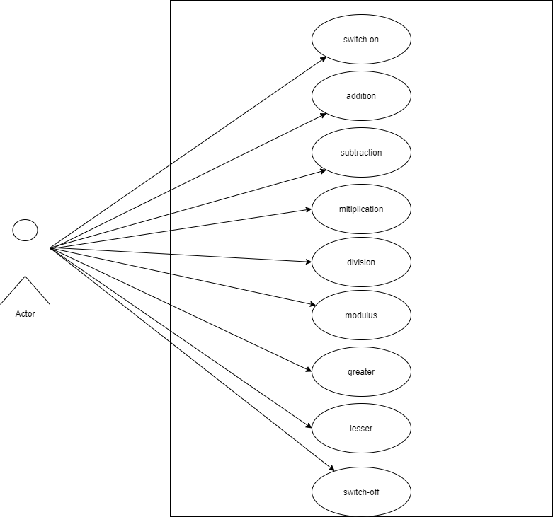

Fig 1: use case diagram for calculator

## Calculator Activity Diagram:

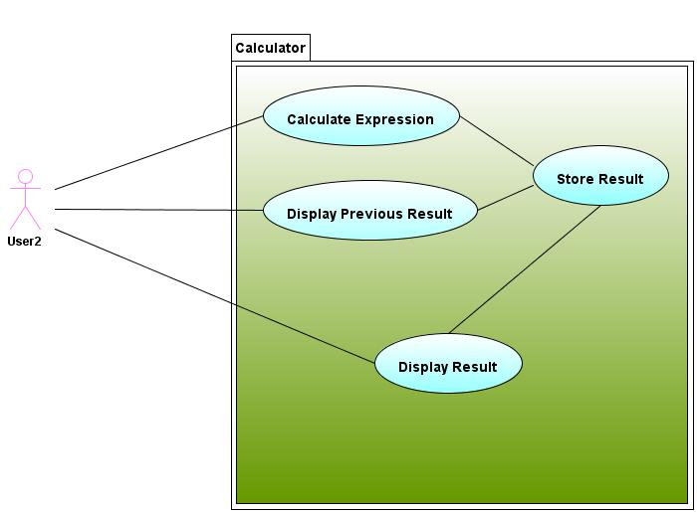

Fig 1: Calculator Activity Diagram

## Use case diagram for calling mathematical operation:

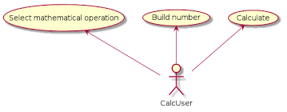

Fig 2: Use case diagram for calling mathematical operation:

## Sequence diagram for computing

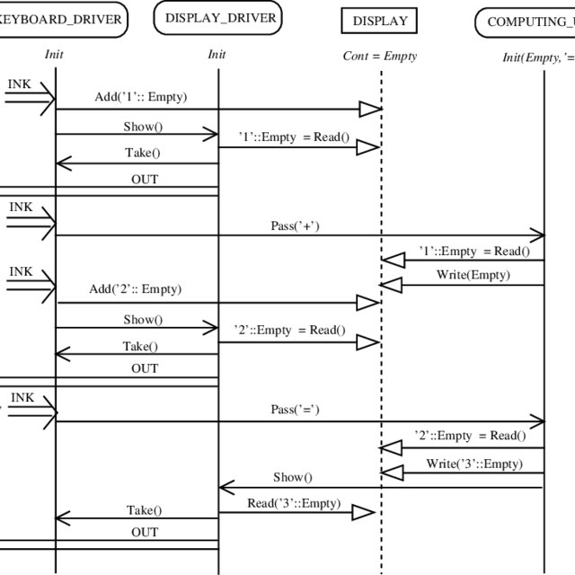

Fig 3: Sequence diagram for computing the result (ref. 3)

# TEST PLAN:

|  |  |  |  |  |  |
| --- | --- | --- | --- | --- | --- |
| ID | DESCRIPTION | PRE-CONDITION | EXPECTED INPUT | EXPECTED OUTPUT | ACTUAL OUTPUT |
| 1 | Check whether the calculator is on | Should have battery charged | On button pressed | Calculator is in on state | Calculator switched on |
| 2 | Check whether switch off button is working | Calculator must in on state | Switch off button pressed | Calculator is in switch off state | Calculator is switched off |
| 3 | Check whether calculator performing addition operation | Calculator must in on state | Two numbers must be given has inputs and addition symbol as operator | Result of Addition of numbers | Addition of numbers |
| 4 | Check whether calculator performing subtraction operation | Calculator must in on state | Two numbers must be given has inputs and subtraction symbol as operator | Result of subtraction of numbers | Result of subtraction of numbers |
| 5 | Check whether calculator performing multiplication operation | Calculator must in on state | Two numbers must be given has inputs and multiplication symbol as operator | Result of subtraction of numbers | Result of subtraction of numbers |
| 6 | Check whether calculator performing division operation | Calculator must in on state | Two numbers must be given has inputs and division symbol as operator | Result of division of numbers | Result of division of numbers |
| 7 | Check whether calculator performing modulus operation | Calculator must in on state | Two numbers must be given has inputs and modulus symbol as operator | Result of modulus of numbers | Result of modulus of numbers |
| 8 | Check whether calculator performing lesser operation | Calculator must in on state | Two numbers must be given has inputs and lesser symbol as operator | Result of lesser of numbers | Result of lesser of numbers |
| 9 | Check whether calculator performing greater operation | Calculator must in on state | Two numbers must be given has inputs and greater symbol as operator | Result of greater of numbers | Result of greater of numbers |
| 10 | Check whether calculator able to through error message when the input is wrong | Calculator must in on state and should contains any expression | Wrong inputs | Error message to be displayed | Error message displayed |

# CI workflow for C programming:

## Updated workflows:

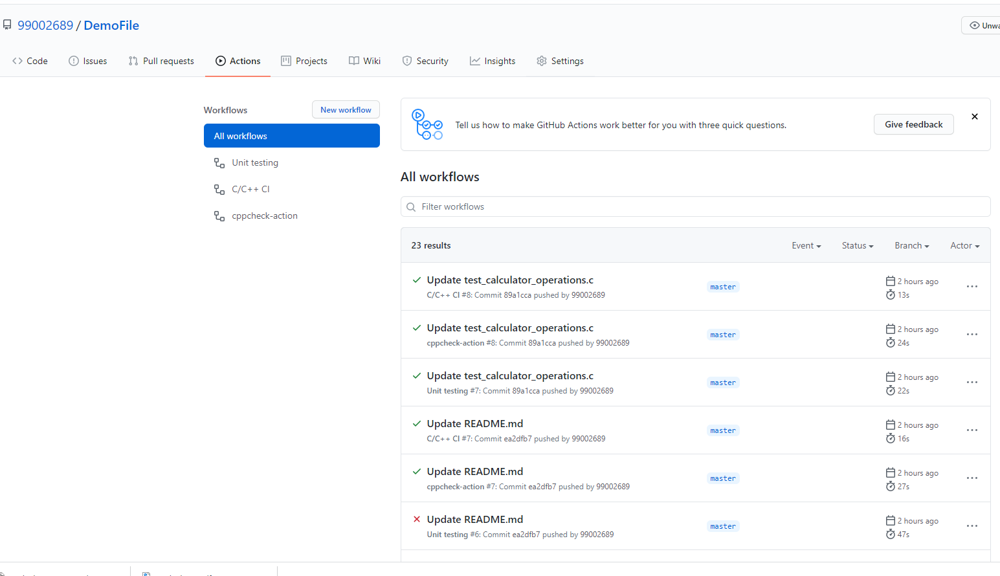

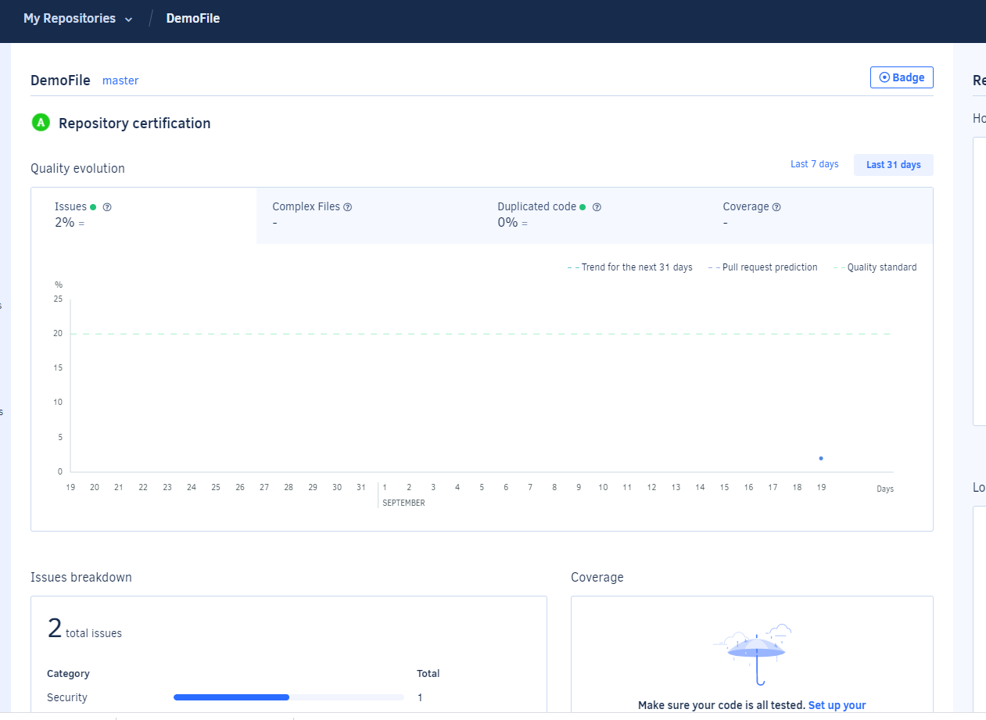

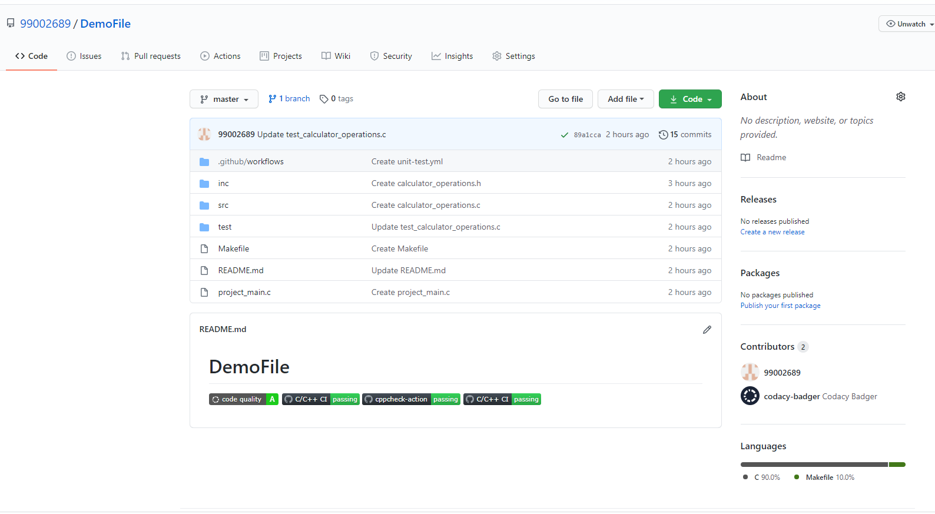

# Agile aspects:

## Theme:

Perform all the basic mathematical operations.

## Epic:

* Perform addition operation.
* Perform subtraction operation.
* Perform multiplication operation
* Perform division operation
* Perform modulus operation
* Perform greater operation
* Perform lesser operation

# User stories:

* “I need a calculator within Rs. 500 and able to perform all the scientific operations and it should be light weight”.
* “I need a calculator it should perform all the graphing tasks, it should be chargeable and the amount for calculator is within Rs. 10000 and it can be used as scientific calculator”.
* “I need a calculator which is very easy to use, durability of the battery must be minimum six months and it should be able to perform all the basic calculations, scientific calculations and the graphing calculations and finally it need to print the result on the paper”.

# REFERENECES:

1. <https://creately.com/blog/diagrams/use-case-diagram-tutorial/>
2. <https://www.researchgate.net/figure/Calculator-a-sequence-diagram-for-the-computation-of-1-2_fig4_2818652>
3. <https://github.com/99002689/DemoFile>