**‘An IoT based smart indoor vertical farming’**

**-Sharanmegha K V**

Contents

List of figures 3

Introduction 4

1. Requirements 5

1.1 Research 5

1.1.1 Aging 5

1.1.2 Costing 6

1.2 High level Requirements: 6

1.3 Low level Requirements: 6

2. Design 7

2.1 Structural UML diagrams 7

2.2 Behavioral UML diagrams 9

3. Test Plan 10

3.1 Test cases 10

4. Implementation 11

4.1 GIT 11

# List of figures

|  |  |  |
| --- | --- | --- |
| **Fig no.** | **Description** | **Page no.** |
| **1.1** | **Advantage of the Vertical farms in modern times** | **5** |
| **1.2** | **Fixed and variable costs** | **6** |
| **1** | **Block diagram for the system** | **7** |
| **2** | **Flow Chart for the system** | **8** |
| **3** | **Use Case diagram for taking action by the user** | **9** |
| **4** | **Use Case diagram for Complete Model** | **9** |

# Introduction

* Vertical farming is the practice of growing plants i n vertically stacked layers.
* Greenhouses in a building of a city.
* Some parameters can be monitored inside the in-door farming such as temperature, humidity, moisture etc..
* In-door farming plays an important role since environment and weather is unpredictable.
* Monitor the growth and factors that affect the plants.

# Requirements

## 1.1 Research

### 1.1.1 Aging

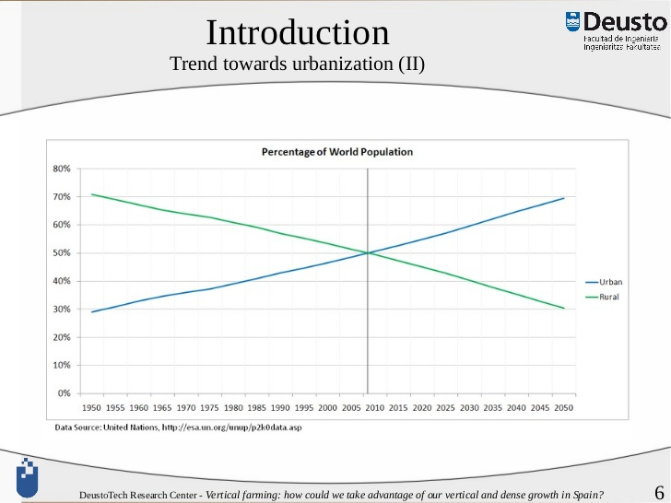

Fig 1.1: Advantage of the Vertical farms in modern times

### 1.1.2 Costing

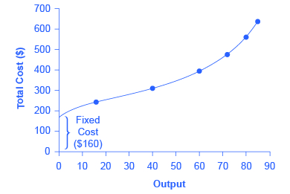

Fig 1.2: Fixed and variable costs

## 1.2 High level Requirements:

* Need to send alert notifications to the user when the tank is empty and the action to be taken by the user based on the alerts received.
* Provides the sensor data to the user through their mobile applications.
* Monitor and control the sensor readings and their thresholds for sending alerts.
* Determining whether there is darkness near the plants.
* Need to send alert messages to user when there is less amount of light to take necessary action.

## 1.3 Low level Requirements:

* Arduino Uno
* Sensors: DHT11, LDR sensor, soil moisture sensor, Ultrasonic sensor, Float sensor
* Arduino IDE software
* Bluetooth module HC-05
* Micro SD card adapter
* Racks for vertical farming
* Plants like Methi, Spinach, Coriander, Marigold

# 2. Design

## 2.1 Structural UML diagrams**:**

Storing and display output and alerts

Monitoring Phase

Arduino UNO

Power supply

Temperature and humidity sensor

Moisture sensor

LED Lights

Water supply

Float sensor

Speakers

pH sensor

HC-05 module

Action taken by user

**Fig 1. Block diagram for the system**



**Fig 2. Flow Chart for the system**

## 2.2 Behavioral UML diagrams**:**

**Fig 3. Use Case diagram for taking action by the user**



**Fig 4. Use Case diagram for Complete Model**

# 3. Test Plan

## 3.1 Test cases

|  |  |  |  |  |
| --- | --- | --- | --- | --- |
| **Test Id** | **Description** | **Expected input** | **Expected output** | **Actual Output** |
| **TC1** | **Alert sent to the user for empty tank** | **Float sensor value** | **Determines whether tank is empty or not** | **Pass** |
| **TC2** | **Alert for darkness near the plants** | **LDR sensor value** | **Determines darkness** | **Pass** |
| **TC3** | **Readings of soil moisture sensor** | **Soil moisture sensor values** | **Displays on the user’s mobile phone** | **Pass** |
| **TC4** | **Readings of LDR sensor** | **Values of LDR sensor** | **Displays the values to the user** | **Pass** |
| **TC5** | **Alerts on Sound level for the growth of plants** | **Values of sound sensor** | **Determines sound/music frequency** | **Pass** |

# 4. Implementation

## 4.1 GIT

GIT Hub account-<https://github.com/99002786/activity1/upload/main>