**My Calculator**

-Sharanmegha K V

PS number-99002786

Contents

1. Requirements 3

1.1 High level Requirements: 3

1.2 Low level Requirements: 3

2. Design 3

2.1 Structural UML diagrams 3

2.2 Behavioural UML Diagrams 6

3. Test Plan 7

3.1 Test cases 7

**Introduction**

An **electronic calculator** is typically a portable electronic device used to perform calculations, ranging from basic arithmetic to complex mathematics. It can perform operations like addition, subtraction, multiplication and division. In addition to this calculator can also find the square root of a number and checks whether the input number is a prime number or not.

1) Arithmetic calculations: As a calculator, it seems obvious that this machine willbe able to perform basic arithmetic calculations. Addition, subtraction,multiplication etc. will be done with this machine.2) Higher level (scientific) calculations: The user will be able to use this calculatorto do sine, cosine, tan and log as well as their inverse operations. Allcalculations deemed “scientific” will be allowed.

# Requirements

## High level Requirements:

Output: This function will display the results of a calculation or memory. Results should

be displayed under the following conditions:1. Whenever the equals sign (=) is input.2. Optionally, whenever the ENTER key is pressed

4.1 System Interfaces

1) Arithmetic: the system will use the built in ALU to compute all the arithmeticthat will be done for the calculator.2) Upper level Calculations: The programmers of the machine will write infunctions that the machine will be able to call to produce upper levelcalculations

## 1.2 Low level Requirements:

# Design

## Structural UML diagrams

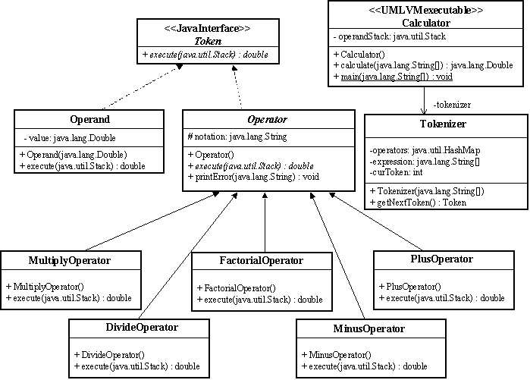

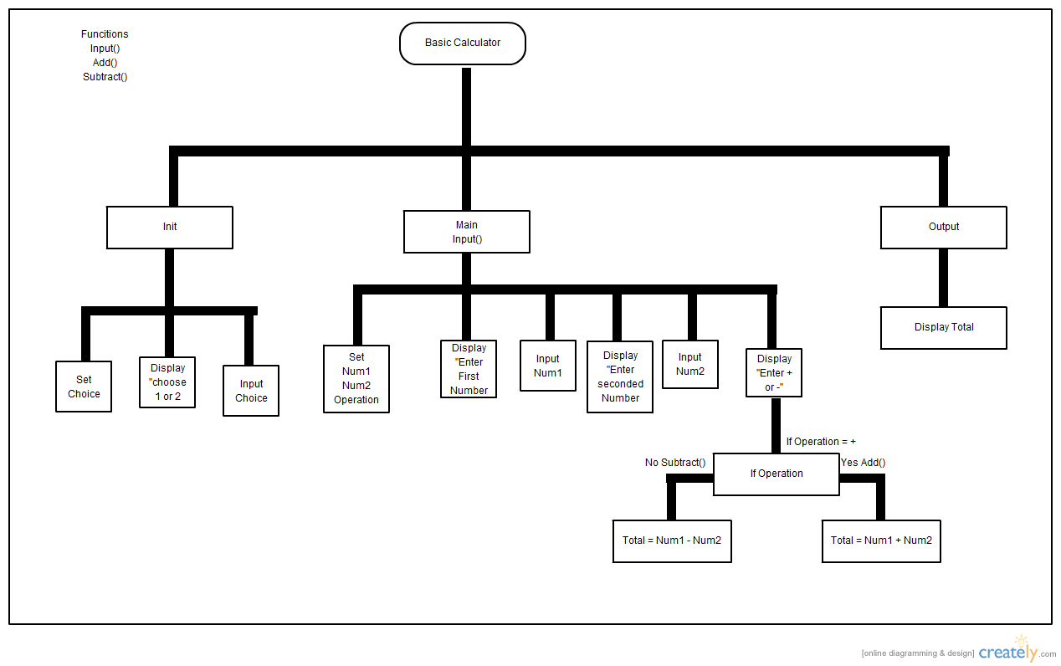

## 2.2 Behavioural UML Diagrams

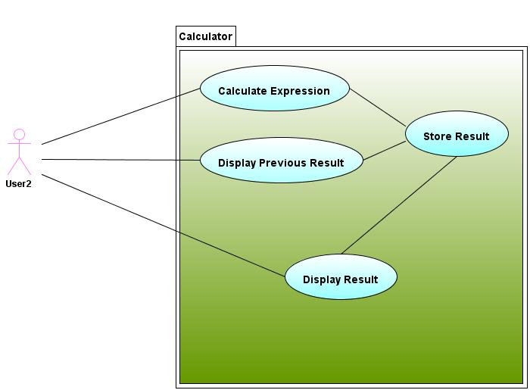

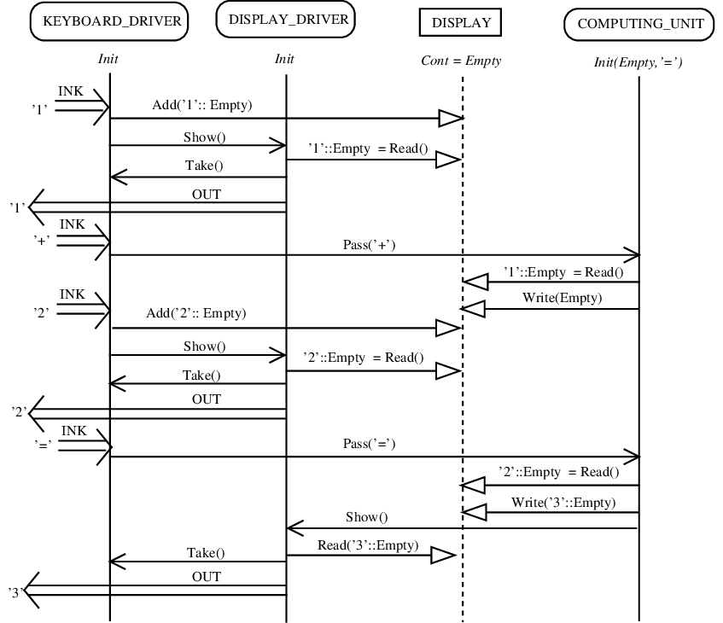

# Test Plan

## 3.1 Test cases