# BANK ACCOUNT MANAGEMENT SYSTEM

# Output

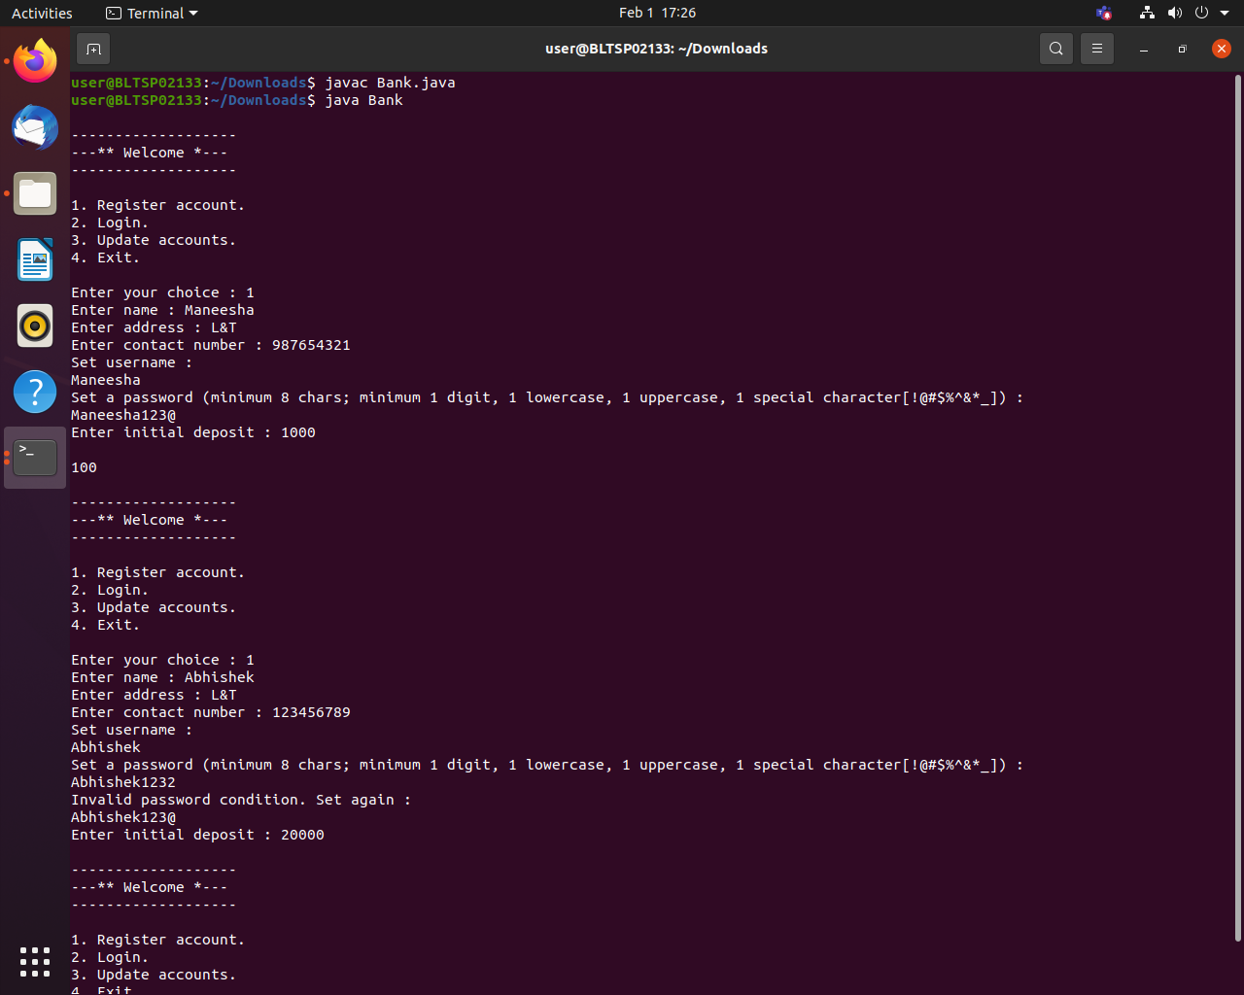Fig 1. Registration

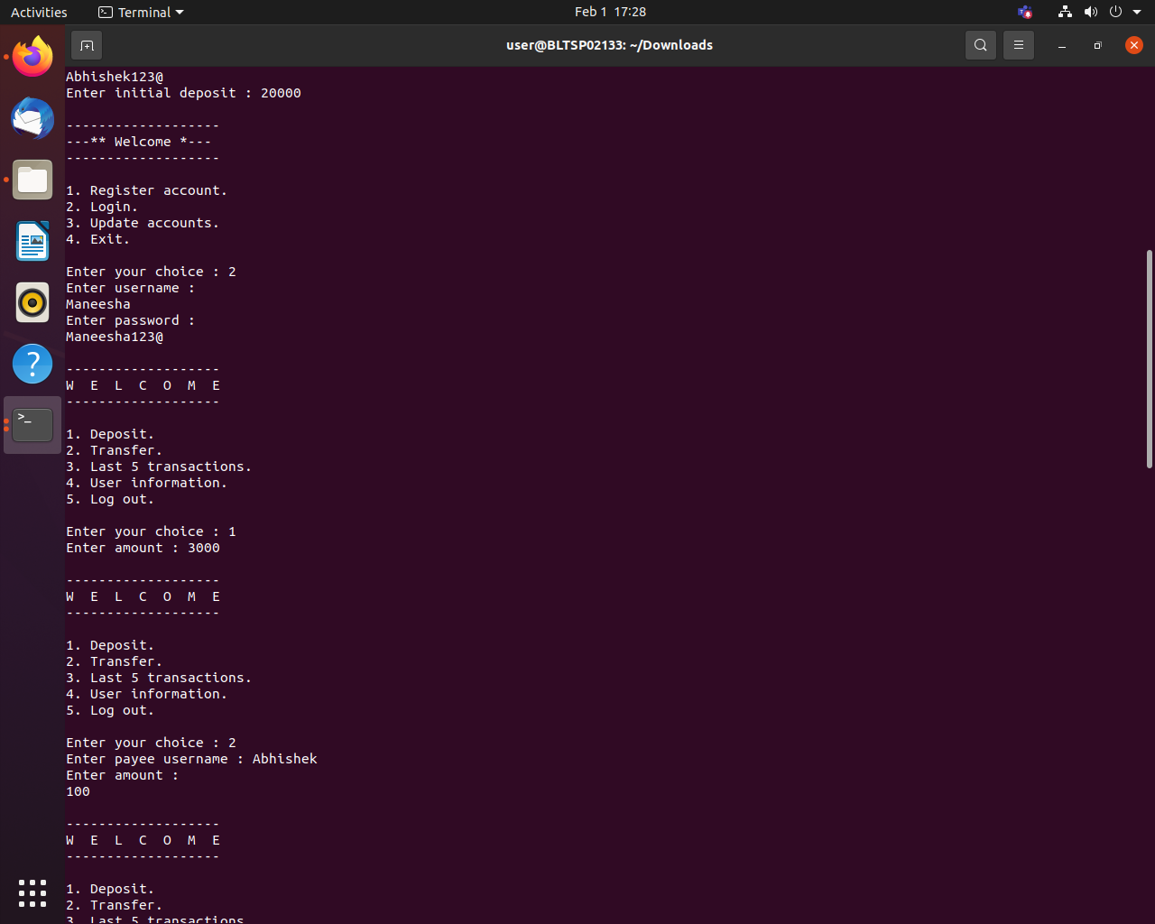

Fig 2. Deposit and Transfer

# 

Fig 3. Transactions

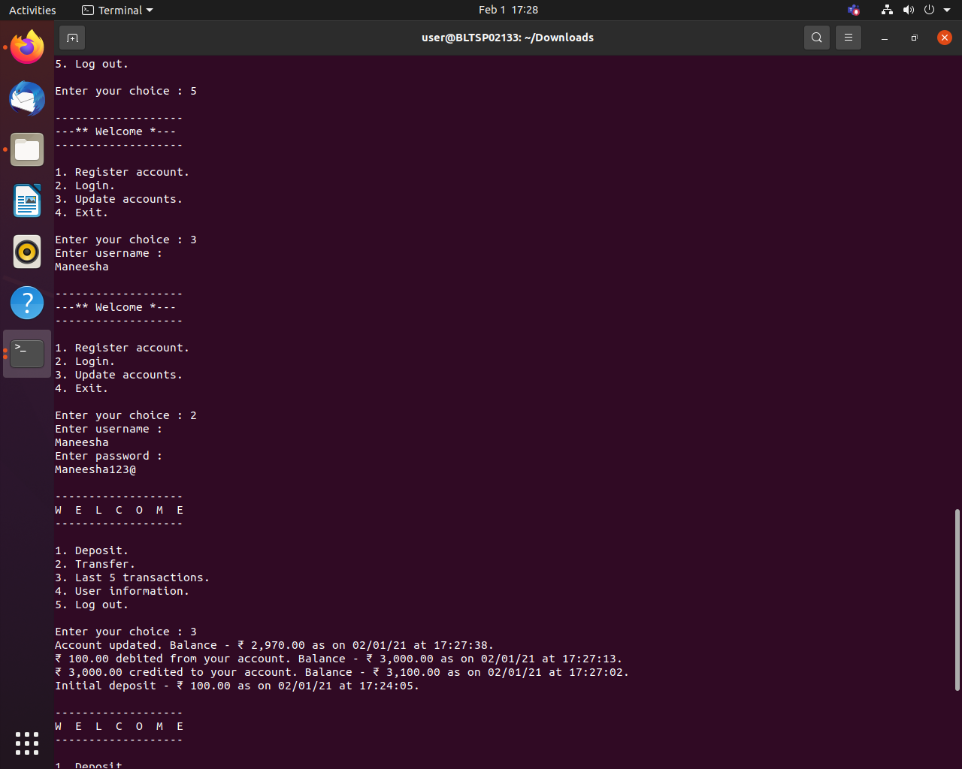

Fig 4. Update

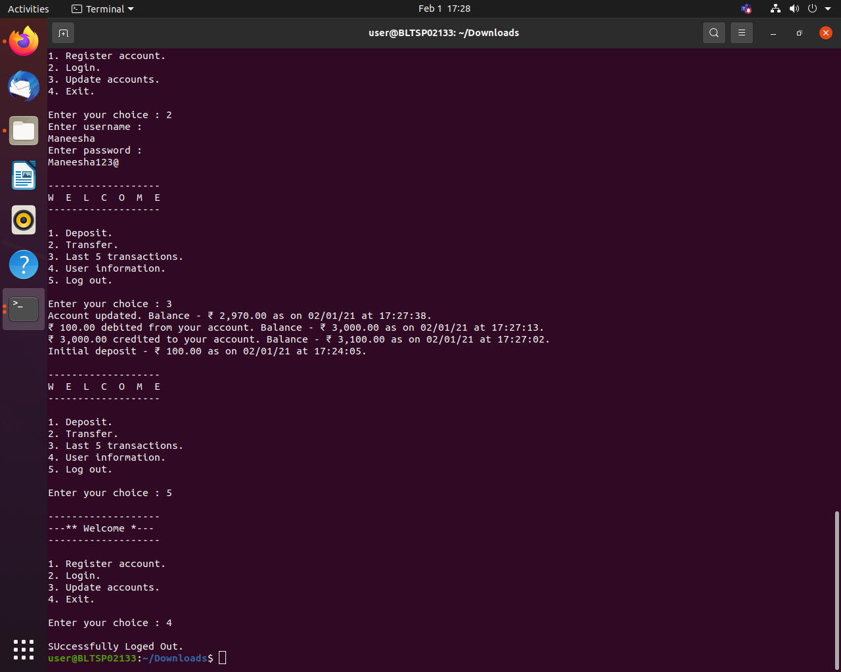Fig 5. Exit