# PASSWORD GENERATOR

# Outputs

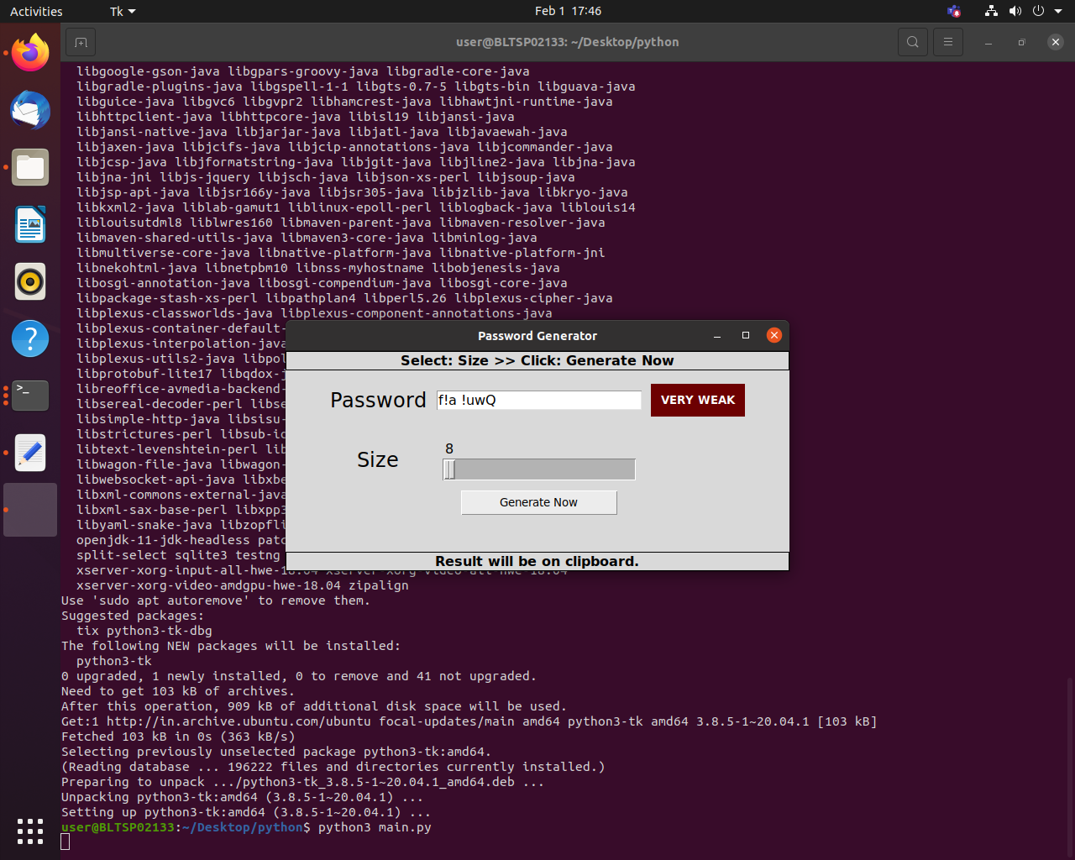

Fig.1. Output-1

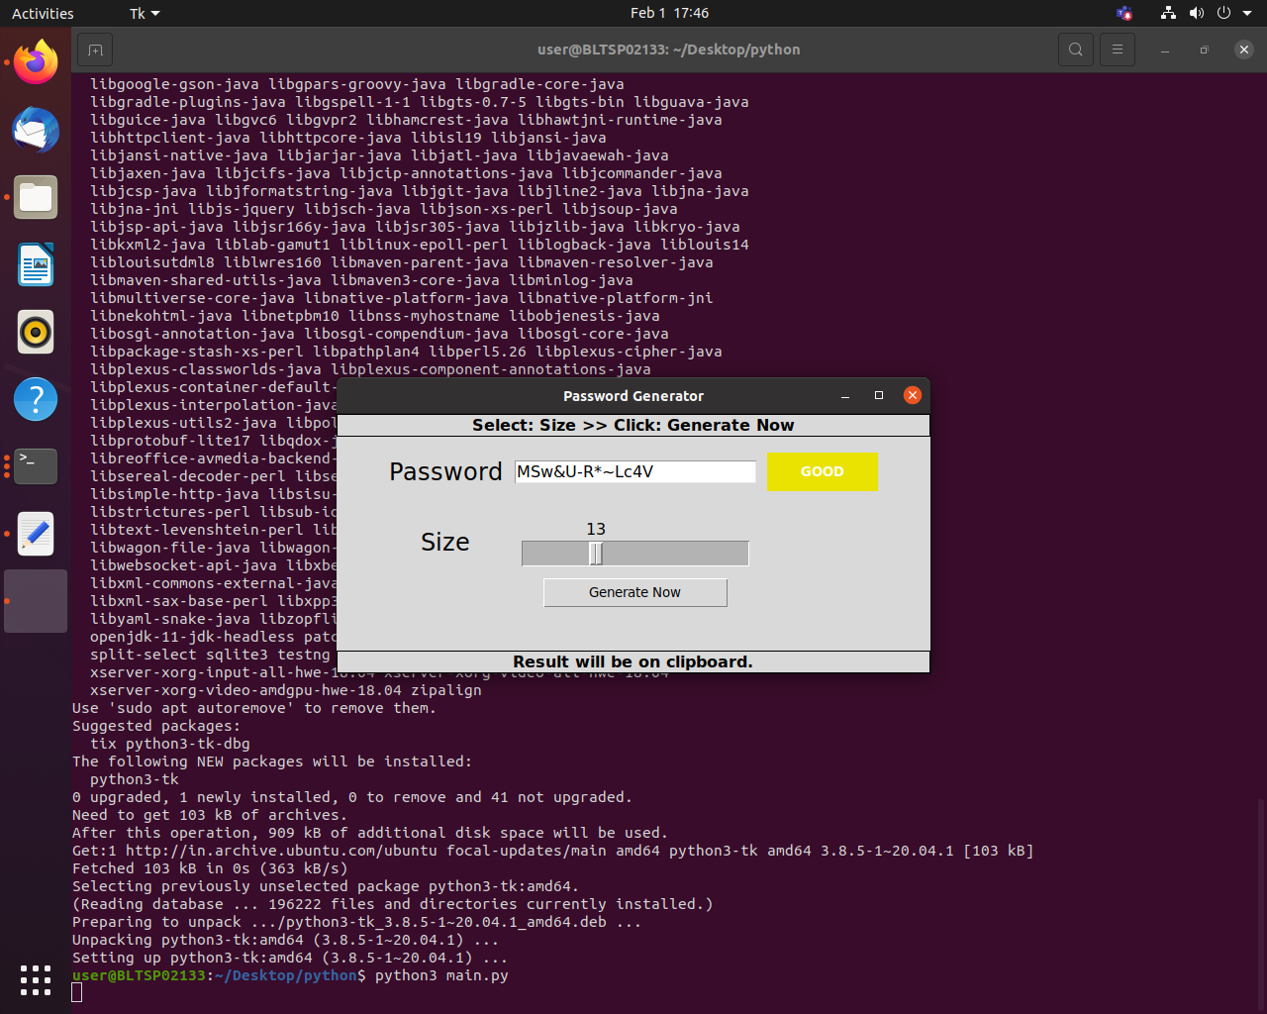

Fig.2. Output-2

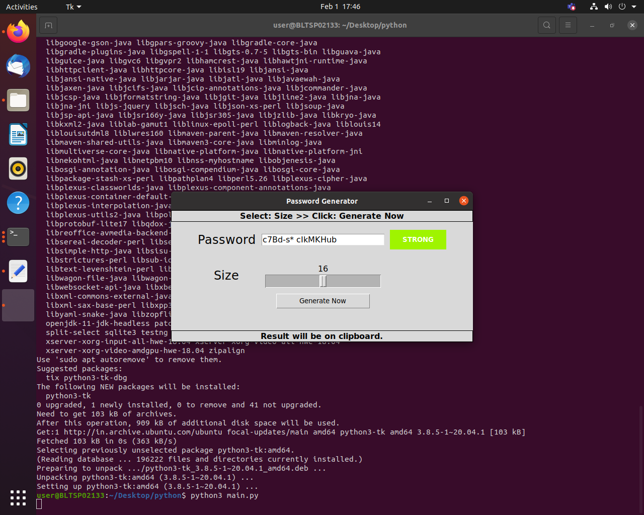

Fig.3. Output-3

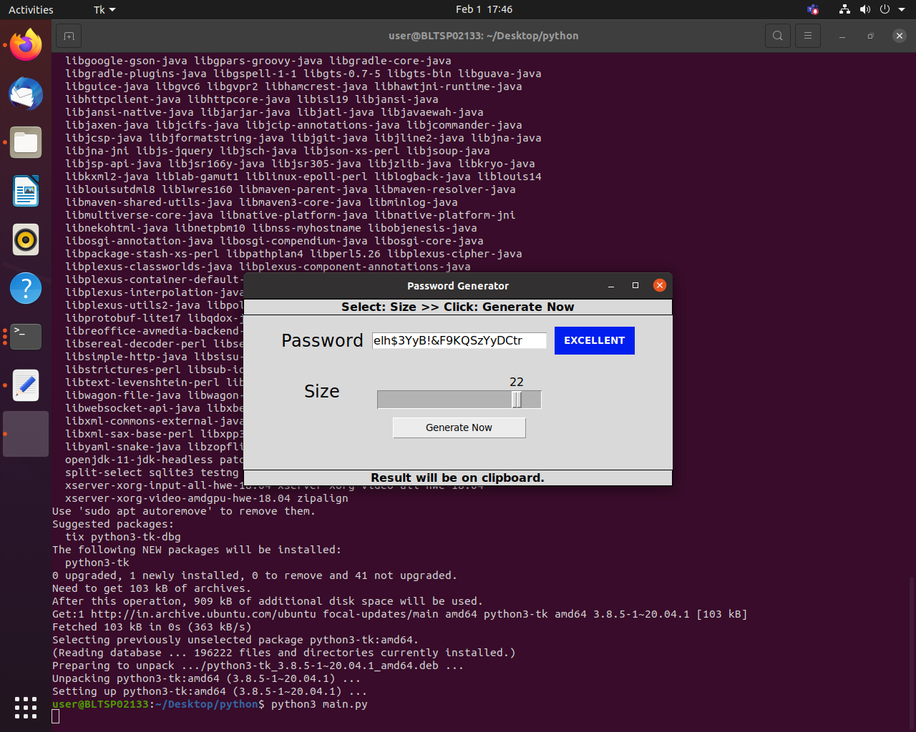

Fig.4. Output-4