./

GENESIS – Advanced Python Programming



|  |  |  |  |  |  |
| --- | --- | --- | --- | --- | --- |
| **Ver. Rel. No.** | **Release Date** | **Prepared. By** | **Reviewed By** | **To be Approved** | **Remarks/Revision Details** |
| 1 | 13-12-20 | Alen V George |  |  |  |
|  |  |  |  |  |  |
|  |  |  |  |  |  |
|  |  |  |  |  |  |
|  |  |  |  |  |  |

**Details**

Contents

Contents 3

Bike Rental System 4

**Day1:** 4

**PEP8 Screenshot** 6

**Day2:** 7

**PEP8 Screenshot** 9

**Day3** 10

**PEP8 Screenshot** 13

# Bike Rental System

## **Day1:**

**Github Link**: <https://github.com/99003146/PythonProject/blob/main/Day1.py>

**Code:**

bikes = {"Pulsar": 20, "Unicorn": 30, "Royal Enfield": 10}

def display():

for (bike, no) in zip(bikes.keys(), bikes.values()):

print("Bike:", bike, "|", "Numbers available: ", no)

def book(bike_name, num):

for values in bikes:

bikes[values] = int(bikes[values])

if bike_name in bikes.keys():

value = bikes.get(bike_name)

if (num <= value):

value = value - num

bikes.pop(bike_name)

bikes[bike_name] = value

print("You have successfully booked %d %s" % (num, bike_name))

else:

print("Required number of bikes not available")

else:

print("Required Bike not available")

def ret_bike(bike_name, num, hours):

cost = num * hours * 50

for values in bikes:

bikes[values] = int(bikes[values])

if bike_name in bikes.keys():

value = bikes.get(bike_name)

value = value + num

bikes.pop(bike_name)

bikes[bike_name] = value

print("**********************************")

print("You have returned  ", bike_name)

print("Number of bikes returned ", num)

print("Total amount payable is Rs :", cost)

print("***********************************")

def main():

print()

print("************BIKE RENTAL SYSTEM***********")

print(" ******50 rs per hour for rentals********")

print("1. Display details of bikes")

print("2. Rent bikes")

print("3. Return bikes")

print("*****************************************")

choice = input("Enter choice: ")

choice = int(choice)

if choice == 1:

display()

if choice == 2:

bike_name = input("Enter name of bike")

no_bikes = input("Enter number of bikes")

no_bikes = int(no_bikes)

book(bike_name, no_bikes)

if choice == 3:

bike_name = input("Enter name of bike")

if bike_name in bikes.keys():

no_bikes = input("Enter number of bikes")

no_bikes = int(no_bikes)

hours = input("Number of hours")

hours = int(hours)

ret_bike(bike_name, no_bikes, hours)

else:

print("Check the bike name")

if __name__ == "__main__":

main()

## **PEP8 Screenshot**

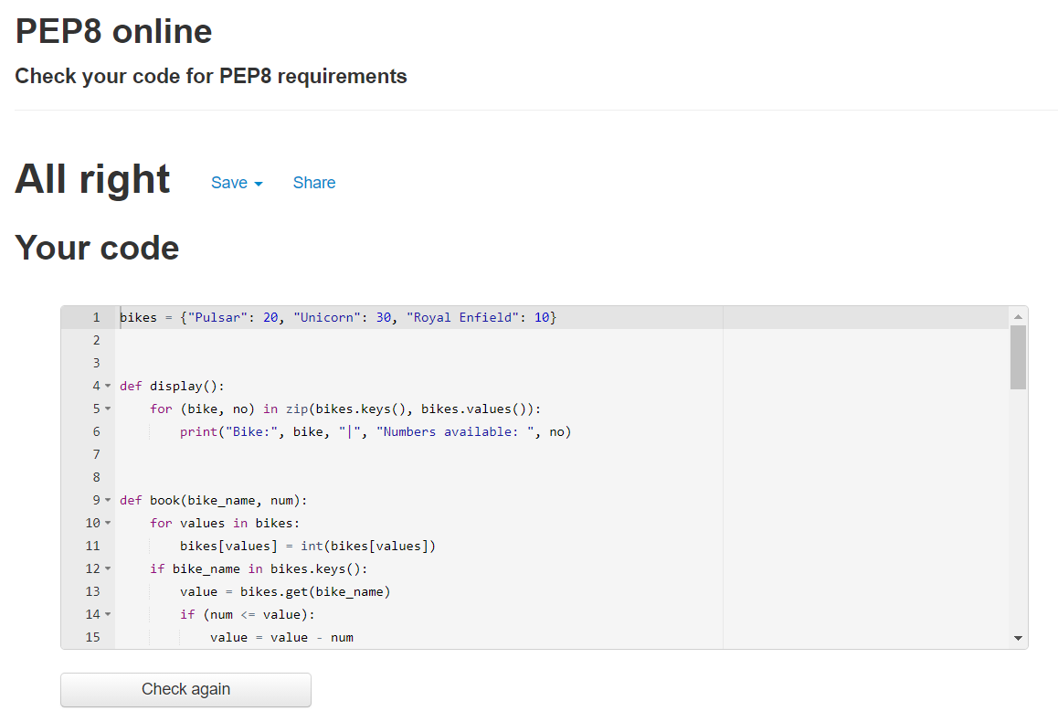

## **Day2:**

**Code:**

from datetime import datetime

bike_l = {"Pulsar": 20, "Unicorn": 30, "Royal Enfield": 10}

class Display:

def __init__(self):

self.bikes = {}

def display(self, bikes):

print("************ BIKES AVAILABLE ******************")

for (bike, no) in zip(bikes.keys(), bikes.values()):

print("Bike:", bike, "|", "Numbers available: ", no)

print("***********************************************")

class Bike(Display):

def __init__(self):

self.bikes = {}

self.bike_name = ""

self.number = 0

def rent(self, bikes, bike_name, number):

self.bikes = bikes

self.bike_name = bike_name

self.number = number

if self.bike_name in self.bikes.keys():

value = self.bikes.get(bike_name)

newval = value-self.number

if(newval >= 0):

self.bikes[self.bike_name] = newval

print("You have rented: ", self.bike_name)

print("Numbers Rented:", self.number)

print("*****************************")

print()

Display.display(self, bike_l)

else:

print("Required Number of bikes not available")

else:

print("Type a valid bike name")

def ret_bike(self, bikes, bike_name, number, hours_used):

if bike_name in bikes.keys():

cost = hours_used*number*50

value = bikes.get(bike_name)

newval = value+number

bikes[bike_name] = newval

print("*******************************")

print("You have returned:", bike_name)

print("Number Returned:", number)

print("Amount Payable:", cost)

class Customer(Bike, Display):

def __init__(self):

self.user_n = ""

self.phone_n = ""

def c_rent(self, user_n, phone_n, bikes, bike_name, number):

if bike_name in bikes.keys():

print("***************************")

print("UserName: ", user_n)

print("Phone number: ", phone_n)

Bike.rent(self, bikes, bike_name, number)

else:

print("\nPlease Enter a valid bike name")

def c_return(self, bike, bike_name, number, hours_used):

now = datetime.now()

current_time = now.strftime("%H:%M:%S")

Bike.ret_bike(self, bike, bike_name, number, hours_used)

print("You have returned the bike at ", current_time)

print()

print("Database Updated")

print("New Count of Bikes")

print()

Display.display(self, bike)

def main():

print("***********************************")

print("Bikes at 50rs per hour")

print("\n1. Display Bike Details")

print("2. Rent Bike")

print("3. Return Bike")

print()

print("**********************************")

choice = input("Enter Choice: ")

if choice == "1":

dis = Display()

dis.display(bike_l)

if choice == "2":

usrname = input("Enter User Name: ")

phoneno = input("Enter Phone Number: ")

bike_n = input("Enter Name of Bike to rent: ")

number = int(input("Enter Number of bikes to rent: "))

ren = Customer()

ren.c_rent(usrname, phoneno, bike_l, bike_n, number)

if choice == "3":

bike_n = input("Enter Name of Bike to return: ")

number = int(input("Enter Number of bikes to return: "))

hours_used = int(input("Enter Number of hours used: "))

retu = Customer()

retu.c_return(bike_l, bike_n, number, hours_used)

if __name__ == "__main__":

main()

## **PEP8 Screenshot**

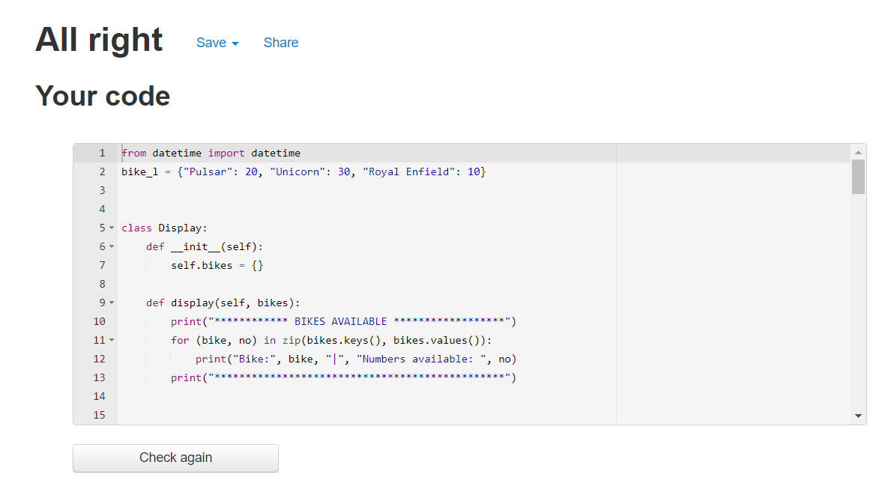

## **Day3**

**Github Link:** <https://github.com/99003146/PythonProject/blob/main/bike-rental.py>

**Code:**

import os

import re

from datetime import datetime

bike_l = {"Pulsar": 20, "Unicorn": 30, "Royal Enfield": 10}

'''Class to Display Details'''

class Display:

def __init__(self):

self.bikes = {}

def display(self, bikes):

self.bikes = bikes

print("************ BIKES AVAILABLE ******************")

for (bike, no) in zip(self.bikes.keys(), self.bikes.values()):

print("Bike:", bike, "|", "Numbers available: ", no)

print("***********************************************")

'''Class for renting and returning'''

class Bike(Display):

def __init__(self):

self.bikes = {}

self.bike_name = ""

self.number = 0

self.hours_used = 0

def rent(self, bikes, bike_name, number):

self.bikes = bikes

self.bike_name = bike_name

self.number = number

if self.bike_name in self.bikes.keys():

value = self.bikes.get(bike_name)

newval = value-self.number

if(newval >= 0):

self.bikes[self.bike_name] = newval

print("You have rented: ", self.bike_name)

print("Numbers Rented:", self.number)

print("*****************************")

print()

os.system('pause')

Display.display(self, bike_l)

else:

print("Required Number of bikes not available")

else:

print("Type a valid bike name")

def ret_bike(self, bikes, bike_name, number, hours_used):

self.bikes = bikes

self.bike_name = bike_name

self.number = number

self.hours_used = hours_used

if self.bike_name in self.bikes.keys():

cost = self.hours_used*self.number*50

value = self.bikes.get(self.bike_name)

newval = value+self.number

bikes[bike_name] = newval

print("*******************************")

print("You have returned:", self.bike_name)

print("Number Returned:", self.number)

print("Amount Payable:", cost)

'''Customer Class'''

class Customer(Bike, Display):

def __init__(self):

self.user_n = ""

self.phone_n = ""

def c_rent(self, user_n, phone_n, bikes, bike_name, number):

self.user_n = user_n

self.phone_n = phone_n

if bike_name in bikes.keys():

print("*********** BILL **************")

print("UserName: ", self.user_n)

print("Phone number: ", self.phone_n)

Bike.rent(self, bikes, bike_name, number)

else:

print("\nPlease Enter a valid bike name")

def c_return(self, bike, bike_name, number, hours_used):

now = datetime.now()

current_time = now.strftime("%H:%M:%S")

Bike.ret_bike(self, bike, bike_name, number, hours_used)

print("You have returned the bike at ", current_time)

print()

os.system('pause')

print("Database Updated")

print("New Count of Bikes")

print()

Display.display(self, bike)

'''Main Function'''

def main():

print("*************** MAIN MENU *******************")

print(" Bikes at 50rs per hour ")

print("\n1. Display Bike Details")

print("2. Rent Bike")

print("3. Return Bike")

print("4. Exit")

print()

print("*********************************************")

choice = input("Enter Choice: ")

if choice == "1":

dis = Display()

dis.display(bike_l)

os.system('pause')

main()

if choice == "2":

usrname = input("Enter User Name: ")

phoneno = input("Enter Phone Number: ")

''' Regex to Match Phone Number'''

number = re.match("[0-9]{10}$", phoneno)

if number is None:

print("Invalid Phone Number! Try Again")

os.system('pause')

main()

else:

bike_n = input("Enter Name of Bike to rent: ")

number = int(input("Enter Number of bikes to rent: "))

ren = Customer()

ren.c_rent(usrname, phoneno, bike_l, bike_n, number)

os.system('pause')

main()

if choice == "3":

bike_n = input("Enter Name of Bike to return: ")

number = int(input("Enter Number of bikes to return: "))

hours_used = int(input("Enter Number of hours used: "))

retu = Customer()

retu.c_return(bike_l, bike_n, number, hours_used)

os.system('pause')

main()

if choice == "4":

exit()

if __name__ == "__main__":

main()

## **PEP8 Screenshot**

