# Learning Report – Embedded C – Hardware

s./



+ Programming + Testing

**Document History**

|  |  |  |  |  |  |
| --- | --- | --- | --- | --- | --- |
| **Ver.Rel.**  **No.** | **Release Date** | **Prepared. By** | **Reviewed By** | **Approved By** | **Remarks/Revision Details** |
| 1.0 | 26-12-20 | Ramya Prathipati |  | Dr. Vivek K and Bhargav N |  |
| 1.1 | 03-01-21 | Ramya Prathipati |  | Dr. Vivek K and Bhargav N |  |
|  |  |  |  |  |  |
|  |  |  |  |  |  |
|  |  |  |  |  |  |

## Contents

* 1. MAKE EXECUTION IN GIT 4
  2. FILES AFTER EXECUTION OF MAKE 5
  3. HEADER SECTION OF MAIN.O 6
  4. MINI PROJECT 7
  5. MAIN LOGIC FUNCTION 7

2.2 GIT LINK 7

## Make Execution in GIT

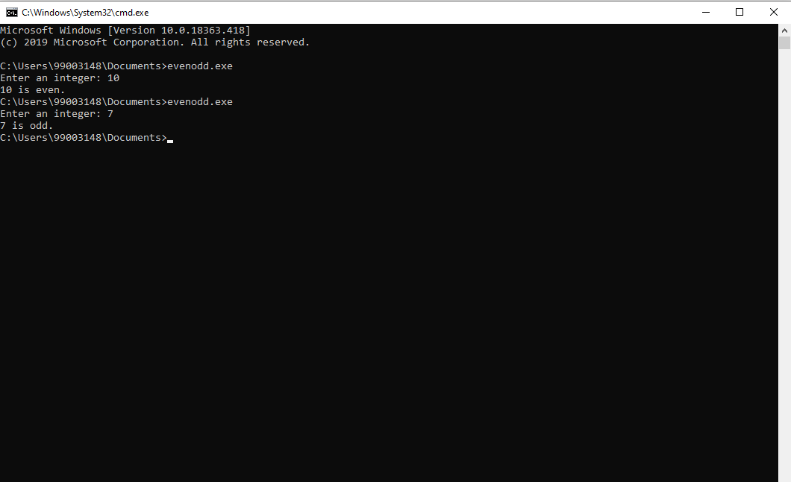

* 1. Files after execution of Make

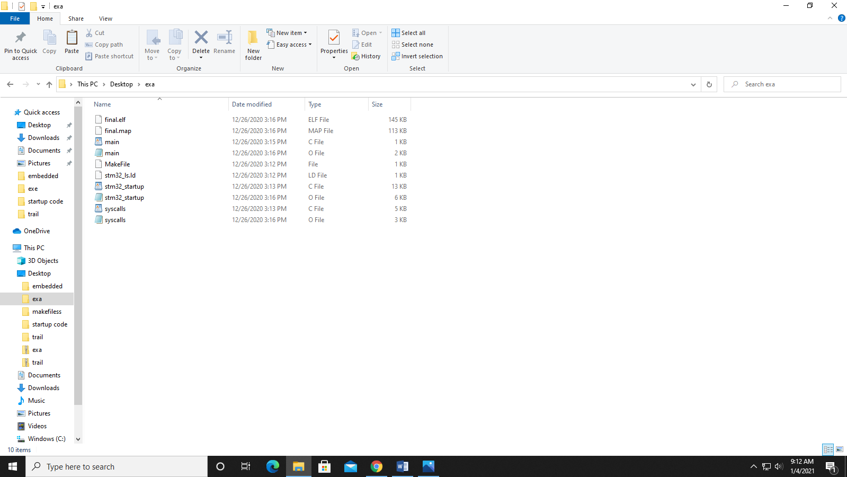

* 1. Header section of main.o

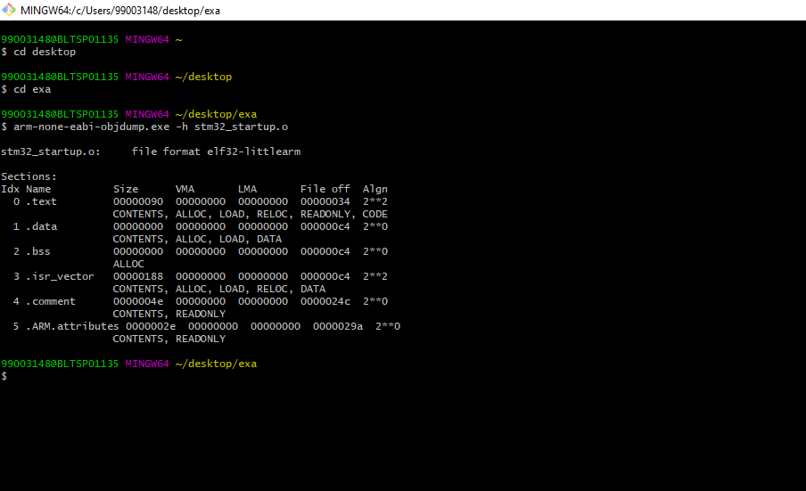

## Mini project

* 1. Main logic function

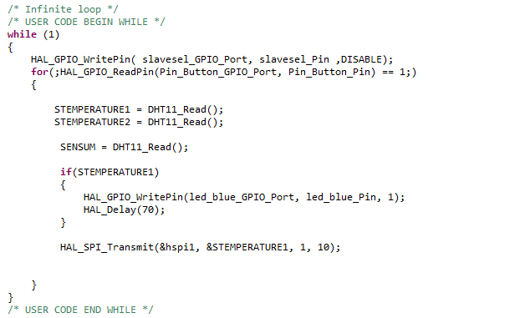

## GIT link:

<https://github.com/99003148/embeddedC.git>