**High level Design:**

**1 Structural diagram:**

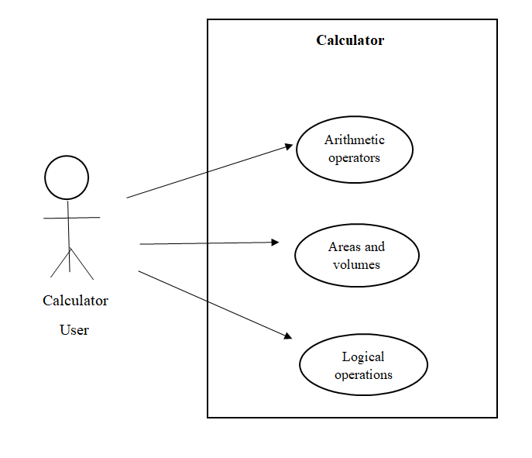

**2 Behavioural diagram:**

