./

GENESIS – Embedded C Hardware Programming



|  |  |  |  |  |  |
| --- | --- | --- | --- | --- | --- |
| **Ver. Rel. No.** | **Release Date** | **Prepared. By** | **Reviewed By** | **To be Approved** | **Remarks/Revision Details** |
| 1.0 | 02/01/2021 | Chaitanya P |  |  |  |
|  |  |  |  |  |  |
|  |  |  |  |  |  |
|  |  |  |  |  |  |
|  |  |  |  |  |  |

**Details**

Contents

1 Contents 3

2 ACTIVITY 1: PERFORM BUILD USING GIT BASH 3

2.1 MAIN FILE 4

3 ACTIVITY 2: LINKER SCRIPT 4

4 ACTIVITY 3: STARTUP CODE 5

5 ACTIVITY 4: BUILD USING MAKEFILE 6

5.1 SCREENSHOT OF OUTPUT AFTER RUNNING MAKE 7

5.2 GITHUB LINK 8

6 MINIPROJECT 8

6.1 SCREENSHOT OF CODE IMPLEMENTATION 9

6.2 GITHUB LINK 10

# ACTIVITY 1: PERFORM BUILD USING GIT BASH

## MAIN FILE

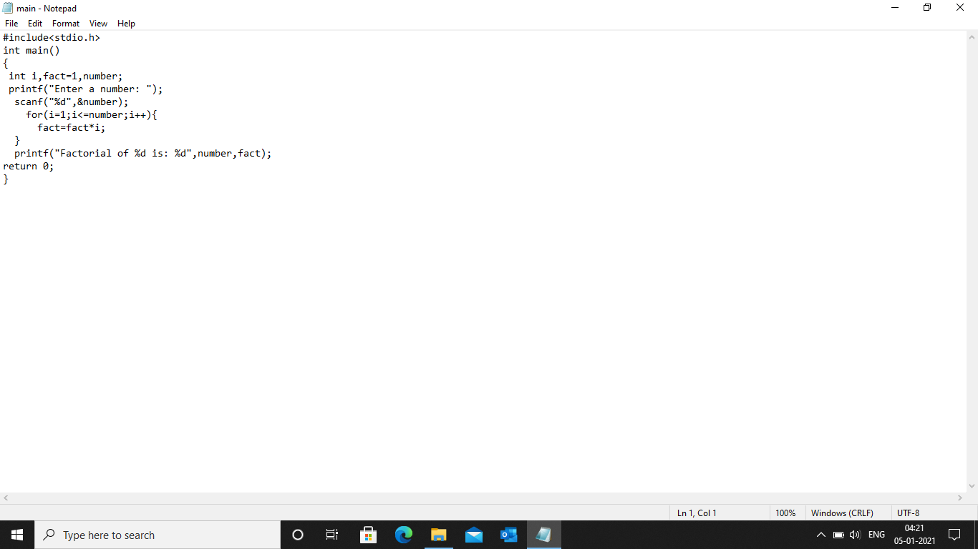

# ACTIVITY 2: LINKER SCRIPT

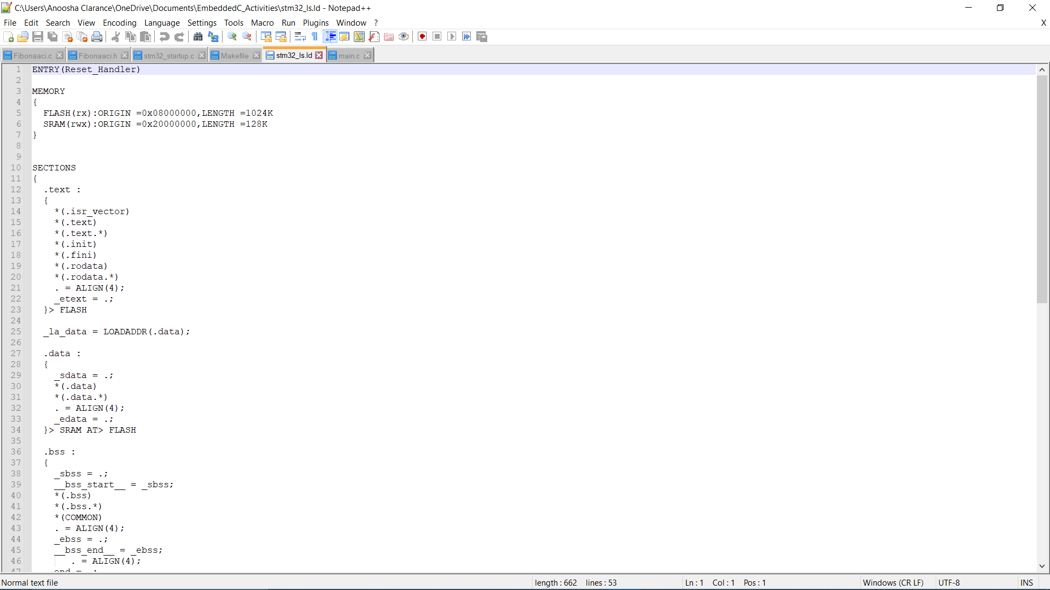

# ACTIVITY 3: STARTUP CODE

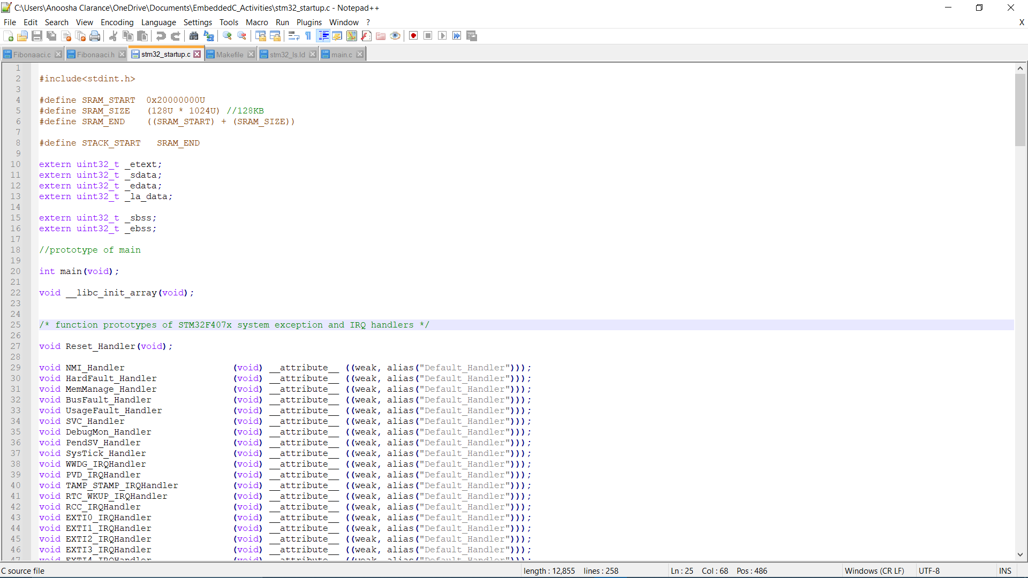

# 

# ACTIVITY 4: BUILD USING MAKEFILE

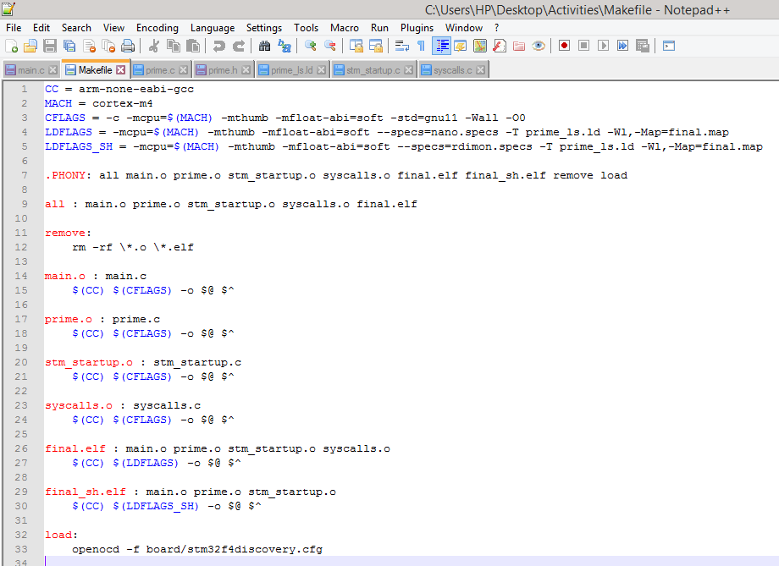

## SCREENSHOT OF OUTPUT AFTER RUNNING MAKE

v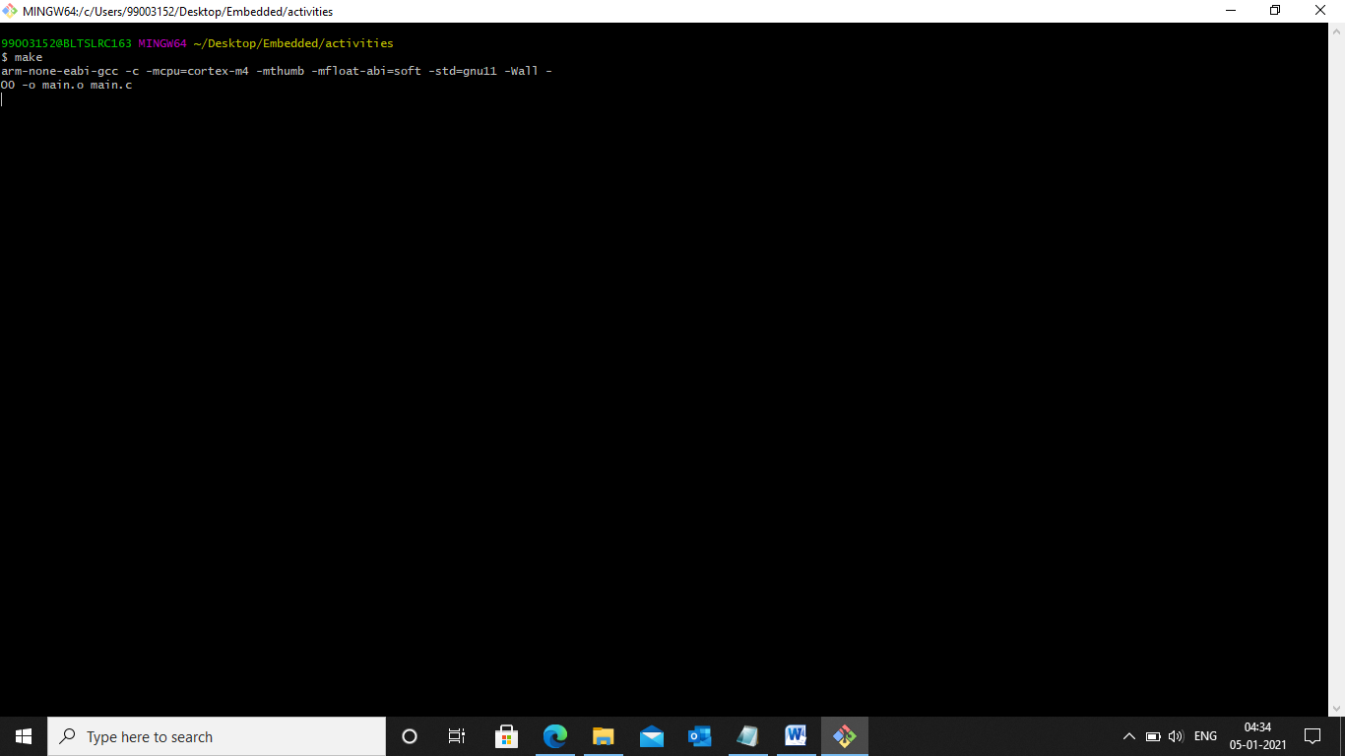

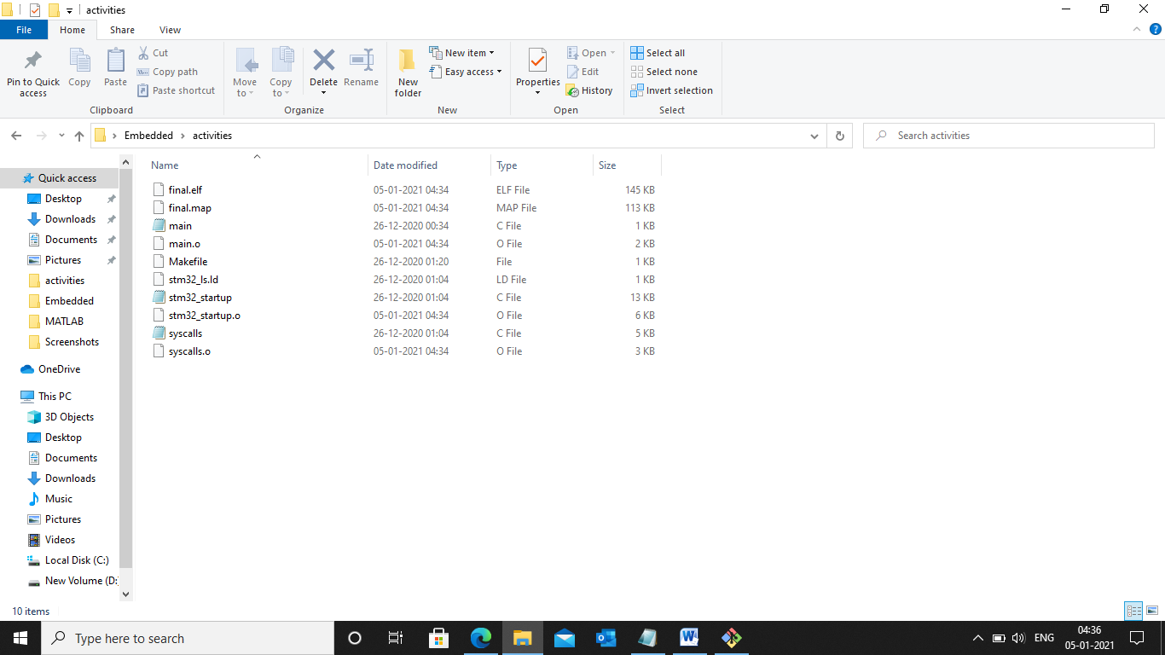

Figure 7:Files Created

## GITHUB LINK

[99003152/embedded_miniproject (github.com)](https://github.com/99003152/embedded_miniproject)

# MINIPROJECT

## SCREENSHOT OF CODE IMPLEMENTATION

Figure 8:Screenshot of code implementation (STM32)

Figure 9:Screenshot of code implementation (Arduino)

## GITHUB LINK

[99003152/embedded_miniproject (github.com)](https://github.com/99003152/embedded_miniproject)