./

Learning Report – INSURANCE MANAGEMENT SYSTEM

Course Code: <CODE>



|  |  |  |  |  |  |
| --- | --- | --- | --- | --- | --- |
| **Ver. Rel. No.** | **Release Date** | **Prepared. By** | **Reviewed By** | **Approved By** | **Remarks/Revision Details** |
| 1 | 10/10/2020 | MADHUSHREE C |  |  |  |
|  |  |  |  |  |  |
|  |  |  |  |  |  |
|  |  |  |  |  |  |
|  |  |  |  |  |  |

**Document History**

# 

**DESIGN**

**UML diagram**

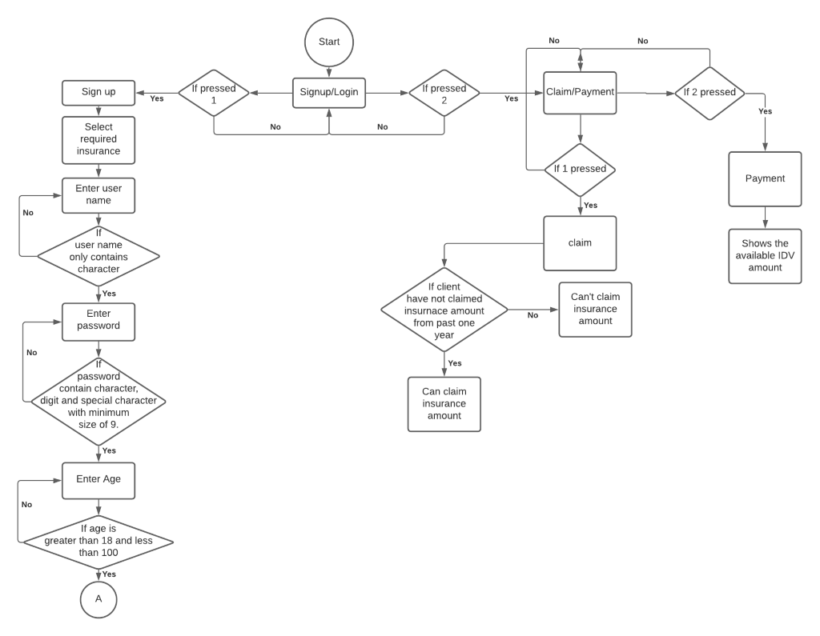

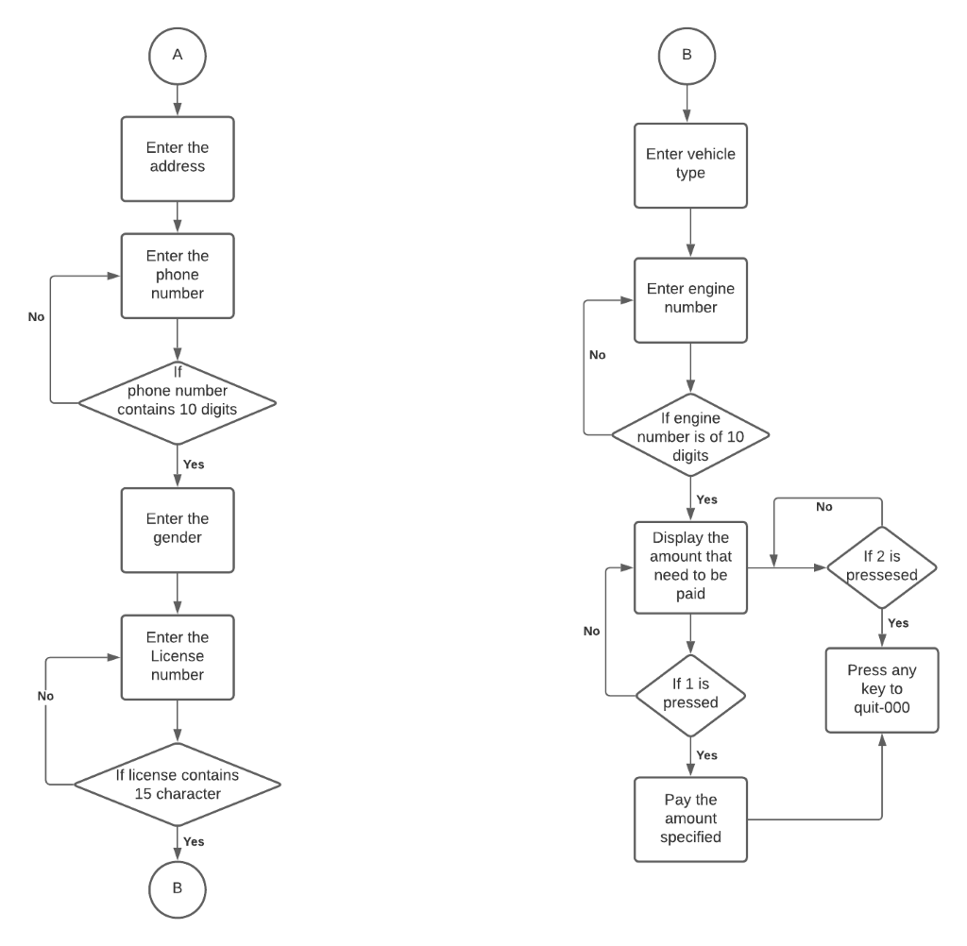

Fig 1 Activity diagram

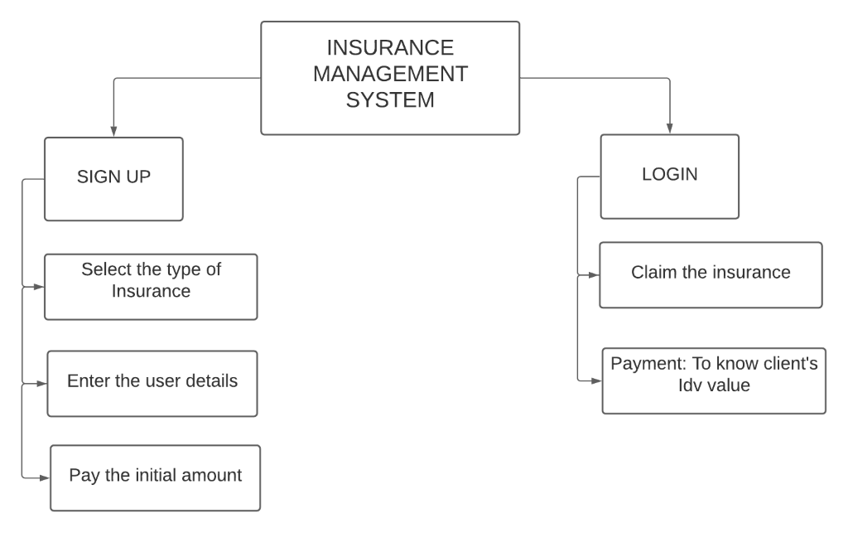

Fig 2 Structural diagram