**Requirements**

State of the art:

|  |  |  |
| --- | --- | --- |
|  | Existing Calculator | Scientific Calculator |
| Medical Application | No functions are present that can be used in medical field | Functions like BMI calculator, BP monitor and blood sugar monitor are present |
| Conversion Application | No unit conversion functions are present | Unit conversion functions like pound to kg, mile to km are present |
| Cost Analysis | Provides lesser functions | Provides numerous functions at the same rate |

4W1H: 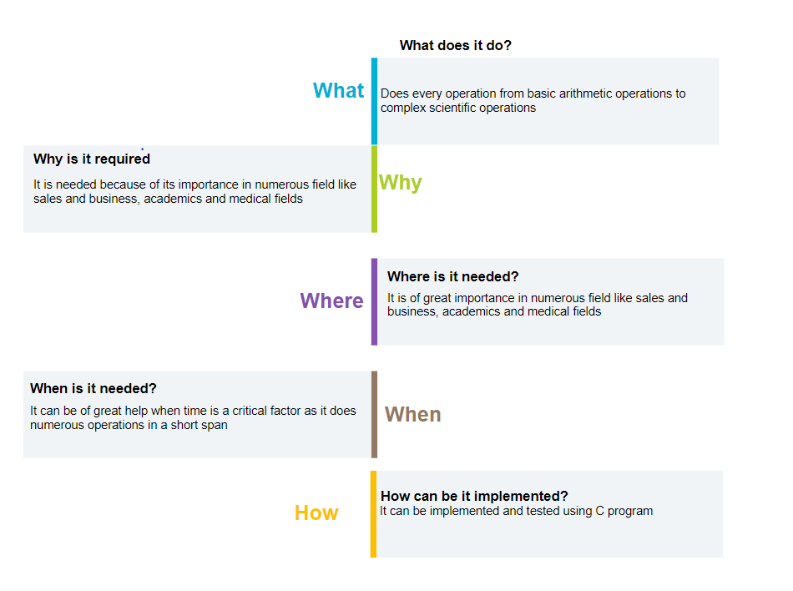

SWOT Analysis:

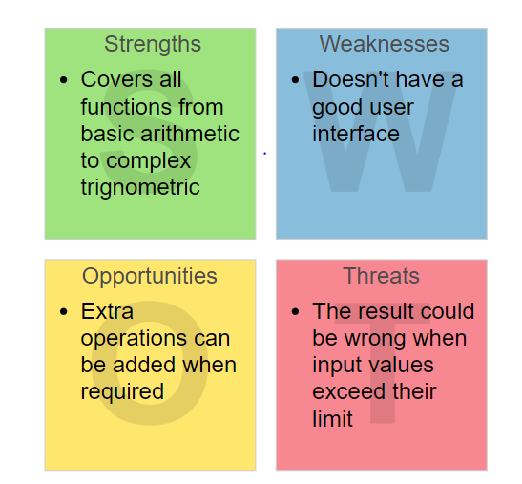

Requirement analysis:

|  |  |  |
| --- | --- | --- |
| Requirement ID | High Level Requirement | Low Level Requirement |
| HL_1 | Arithmetic functions | Addition, Subtraction, Multiplication, Division, Modulo-division, Factorial, IsPrime, IsEvenOdd, Square, Cube, Power |
| HL_2 | Scientific functions | Sin, Cos, Tan, Sinh, Cosh, Tanh, Right Shift, Left Shift, Bit_and, Bit_or, Bit_exor, Bit_complement, Pythogoras |
| HL_3 | Medical functions | BMI calculator, Blood sugar monitor, Blood pressure monitor, BPM monitor, Age calculator |
| HL_4 | Conversion functions | Pound to Kg, Mile to km, Celsius to Fahrenheit, Inch to cm |