Design:

High level design:

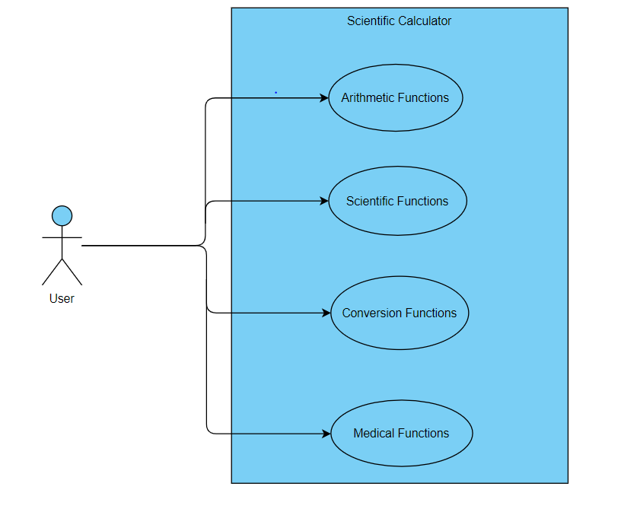

Fig : Behavioural - Use case diagram

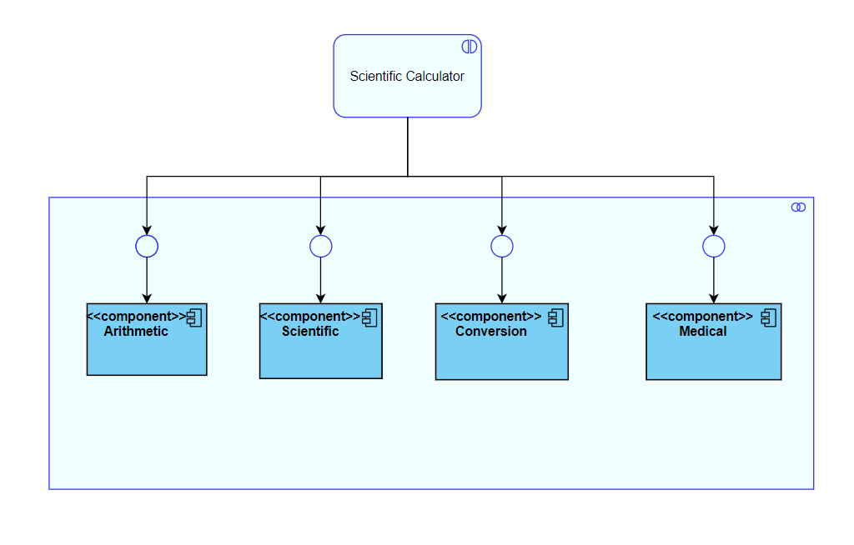

Fig :Structural - Component diagram

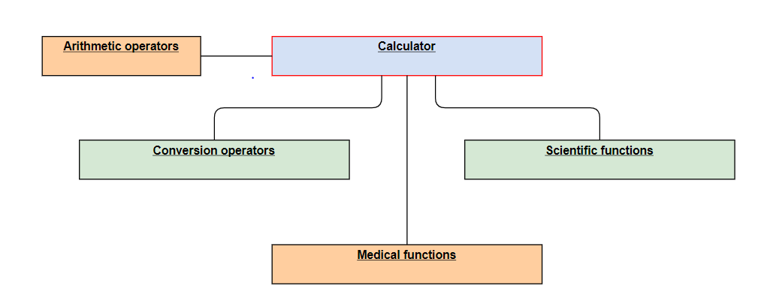

Fig : Structural - Deployment diagram

Low Level Design:

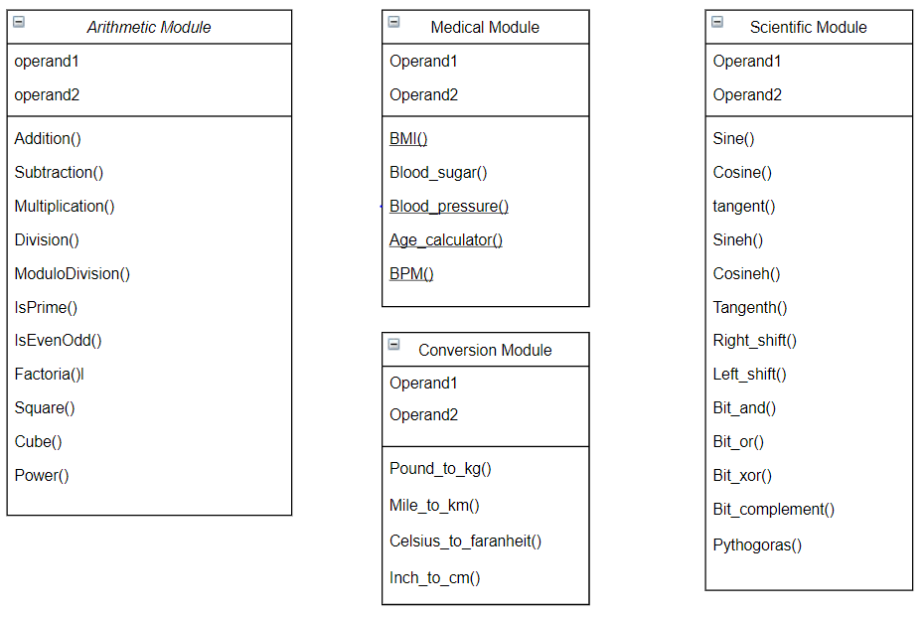

Fig : Structural - Class diagram

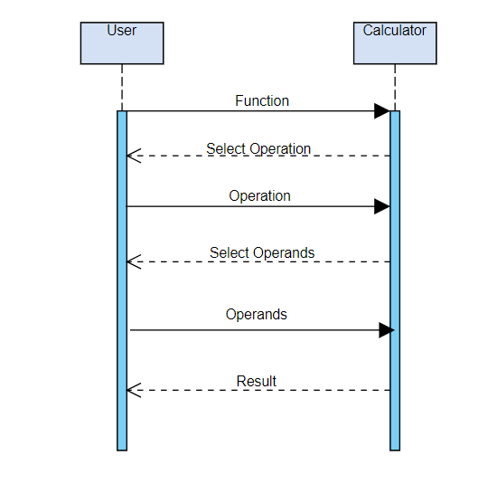

Fig : Behavioural - Sequence diagram

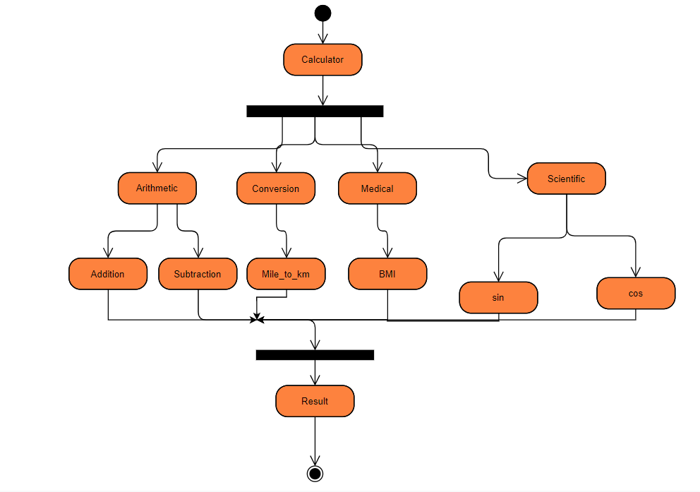

Fig : Behavioural - Activity diagram