./

Learning Report – Embedded C – Hardware + Programming + Testing



|  |  |  |  |  |  |
| --- | --- | --- | --- | --- | --- |
| **Ver. Rel. No.** | **Release Date** | **Prepared. By** | **Reviewed By** | **To be Approved** | **Remarks/Revision Details** |
| 1.0 | 29/12/2020 | SHREYA KORI |  |  |  |
| 1.1 | 03/01/2021 | SHREYA KORI |  |  |  |
|  |  |  |  |  |  |
|  |  |  |  |  |  |
|  |  |  |  |  |  |

**Details**

Table of Contents

Table of Contents 3

1. ACTIVITY 1: BUILD PROCESS 4

**1.1. main.c 4**

2. ACTIVITY 2: LINKER SCRIPT 6

3. ACTIVITY 3: HEADER FILE 7

**3.1 MCU- Specific Header File 7**

**3.2 GPIO-Specific Header File 10**

**3.3 Source File: 12**

4. ACTIVITY 4: 17

**GITHUB LINK: https://github.com/99003163/Embedded_C 17**

REFEERENCES: 17

# ACTIVITY 1: BUILD PROCESS

## **main.c**

#include<stdio.h>

int main()

{

int num1=5;

int num2=10;

int addition;

addition = num1+num2;

printf("the sum is :",addition);

return 0;

}

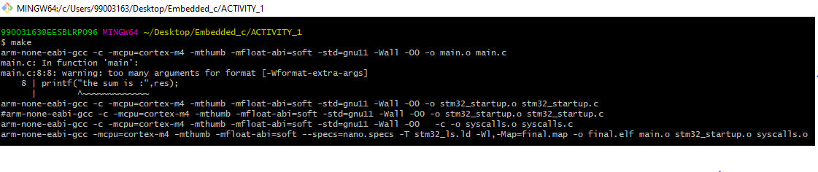

**Fig. 1: Make using GIT Bash**

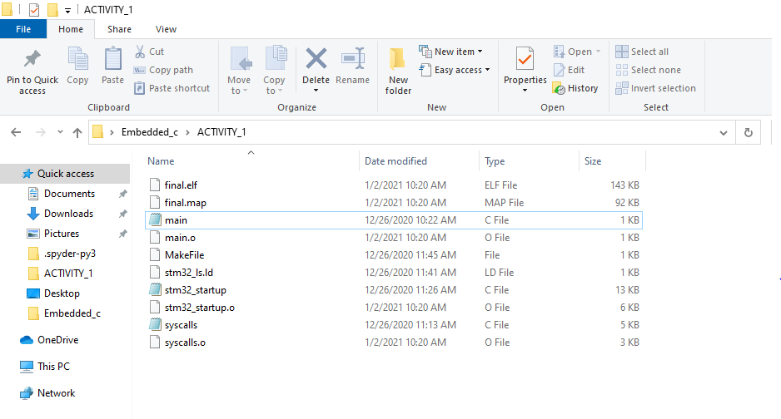

**Fig. 2: Activity Folder**

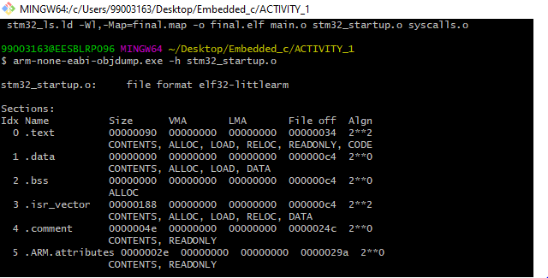

**Fig. 3: Memory Organization**

# ACTIVITY 2: LINKER SCRIPT

ENTRY(Reset_Handler)

MEMORY

{

FLASH(rx):ORIGIN =0x08000000,LENGTH =1024K

SRAM(rwx):ORIGIN =0x20000000,LENGTH =128K

}

SECTIONS

{

.text :

{

*(.isr_vector)

*(.text)

*(.text.*)

*(.init)

*(.fini)

*(.rodata)

*(.rodata.*)

. = ALIGN(4);

_etext = .;

}> FLASH

_la_data = LOADADDR(.data);

.data :

{

_sdata = .;

*(.data)

*(.data.*)

. = ALIGN(4);

_edata = .;

}> SRAM AT> FLASH

.bss :

{

_sbss = .;

__bss_start__ = _sbss;

*(.bss)

*(.bss.*)

*(COMMON)

. = ALIGN(4);

_ebss = .;

__bss_end__ = _ebss;

. = ALIGN(4);

end = .;

__end__ = .;

}> SRAM

}

# ACTIVITY 3: HEADER FILE

## **3.1 MCU- Specific Header File**

**#include** <stdint.h>

**#ifndef** INC_STM32F4XX_H_

**#define** INC_STM32F4XX_H_

**#define** __vo **volatile**

/* other definitions*/

**#define** ENABLE 1

**#define** DISABLE 0

**#define** GPIO_PIN_SET ENABLE

**#define** GPIO_PIN_RESET DISABLE

/* Defining macros for the various memory */

**#define** FLASH_ADDR 0x80000000U

**#define** SRAM1_ADDR 0x20000000U

**#define** SRAM2_ADDR 0x2001C000U

**#define** ROM_ADDR 0X1FFF0000U

**#define** SRAM_ADDR SRAM1_ADDR

/* Defining macros for bus system */

**#define** AHB1_ADDR 0x40020000U

**#define** AHB2_ADDR 0x50000000U

**#define** APB1_ADDR 0x40000000U

**#define** APB2_ADDR 0x40010000U

**#define** PERI_ADDR APB1_ADDR

/* Defining macros for peripherals hanging on AHB1 Bus */

**#define** GPIOA_ADDR (AHB1_ADDR + 0x0000U)

**#define** GPIOB_ADDR (AHB1_ADDR + 0x0400U)

**#define** GPIOC_ADDR (AHB1_ADDR + 0x0800U)

**#define** GPIOD_ADDR (AHB1_ADDR + 0x0C00U)

**#define** GPIOE_ADDR (AHB1_ADDR + 0x1000U)

**#define** GPIOF_ADDR (AHB1_ADDR + 0x1400U)

**#define** GPIOG_ADDR (AHB1_ADDR + 0x1800U)

**#define** GPIOH_ADDR (AHB1_ADDR + 0x1C00U)

**#define** GPIOI_ADDR (AHB1_ADDR + 0x2000U)

**#define** RCC_ADDR (AHB1_ADDR + 0x3800U)

/*Defining the macros for peripherals which are hanging on to APB1 bus*/

**#define** SPI2_I2S2_ADDR (APB1_ADDR + 0X3800U)

**#define** SPI3_I2S3_ADDR (APB1_ADDR + 0X3C00U)

**#define** USART2_ADDR (APB1_ADDR + 0X4400U)

**#define** USART3_ADDR (APB1_ADDR + 0X4800U)

**#define** UART4_ADDR (APB1_ADDR + 0X4C00U)

**#define** UART5_ADDR (APB1_ADDR + 0X5000U)

**#define** I2C1_ADDR (APB1_ADDR + 0X5400U)

**#define** I2C2_ADDR (APB1_ADDR + 0X5800U)

**#define** I2C3_ADDR (APB1_ADDR + 0X5C00U)

**#define** CAN1_ADDR (APB1_ADDR + 0X6400U)

**#define** CAN2_ADDR (APB1_ADDR + 0X6800U)

/*Defining the macros for peripherals which are hanging on to APB2 bus*/

**#define** USART1_ADDR (APB2_ADDR + 0X1000U)

**#define** USART6_ADDR (APB2_ADDR + 0X1400U)

**#define** SPI1_ADDR (APB2_ADDR + 0X3000U)

**#define** RCC ((RCC_GPIO_Reg_def_t*)RCC_ADDR)

/* GPIO Peripheral Registers */

**typedef** **struct**

{

uint32_t MODER;

uint32_t OTYPER;

uint32_t OSPEEDR;

uint32_t PUPDR;

uint32_t IDR;

uint32_t ODR;

uint32_t BSRR;

uint32_t LCKR;

uint32_t AFR[2]; //AFRL[0](Low Register) & AFRH[1](High Register)

}GPIO_Reg_def_t;

/* RCC Registers*/

**typedef** **struct**

{

__vo uint32_t RCC_CR;

__vo uint32_t RCC_PLLCFGR;

__vo uint32_t RCC_CFGR;

__vo uint32_t RCC_CIR;

__vo uint32_t RCC_AHB1RSTR;

__vo uint32_t RCC_AHB2RSTR;

__vo uint32_t RCC_AHB3RSTR;

uint32_t RESERVED0;

__vo uint32_t RCC_APB1RSTR;

__vo uint32_t RCC_APB2RSTR;

uint32_t RESERVED1[2];

__vo uint32_t RCC_AHB1ENR;

__vo uint32_t RCC_AHB2ENR;

uint32_t RESERVED2[2];

__vo uint32_t RCC_AHB3ENR;

__vo uint32_t RCC_APB1ENR;

__vo uint32_t RCC_APB2ENR;

__vo uint32_t RCC_AHB1LPENR;

__vo uint32_t RCC_AHB2LPENR;

__vo uint32_t RCC_AHB3LPENR;

__vo uint32_t RCC_APB1LPENR;

__vo uint32_t RCC_APB2LPENR;

__vo uint32_t RCC_BDCR;

__vo uint32_t RCC_CSR;

__vo uint32_t RCC_SSCGR;

__vo uint32_t RCC_PLLI2SCFGR;

__vo uint32_t RCC_PLLSAICFGR;

__vo uint32_t RCC_DCKCFGR;

} RCC_GPIO_Reg_def_t;

/* GPIO Clock Enable */

**#define** GPIOA_PE_CLOCK_ENABLE() RCC->RCC_AHB1ENR |= 1<<0

**#define** GPIOB_PE_CLOCK_ENABLE() RCC->RCC_AHB1ENR |= 1<<1

**#define** GPIOC_PE_CLOCK_ENABLE() RCC->RCC_AHB1ENR |= 1<<2

**#define** GPIOD_PE_CLOCK_ENABLE() RCC->RCC_AHB1ENR |= 1<<3

**#define** GPIOE_PE_CLOCK_ENABLE() RCC->RCC_AHB1ENR |= 1<<4

**#define** GPIOF_PE_CLOCK_ENABLE() RCC->RCC_AHB1ENR |= 1<<5

**#define** GPIOG_PE_CLOCK_ENABLE() RCC->RCC_AHB1ENR |= 1<<6

**#define** GPIOH_PE_CLOCK_ENABLE() RCC->RCC_AHB1ENR |= 1<<7

**#define** GPIOI_PE_CLOCK_ENABLE() RCC->RCC_AHB1ENR |= 1<<8

/* GPIO Clock Disable

#define GPIOA_PE_CLOCK_DISABLE() RCC->RCC_AHB1ENR &= ~(1<<0)

#define GPIOB_PE_CLOCK_DISABLE() RCC->RCC_AHB1ENR &= ~(1<<0)

#define GPIOC_PE_CLOCK_DISABLE() RCC->RCC_AHB1ENR &= ~(1<<0)

#define GPIOD_PE_CLOCK_DISABLE() RCC->RCC_AHB1ENR &= ~(1<<0)

#define GPIOE_PE_CLOCK_DISABLE() RCC->RCC_AHB1ENR &= ~(1<<0)

#define GPIOF_PE_CLOCK_DISABLE() RCC->RCC_AHB1ENR &= ~(1<<0)

#define GPIOG_PE_CLOCK_DISABLE() RCC->RCC_AHB1ENR &= ~(1<<0)

#define GPIOH_PE_CLOCK_DISABLE() RCC->RCC_AHB1ENR &= ~(1<<0)

#define GPIOI_PE_CLOCK_DISABLE() RCC->RCC_AHB1ENR &= ~(1<<0)*/

/* GPIO Clock Reset */

**#define** GPIOA_PE_CLOCK_RESET() **do**{RCC->RCC_AHB1RSTR |= (1<<0);RCC->RCC_AHB1RSTR &= ~(1<<0);}**while**(DISABLE)

**#define** GPIOB_PE_CLOCK_RESET() **do**{RCC->RCC_AHB1RSTR |= (1<<1);RCC->RCC_AHB1RSTR &= ~(1<<1);}**while**(DISABLE)

**#define** GPIOC_PE_CLOCK_RESET() **do**{RCC->RCC_AHB1RSTR |= (1<<2);RCC->RCC_AHB1RSTR &= ~(1<<2);}**while**(DISABLE)

**#define** GPIOD_PE_CLOCK_RESET() **do**{RCC->RCC_AHB1RSTR |= (1<<3);RCC->RCC_AHB1RSTR &= ~(1<<3);}**while**(DISABLE)

**#define** GPIOE_PE_CLOCK_RESET() **do**{RCC->RCC_AHB1RSTR |= (1<<4);RCC->RCC_AHB1RSTR &= ~(1<<4);}**while**(DISABLE)

**#define** GPIOF_PE_CLOCK_RESET() **do**{RCC->RCC_AHB1RSTR |= (1<<5);RCC->RCC_AHB1RSTR &= ~(1<<5);}**while**(DISABLE)

**#define** GPIOG_PE_CLOCK_RESET() **do**{RCC->RCC_AHB1RSTR |= (1<<6);RCC->RCC_AHB1RSTR &= ~(1<<6);}**while**(DISABLE)

**#define** GPIOH_PE_CLOCK_RESET() **do**{RCC->RCC_AHB1RSTR |= (1<<7);RCC->RCC_AHB1RSTR &= ~(1<<7);}**while**(DISABLE)

**#define** GPIOI_PE_CLOCK_RESET() **do**{RCC->RCC_AHB1RSTR |= (1<<8);RCC->RCC_AHB1RSTR &= ~(1<<8);}**while**(DISABLE)

/* GPIO Peripheral */

**#define** GPIOA ((GPIO_Reg_def_t*)GPIOA_ADDR)

**#define** GPIOB ((GPIO_Reg_def_t*)GPIOB_ADDR)

**#define** GPIOC ((GPIO_Reg_def_t*)GPIOC_ADDR)

**#define** GPIOD ((GPIO_Reg_def_t*)GPIOD_ADDR)

**#define** GPIOE ((GPIO_Reg_def_t*)GPIOE_ADDR)

**#define** GPIOF ((GPIO_Reg_def_t*)GPIOF_ADDR)

**#define** GPIOG ((GPIO_Reg_def_t*)GPIOG_ADDR)

**#define** GPIOH ((GPIO_Reg_def_t*)GPIOH_ADDR)

**#define** GPIOI ((GPIO_Reg_def_t*)GPIOI_ADDR)

**#endif** /* INC_STM32F4XX_H_ */

## **3.2 GPIO-Specific Header File**

**#include** "stm32f4xx.h"

**#ifndef** INC_STM32F4XX_GPIO_DRIVER_H_

**#define** INC_STM32F4XX_GPIO_DRIVER_H_

/* GPIO Pin Configuration*/

**typedef** **struct**

{

uint8_t GPIO_Pin_Number;

uint8_t GPIO_PinMode;

uint8_t GPIO_Pin_Speed;

uint8_t GPIO_Pin_PuPd_Control;

uint8_t GPIO_Pin_OP_Type;

uint8_t GPIO_Pin_Alt_Fun_Mode;

}GPIO_PIN_CONFIG_T;

/* GPIO Handle Structure */

**typedef** **struct**

{

GPIO_Reg_def_t *pGPIOx;

GPIO_PIN_CONFIG_T PIN_CONFIG;

}GPIO_HANDLE_T;

/* GPIO pin numbering */

**#define** GPIO_PIN_NUMBER_0 0

**#define** GPIO_PIN_NUMBER_1 1

**#define** GPIO_PIN_NUMBER_2 2

**#define** GPIO_PIN_NUMBER_3 3

**#define** GPIO_PIN_NUMBER_4 4

**#define** GPIO_PIN_NUMBER_5 5

**#define** GPIO_PIN_NUMBER_6 6

**#define** GPIO_PIN_NUMBER_7 7

**#define** GPIO_PIN_NUMBER_8 8

**#define** GPIO_PIN_NUMBER_9 9

**#define** GPIO_PIN_NUMBER_10 10

**#define** GPIO_PIN_NUMBER_11 11

**#define** GPIO_PIN_NUMBER_12 12

**#define** GPIO_PIN_NUMBER_13 13

**#define** GPIO_PIN_NUMBER_14 14

**#define** GPIO_PIN_NUMBER_15 15

/* GPIO Operating Modes */

**#define** GPIO_PIN_MODE_IN 0

**#define** GPIO_PIN_MODE_OUT 1

**#define** GPIO_PIN_MODE_ALT 2

**#define** GPIO_PIN_MODE_ANALOG 3

**#define** GPIO_PIN_MODE_RT 4

**#define** GPIO_PIN_MODE_FT 5

**#define** GPIO_PIN_MODE_RFT 6

/* GPIO pin possible output speeds*/

**#define** GPIO_PIN_SPEED_LOW 0

**#define** GPIO_PIN_SPEED_MEDIUM 1

**#define** GPIO_PIN_SPEED_FAST 2

**#define** GPIO_PIN_SPEED_HIGH 3

/* GPIO*/

**#define** GPIO_PIN_PUPD_CONTROL_0 0

**#define** GPIO_PIN_PUPD_CONTROL_1 1

**#define** GPIO_PIN_PUPD_CONTROL_2 2

**#define** GPIO_PIN_PUPD_CONTROL_3 3

/* GPIO Pin Output Types */

**#define** GPIO_OP_TYPE_PP 0

**#define** GPIO_OP_TYPE_OD 1

/* GPIO pin pull up and pull down configuration */

**#define** GPIO_NO_PUPD 0

**#define** GPIO_PIN_PU 1

**#define** GPIO_PIN_PD 2

**void** **GPIO_PeriClockControl**(GPIO_Reg_def_t *pGPIOx,uint8_t EnorDi);

**void** **GPIO_Init**(GPIO_HANDLE_T *pGPIOHandle);

**void** **GPIO_DeInit**(GPIO_Reg_def_t *pGIOx);

uint8_t **GPIO_ReadFromInputPin**(GPIO_Reg_def_t *pGPIOx,uint8_t PinNumber);

uint16_t **GPIO_ReadFromInputPort**(GPIO_Reg_def_t *pGPIOx);

**void** **GPIO_WriteToOutputPin**(GPIO_Reg_def_t *pGPIOx,uint8_t PinNumber,uint8_t value);

**void** **GPIO_WriteToOutputPort**(GPIO_Reg_def_t *pGPIOx,uint8_t value);

**void** **GPIO_ToggleOutputPin**(GPIO_Reg_def_t *pGPIOx,uint8_t PinNumber);

**#endif** /* INC_STM32F4XX_GPIO_DRIVER_H_ */

## **Source File:**

**#include** "stm32f4XX_GPIO_driver.h"

**void** **GPIO_PeriClockControl**(GPIO_Reg_def_t *pGPIOx,uint8_t EnorDi)

{

**if**(EnorDi == ENABLE)

{

**if**(pGPIOx == GPIOA)

{

GPIOA_PE_CLOCK_ENABLE();

}

**else** **if**(pGPIOx == GPIOB)

{

GPIOB_PE_CLOCK_ENABLE();

}

**else** **if**(pGPIOx == GPIOC)

{

GPIOC_PE_CLOCK_ENABLE();

}

**else** **if**(pGPIOx == GPIOD)

{

GPIOD_PE_CLOCK_ENABLE();

}

**else** **if**(pGPIOx == GPIOE)

{

GPIOE_PE_CLOCK_ENABLE();

}

**else** **if**(pGPIOx == GPIOF)

{

GPIOF_PE_CLOCK_ENABLE();

}

**else** **if**(pGPIOx == GPIOG)

{

GPIOG_PE_CLOCK_ENABLE();

}

**else** **if**(pGPIOx == GPIOH)

{

GPIOH_PE_CLOCK_ENABLE();

}

**else** **if**(pGPIOx == GPIOI)

{

GPIOI_PE_CLOCK_ENABLE();

}

}

**else**

{

**if**(pGPIOx == GPIOA)

{

GPIOA_PE_CLOCK_RESET();

}

**else** **if**(pGPIOx == GPIOB)

{

GPIOB_PE_CLOCK_RESET();

}

**else** **if**(pGPIOx == GPIOC)

{

GPIOC_PE_CLOCK_RESET();

}

**else** **if**(pGPIOx == GPIOD)

{

GPIOD_PE_CLOCK_RESET();

}

**else** **if**(pGPIOx == GPIOE)

{

GPIOE_PE_CLOCK_RESET();

}

**else** **if**(pGPIOx == GPIOF)

{

GPIOF_PE_CLOCK_RESET();

}

**else** **if**(pGPIOx == GPIOG)

{

GPIOG_PE_CLOCK_RESET();

}

**else** **if**(pGPIOx == GPIOH)

{

GPIOH_PE_CLOCK_RESET();

}

**else** **if**(pGPIOx == GPIOI)

{

GPIOI_PE_CLOCK_RESET();

}

}

}

**void** **GPIO_Init**(GPIO_HANDLE_T *pGPIOHandle)

{

//1. configuring the mode

uint32_t temp=0;

**if**(pGPIOHandle->PIN_CONFIG.GPIO_PinMode <= GPIO_PIN_MODE_ANALOG )//non interrupt modes

{

temp = pGPIOHandle->PIN_CONFIG.GPIO_PinMode<<(2*pGPIOHandle->PIN_CONFIG.GPIO_Pin_Number);

pGPIOHandle->pGPIOx->MODER |= temp;

}

**else**

{

//interrupt mode FT, RT ,FTRT

}

//2. configuring the speed

uint32_t temp1=0;

temp1 = pGPIOHandle->PIN_CONFIG.GPIO_Pin_Speed<<(2*pGPIOHandle->PIN_CONFIG.GPIO_Pin_Number);

pGPIOHandle->pGPIOx->OSPEEDR |= temp1;

//3. configuring the pu pd control

uint32_t temp2=0;

temp2 = pGPIOHandle->PIN_CONFIG.GPIO_Pin_PuPd_Control<<(2*pGPIOHandle->PIN_CONFIG.GPIO_Pin_Number);

pGPIOHandle->pGPIOx->PUPDR |= temp2;

//4. configuring the output type

uint32_t temp3=0;

temp3 = pGPIOHandle->PIN_CONFIG.GPIO_Pin_OP_Type<<(pGPIOHandle->PIN_CONFIG.GPIO_Pin_Number);

pGPIOHandle->pGPIOx->OTYPER |= temp3;

uint32_t tempA = pGPIOHandle->PIN_CONFIG.GPIO_Pin_Number /8;

uint32_t tempB = pGPIOHandle->PIN_CONFIG.GPIO_Pin_Number %8;

pGPIOHandle->pGPIOx->AFR[tempA] |= pGPIOHandle->PIN_CONFIG.GPIO_Pin_Alt_Fun_Mode << (4*tempB);

**if**(tempA == 0)

{

**if**(tempB == 0);

}

}

**void** **GPIO_DeInit**(GPIO_Reg_def_t *pGIOx)

{

**if**(EnorDi == ENABLE)

{

**if**(pGPIOx == GPIOA)

{

GPIOA_PE_CLOCK_ENABLE();

}

**else** **if**(pGPIOx == GPIOB)

{

GPIOB_PE_CLOCK_ENABLE();

}

**else** **if**(pGPIOx == GPIOC)

{

GPIOC_PE_CLOCK_ENABLE();

}

**else** **if**(pGPIOx == GPIOD)

{

GPIOD_PE_CLOCK_ENABLE();

}

**else** **if**(pGPIOx == GPIOE)

{

GPIOE_PE_CLOCK_ENABLE();

}

**else** **if**(pGPIOx == GPIOF)

{

GPIOF_PE_CLOCK_ENABLE();

}

**else** **if**(pGPIOx == GPIOG)

{

GPIOG_PE_CLOCK_ENABLE();

}

**else** **if**(pGPIOx == GPIOH)

{

GPIOH_PE_CLOCK_ENABLE();

}

**else** **if**(pGPIOx == GPIOI)

{

GPIOI_PE_CLOCK_ENABLE();

}

}

**else**

{

**if**(pGPIOx == GPIOA)

{

GPIOA_PE_CLOCK_ENABLE();

}

**else** **if**(pGPIOx == GPIOB)

{

GPIOB_PE_CLOCK_ENABLE();

}

**else** **if**(pGPIOx == GPIOC)

{

GPIOC_PE_CLOCK_ENABLE();

}

**else** **if**(pGPIOx == GPIOD)

{

GPIOD_PE_CLOCK_ENABLE();

}

**else** **if**(pGPIOx == GPIOE)

{

GPIOE_PE_CLOCK_ENABLE();

}

**else** **if**(pGPIOx == GPIOF)

{

GPIOF_PE_CLOCK_ENABLE();

}

**else** **if**(pGPIOx == GPIOG)

{

GPIOG_PE_CLOCK_ENABLE();

}

**else** **if**(pGPIOx == GPIOH)

{

GPIOH_PE_CLOCK_ENABLE();

}

**else** **if**(pGPIOx == GPIOI)

{

GPIOI_PE_CLOCK_ENABLE();

}// To be done

}

}

uint8_t **GPIO_ReadFromInputPin**(GPIO_Reg_def_t *pGPIOx,uint8_t PinNumber)

{

uint8_t value;

value = (uint8_t)((pGPIOx->IDR >> PinNumber) * (0x00000001));

**return** value;

}

uint16_t **GPIO_ReadFromInputPort**(GPIO_Reg_def_t *pGPIOx)

{

uint16_t value;

value = (uint16_t)(pGPIOx->IDR);

**return** value;

}

**void** **GPIO_WriteToOutputPin**(GPIO_Reg_def_t *pGPIOx,uint8_t PinNumber,uint8_t value)

{

**if**(value == GPIO_PIN_SET)

{

pGPIOx->ODR |= (1 << PinNumber);

}

**else**

{

pGPIOx->ODR &= ~(1 << PinNumber);

}

}

**void** **GPIO_WriteToOutputPort**(GPIO_Reg_def_t *pGPIOx,uint8_t value)

{

pGPIOx->ODR = value;

}

**void** **GPIO_ToggleOutputPin**(GPIO_Reg_def_t *pGPIOx,uint8_t PinNumber)

{

pGPIOx->ODR ^= (1<<PinNumber);

}

# ACTIVITY 4:

## **GITHUB LINK:** <https://github.com/99003163/Embedded_C>

## **LOGIC CODE**

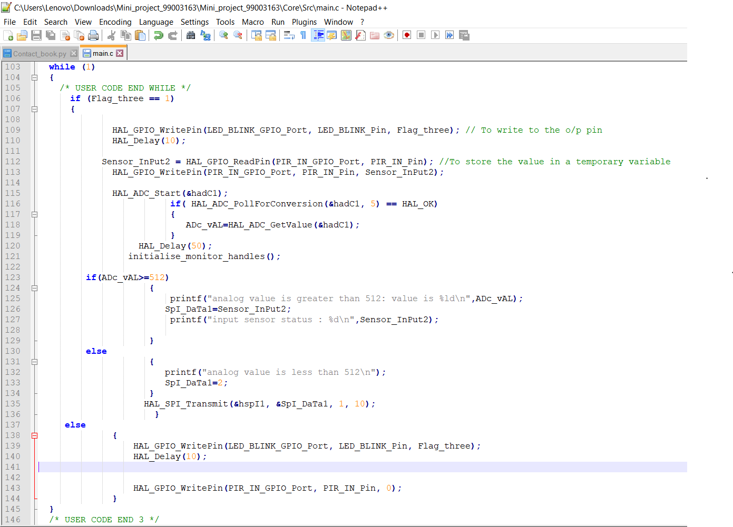

## **ARDUINO CODE**

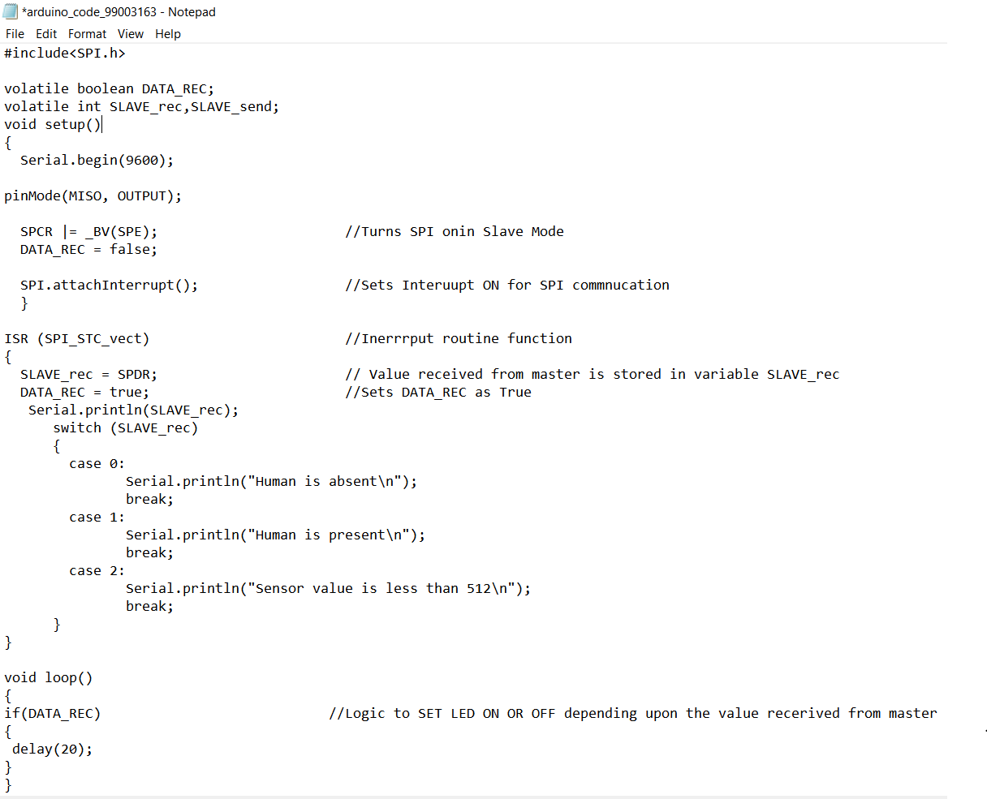

# REFEERENCES:

[1]. <http://web.cs.iastate.edu/~smkautz/cs227s13/labs/lab6/page04.html>

[2]. <https://youtu.be/2Hm8eEHsgls>

[3].<https://youtu.be/Bsq6P1B8JqI>