

GENESIS – Applied SDLC and Software Testing Learning Report

./

GENESIS - Learning Outcome & Mini-project Summary Report

Document History

|  |  |  |  |  |  |
| --- | --- | --- | --- | --- | --- |
| **Ver. Rel.**  **No.** | **Release Date** | **Prepared. By** | **Reviewed By** | **Approved By** | **Remarks/Revision Details** |
| 1.0 | 07th Dec 2020 | Trupthi B  Shreya Kori Mehulkumar P Jain |  |  |  |
| 1.1 |  |  |  |  |  |
| 1.2 |  |  |  |  |  |
|  |  |  |  |  |  |
|  |  |  |  |  |  |

Contents

Requirements of the project 6

1.1 Requirements ………………………………………………………………………………………………………... 6

1.1.1 High Level Requirements 6

1.1.2 Low Level Requirements 6

1.2 4W1H ……………………………….. 7

1.3 SWOT Analysis ………………. 7

1.4 Design of the Project 8

1.4.1 Strucrural Diagrams 8

1.4.2 Behavioral Diagrams 9

1.5 Test Plan ………………………… 11

**Table of Figures**

Fig 1.1 Class Diagram of Calculator …………………………………………………………………………………...……………… 8

Fig 1.2 Class Diagram of Scientific Calculator ………………………………………………………………………………………... 8

Fig 1.3 Component Diagram of Scientific Calculator …………………………………………………………………………………. 9

Fig 1.4 Case Diagram of Prime Function ……………………………………………………………………………………………… 9

Fig 1.5 Case Diagram of Factorial Calculator ………………………………………………………………………………………... 10

Fig 1.6 Case Diagram of Trigonometric Function …………………………………………………………………………………… 10

**List of Tables**

Table 1.1 High level requirements for scientific calculator 6

Table 1.2 Low level requirements for scientific calculator 6

Table 1.3 SWOT Analysis ……………………………………………………………………………………………………………… 7

# Requirements of the project

## Requirements

To develop a scientific calculator which has not only the arithmetic functionality but also there are other functionalities such as special functions (i.e., square root, factorial, prime, etc.), trigonometric functions and conversion functions (i.e., meter to centimeter, etc.)

### 1.1.1 High Level Requirements

Table 1.1 High level requirements for scientific calculator

|  |  |
| --- | --- |
| **ID** | **Description** |
| HL1 | Arithmetic Functions |
| HL2 | Special Function |
| HL3 | Trigonometric Functions |
| HL4 | Conversion Functions |
| HL5 | Logical Functions |

### 1.1.2 Low Level Requirements

Table 1.2 Low level requirements for scientific calculator

|  |  |
| --- | --- |
| **ID** | **Description** |
| HL1_L1 | Add |
| HL1_L2 | Subtract |
| HL1_L3 | Multiply |
| HL1_L4 | Divide |
| HL2_L1 | Nth power |
| HL2_L2 | Square |
| HL2_L3 | Factorial |
| HL2_L4 | Greater |
| HL2_L5 | Smaller |
| HL2_L6 | Prime |
| HL2_L7 | Modulus |
| HL2_L8 | Square root |
| HL3_L1 | Sine Value |
| HL3_L2 | Cos Value |
| HL3_L3 | Tan Value |
| HL4_L1 | Centimetre to meter |
| HL4_L2 | Meter to Centimetre |
| HL4_L3 | Meter to Kilometre |
| HL4_L4 | Kilometre to Meter |
| HL4_L5 | Inch to Centimetre |
| HL4_L6 | Centimetre to inch |
| HL5_L1 | AND |
| HL5_L2 | OR |
| HL5_L3 | NOT |
| HL5_L4 | NAND |
| HL5_L5 | NOR |
| HL5_L6 | XOR |
| HL5_L7 | XNOR |

## 1.2 4W1H

* What: Scientific calculator is a device used for computations like addition, subtraction etc. along with complex computations like logarithm, exponential, trigonometric etc.,
* Why: To reduce time consumption required to do computations manually.
* When: It is used when we required computations with functions which cannot be easily defined.
* Where: Complex, complicated computation is needed in in fields of aerospace, mathematics, engineering etc.,
* How: Scientific calculator can be used with the numbers along with defined functions required for the computation.

## 1.3 SWOT Analysis

Table 1.3 SWOT Analysis

|  |  |
| --- | --- |
| **Strengths**   * The scientific calculator created helps in computation of arithmetic, logical, distance conversions, trigonometric. * Special functions like factorial, power, prime numbers, modulus. | **Weakness**   * Arithmetic computation with negative numbers is not done. * Computation with floating points is not done. |
| **Opportunities**   * Program with negative numbers is can be developed. * Program for Decimal numbers computation is needed | **Threats**   * Imaginary numbers can’t be displayed * Fault results for invalid inputs |

## 1.4 Design of the Project

### 1.4.1 Strucrural Diagrams

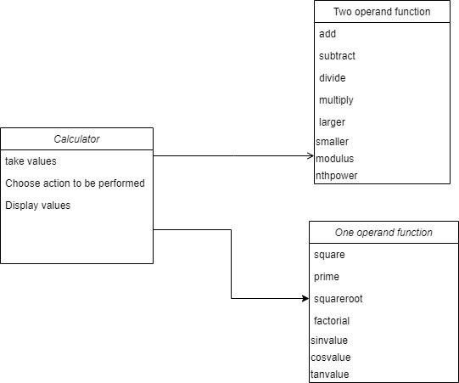

Fig 1.1 Class Diagram of Calculator

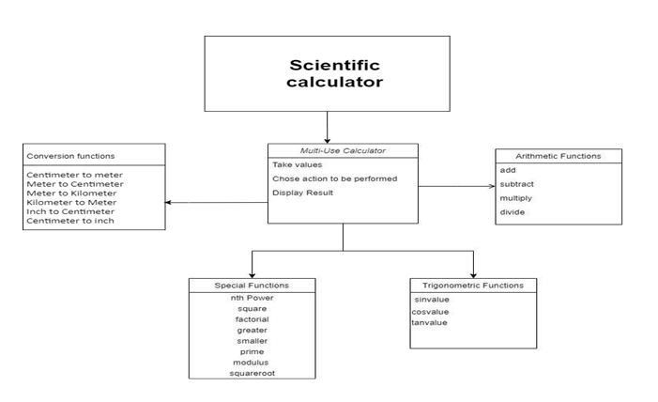

Fig 1.2 Class Diagram of Scientific Calculator

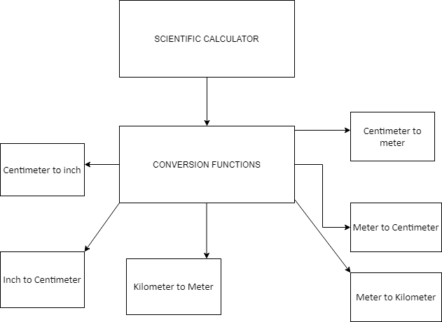

Fig 1.3 Component Diagram of Scientific Calculator

### 1.4.2 Behavioral Diagrams

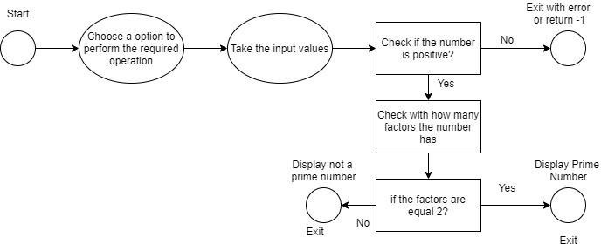

Fig 1.4 Case Diagram of Prime Function

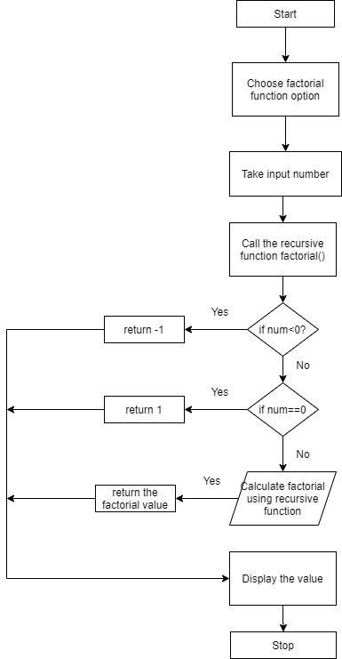

Fig 1.5 Case Diagram of Factorial Calculator

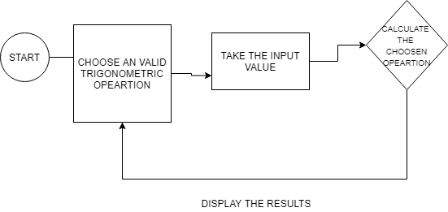

Fig 1.6 Case Diagram of Trigonometric Function

## 1.5 Test Plan

|  |  |  |  |  |  |  |  |  |  |  |
| --- | --- | --- | --- | --- | --- | --- | --- | --- | --- | --- |
| ID | Description | | | Pre-Condition | | Expected Input | Expected Output | | Actual Output | |
| HL1_L1_1 | Addition of values | | | Choose addition from all options | | Two int operands | Sum of the two operands | |  | |
| HL1_L1_2 | Addition of values | | | Choose addition from all options | | Any one int operand >= to  65535 | Error as int return value can  only give 65535 | |  | |
| HL1_L2_1 | Subtraction of values | | | Choose subtract  from all options | | Two int operands | difference of the  two operands | |  | |
| HL1_L2_2 | Subtraction of values | | | Choose subtract from all options | | Any one int operand >= to  65535 | Error as int return value can  only give 65535 | |  | |
| HL1_L3_1 | Multiplication of values | | | Choose multiply from all the  options | | Two int  operands | Product of two operands | |  | |
| HL1_L4_1 | Division of values | | | Choose divide from all the  options | | Two non-zero int operands | division of two operands | |  | |
| HL1_L4_2 | Division of values | | | Choose divide from all the  options | | Two int  operands with divisor 0 | Divide by 0 error | |  | |
| HL2_L1_1 | Nth Power | | | Choose Power from all the  options | | Two non-zero int operands | Operand1 raised to power of  operand2 | |  | |
| HL2_L1_2 | Nth Power | | | Choose Power from all the  options | | Two int operands with  operand2 =0 | Return 1 | |  | |
| HL2_L2_1 | Square | | | Choose Square from all the  options | | One int operand | Returns operand raised to power  2 | |  | |
| HL2_L3_1 | Factorial | | | Choose factorial from all the  options | | One int operand non-zero and  non-negative | Returns factorial of operand | |  | |
| HL2_L3_2 | Factorial | | | Choose factorial from all the  options | | One int operand equal to 0 | Returns 1 | |  | |
| HL2_L3_3 | Factorial | | | Choose factorial from all the  options | | One int operand negative | Error and return  -1 | |  | |
| HL2_L4_1 | Greater | | | Choose Greater from all the  options | | Two int  operands | Greater of  operand1 and operand 2 | |  | |
| HL2_L5_1 | Smaller | | | Choose Smaller  from all the options | | Two int  operands | Smaller of  operand1 and operand 2 | |  | |
| HL2_L6_1 | Prime | | | Choose prime  from all the options | | One int operand  non-zero and non-negative | Returns if prime or not | |  | |
| HL2_L6_2 | | Prime | Choose prime from all the  options | | One int operand equal to 0 or 1 | | Error and returns  -1 |  | |
| HL2_L6_3 | | Prime | Choose prime from all the  options | | One int operand negative | | Error and return  -1 |  | |
| HL2_L7_1 | | Modulus | Choose modulus from all the  options | | Two int  operands | | Returns the remainder |  | |
| HL2_L8_1 | | Square root | Choose modulus from all the  options | | One int operand | | Returns float value of square  root of operand1 |  | |
| HL3_L1_1 | | Sin Value | Choose sin value from all the  options | | One float operand | | Returns sine of operand1 in float |  | |
| HL3_L2_1 | | Cos Value | Choose cos value from all the options | | One float operand | | Returns cosine of operand1 in float |  | |
| HL3_L3_1 | | Tan Value | Choose tan value from all the  options | | One float operand not 90  degrees | | Returns sine of operand1  tangent in float |  | |
| HL3_L3_2 | | Tan Value | Choose tan value from all the  options | | One float operand equal  90 degrees | | Error as value not defined  returns -1 |  | |
| HL4_L1_1 | | Centimeter to meter | Choose CMTOM from all the options | | One float operand | | Returns value in meters in float |  | |
| HL4_L2_1 | | Meter to centimeter | Choose MTOCM from all the options | | One float operand | | Returns value in centimeters in  float |  | |
| HL4_L3_1 | | Meter to kilometer | Choose MTOKM from all the options | | One float operand | | Returns value in kilometers in  float |  | |
| HL4_L4_1 | | Kilometer to meter | Choose KMTOM from all the options | | One float operand | | Returns value in meters in float |  | |
| HL4_L5_1 | | Inch to centimeter | Choose  INCHTOM from all the options | | One float operand | | Returns value in  centimeters in float |  | |
| HL4_L6_1 | | Centimeter to inch | Choose MTOINCH from  all the options | | One float operand | | Returns value in inches in float |  | |
| HL5_L1_1 | | Logical AND | Choose AND operation from all the options | | Two int operands | | Returns AND of two values in int |  | |
| HL5_L1_2 | | Logical AND | Choose AND operation from all the options | | In two int any one operand is invalid | | Returns error as another operand is invalid |  | |
| HL5_L2_1 | | Logical OR | Choose OR operation from all the options | | Two int operands | | Returns OR of two values in int |  | |
| HL5_L2_2 | | Logical OR | Choose OR operation from all the options | | In two int any one operand is invalid | | Returns error as another operand is invalid |  | |
| HL5_L3_1 | | Logical NOT | Choose NOT operation from all the options | | int operand | | Returns NOT of int operand |  | |
| HL5_L3_2 | | Logical NOT | Choose NOT operation from all the options | | Invalis int operands | | Returns error as operand is invalid |  | |
| HL5_L4_1 | | Logical NAND | Choose NAND operation from all the options | | Two int operands | | Returns NAND of two values in int |  | |
| HL5_L4_2 | | Logical NAND | Choose NAND operation from all the options | | In two int any one operand is invalid | | Returns error as another operand is invalid |  | |
| HL5_L5_1 | | Logical NOR | Choose NOR operation from all the options | | Two int operands | | Returns NOR of two values in int |  | |
| HL5_L5_2 | | Logical NOR | Choose NOR operation from all the options | | In two int any one operand is invalid | | Returns error as another operand is invalid |  | |
| HL5_L6_1 | | Logical XOR | Choose XOR operation from all the options | | Two int operands | | Returns XOR of two values in int |  | |
| HL5_L6_2 | | Logical XOR | Choose XOR operation from all the options | | In two int any one operand is invalid | | Returns error as another operand is invalid |  | |
| HL5_L7_1 | | Logical XNOR | Choose XNOR operation from all the options | | Two int operands | | Returns XNOR of two values in int |  | |
| HL5_L7_2 | | Logical XNOR | Choose XNOR operation from all the options | | In two int any one operand is invalid | | Returns error as another operand is invalid |  | |