./

GENESIS – Embedded C Hardware Programming



|  |  |  |  |  |  |
| --- | --- | --- | --- | --- | --- |
| **Ver. Rel. No.** | **Release Date** | **Prepared. By** | **Reviewed By** | **To be Approved** | **Remarks/Revision Details** |
| 1.0 | 02/01/2021 | Lakshmi N |  |  |  |
|  |  |  |  |  |  |
|  |  |  |  |  |  |
|  |  |  |  |  |  |
|  |  |  |  |  |  |

**Details**

**Table of Contents**

[1 ACTIVITY 1: PERFORM BUILD USING GIT BASH 4](#_Toc60643023)

[1.1 PRIME.C FILE 4](#_Toc60643024)

[1.2 PRIME.H FILE 4](#_Toc60643025)

[1.3 MAIN FILE 5](#_Toc60643026)

[1.4 SCREENSHOT OF BUILD AFTER RUNNING IN GIT BASH 5](#_Toc60643027)

[2 ACTIVITY 2: LINKER SCRIPT 6](#_Toc60643028)

[3 ACTIVITY 3: STARTUP CODE 7](#_Toc60643029)

[4 ACTIVITY 4: BUILD USING MAKEFILE 8](#_Toc60643030)

[4.1 SCREENSHOT OF MAKEFILE 8](#_Toc60643031)

[4.2 SCREENSHOT OF OUTPUT AFTER RUNNING MAKE 9](#_Toc60643032)

[4.3 FILES CREATED 9](#_Toc60643033)

[4.4 GITHUB LINK 10](#_Toc60643034)

[5 MINIPROJECT 10](#_Toc60643035)

[5.1 SCREENSHOT OF CODE IMPLEMENTATION 10](#_Toc60643036)

[5.2 GITHUB LINK 12](#_Toc60643037)

**List of Figures**

[Figure 1: prime.c file 4](#_Toc60643038)

[Figure 2: prime.h file 4](file:///C:\Users\99003165\Downloads\GENESIS_Embedded_C_99003165.docx#_Toc60643039)

[Figure 3: main.c file 5](file:///C:\Users\99003165\Downloads\GENESIS_Embedded_C_99003165.docx#_Toc60643040)

[Figure 4: Git bash output 5](file:///C:\Users\99003165\Downloads\GENESIS_Embedded_C_99003165.docx#_Toc60643041)

[Figure 5: Starup code 7](#_Toc60643042)

[Figure 6: Makefile 8](file:///C:\Users\99003165\Downloads\GENESIS_Embedded_C_99003165.docx#_Toc60643043)

[Figure 7: Output in Git bash 9](file:///C:\Users\99003165\Downloads\GENESIS_Embedded_C_99003165.docx#_Toc60643044)

[Figure 8: Files Created 9](file:///C:\Users\99003165\Downloads\GENESIS_Embedded_C_99003165.docx#_Toc60643045)

[Figure 9: Screenshot of code implementation 10](file:///C:\Users\99003165\Downloads\GENESIS_Embedded_C_99003165.docx#_Toc60643046)

[Figure 10: Code in STMCUBEIDE 11](file:///C:\Users\99003165\Downloads\GENESIS_Embedded_C_99003165.docx#_Toc60643047)

[Figure 11: Arduino IDE 12](file:///C:\Users\99003165\Downloads\GENESIS_Embedded_C_99003165.docx#_Toc60643048)

# ACTIVITY 1: PERFORM BUILD USING GIT BASH

## PRIME.C FILE

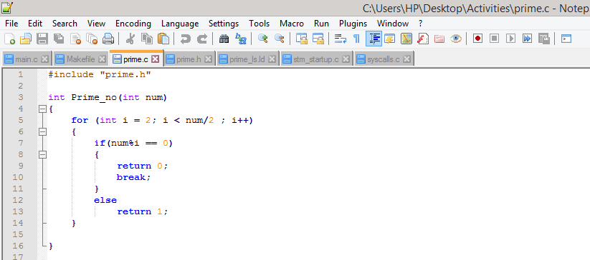

Figure 1: prime.c file

## C:\Users\HP\Desktop\Activities\Capture_H.PNGPRIME.H FILE

Figure 2: prime.h file

## MAIN FILE

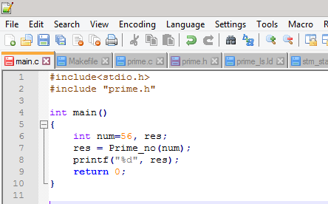

Figure 3: main.c file

## SCREENSHOT OF BUILD AFTER RUNNING IN GIT BASH

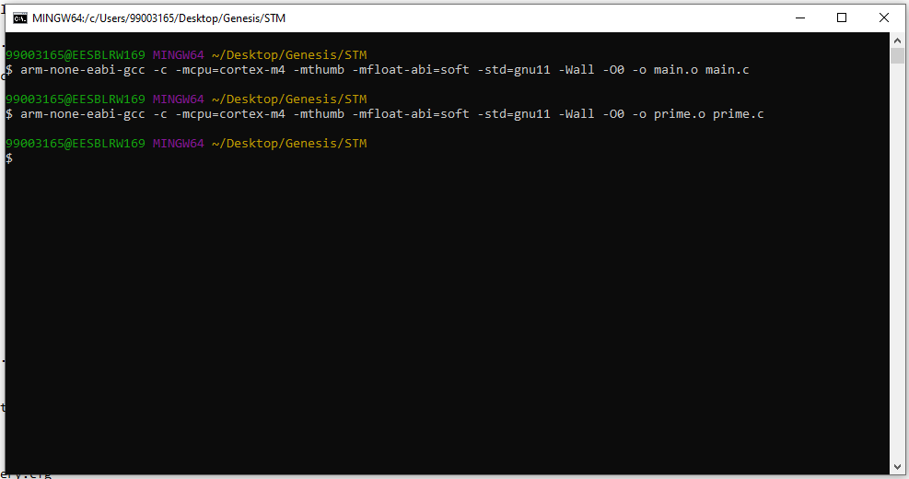

Figure 4: Git bash output

# ACTIVITY 2: LINKER SCRIPT

* The Linker Script is a text file made up of a series of Linker directives which tell the Linker where the available memory is and how it should be used.

ENTRY(Reset\_Handler)

MEMORY

{

FLASH(rx):ORIGIN =0x08000000,LENGTH =1024K

SRAM(rwx):ORIGIN =0x20000000,LENGTH =128K

}

SECTIONS

{

.text :

{

\*(.isr\_vector)

\*(.text)

\*(.text.\*)

\*(.init)

\*(.fini)

\*(.rodata)

\*(.rodata.\*)

. = ALIGN(4);

\_etext = .;

}> FLASH

\_la\_data = LOADADDR(.data);

.data :

{

\_sdata = .;

\*(.data)

\*(.data.\*)

. = ALIGN(4);

\_edata = .;

}> SRAM AT> FLASH

.bss :

{

\_sbss = .;

\_\_bss\_start\_\_ = \_sbss;

\*(.bss)

\*(.bss.\*)

\*(COMMON)

. = ALIGN(4);

\_ebss = .;

\_\_bss\_end\_\_ = \_ebss;

. = ALIGN(4);

end = .;

\_\_end\_\_ = .;

}> SRAM

}

# C:\Users\HP\Desktop\Activities\Capture_Starup.PNGACTIVITY 3: STARTUP CODE

Figure 5: Starup code

# ACTIVITY 4: BUILD USING MAKEFILE

## SCREENSHOT OF MAKEFILE

Figure 6: Makefile

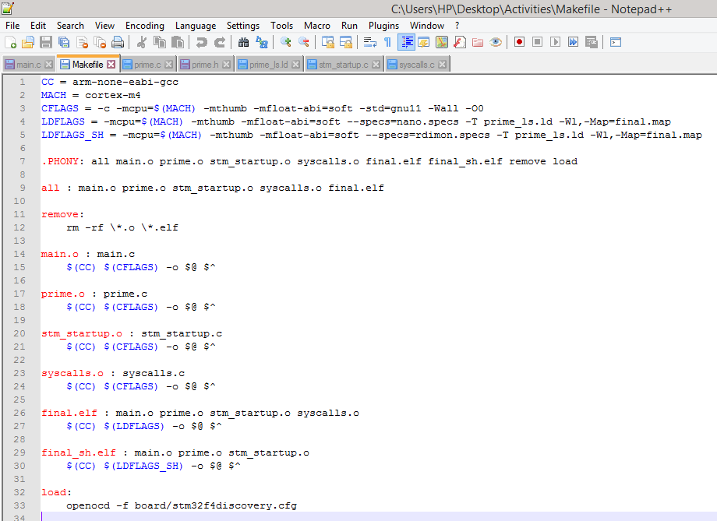

## C:\Users\HP\Desktop\Activities\Capture_make.PNGSCREENSHOT OF OUTPUT AFTER RUNNING MAKE

Figure 7: Output in Git bash

## C:\Users\HP\Desktop\Activities\Capture_Files.PNGFILES CREATED

Figure 8: Files Created

## GITHUB LINK

<https://github.com/99003165/Embedded_C/tree/master/ACTIVITIES>

# MINIPROJECT

## SCREENSHOT OF CODE IMPLEMENTATION

Figure 9: Screenshot of code implementation

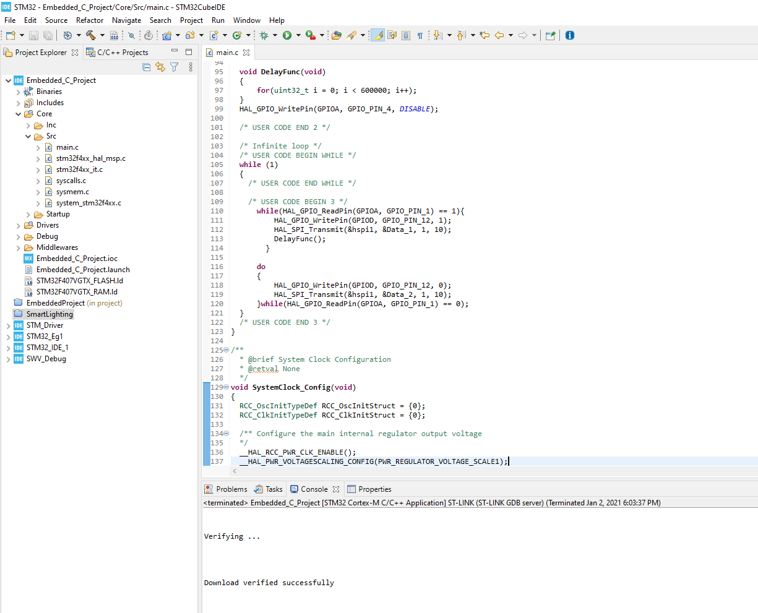

Figure : Code in STMCUBEIDE

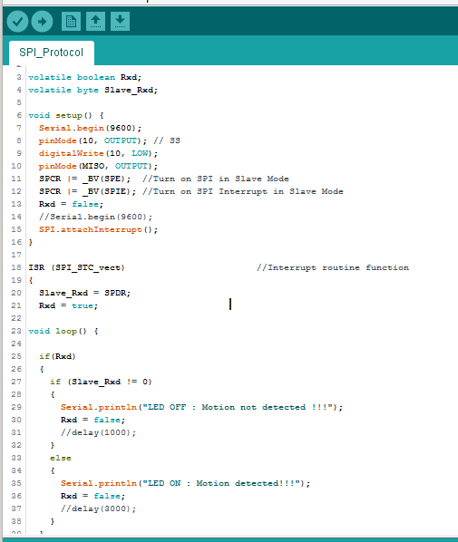

Figure 11: Arduino IDE

## GITHUB LINK

<https://github.com/99003165/Embedded_C/tree/master/STM32/Embedded_C_Project>