# Requirements

## State of the Art

A **scientific calculator** is a type of electronic calculator, usually but not always handheld, designed to calculate problems in science, engineering, and mathematics. They have completely replaced slide rules in traditional applications, and are widely used in both education and professional settings.

In certain context such as higher education, scientific calculators have been superseded by graphing calculators, which offer a superset of scientific calculator functionality along with the ability to graph input data and write and store programs for the device. There is also some overlap with the financial calculator market.

### Aging

* The first scientific calculator that included all of the basic ideas above was the programmable Hewlett-Packard HP-9100A,[[1]](https://en.wikipedia.org/wiki/Scientific_calculator#cite_note-1) released in 1968.
* The HP-35, introduced on February 1, 1972, was Hewlett-Packard's first pocket calculator and the world's first handheld scientific calculator.
* Texas Instruments (TI), after the production of several units with scientific notation, introduced a handheld scientific calculator on January 15, 1974, in the form of the SR-50.
* Casio, Canon and Sharp have also been major players, with Casio's fx series (beginning with the Casio fx-1 in 1972[[5]](https://en.wikipedia.org/wiki/Scientific_calculator#cite_note-5)) being a very common brand, used particularly in schools. Casio is also a major player in the graphing calculator market, and was the first company to produce one (Casio fx-7000G).

### Costing

Most of the online calculators are free of cost. Physical calculators cost vary from approximately 500 to 12000 Indian rupees.

## What Why Where When How

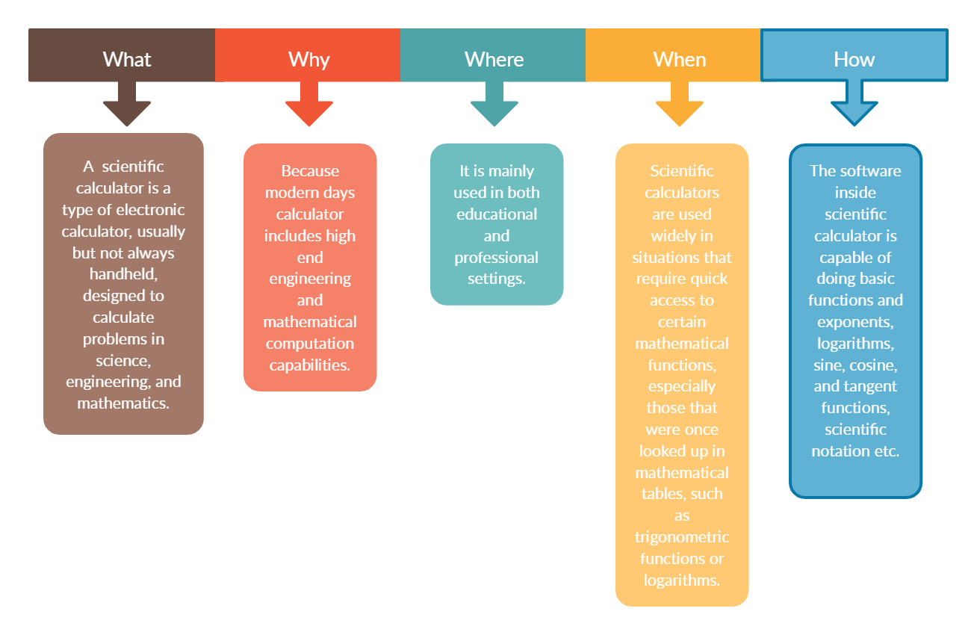

Figure 1 What Why Where When How

## My Product

### High Level Requirements

Table 1 High Level Requirements

|  |  |
| --- | --- |
| Requirement ID | Description |
| HLR10 | The program shall be able to compute basic trigonometric functions. |
| HLR20 | The program shall be able to compute hyperbolic functions. |
| HLR30 | The program shall be able to compute temperature conversions |

### Low Level Requirements

Table 2Low Level Requirements

|  |  |
| --- | --- |
| Requirement ID | Description |
| LLR11 | The program shall be able to compute the sine function. |
| LLR12 | The program shall be able to compute the cosine function. |
| LLR13 | The program shall be able to compute the tangent function. |
| LLR21 | The program shall be able to compute the hyperbolic sine function. |
| LLR22 | The program shall be able to compute the hyperbolic cosine. |
| LLR23 | The program shall be able to compute the hyperbolic tangent function. |
| LLR31 | The program shall be able to compute the temperature conversions |

## SWOT Analysis

Table 3 SWOT Analysis

|  |  |
| --- | --- |
| **Strength**   * Can solve complicated problems easily * It gives more accurate results | **Weakness**   * Can’t calculate complex values * Fixed Accuracy |
| **Opportunities**   * It can be integrated with smart devices | **Threats**   * Calculators integrated with smart devices poses some amount of security threads |