./



GENESIS – Advanced Python Learning Report

|  |  |  |  |  |  |
| --- | --- | --- | --- | --- | --- |
| **Ver. Rel. No.** | **Release Date** | **Prepared. By** | **Reviewed By** | **To be Approved** | **Remarks/Revision Details** |
| 1.0 | 11-12-20 | 1. Megha Annie George |  | Srinivas K |  |
| 2.0 | 12-12-20 | 1. Megha Annie George |  | Srinivas K |  |
|  |  |  |  |  |  |
|  |  |  |  |  |  |
|  |  |  |  |  |  |

**Details**

Random Password Generator

Contents

Contents 3

List of Figures 3

ACTIVITY 1 – LEGACY CODE 3

1 PYTHON CODE 4

2 PEP8 SCREENSHOT 6

3 INPUT FILE SCREENSHOT 6

4 OUTPUT FILE SCREENSHOT 7

ACTIVITY 2 – APPLYING OOP CONCEPTS 8

1 PYTHON CODE 8

2 PEP8 SCREENSHOT 10

3 INPUT FILE SCREENSHOT 11

4 OUTPUT FILE SCREENSHOT 11

ACTIVITY 3 – REGEX PRACTICE 12

1 PRACTICE CODE 12

GITHUB LINK 14

# List of Figures

Figure 1 PEP8 SCREENSHOT – LEGACY CODE 6

Figure 2 INPUT FILE SCREENSHOT – LEGACY CODE 6

Figure 3 OUTPUT FILE SCREENSHOT – LEGACY CODE 7

Figure 4 PEP8 SCREENSHOT - APPLYING OOP 10

Figure 5 INPUT FILE - APPLYING OOP 11

Figure 6 OUTPUT FILE SCREENSHOT - APPYING OOP 11

Figure 7 REGEX PRACTICE 1 12

Figure 8 REGEX PRACTICE 2 13

# ACTIVITY 1 – LEGACY CODE

# PYTHON CODE

# Importing libraries

import random

import string as s

# To generate password

class password_generator:

# Constructor

def __init__(self):

self.pwd_len = 0

self.pwd_stren = "weak"

self.gen_pwd = ""

# To accept length

def get_length(self, length):

try:

self.pwd_len = int(length)

assert (self.pwd_len > 4 and self.pwd_len < 20)

except ValueError:

print("Password Length: Invalid! Input is not an integer")

except AssertionError:

print("Password Length: Invalid! Input must be between 4 and 20")

else:

print("Password Length: ", self.pwd_len)

# To calculate password strength

def calc_strength(self):

if (self.pwd_len < 4 or self.pwd_len > 20):

self.pwd_stren = "Invalid"

elif (self.pwd_len >= 4 and self.pwd_len <= 7):

self.pwd_stren = "Weak"

elif (self.pwd_len >= 8 and self.pwd_len <= 11):

self.pwd_stren = "Moderate"

else:

self.pwd_stren = "Strong"

print("Password Strength: ", self.pwd_stren, '\n')

# To generate random password

def generate_password(self):

if (self.pwd_len < 4 or self.pwd_len > 20):

self.gen_pwd = "Invalid"

else:

self.gen_pwd = random.choice(s.ascii_uppercase) + \

random.choice(s.ascii_lowercase) + \

random.choice(s.digits) + random.choice(s.punctuation)

for a in range(self.pwd_len - 4):

self.gen_pwd = self.gen_pwd + random.choice(s.ascii_uppercase +

s.ascii_lowercase +

s.digits +

s.punctuation)

password_list = list(self.gen_pwd)

random.shuffle(password_list)

self.gen_pwd = ''.join(password_list)

print("Generated password: ", self.gen_pwd)

# To handle input and output files

class input_output_file_handling:

def read_write_file(self):

object1 = password_generator()

fr = open("input.txt", "r")

fw = open("output.txt", "a")

for each_line in fr:

length = each_line

object1.get_length(length)

object1.generate_password()

object1.calc_strength()

fw.write("Password Length: " + each_line +

"Generated Password: " + object1.gen_pwd + '\n' +

"Password Strength: " + object1.pwd_stren + '\n\n')

fr.close()

fw.close()

# To display password criteria

print("Welcome to Random Password Generator!")

print("\nThe password strength is as follows:")

print("\nWeak\t\t:\t4 - 7 Characters")

print("Moderate\t:\t8 - 11 Characters")

print("Strong\t\t:\t12+ Characters")

print("\nNote : Minimum password length should be 4\n")

in_out_obj = input_output_file_handling()

in_out_obj.read_write_file()

# PEP8 SCREENSHOT

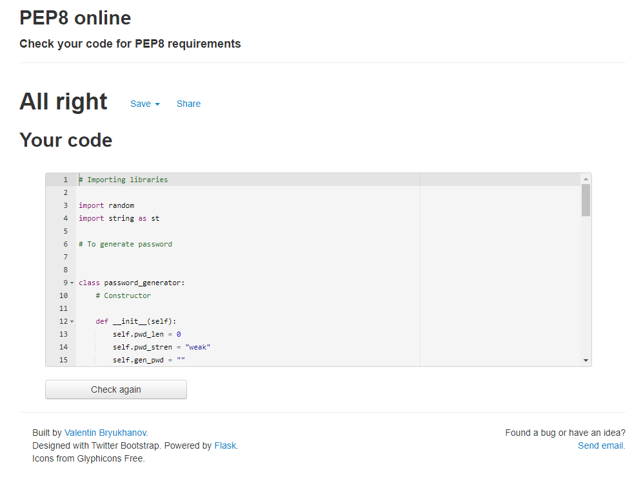

Figure PEP8 SCREENSHOT – LEGACY CODE

# INPUT FILE SCREENSHOT

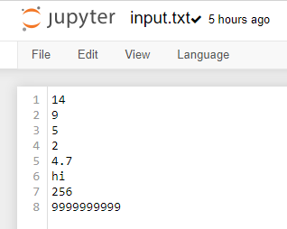

Figure INPUT FILE SCREENSHOT – LEGACY CODE

# OUTPUT FILE SCREENSHOT

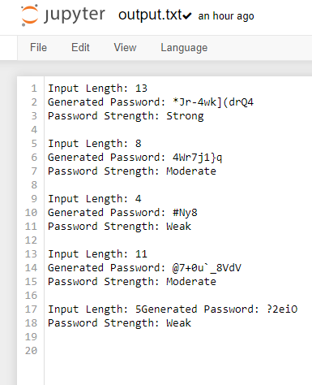

Figure OUTPUT FILE SCREENSHOT – LEGACY CODE

# ACTIVITY 2 – APPLYING OOP CONCEPTS

# PYTHON CODE

# Importing libraries

import random

import string as s

# Class to get length

class get_length:

# Constructor

def __init__(self):

self.pwd_len = 0

# To accept length

def get_len(self, length):

try:

self.pwd_len = int(length)

assert (self.pwd_len > 4 and self.pwd_len < 20)

except ValueError:

print("Password Length: Invalid! Input is not an integer")

except AssertionError:

print("Password Length: Invalid! Input must be between 4 and 20")

else:

print("Password Length: ", self.pwd_len)

# To calculate strength

class calculate_strength(get_length):

# Constructor

def __init__(self):

self.pwd_stren = ""

super().__init__()

# To calculate password strength

def calc_stren(self):

if (self.pwd_len < 4 or self.pwd_len > 20):

self.pwd_stren = "Invalid"

elif (self.pwd_len >= 4 and self.pwd_len <= 7):

self.pwd_stren = "Weak"

elif (self.pwd_len >= 8 and self.pwd_len <= 11):

self.pwd_stren = "Moderate"

else:

self.pwd_stren = "Strong"

print("Password Strength: ", self.pwd_stren, '\n')

# To generate random password

class generate_password(get_length):

# Constructor

def __init__(self):

self.gen_pwd = ""

super().__init__()

# To generate password

def generate_pwd(self):

if (self.pwd_len < 4 or self.pwd_len > 20):

self.gen_pwd = "Invalid"

else:

self.gen_pwd = random.choice(s.ascii_uppercase) + \

random.choice(s.ascii_lowercase) + \

random.choice(s.digits) + random.choice(s.punctuation)

for a in range(self.pwd_len - 4):

self.gen_pwd = self.gen_pwd + random.choice(s.ascii_uppercase +

s.ascii_lowercase +

s.digits +

s.punctuation)

password_list = list(self.gen_pwd)

random.shuffle(password_list)

self.gen_pwd = ''.join(password_list)

print("Generated password: ", self.gen_pwd)

# To handle input and output files

class input_output_file_handling(calculate_strength, generate_password):

def __init__(self):

super().__init__()

def read_write_file(self):

fr = open("input.txt", "r")

fw = open("log.txt", "a")

for each_line in fr:

length = each_line

self.get_len(length)

self.generate_pwd()

self.calc_stren()

fw.write("Password Length: " + each_line +

"Generated Password: " + self.gen_pwd + '\n' +

"Password Strength: " + self.pwd_stren + '\n\n')

fr.close()

fw.close()

# To display password criteria

print("Welcome to Random Password Generator!")

print("\nThe password strength is as follows:")

print("\nWeak\t\t:\t4 - 7 Characters")

print("Moderate\t:\t8 - 11 Characters")

print("Strong\t\t:\t12+ Characters")

print("\nNote : Minimum password length should be 4\n")

in_out_obj = input_output_file_handling()

in_out_obj.read_write_file()

# PEP8 SCREENSHOT

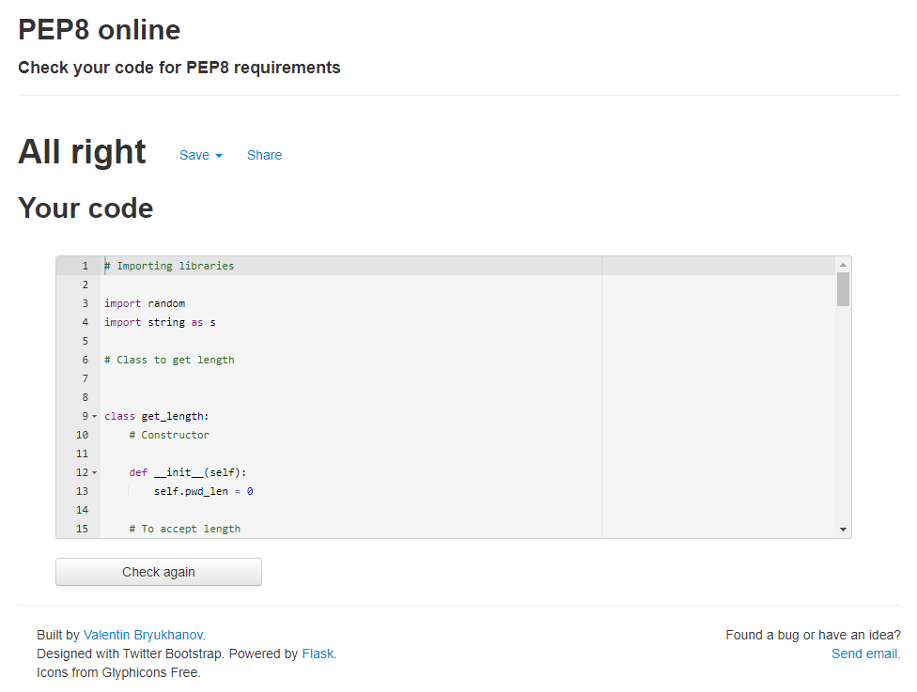

Figure PEP8 SCREENSHOT - APPLYING OOP

# INPUT FILE SCREENSHOT



Figure INPUT FILE - APPLYING OOP

# OUTPUT FILE SCREENSHOT

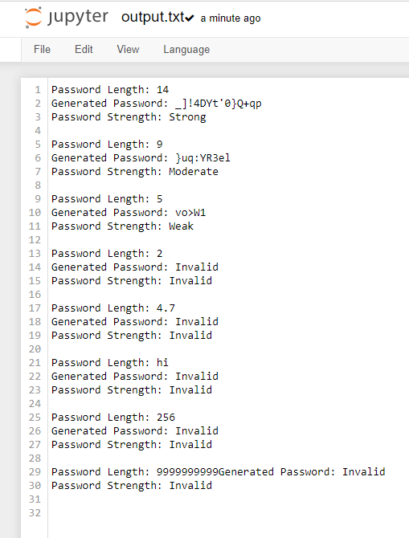

Figure OUTPUT FILE SCREENSHOT - APPYING OOP

# ACTIVITY 3 – REGEX PRACTICE

# PRACTICE CODE

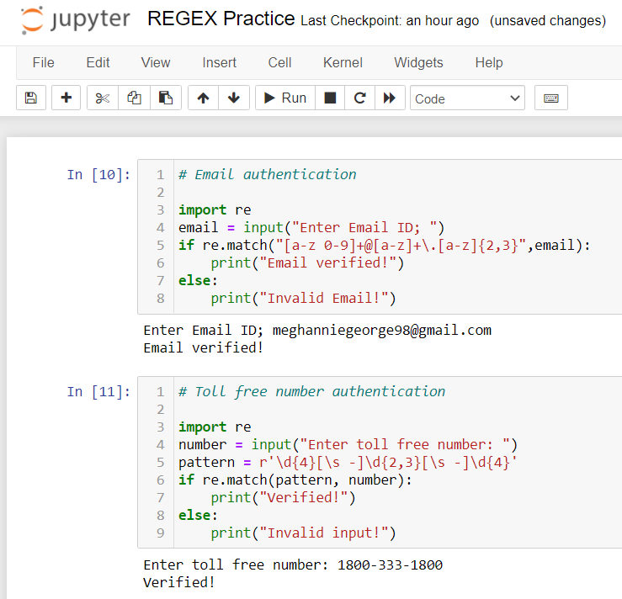

Figure REGEX PRACTICE 1

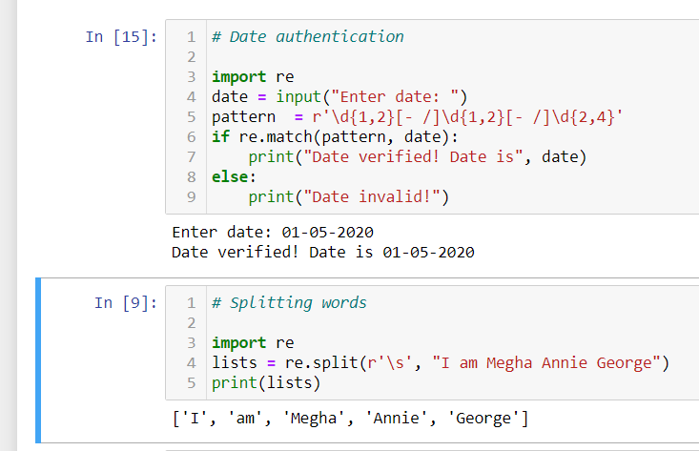

Figure REGEX PRACTICE 2

# GITHUB LINK

* <https://github.com/99003169/my_repo>