./

Virtual Interview Assistant

Course Code: <CODE>



Version Number:

Team Members :

Team No:

Module: Model Based System Engineering

|  |  |  |  |  |  |
| --- | --- | --- | --- | --- | --- |
| **Ver. Rel. No.** | **Release Date** | **Prepared. By** | **Reviewed By** | **Approved By** | **Remarks/Revision Details** |
| 1.0 | 13-11-2020 | Hareesh |  |  |  |
|  |  |  |  |  |  |
|  |  |  |  |  |  |
|  |  |  |  |  |  |
|  |  |  |  |  |  |

**Document History**

# 

**TABLE OF CONTENTS** **PAGE NO.**

1 TITLE 1

2 PROBLEM STATEMENT 4

3 DESCRIPTION 4

4 REQUIREMENT GATHERING 5

5 DESIGN 6

6 TEST PLAN 7

7 TEST CASE 7

8 EXPECTED RESULTS 8

**Virtual Interview Assistant**

**Problem statement**

To design a virtual interview assistant which helps the recruiter to find the best talent to an organization.

**Description**

Virtual Interview assistant will track the performance of students who appear for job in any company and give the results of the interview. It is very difficult for an recruiter to keep track of records of the applicants who meets the criteria for the above job role and to conduct interviews for the selected applicants and announce the results. In order to make this process much more easier virtual interview assistant can be used. This tool will automatically does the above work and gives the result to the recruiter. The information of the applicants who are applying for the job are stored in a file. Based on the criteria set by the recruiter the applicants will get short listed and move forward to the next round of interviews. The number of interviewers can be decided by the recruiter. If the performance of the applicants are satisfied by the interviewers they will get selected and will be offered job. This will make the process of recruitment easier for any organization.

**Requirements gathering**

**Software requirements**

Operating system : windows 7 or higher version

Programming language : C program

IDE : code blocks version 20.3

Compiler : GNU GCC Compiler

**Functional requirements**

1. Interviewer should be able to update the scores of the candidate after interview.
2. The results of each rounds must be available to the recruiter.
3. Allocating panels for conducting Interviews.
4. Given an applicant Id, the recruiter should be able to get the status of interview process.

**Design**

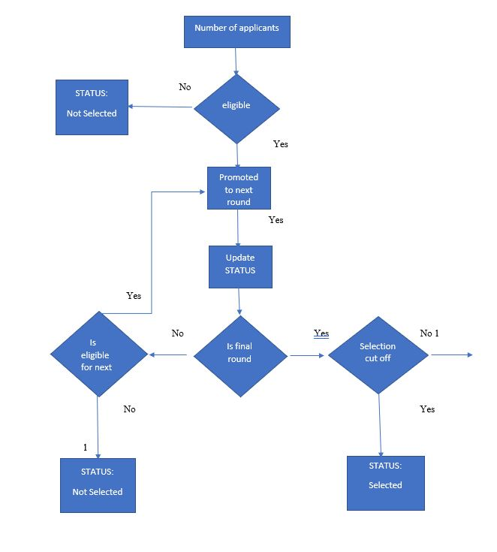

**Test Plan**

**Objectives**

1. To make the applicants data available for recruiter.
2. To select the applicants based on the eligibility criteria marks.
3. To allocate panels for interview
4. To update the status of interview process till the final round.
5. To select the candidates if the selection cut off is achieved.

**Test Cases**

Sample file/database available to recruiter

|  |  |  |  |
| --- | --- | --- | --- |
| Candidate Id | Candidate Name | Status | CGPA |
| 4567 | A | 0 | 8.9 |
| 7865 | B | 0 | 7.3 |
| 9876 | C | 0 | 8 |

**Eligibility Criteria**: 7.5 (CGPA of the applicant)

**Number of interviewers**: 2

|  |  |
| --- | --- |
| Interviewer Id | Interviewer Name |
| 12 | I-A |
| 13 | I-B |

**Enter the number of rounds**: 2 (decided by the recruiter)

|  |  |  |  |  |  |
| --- | --- | --- | --- | --- | --- |
| Candidate Id | Candidate Number | Status of eligibility | Status of Round 1 | Status of Round 2 |  |
| 4567 | A | selected | selected | selected |  |
| 1678 | V | selected | Rejected | NA |  |

**Interview selection Cut off**: 8

Test case 1. Eligible applicants for Interview rounds

Test case 2. Allocation of panels for interviews

Test case 3. Final selected applicants after interviews.

**Expected Results**

1.

|  |  |  |
| --- | --- | --- |
| Candidate Id | Candidate Name | CGPA |
| 4567 | A | 8.9 |
| 9876 | C | 8 |

2.

|  |  |  |  |  |  |
| --- | --- | --- | --- | --- | --- |
| Panel No. | Interviewer Id | Interviewer Name | Candidate Id | Candidate Name | Selection cut off |
| 1 | 12 | I-A | 4567 | A | 9 |
| 2 | 13 | I-B | 9876 | C | 7 |

3.

|  |  |  |  |
| --- | --- | --- | --- |
| Candidate Id | Candidate Name | Status | Remarks |
| 4567 | A | 1 | selected |

**Output**

|  |  |
| --- | --- |
| **Test case** | **Result** |
| **1** | **Pass** |
| **2** | **Pass** |
| **3** | **Pass** |