./

GENESIS – Embedded C Learning Report



|  |  |  |  |  |  |
| --- | --- | --- | --- | --- | --- |
| **Ver. Rel. No.** | **Release Date** | **Prepared. By** | **Reviewed By** | **To be Approved** | **Remarks/Revision Details** |
| V1.0 | 02/01/2021 | Shriram M.S |  |  |  |
|  |  |  |  |  |  |
|  |  |  |  |  |  |
|  |  |  |  |  |  |
|  |  |  |  |  |  |

**Details**

**Table of Contents**

1 ACTIVITY 1: PERFORM BUILD USING GIT BASH 4

1.1 EVENODD.C FILE 4

1.2 EVENODD.H FILE 4

1.3 MAIN FILE 5

1.4 SCREENSHOT OF BUILD AFTER RUNNING IN GIT BASH 5

2 ACTIVITY 2: LINKER SCRIPT (CODE) 6

3 ACTIVITY 3: STARTUP CODE 7

4 ACTIVITY 4: BUILD USING MAKEFILE 8

4.1 SCREENSHOT OF MAKEFILE 8

4.2 SCREENSHOT OF OUTPUT AFTER RUNNING MAKE 8

4.3 OUTPUT FILES CREATED 9

4.4 GITHUB LINK 9

5 MINIPROJECT 10

5.1 SCREENSHOT OF STM32 IDE BUILD 10

5.2 SCREENSHOT OF SERIAL MONITOR OUTPUT 11

5.2.1 AMBIENT CONDITION – GREEN LED TOGGLES 11

5.2.2 THRESHOLD CONDITION – RED LED TOGGLES 11

5.3 GITHUB LINK 11

**List Of Figures**

Figure 1 : EVENODD.C 4

Figure 2 : EVENODD.H 4

Figure 3 : MAIN.C 5

Figure 4 : BUILD OF MAIN & EVENODD 5

Figure 5 : STARTUP CODE 7

Figure 6 : MAKEFILE SCREENSHOT 8

Figure 7 : MAKEFILE OUTPUT 8

Figure 8 : OUTPUT FILES CREATED AFTER MAKE 9

Figure 9 : SCREENSHOT OF FINAL BUILD 10

Figure 10 : AMBIENT TEMPERATURE CONDITION 11

Figure 11 : INCONVINIENT TEMPERATURE CONDITION 11

# ACTIVITY 1: PERFORM BUILD USING GIT BASH

## EVENODD.C FILE

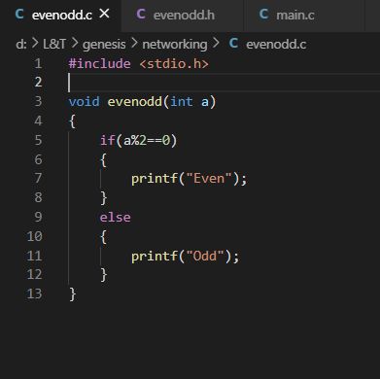

Figure : EVENODD.C

## EVENODD.H FILE

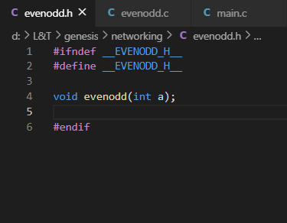

Figure : EVENODD.H

## MAIN FILE

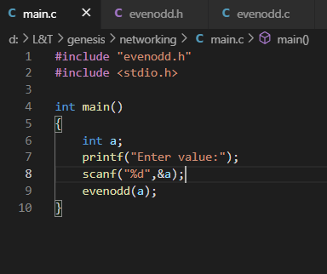

Figure : MAIN.C

## SCREENSHOT OF BUILD AFTER RUNNING IN GIT BASH

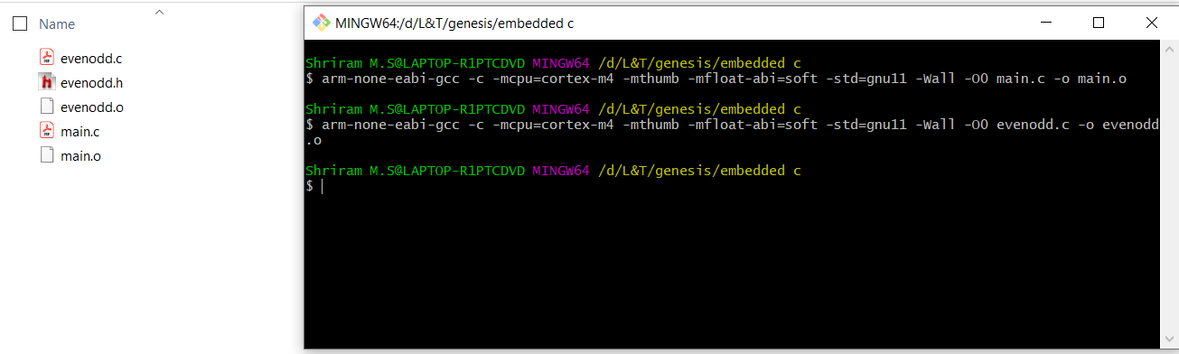

Figure : BUILD OF MAIN & EVENODD

# ACTIVITY 2: LINKER SCRIPT (CODE)

ENTRY(Reset_Handler)

MEMORY

{

FLASH(rx):ORIGIN =0x08000000,LENGTH =1024K

SRAM(rwx):ORIGIN =0x20000000,LENGTH =128K

}

SECTIONS

{

.text :

{

*(.isr_vector)

*(.text)

*(.text.*)

*(.init)

*(.fini)

*(.rodata)

*(.rodata.*)

. = ALIGN(4);

_etext = .;

}> FLASH

_la_data = LOADADDR(.data);

.data :

{

_sdata = .;

*(.data)

*(.data.*)

. = ALIGN(4);

_edata = .;

}> SRAM AT> FLASH

.bss :

{

_sbss = .;

__bss_start__ = _sbss;

*(.bss)

*(.bss.*)

*(COMMON)

. = ALIGN(4);

_ebss = .;

__bss_end__ = _ebss;

. = ALIGN(4);

end = .;

__end__ = .;

}> SRAM

}

# ACTIVITY 3: STARTUP CODE

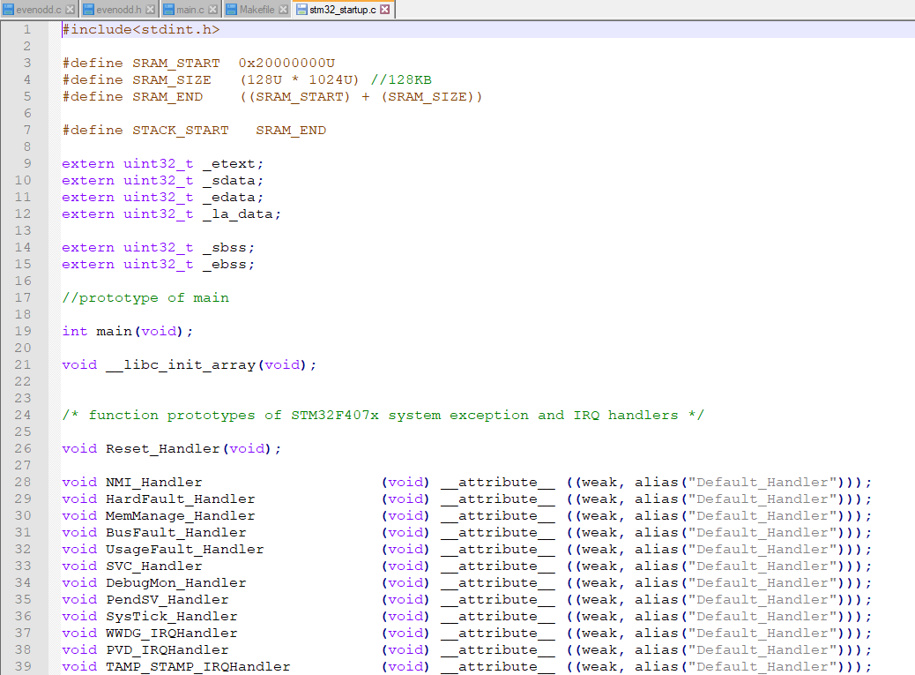

Figure : STARTUP CODE

# ACTIVITY 4: BUILD USING MAKEFILE

## SCREENSHOT OF MAKEFILE

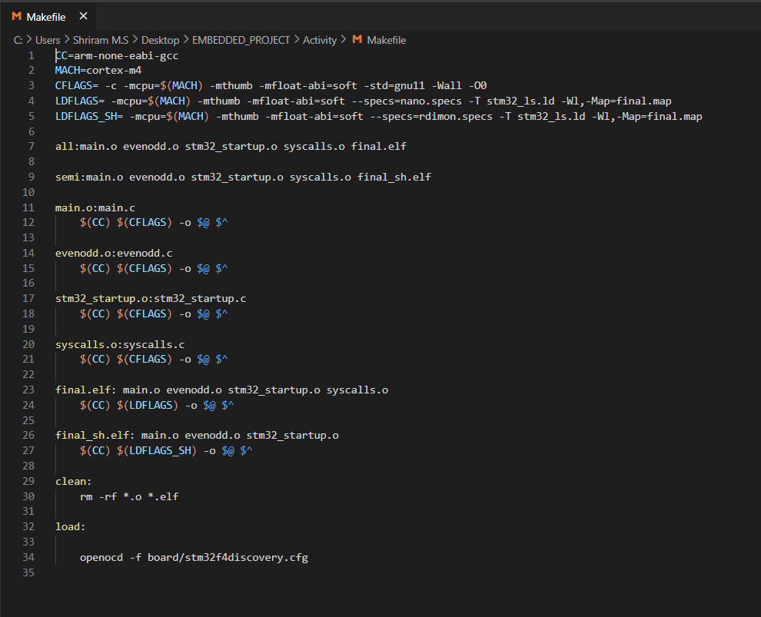

Figure : MAKEFILE SCREENSHOT

## SCREENSHOT OF OUTPUT AFTER RUNNING MAKE

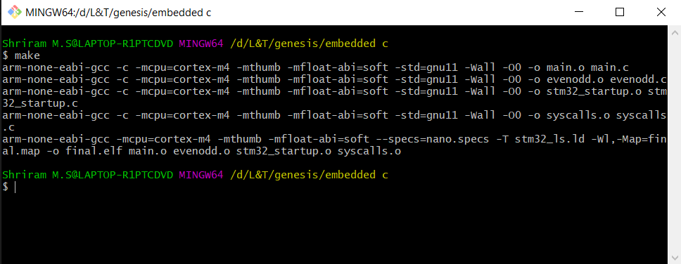

Figure : MAKEFILE OUTPUT

## OUTPUT FILES CREATED

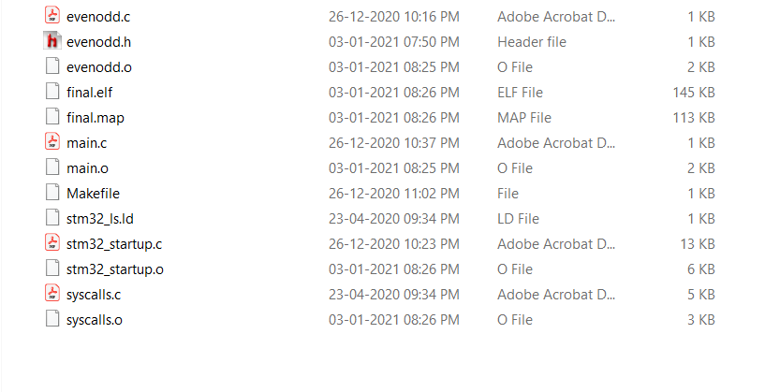

Figure : OUTPUT FILES CREATED AFTER MAKE

## GITHUB LINK

* [EMBEDDED_PROJECT/Activity at master · 99003173/EMBEDDED_PROJECT (github.com)](https://github.com/99003173/EMBEDDED_PROJECT/tree/master/Activity)

# MINIPROJECT

## SCREENSHOT OF STM32 IDE BUILD

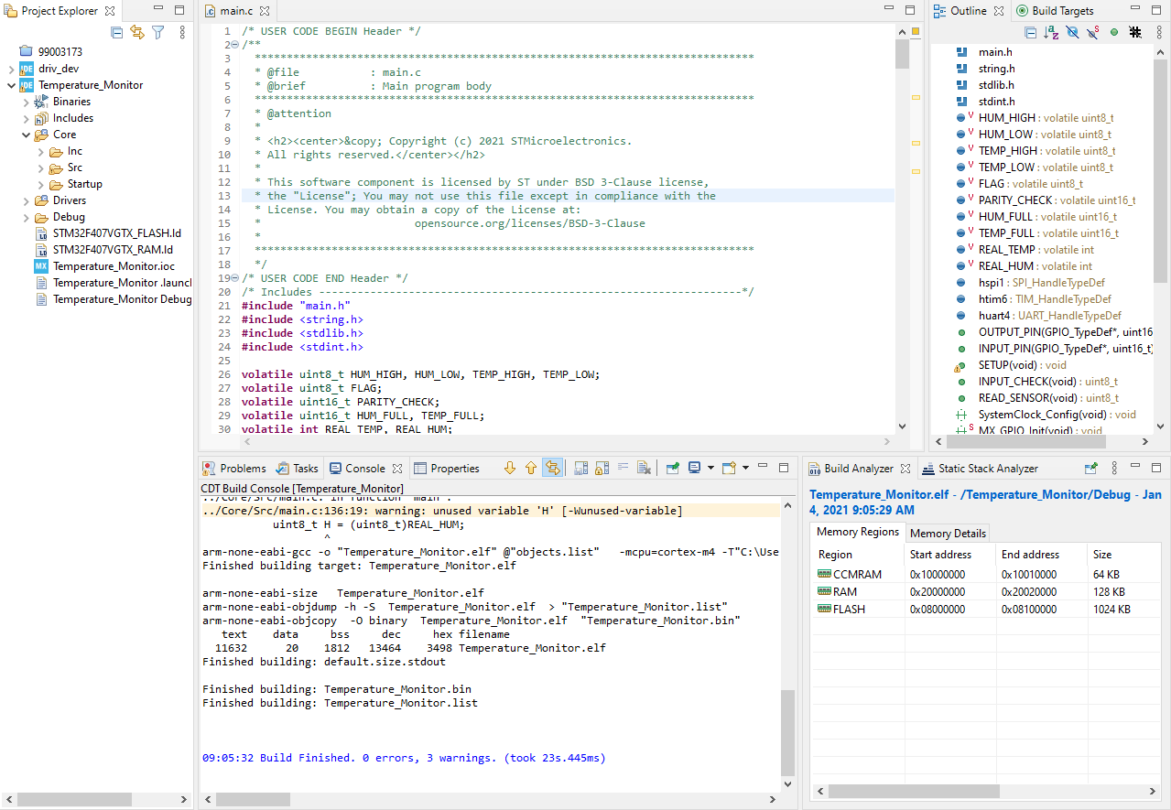

Figure : SCREENSHOT OF FINAL BUILD

## SCREENSHOT OF SERIAL MONITOR OUTPUT

### AMBIENT CONDITION – GREEN LED TOGGLES

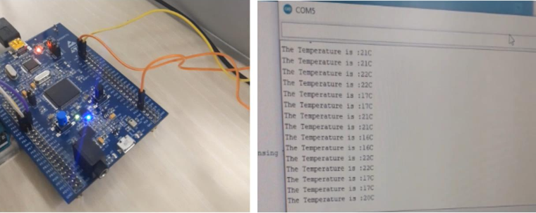

Figure : AMBIENT TEMPERATURE CONDITION

### THRESHOLD CONDITION – RED LED TOGGLES

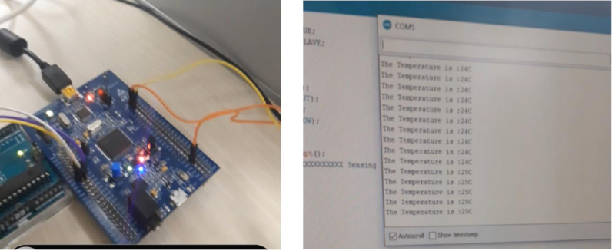

Figure : INCONVINIENT TEMPERATURE CONDITION

## GITHUB LINK

* [99003173/EMBEDDED_PROJECT (github.com)](https://github.com/99003173/EMBEDDED_PROJECT)