./

GENESIS – Advanced Python and Testing Project Summary



|  |  |  |  |  |  |
| --- | --- | --- | --- | --- | --- |
| **Ver. Rel. No.** | **Release Date** | **Prepared. By** | **Reviewed By** | **To be Approved** | **Remarks/Revision Details** |
| V1.1 | 11/12/2020 | Shriram M S |  |  |  |
| V1.2 | 12/12/2020 | Shriram M S |  |  |  |
| V1.3 | 13/12/2020 | Shriram M S |  |  |  |
|  |  |  |  |  |  |
|  |  |  |  |  |  |

**Details**

Contents

Contents 3

Stadium Ticket Booking System 4

1 ACTIVITY 1 (11/12/2020) 4

1.1 Python Code 4

1.2 PEP8 Online 6

1.3 Input Files Screenshot 7

1.3.1 Match Schedule Input Excel File 7

1.3.2 Booking Detail Input Excel File 8

1.3.3 Login Detail Input Excel File 8

1.4 Output Files Screenshot 9

1.4.1 Confirmation Details Output Excel File 9

2 ACTIVITY 2 (12/12/2020) 9

2.1 Python Code 10

2.2 PEP8 Online 15

2.3 Input Files Screenshot 15

2.3.1 Mumbai Stadium Schedule - Input Excel File 16

2.3.2 Kolkata Stadium Schedule - Input Excel File 16

2.3.3 Chennai Stadium Schedule - Input Excel File 16

2.4 Output Files Screenshot 17

2.4.1 Booking Detail - Output Excel File 17

3 RegEx Practice 17

3.1 Code 17

3.2 Output 18

**LIST OF TABLES**

Figure 1 : PEP8 ONLINE SCREENSHOT ACTIVITY 1 6

Figure 2 : MATCH SCHEDULE SCREENSHOT ACTIVITY 1 7

Figure 3 : BOOKING DETAIL SCREENSHOT ACTIVITY 1 7

Figure 4 : LOGIN DETAIL SCREENSHOT ACTIVITY 1 8

Figure 5 : CONFIRMATION DETAIL SCREENSHOT ACTIVITY 1 9

Figure 6 :PEP8 ONLINE SCREENSHOT ACTIVITY 2 15

Figure 7 : MUMBAI SCHEDULE SCREENSHOT ACTIVITY 2 15

Figure 8 : KOLKATA SCHEDULE SCREENSHOT ACTIVITY 2 16

Figure 9 : CHENNAI SCHEDULE SCREENSHOT ACTIVITY 2 16

Figure 10 : BOOKING DETAILS SCREENSHOT ACTIVITY 2 17

Figure 11 : REGEX PRACTICE CODE SCREENSHOT 18

Figure 12 : REGEX PRACTICE CODE OUTPUT SCREENSHOT 19

# Stadium Ticket Booking System

# ACTIVITY 1 (11/12/2020)

## Python Code

import pandas as pd

pd.set_option("display.max_columns",None)

# File to view match schedule

df=pd.read_csv("schedule.csv")

# Input file to see user booking details

bd=pd.read_csv("booking_details.csv")

# File to see authentication details

log=pd.read_csv("login_details.csv")

class stadium:

tot_capacity=0

tot_seat_available=0

tot_seats_booked=0

cost=1000

tot_cost=0

def details(self,tot_capacity):

self.tot_capacity=tot_capacity

def seats_available(self):

tot_seat_available=self.tot_capacity-self.tot_seats_booked

return tot_seat_available

def book_ticket(self,match_booked):

print("\nTotal no. of tickets to book",bd.no_of_tickets[0])

bookings=bd.no_of_tickets[0]

if self.seats_available() < bookings:

print("Enough tickets not available")

self.match_schedule()

else:

self.tot_cost=self.cost*bookings

self.tot_seats_booked+=bookings

print(f"Total cost for {bookings} tickets are {self.tot_cost}")

self.tot_seat_available=self.tot_capacity-self.tot_seats_booked

temp_output=[[str(bd.audience_id[0]),str(bookings),\

str(self.tot_cost),str("1001 plus "+str(bookings))]]

output=pd.DataFrame(temp_output)

# Output file that shows booking confirmation details

output.to_csv("confirmation_details.csv",index=False,\

mode="a",header=False)

def match_schedule(self,tot_capacity):

self.tot_capacity=tot_capacity

print("\nSchedule is")

print(f"1){df.AWAY[0]} X {df.HOME[0]} {df.FORMAT[0]} on {df.DATE[0]}")

print(f"2){df.AWAY[1]} X {df.HOME[1]} {df.FORMAT[1]} on {df.DATE[1]}")

print(f"3){df.AWAY[2]} X {df.HOME[2]} {df.FORMAT[2]} on {df.DATE[2]}")

print("Match to be booked:",bd.match_number[0])

match_booked=bd.match_number[0]

print("Seat Available:",self.seats_available())

self.book_ticket(match_booked)

mumbai=stadium()

kolkata=stadium()

chennai=stadium()

def match():

print("\n\nWhich stadium to book tickets")

print("1)Mumbai")

print("2)Kolkata")

print("3)Chennai")

print("Choose Stadium:",bd.city[0])

selected_stadium=bd.city[0]

if selected_stadium == 1:

mumbai.match_schedule(50000)

elif selected_stadium == 2:

kolkata.match_schedule(60000)

elif selected_stadium == 3:

chennai.match_schedule(70000)

def login():

if log.original_id[0] == bd.audience_id[0]:

match()

elif log.original_id[1] == bd.audience_id[0]:

match()

else:

print("No ID Found")

login()

## PEP8 Online

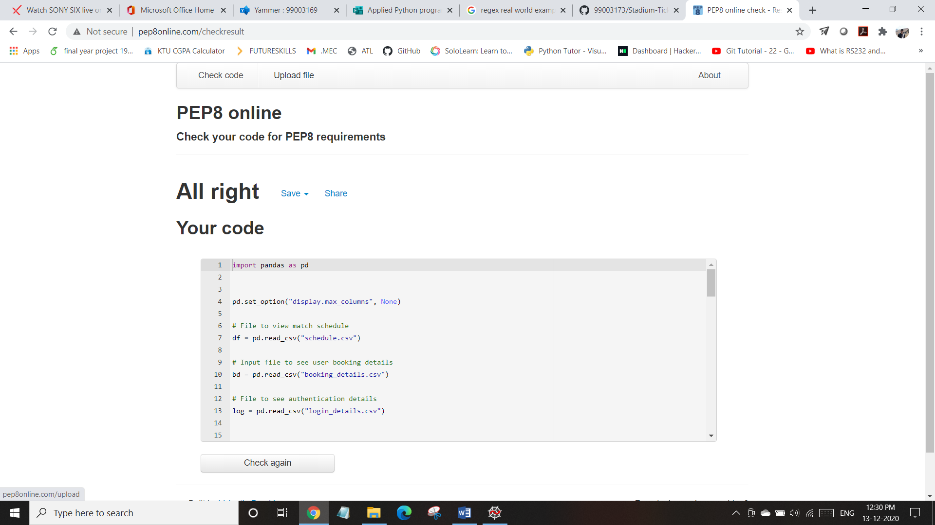

Figure : PEP8 ONLINE SCREENSHOT ACTIVITY 1

## Input Files Screenshot

### Match Schedule Input Excel File

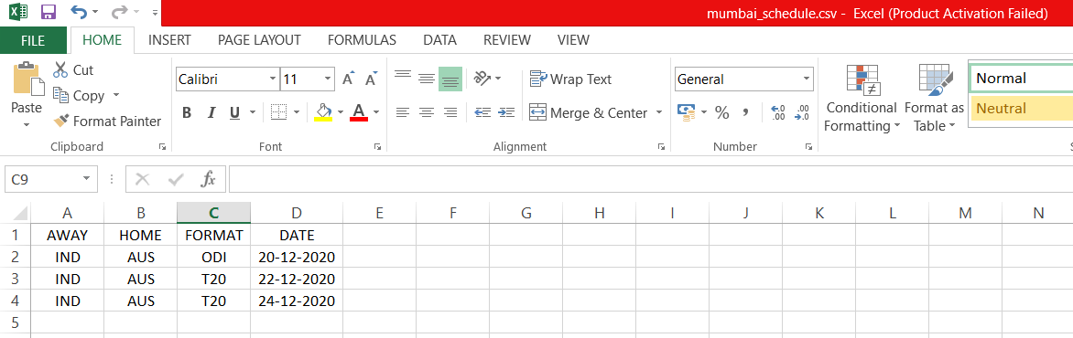

Figure : MATCH SCHEDULE SCREENSHOT ACTIVITY 1

### Booking Detail Input Excel File

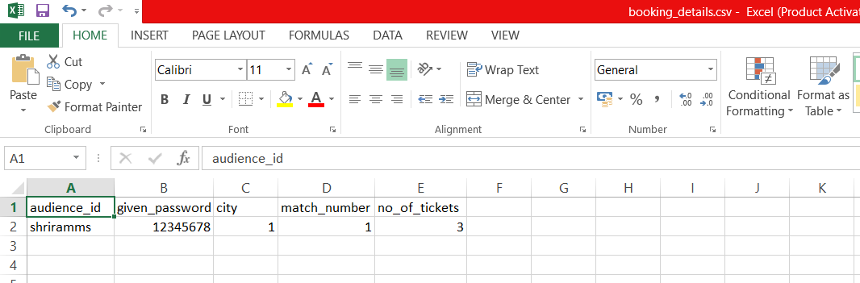

Figure : BOOKING DETAIL SCREENSHOT ACTIVITY 1

### Login Detail Input Excel File

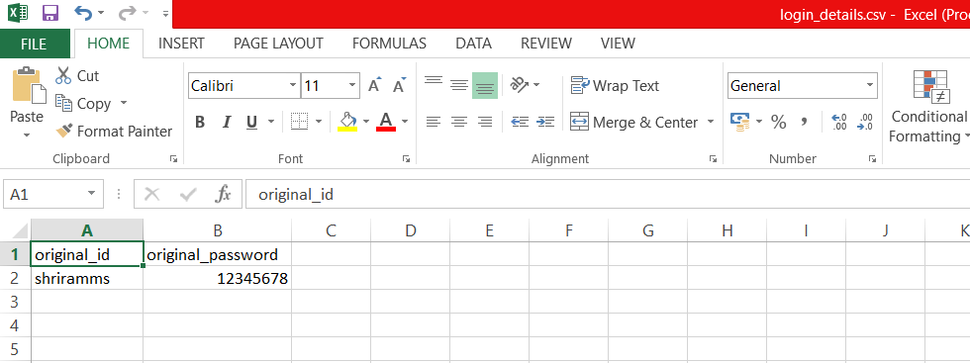

Figure : LOGIN DETAIL SCREENSHOT ACTIVITY 1

## Output Files Screenshot

### Confirmation Details Output Excel File



Figure : CONFIRMATION DETAIL SCREENSHOT ACTIVITY 1

# ACTIVITY 2 (12/12/2020)

## Python Code

import pandas as pd

from datetime import datetime

pd.set_option("display.max_columns", None)

# File to view match schedule's

mf = pd.read_csv("mumbai_schedule.csv")

kf = pd.read_csv("kolkata_schedule.csv")

cf = pd.read_csv("chennai_schedule.csv")

# Class to update seat availability for all the matches

class seat:

# Function to initialize attributes

def __init__(self):

self.tot_seats_available_1 = 0

self.tot_seats_booked_1 = 0

self.tot_seats_available_2 = 0

self.tot_seats_booked_2 = 0

self.tot_seats_available_3 = 0

self.tot_seats_booked_3 = 0

# Function to update seat availability

def seats_available(self, tot_capacity, match_booked):

if match_booked == 1:

self.tot_seats_available_1 = tot_capacity - self.tot_seats_booked_1

return self.tot_seats_available_1

elif match_booked == 2:

self.tot_seats_available_2 = tot_capacity - self.tot_seats_booked_2

return self.tot_seats_available_2

elif match_booked == 3:

self.tot_seats_available_3 = tot_capacity - self.tot_seats_booked_3

return self.tot_seats_available_3

# Function to display stadium seat availability details

def display_stadium_detail(self, tot_capacity):

print(f"\nTotal Capacity:{tot_capacity}")

if self.match_booked == 1:

print(f"Total Seats Booked:{self.tot_seats_booked_1}")

print(f"Total Seats Available:

{self.seats_available(tot_capacity, self.match_booked)}")

elif self.match_booked == 2:

print(f"Total Seats Booked:{self.tot_seats_booked_2}")

print(f"Total Seats Available: {self.seats_available

(tot_capacity,

self.match_booked)}")

elif self.match_booked == 3:

print(f"Total Seats Booked:{self.tot_seats_booked_3}")

print(f"Total Seats Available: {self.seats_available

(tot_capacity,

self.match_booked)}")

# Class to update the audience member's name

class name:

# Function to initialize attributes

def __init__(self):

self.username = ""

def name_entry(self, username):

self.username = username

# Class to save details about an audience member's ticket bookings

class user(seat, name):

# Function to initialize attributes

def __init__(self, stadium_name):

self.stadium_name = stadium_name

self.bookings = 0

self.tot_cost = 0

self.match_booked = 0

self.date = 0

self.time = 0

super().__init__()

# Function to display booking details

def booking_details(self):

print(f"\nUsername : {self.username}")

print(f"Stadium : {self.stadium_name}")

print(f"Match : {self.match_booked}")

print(f"Tickets : {self.bookings}")

print(f"Total Cost : {self.tot_cost}")

print(f"Booked on : {self.date} {self.time}")

if self.stadium_name == "Mumbai":

temp_output = [[self.username, self.stadium_name,

str(f"{mf.AWAY[self.match_booked-1]} X

{mf.HOME[self.match_booked-1]}

{mf.FORMAT[self.match_booked-1]}"),

str(f"{mf.DATE[self.match_booked-1]}"),

self.bookings, self.tot_cost,

self.date, self.time]]

if self.stadium_name == "Kolkata":

temp_output = [[self.username, self.stadium_name,

str(f"{kf.AWAY[self.match_booked-1]} X

{kf.HOME[self.match_booked-1]}

{kf.FORMAT[self.match_booked-1]}"),

str(f"{kf.DATE[self.match_booked-1]}"),

self.bookings, self.tot_cost,

self.date, self.time]]

if self.stadium_name == "Chennai":

temp_output = [[self.username, self.stadium_name,

str(f"{cf.AWAY[self.match_booked-1]} X

{cf.HOME[self.match_booked-1]}

{cf.FORMAT[self.match_booked-1]}"),

str(f"{cf.DATE[self.match_booked-1]}"),

self.bookings, self.tot_cost,

self.date, self.time]]

output = pd.DataFrame(temp_output)

# Output file that shows booking confirmation details

output.to_csv("booking_details.csv",

index=False, mode="a", header=False)

# Function to book tickets

def book_ticket(self, cost, tot_capacity):

self.bookings = int(input(f"Tickets(Rs{cost}) to Book:"))

self.date = datetime.now().date()

self.time = datetime.now().time()

print(f"Booked on {self.date} at {self.time}")

if self.match_booked == 1:

if self.bookings <= self.seats_available(tot_capacity,

self.match_booked):

self.tot_cost = cost*self.bookings

self.booking_details()

self.tot_seats_booked_1 += self.bookings

self.tot_seats_available_1 =

tot_capacity - self.tot_seats_booked_1

elif self.match_booked == 2:

if self.bookings <= self.seats_available(tot_capacity,

self.match_booked):

self.tot_cost = cost*self.bookings

self.booking_details()

self.tot_seats_booked_2 += self.bookings

self.tot_seats_available_2 =

tot_capacity - self.tot_seats_booked_2

elif self.match_booked == 3:

if self.bookings <= self.seats_available(tot_capacity,

self.match_booked):

self.tot_cost = cost*self.bookings

self.booking_details()

self.tot_seats_booked_3 += self.bookings

self.tot_seats_available_3 =

tot_capacity - self.tot_seats_booked_3

# Objects of user pertaining to particular stadiums

u1 = user("Mumbai")

u2 = user("Kolkata")

u3 = user("Chennai")

# Class to update cost of each stadiums

class cost:

# Function to initialize attributes

def __init__(self):

self.cost = 0

def cost_detail(self, cost):

self.cost = cost

# Class to save details about stadiums

class stadium(cost):

# Function to initialize attributes

def __init__(self):

self.tot_capacity = 0

super().__init__()

# Function to update stadium capacity and ticket cost

def capacity_detail(self, tot_capacity, cost):

self.tot_capacity = tot_capacity

self.cost_detail(cost)

# Function to see schedule of matches

def match_schedule(self, u):

if u.stadium_name == "Mumbai":

print("\nSchedule is")

print(f"1.{mf.AWAY[0]} X {mf.HOME[0]}

{mf.FORMAT[0]} on {mf.DATE[0]}")

print(f"2.{mf.AWAY[1]} X {mf.HOME[1]}

{mf.FORMAT[1]} on {mf.DATE[1]}")

print(f"3.{mf.AWAY[2]} X {mf.HOME[2]}

{mf.FORMAT[2]} on {mf.DATE[2]}")

u1.match_booked = int(input("Match to be booked:"))

u1.display_stadium_detail(self.tot_capacity)

u1.name_entry(input("Enter Username"))

u1.book_ticket(self.cost, self.tot_capacity)

u1.display_stadium_detail(self.tot_capacity)

if u.stadium_name == "Kolkata":

print("\nSchedule is")

print(f"1.{kf.AWAY[0]} X {kf.HOME[0]}

{kf.FORMAT[0]} on {kf.DATE[0]}")

print(f"2.{kf.AWAY[1]} X {kf.HOME[1]}

{kf.FORMAT[1]} on {kf.DATE[1]}")

print(f"3.{kf.AWAY[2]} X {kf.HOME[2]}

{kf.FORMAT[2]} on {kf.DATE[2]}")

u2.match_booked = int(input("Match to be booked:"))

u2.display_stadium_detail(self.tot_capacity)

u2.name_entry(input("Enter Username"))

u2.book_ticket(self.cost, self.tot_capacity)

u2.display_stadium_detail(self.tot_capacity)

if u.stadium_name == "Chennai":

print("\nSchedule is")

print(f"1.{cf.AWAY[0]} X {cf.HOME[0]}

{cf.FORMAT[0]} on {cf.DATE[0]}")

print(f"2.{cf.AWAY[1]} X {cf.HOME[1]}

{cf.FORMAT[1]} on {cf.DATE[1]}")

print(f"3.{cf.AWAY[2]} X {cf.HOME[2]}

{cf.FORMAT[2]} on {cf.DATE[2]}")

u3.match_booked = int(input("Match to be booked:"))

u3.display_stadium_detail(self.tot_capacity)

u3.name_entry(input("Enter Username"))

u3.book_ticket(self.cost, self.tot_capacity)

u3.display_stadium_detail(self.tot_capacity)

# Objects of stadium created for user access

mumbai = stadium()

kolkata = stadium()

chennai = stadium()

# Function acting as a menu to show stadiums available for booking

def match():

print("\n\nWhich stadium to book tickets")

print("1)Mumbai")

print("2)Kolkata")

print("3)Chennai")

selected_stadium = int(input("Choose Stadium:"))

if selected_stadium == 1:

mumbai.capacity_detail(50000, 1200)

mumbai.match_schedule(u1)

match()

elif selected_stadium == 2:

kolkata.capacity_detail(60000, 1100)

kolkata.match_schedule(u2)

match()

elif selected_stadium == 3:

chennai.capacity_detail(70000, 1000)

chennai.match_schedule(u3)

match()

else:

return 0

match()

## PEP8 Online

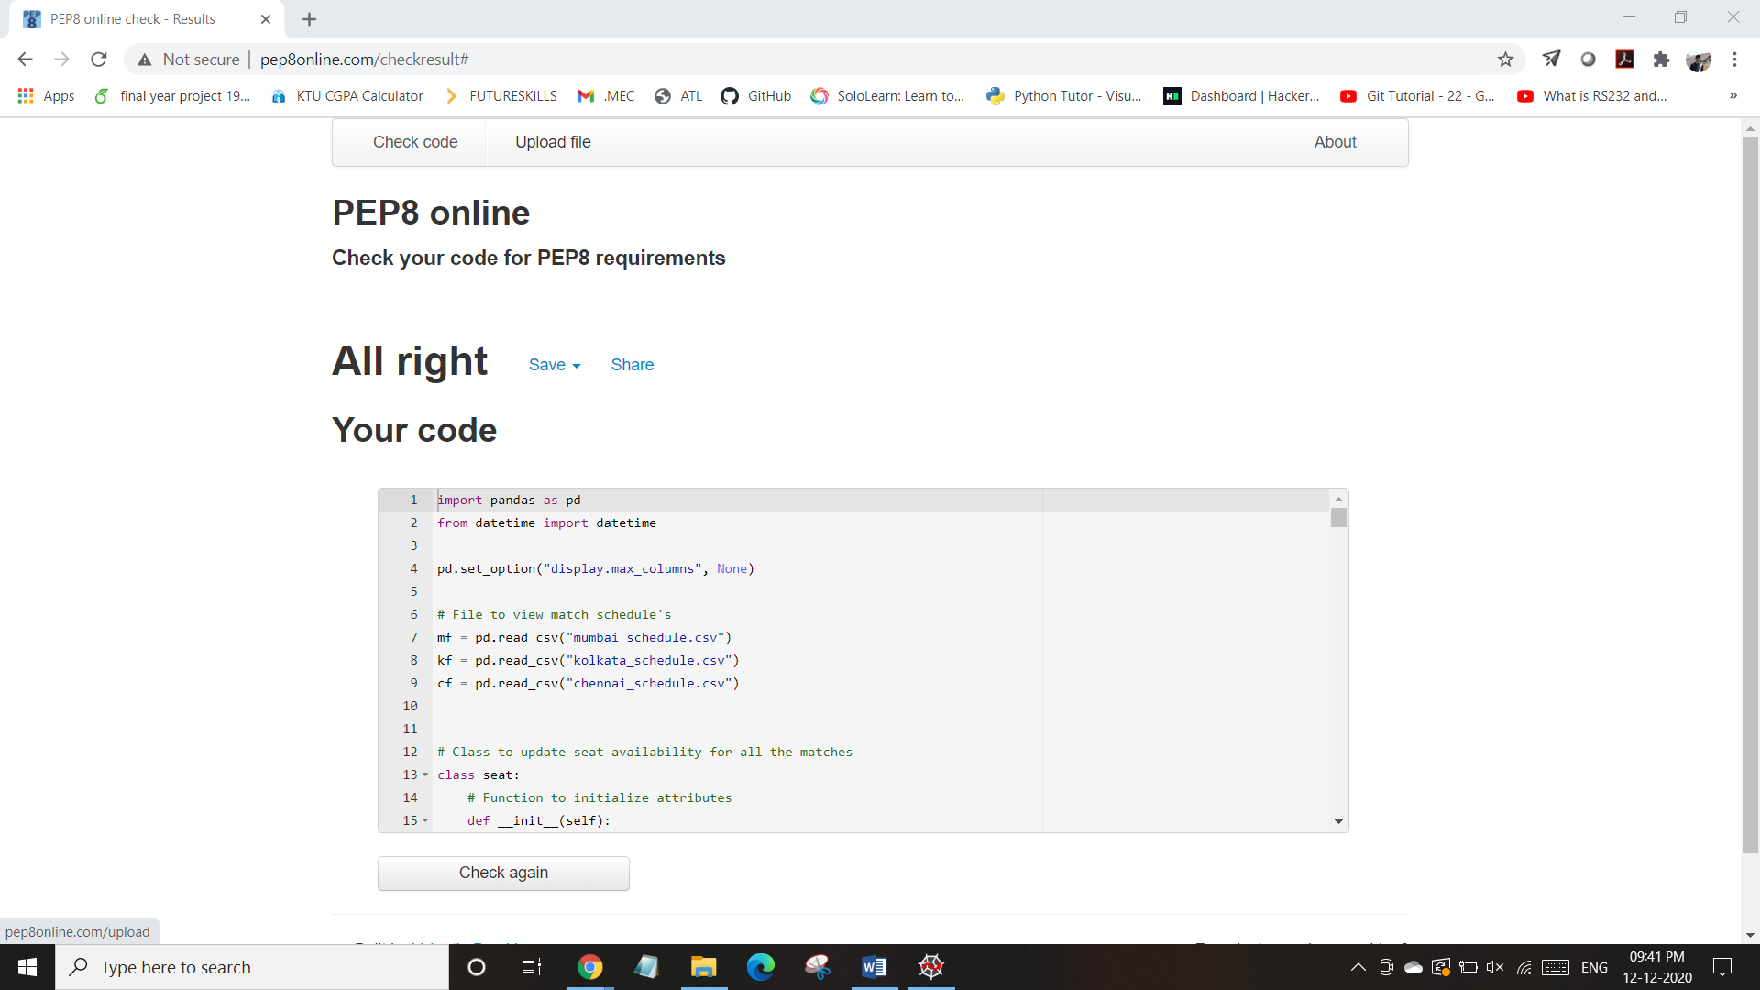

Figure :PEP8 ONLINE SCREENSHOT ACTIVITY 2

## Input Files Screenshot

### Mumbai Stadium Schedule - Input Excel File



Figure : MUMBAI SCHEDULE SCREENSHOT ACTIVITY 2

### Kolkata Stadium Schedule - Input Excel File

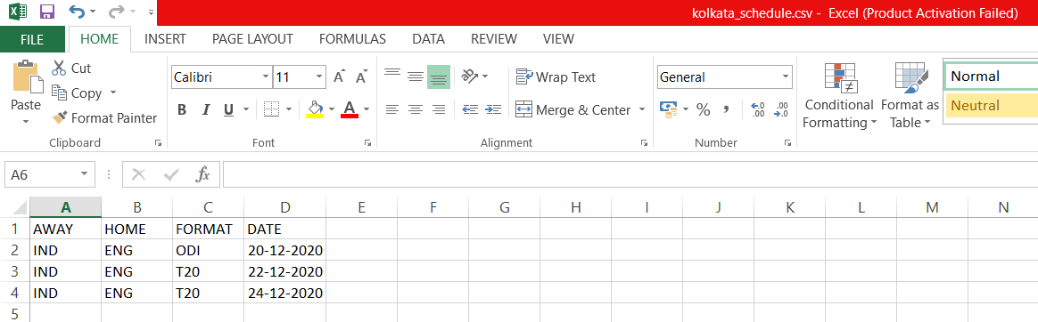

Figure : KOLKATA SCHEDULE SCREENSHOT ACTIVITY 2

### Chennai Stadium Schedule - Input Excel File

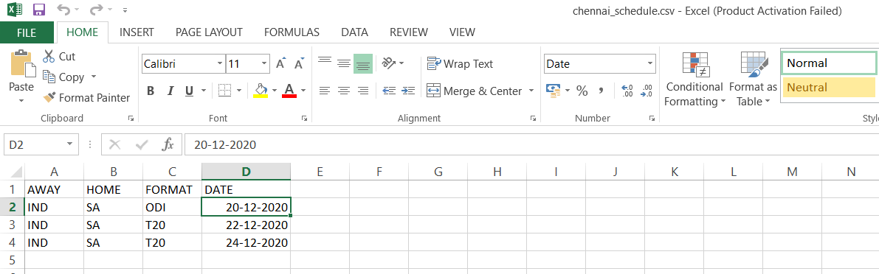

Figure : CHENNAI SCHEDULE SCREENSHOT ACTIVITY 2

## Output Files Screenshot

### Booking Detail - Output Excel File

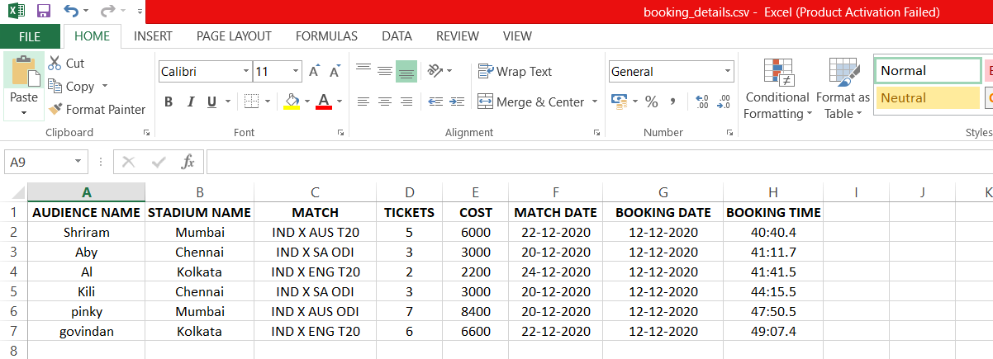

Figure : BOOKING DETAILS SCREENSHOT ACTIVITY 2

# RegEx Practice

## Code

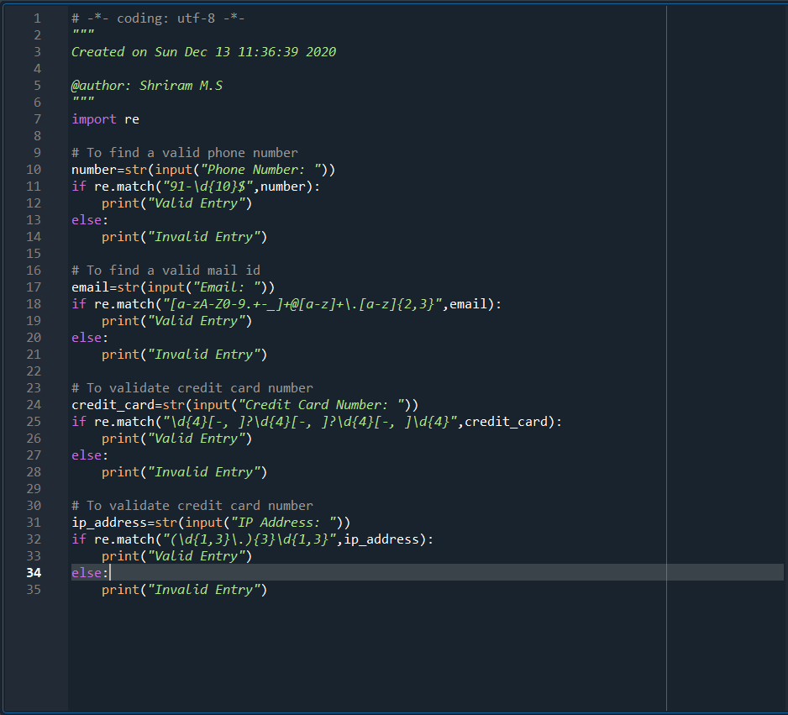

Figure : REGEX PRACTICE CODE SCREENSHOT

## Output

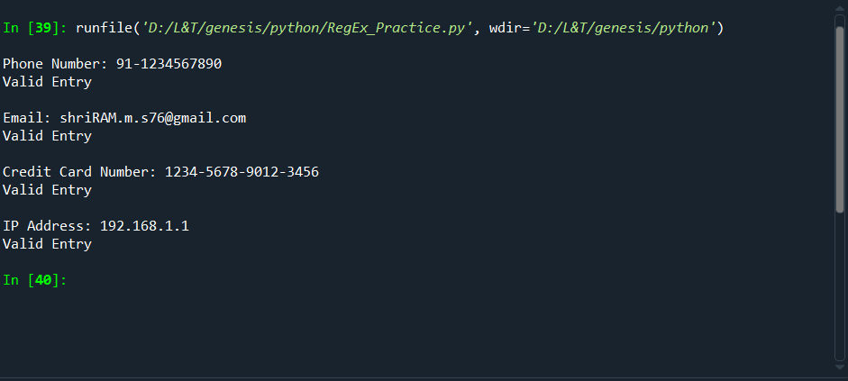

Figure : REGEX PRACTICE CODE OUTPUT SCREENSHOT