# Learning Report – Embedded C – Hardware

s./



+ Programming + Testing

**Document History**

|  |  |  |  |  |  |
| --- | --- | --- | --- | --- | --- |
| **Ver.Rel.**  **No.** | **Release Date** | **Prepared. By** | **Reviewed By** | **Approved By** | **Remarks/Revision Details** |
| 1.0 | 26-12-20 | Sowjanya sree |  | Dr. Vivek K and Bhargav N |  |
| 1.1 | 03-01-21 | Sowjanya Sree |  | Dr. Vivek K and Bhargav N |  |
|  |  |  |  |  |  |
|  |  |  |  |  |  |
|  |  |  |  |  |  |

## Contents

1. MAKE 4

1.1 Files after execution of make

1.2 Header section of main.o

2.0 MINI PROJECT 7

2.1 MAIN LOGIC FUNCTION 7

2.2GIT LINK 7

# 1.0 Files after execution of make:

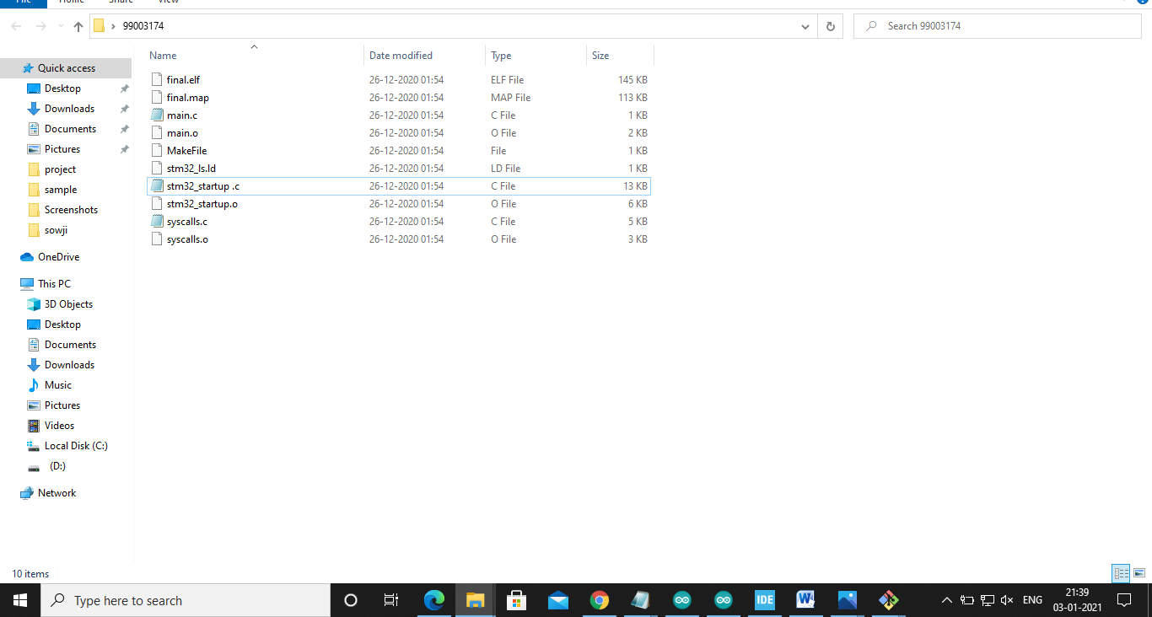

1.2Header section of main.o:

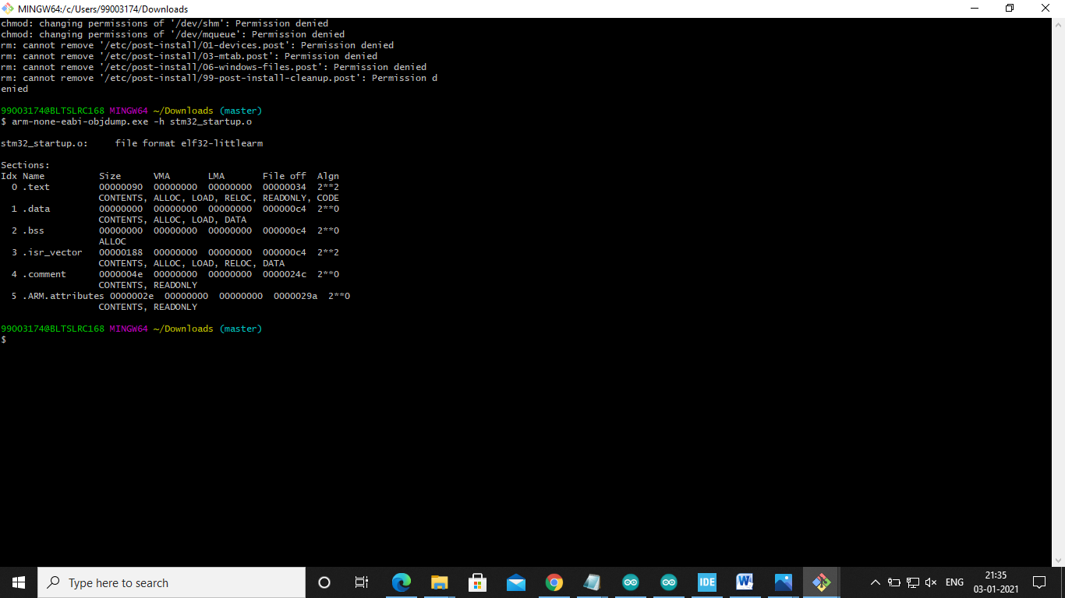

## Mini project

2.1 Main logic function:

## C:\Users\99003174\Pictures\Screenshots\Screenshot (18).png

2.2 GIT link:

<https://github.com/99003174/Embedded-c.git>