**Design**

**UML Diagram**

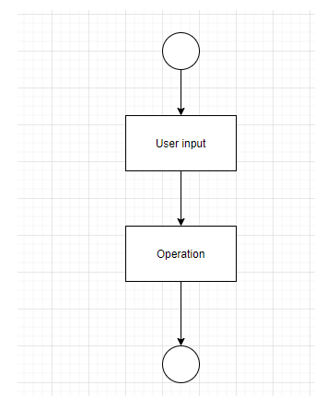

Fig 1. UML Diagram

**Class Diagram**

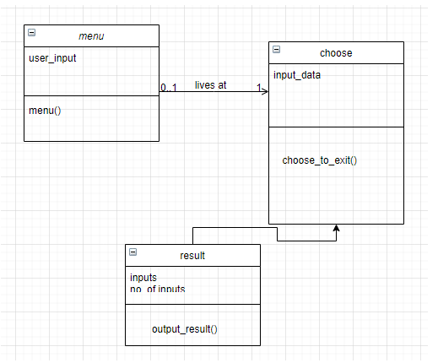

Fig 2. Class Diagram

**State Diagram**

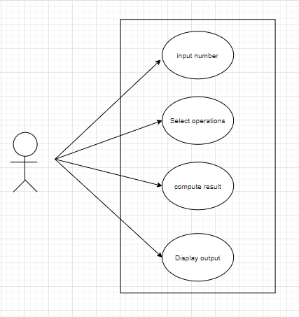

Fig 3. State Diagram

**Activity Diagram**

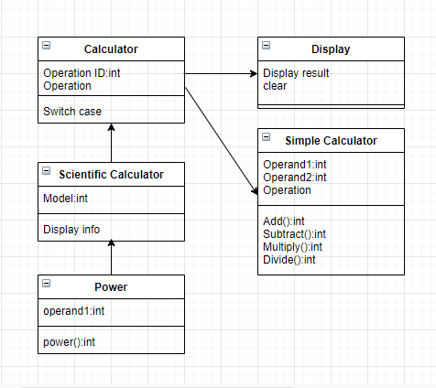

Fig 4. Activity Diagram

**Sequence Diagram**

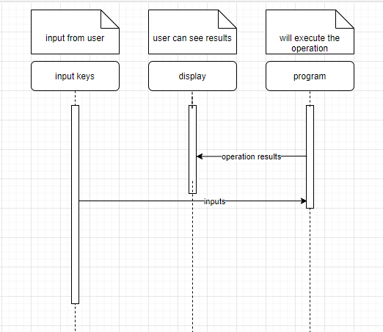

Fig 5. Sequence Diagram

**Flow Chart**

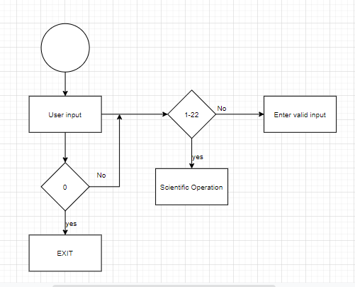

Fig 6. Flow Chart