./

GENESIS – EmbeddedC Learning Report



|  |  |  |  |  |  |
| --- | --- | --- | --- | --- | --- |
| **Ver. Rel. No.** | **Release Date** | **Prepared. By** | **Reviewed By** | **To be Approved** | **Remarks/Revision Details** |
| 1. | 2/1/2021 | G. Jnana Deepika |  |  |  |
|  |  |  |  |  |  |
|  |  |  |  |  |  |
|  |  |  |  |  |  |
|  |  |  |  |  |  |

**Details**

Contents

Activity 1 ………………………………………………………………………………………………………………………………………..4

Activity 2…………………………………………………………………………………………………………………………………………5

Activity 3…………..…………………………………………………………………………………………………………………………….6

Activity 4…..……………………………………………………………………………………………………………………………………7

**ACTIVITY 1:**

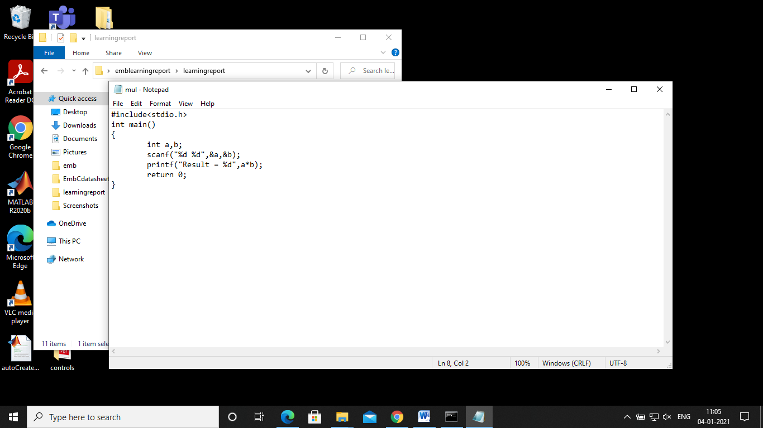

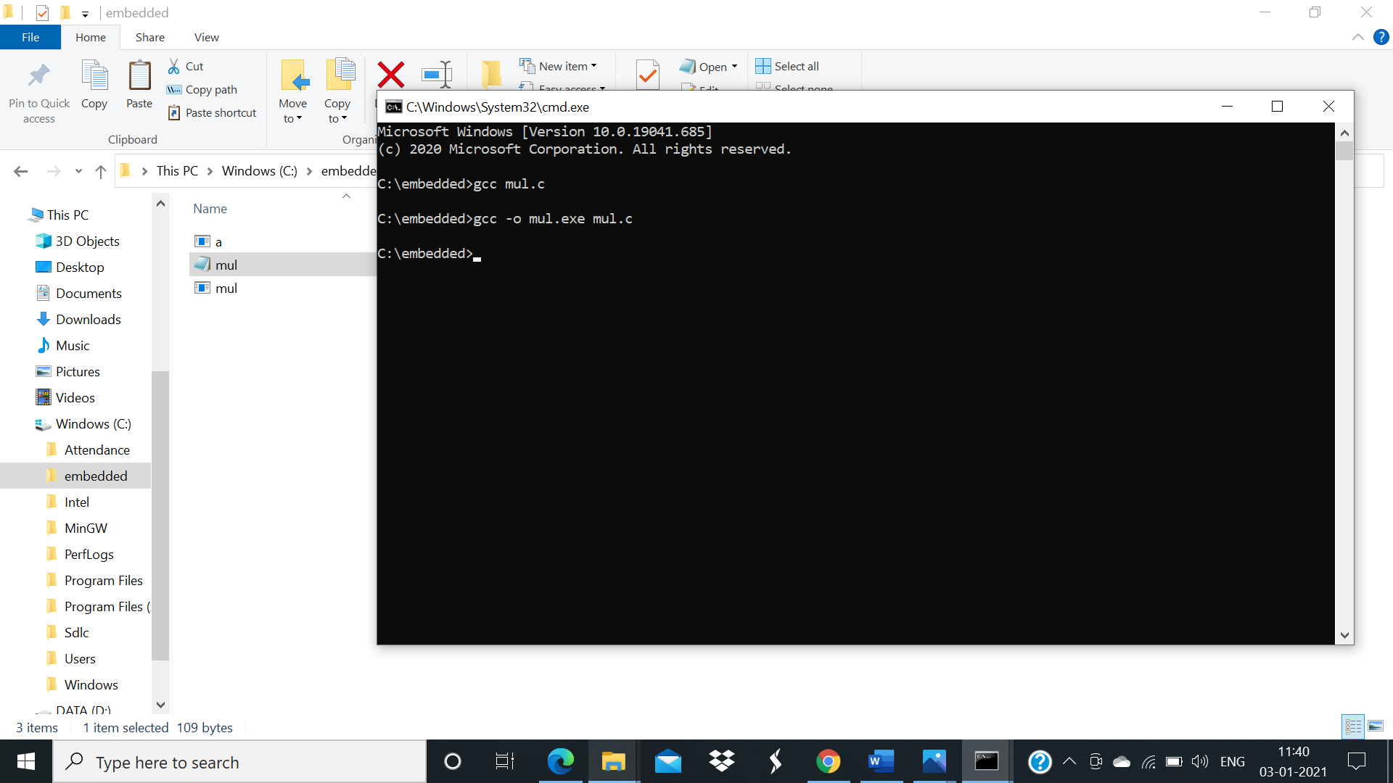

**Activity 2:**

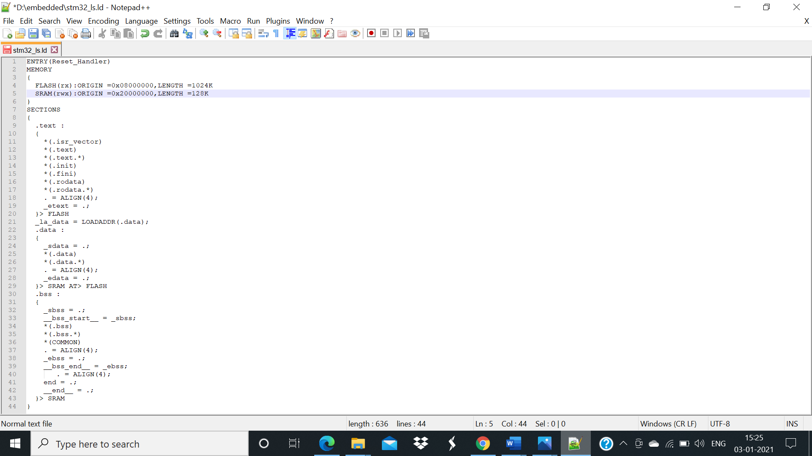

**ACTIVITY 3:**

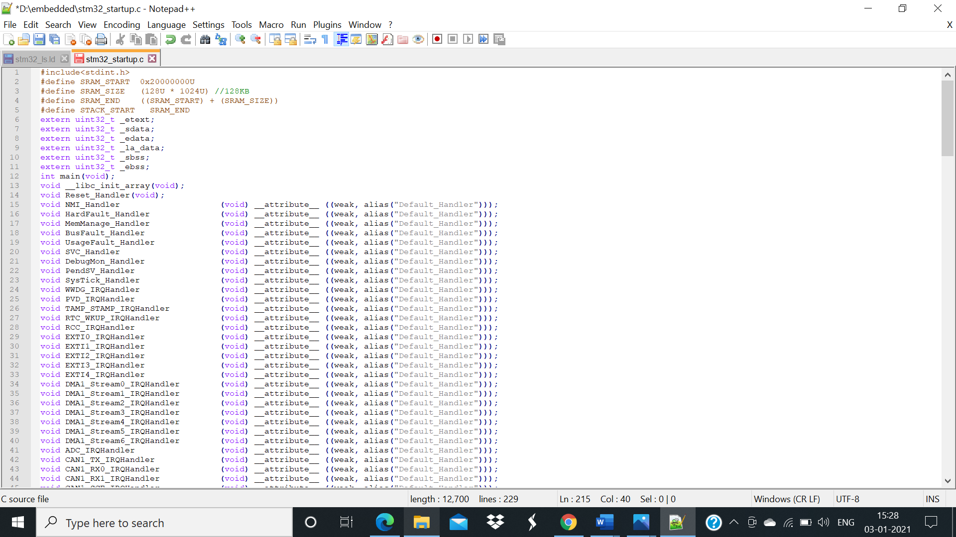

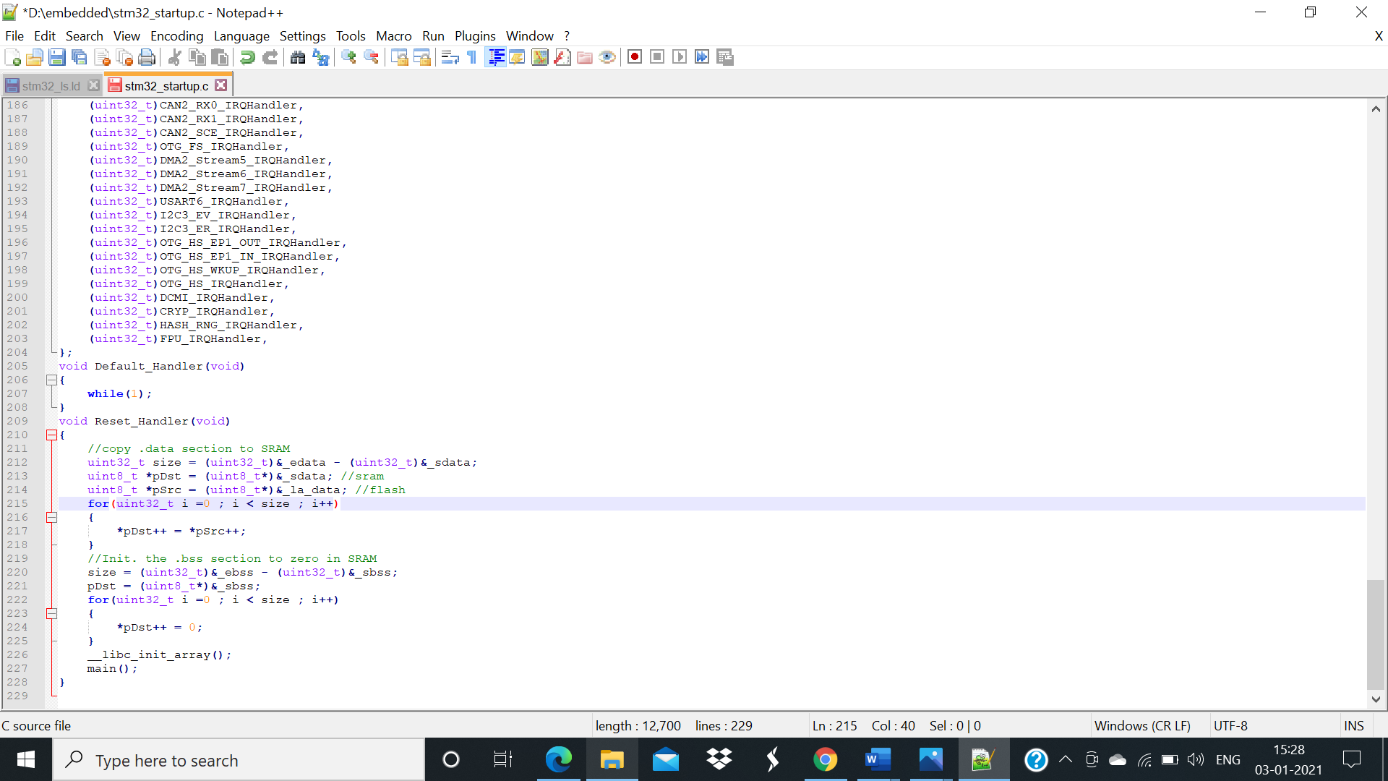

**ACTIVITY 4:**

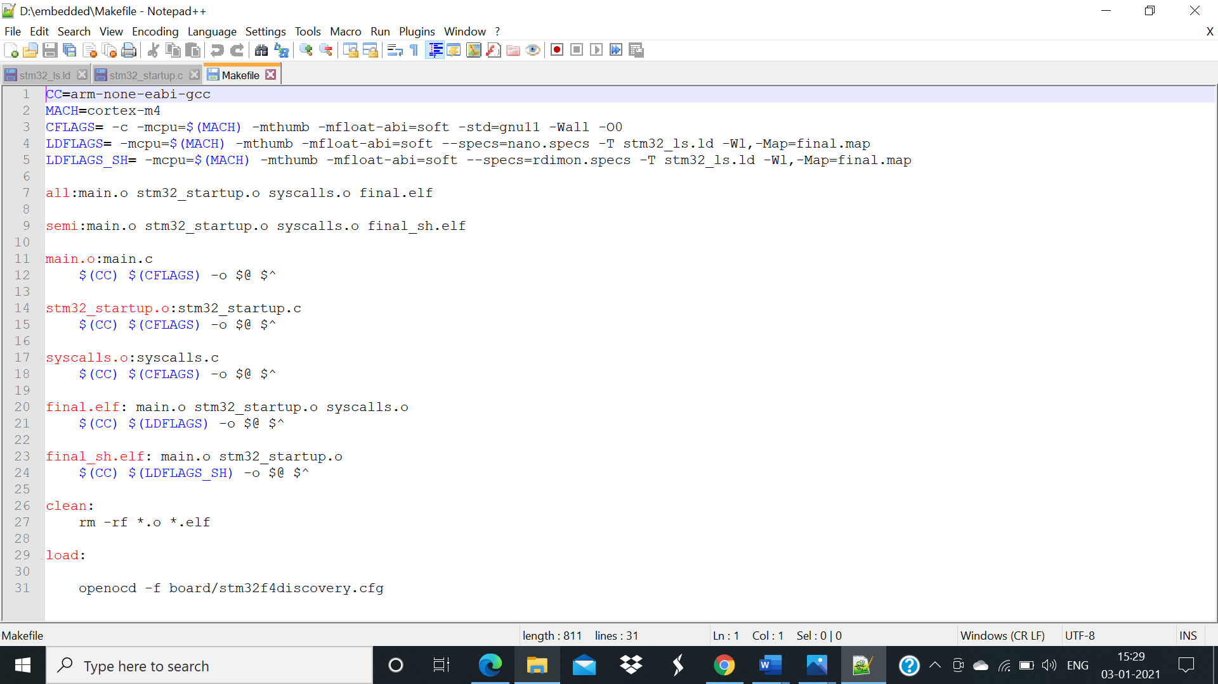

**Screenshot of final elf file generation:**

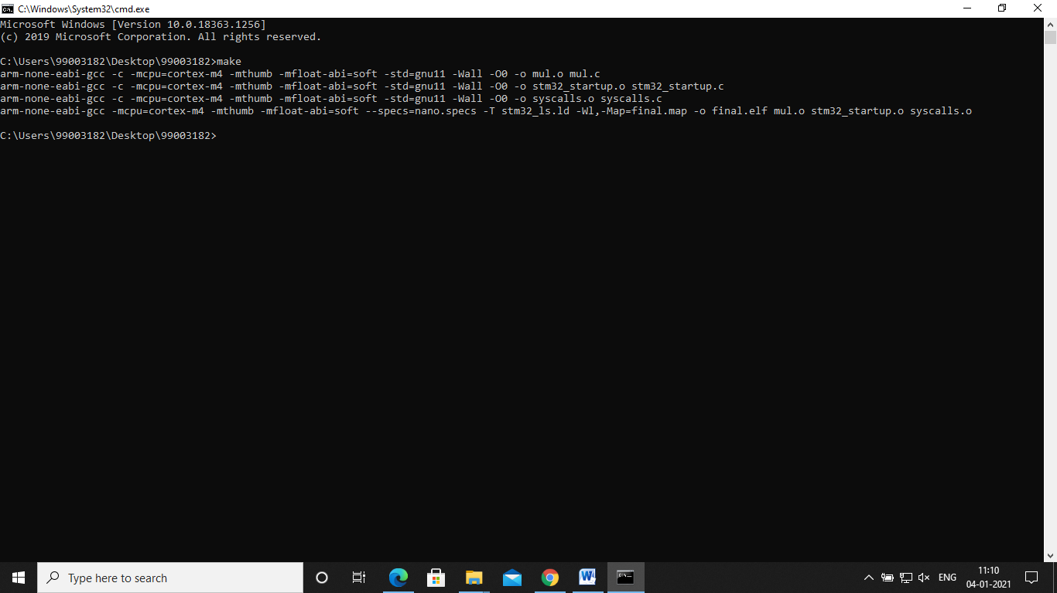

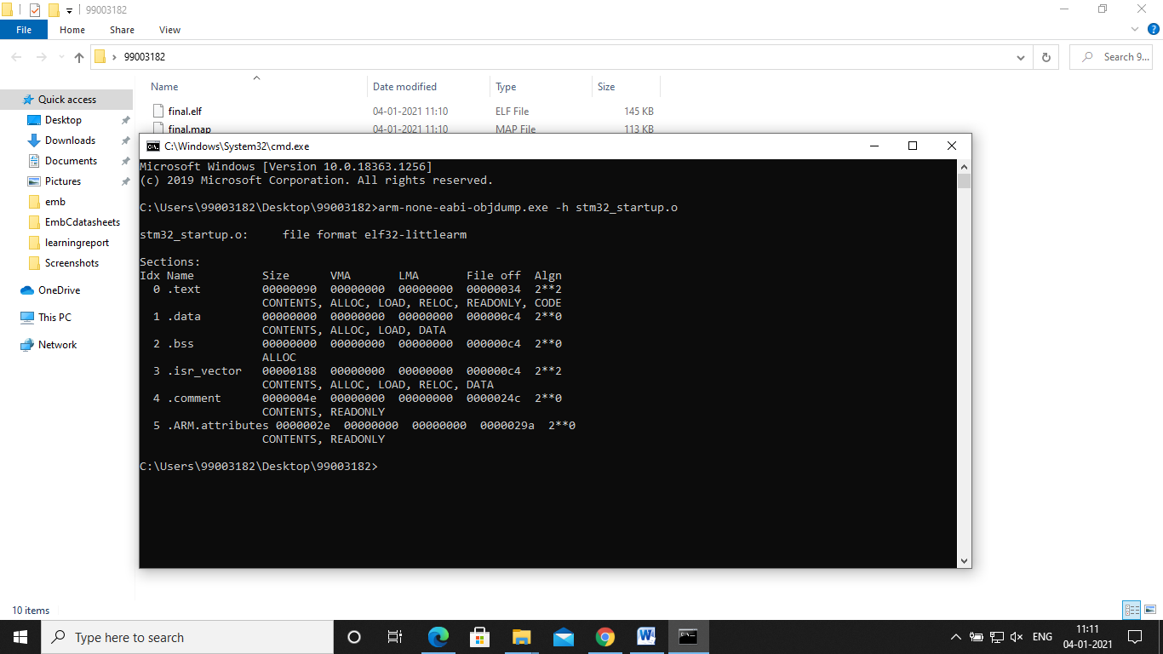

**Github Link:**

**https://github.com/99003182/embeddedcminiproject.git**