./

Report

on

Washing Machine System

Course Code: <CODE>



Version Number:

Team Members :

Team No:

Module: Model Based System Engineering

**Contents:**

1. **Problem Statement**
2. **Introduction**
3. **Proposed system**
4. **Requirements**
5. **Test Plan and Test cases**
6. **Expected Results**
7. **Output**

**1.Problem Statement:**

To design a washing machine system which takes user inputs based on which it performs actions like wash, rinse, spin and soak etc. in the washing machine.

**2. Introduction:**

Washing machine supports three functional modes:

1. Fully Automatic Mode: In fully automatic mode, once the system is started it perform independently without user interference. This mode instantaneously senses cloth quantity and requirement of water, water temperature, detergent, load, wash cycle time and perform operation accordingly.
2. Semi-Automatic Mode: In this semiautomatic mode in which washing conditions are predefined. Once the predefined mode is started the system perform its job.
3. Manual Mode: In this mode, user has to specify which operation he wants to do and has to provide related information to the control system. Then the system asks the user to enter the wash time, amount of water and the load.

**3.Proposed system:**

In manual mode washing machines, a user has to specify which operation he wants to do and has to provide related information to the control system. For example, if a user wants to only rinse clothes but not wash then he has to select the ‘rinse’ option manually. Washing machine system is one which takes all the user inputs and controls the speed of the motor in different phases such as in Washing, Cleaning, Drying etc and all kinds of sensors and displays the corresponding action which will be taken based on user inputs in the display unit.

This project aims at developing code which will be a replica of a washing machine system which produces output based on user input.

**Features:**

* user is allowed to power on the washing machine
* user can access previous log activities
* user can choose the load capacity of clothes
* user can choose washing method
* user can set soak time if soaking is chosen
* user gets the summary of all the chosen options with total time taken to wash the clothes at the end

**4.Requirements:**

**Software:** Dev-C++

Dev-C++ is a free full-featured integrated development environment (IDE) distributed under the GNU General Public License for programming in C and C++. It is written in Delphi. It is bundled with, and uses, the MinGW or TDM-GCC 64bit port of the GCC as its compiler. Dev-C++ can also be used in combination with Cygwin or any other GCC-based compiler.

**Programming Language:** C

**Use Case Diagram:**

A use case diagram in the Unified Modelling Language (UML) is a type of behavioral diagram defined by and created from a Use-case analysis. Its purpose is to present a graphical overview of the functionality provided by a system in terms of actors, their goals (represented as use cases), and any dependencies between those use cases.

The main purpose of a use case diagram is to show what system functions are performed for which actor. Roles of the actors in the system can be depicted.

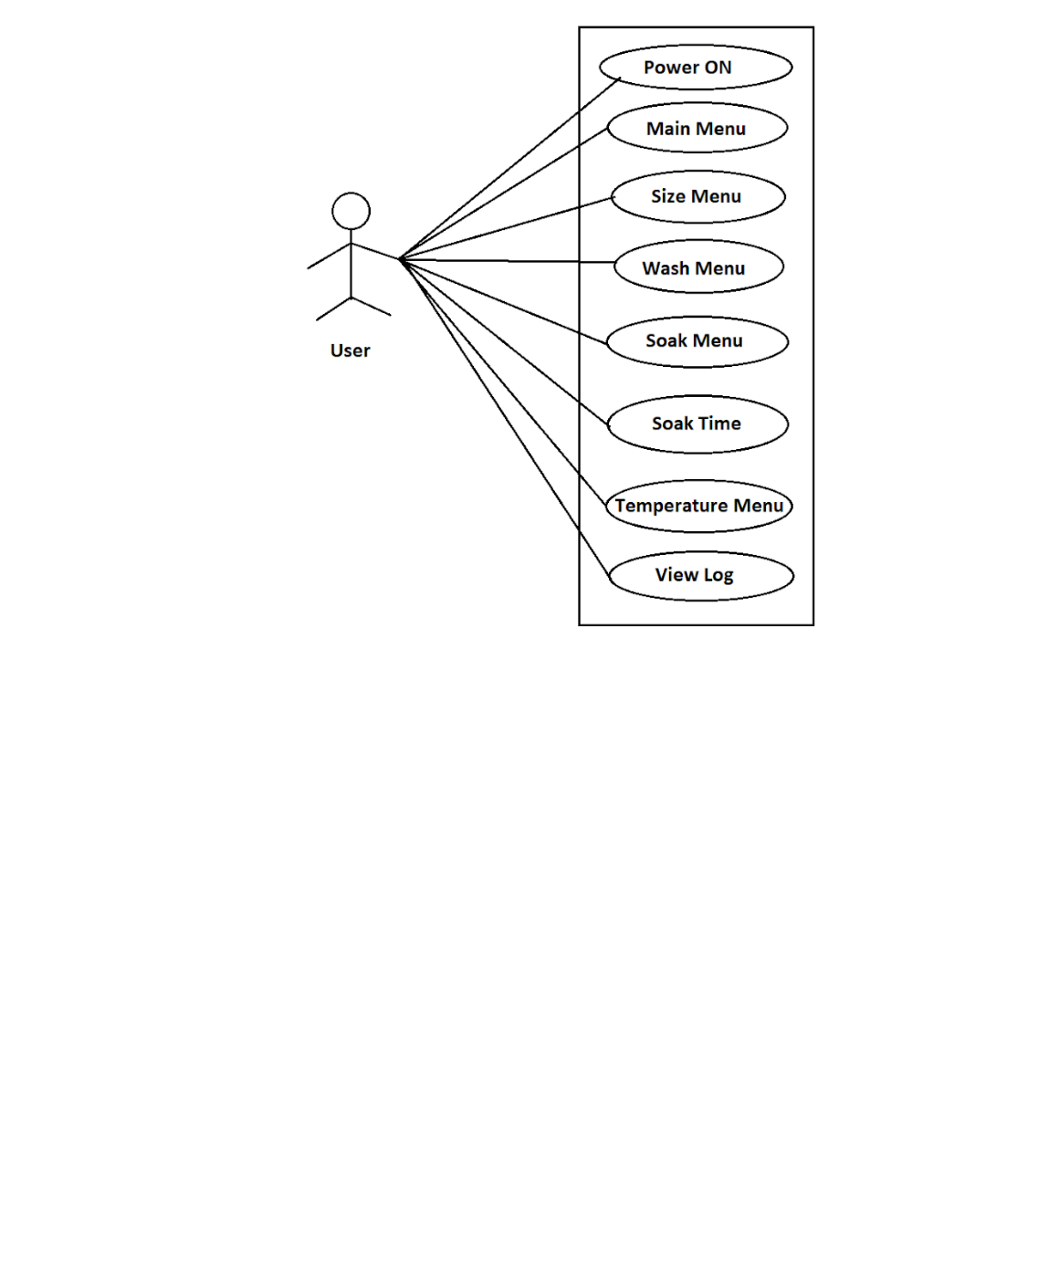

Figure1. Use case diagram of user

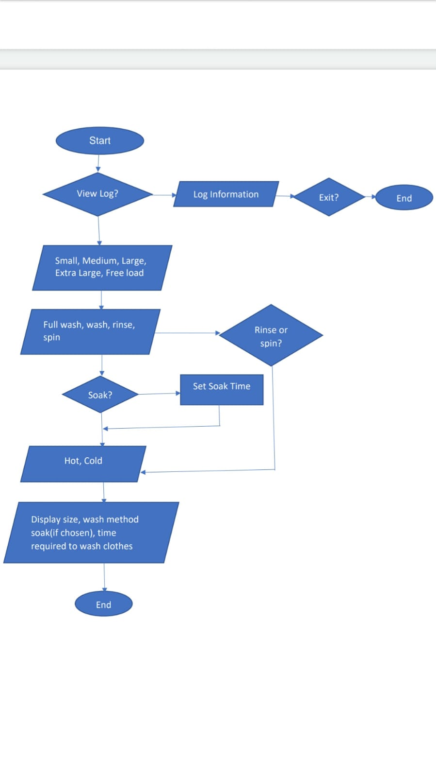

Figure2. Flowchart of washing machine system

**5.Test plan and Test cases:**

Washing machine will have many buttons using which user gives the input.

|  |  |  |  |
| --- | --- | --- | --- |
| **TC#** | **Test Cases** | **Expected output** | **Status of Execution** |
| **1** | **Turning on the washing machine:** Press letter ‘o’ to start washing machine. | On pressing the ‘o’ Main menu should appear. On pressing any other key message, the washing machine is off and has to be displayed. | Pass |
| **2** | **Main menu:** Press letter ‘w’ to wash clothes Press letter ‘v’ to view previous options chosen by the user | If ‘w’ is pressed then the Size menu should appear. If ‘v’ is pressed then the previous log should appear. | Pass |
| **3** | **Size menu:** Press ‘s’ for small size, ‘m’ for medium size, ‘l’ for large size, ‘x’ for extra-large size, ‘f’ for freeload. | After choosing a specific option from the Size menu, the wash menu should appear. | Pass |
| **4** | **Wash menu:** Press ‘f’ for full wash, ‘w’ for wash, ‘s’ for spin, ‘r’ for rinse | If the option full wash or wash is selected then the soak menu should appear. If spin or rinse is selected, a direct temperature menu should appear. | Pass |
| **5** | **Soak menu:** Press ‘y’ for soaking, ‘n’ for not soaking | If ‘y’ is pressed soak time has to be set between 1 to 60 minutes if greater than 60 min is given then invalid message has to be shown. If ‘n’ is pressed then the temperature menu should appear. | Pass |
| **6** | **Temperature menu:** Press ‘h’ to choose hot water, ‘c’ to choose cold water for operation | After choosing ‘h’ or ‘c’, options selected by the user so far has to be displayed including wash time and soak time (if selected) with the total time for washing the clothes | Pass |

**6.Expected Results:**

The system should run without any error. The user should be allowed to power on the washing machine by pressing ‘o’, then user will be given two choices where user can press ‘v’ to view previous log and ‘w’ for washing clothes which will display size menu. The size menu is used to select the clothes size if free load is selected then machine decides the size. Next the user has to choose the washing method in wash menu where full wash and wash will be provided with the option of soaking. If ‘y’ is pressed in soak menu then the user has to give the soaking duration. Finally, in the display all the options selected by the user should be displayed.

**7.Output**

**When program is RUN without any errors, we will obtain the output will be as follows:**

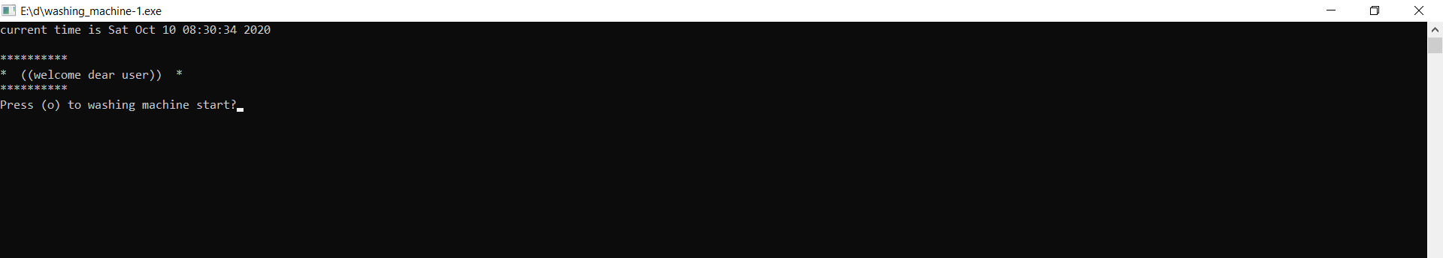

**Figure3. Welcome message and on and off state**

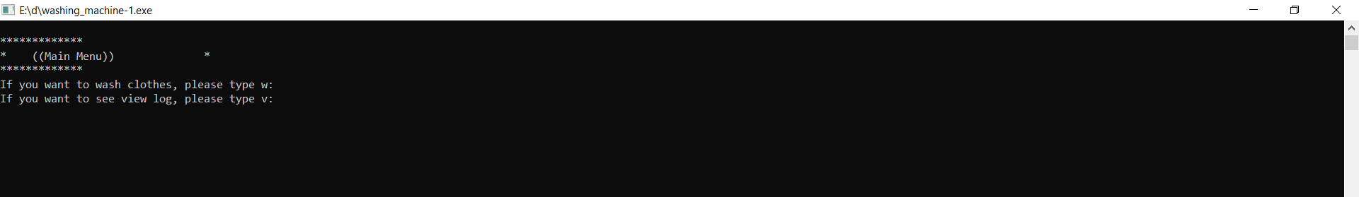

**Figure4. Main Menu to choose between view log and wash**

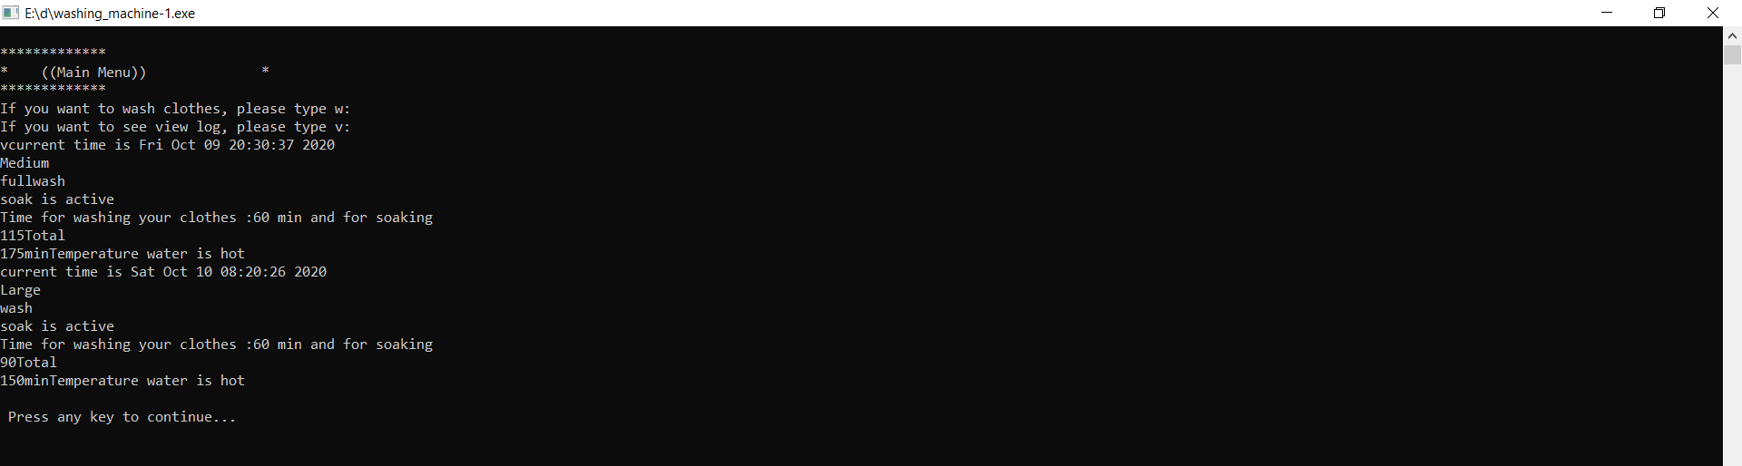

**Figure5. If view log is chosen by user**

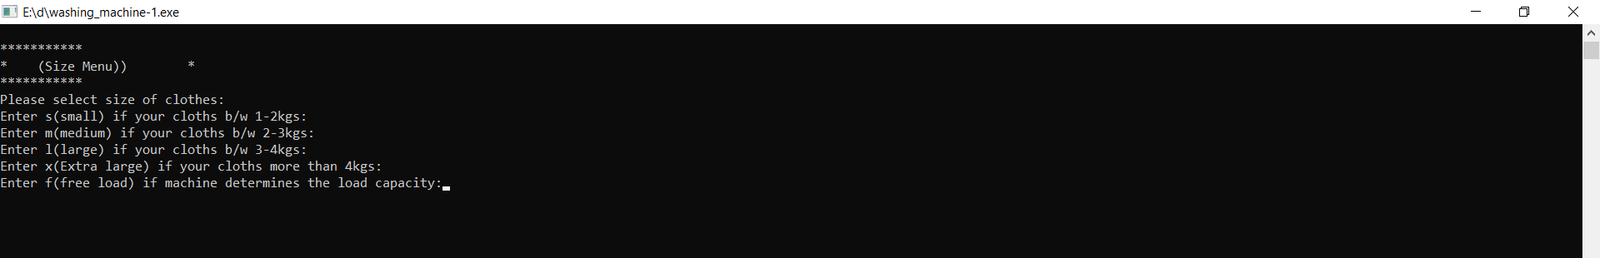

**Figure6. Size Menu if wash is selected by user**

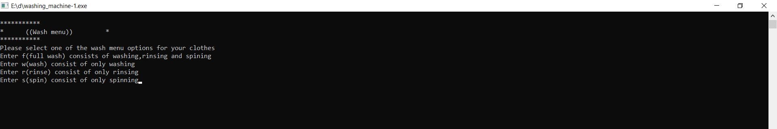

**Figure7. Wash Menu to choose washing method**

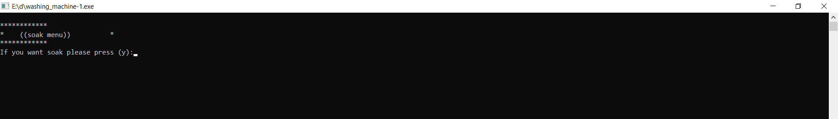

**Figure8. Soak Menu if full wash or wash method is chosen by user**

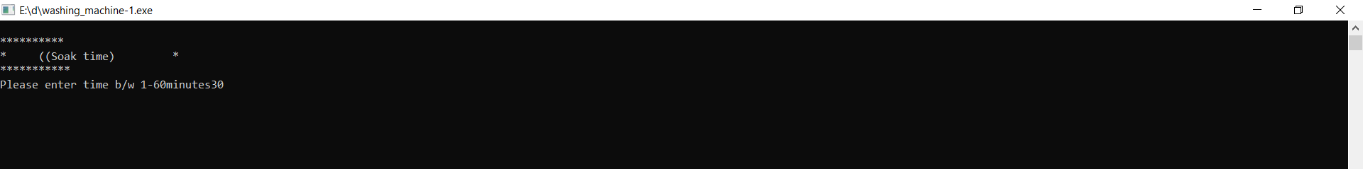

**Figure9. Soak Time has to be set by user if soaking is selected**

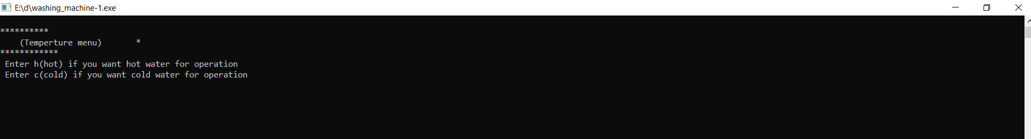

**Figure10. Temperature Menu to choose type of water for operation**

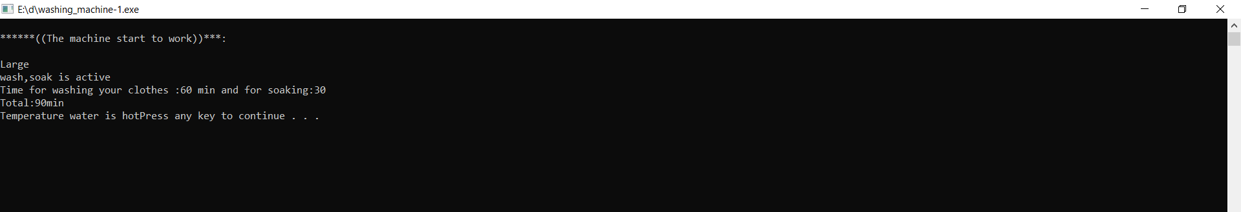

**Figure11. Final output which display all the options chosen by user when soak is selected**

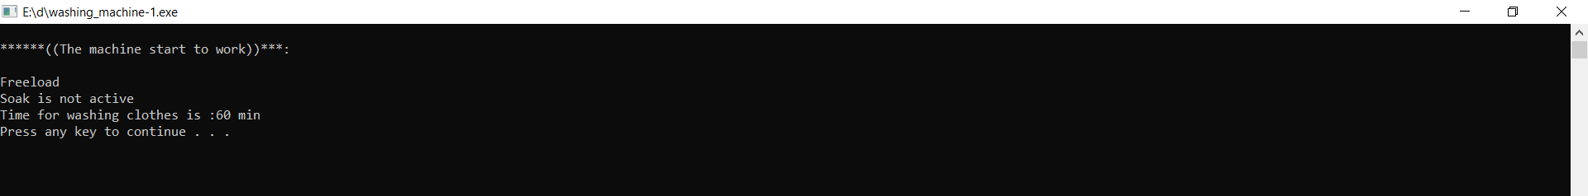

**Figure12. Final output which display all the options chosen by user when soak is not selected**

**Document History**

|  |  |  |  |  |  |
| --- | --- | --- | --- | --- | --- |
| **Ver. Rel. No.** | **Release Date** | **Prepared. By** | **Reviewed By** | **Approved By** | **Remarks/Revision Details** |
|  |  |  |  |  |  |
|  |  |  |  |  |  |
|  |  |  |  |  |  |
|  |  |  |  |  |  |
|  |  |  |  |  |  |

# 