./

GENESIS - Learning Report

Embedded c



|  |  |  |  |  |  |
| --- | --- | --- | --- | --- | --- |
| **Ver. Rel. No.** | **Release Date** | **Prepared. By** | **Reviewed By** | **To be Approved** | **Remarks/Revision Details** |
| 1 | 02/01/2021 | Rithesh R Prabhu |  |  |  |
|  |  |  |  |  |  |
|  |  |  |  |  |  |
|  |  |  |  |  |  |
|  |  |  |  |  |  |

**Details**

**CONTENTS**

**Activity 1: Build Process 4**

**Activity 2: Linker Script 5**

**Activity 3: Startup Code 6**

**Activity 4: Makefile 7**

**Activity 5: Mini Project 8**

# Activity-1:

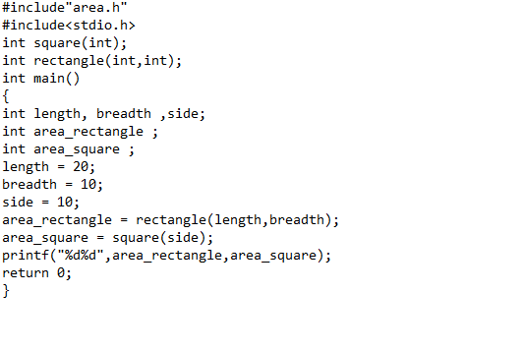

Fig 1- Program code

# Acitivity 2:Linker Script

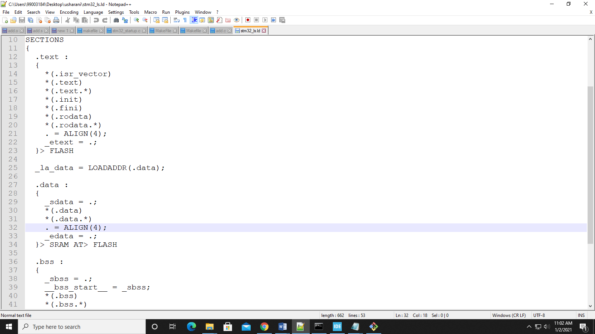

Fig 2: Linker Script

# **Activity-3**: Start-up Code:

Various Address of Interrupt Subroutine Vectors(ISR) and its priorities of ISR’s:

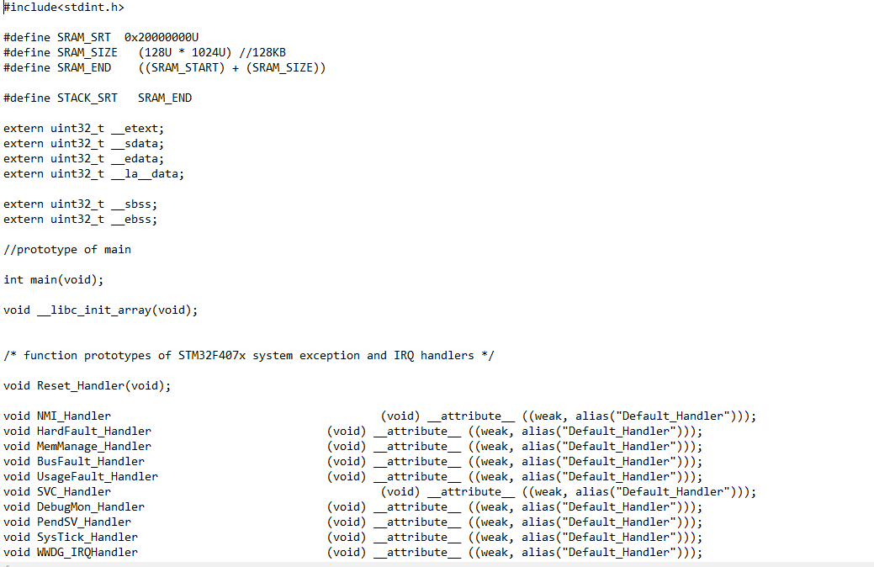

Fig 3- Startup code

**Activity-4:**

Makefile:

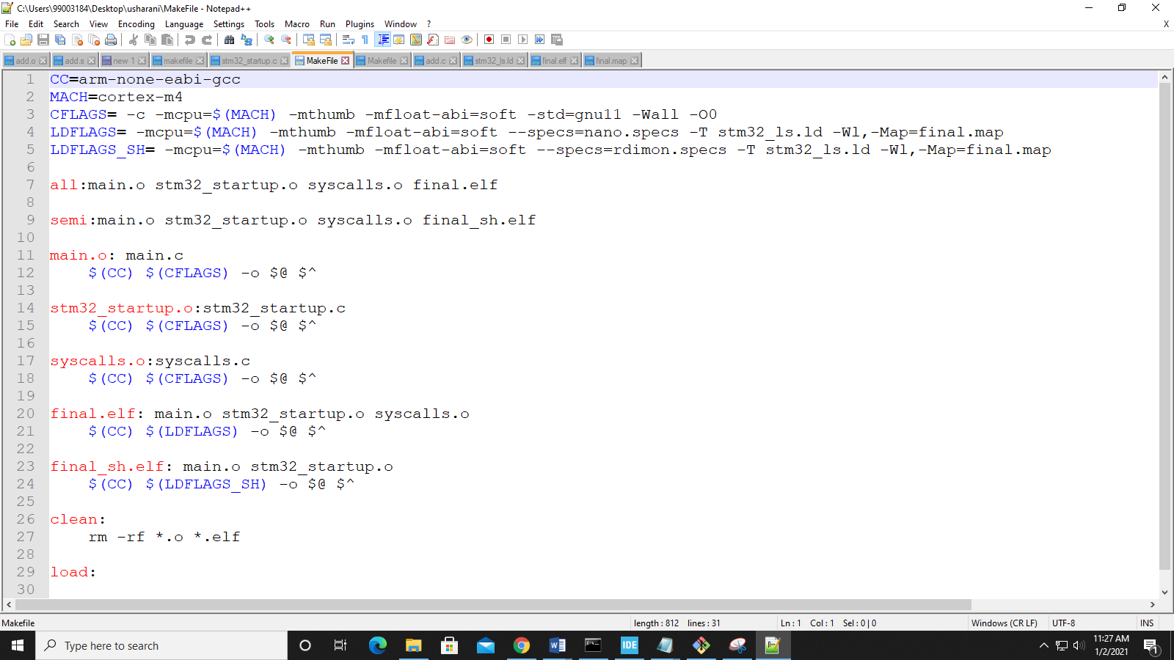

Fig 4- Makefile

# Activity 5: Mini Project

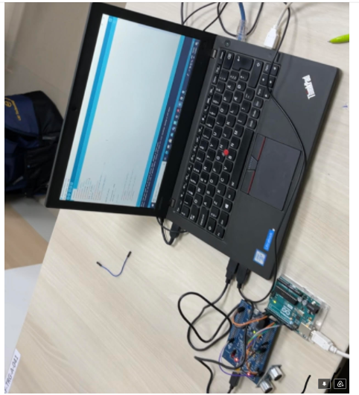

Fig 5: Output of mini project

Github Link: <https://github.com/99003188/DistanceDectectionUsingUltraSonicSensor.git>