# PS NO. 99003188

# Project: Alarm Clock (without oops concept) PS NO. 99003188

# importing date and time model

import datetime

# Enter the time in HH:MM format 12 hour clock

print("Enter the time in 12 hours format(HH:MM) ")

alarm_hour = int(input("Enter HH: "))

# The hour must be between 1 and 12

if (alarm_hour > 13 or alarm_hour < 1):

print("please enter a valid time")

exit()

alarm_minute = int(input("Enter MM: "))

# The minute must be between 0 and 60

if (alarm_minute > 61 or alarm_minute < 0):

print("please enter a valid time")

exit()

# The time convention is am or pm

alarm_am_pm = str(input("am or pm: "))

if (alarm_am_pm != "am" and alarm_am_pm != "pm"):

print("please enter valid details")

exit()

if (alarm_am_pm == 'pm'):

alarm_hour = alarm_hour+12

# Creating a function for functioning of the clock,

# checks the time and hour

def alarm_clock():

while(1):

if (alarm_hour == datetime.datetime.now().hour and

alarm_minute == datetime.datetime.now().minute):

print("wake up now")

break

# calling alarm_call function

alarm_clock()

# defining a function named snooze

def alarm_snooze():

global alarm_minute, alarm_hour, alarm_am_pm

alarm_minute1 = alarm_minute

alarm_hour1 = alarm_hour

miss_var1 = str(input("Enter Y to snooze "))

if (miss_var1 == "Y"):

alarm_snooze_min = int(input("Enter the snooze time in MM format: "))

if (alarm_snooze_min > 31 or alarm_snooze_min < 0):

print("Enter a valid time: ")

exit()

alarm_minute1 = alarm_minute1+alarm_snooze_min

if(alarm_minute1 > 61):

alarm_hour1 = alarmhour1+1

if (alarm_hour1 > 12):

alarm_hour1 = 1

alarm_minute1 = alarm_minute1+alarm_snooze_min-60

while(1):

if (alarm_hour1 == datetime.datetime.now().hour and

alarm_minute1 == datetime.datetime.now().minute):

print("wake up now")

break

# calling a function

alarm_snooze()

Github link: <https://github.com/99003188/pythonminiproject>

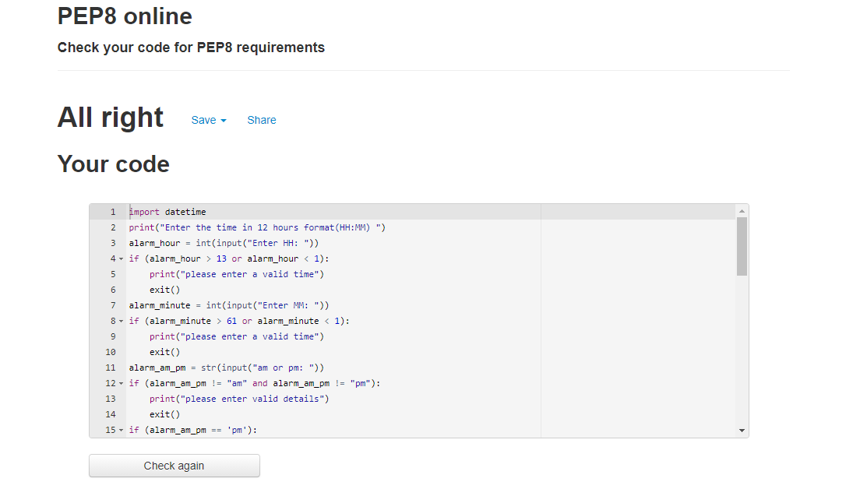

Fig1: Code quality

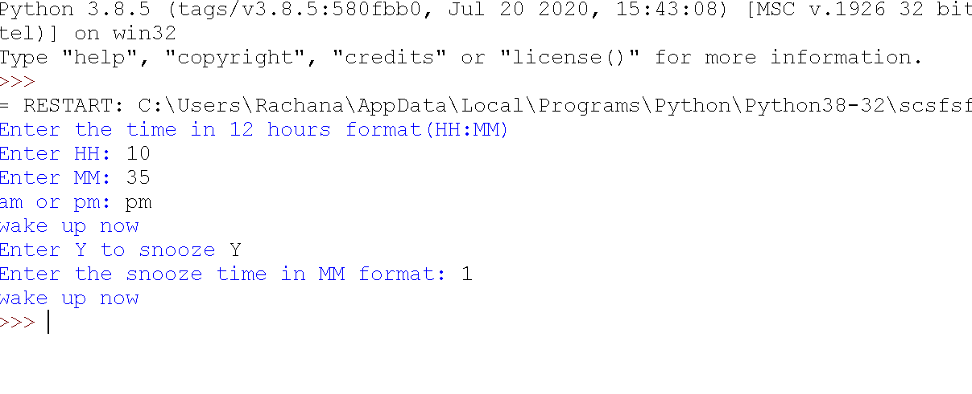Fig2: Output of the project