./

GENESIS - Learning Outcome & Mini-project Summary Report



|  |  |  |  |  |  |
| --- | --- | --- | --- | --- | --- |
| **Ver. Rel. No.** | **Release Date** | **Prepared. By** | **Reviewed By** | **To be Approved** | **Remarks/Revision Details** |
| 1 | 10/12/20 | Rithesh R Prabhu |  |  | Code without oops |
| 2 | 11/12/20 | Rithesh R prabhu |  |  | Code with oops |
| 3 | 12/12/20 | Rithesh R Prabhu |  |  | Code with oops and RE |
|  |  |  |  |  |  |
|  |  |  |  |  |  |

**Details**

Table of Contents

Table of Contents 3

1: Python Code without OOPs 4

1.1: Source code 4

2: Python Code with OOPS 7

2.1: Source code 7

List of Figures:

Figure 1:Code Quality 6

Figure 2: output of the project 6

Figure 3:Code Quality (oops concept) 10

Figure 4:ouput(oops concept) 10

## 1: Python Code without OOPs

### 1.1: Source code

# importing date and time model

import datetime

# Enter the time in HH:MM format 12 hour clock

print("Enter the time in 12 hours format(HH:MM) ")

alarm_hour = int(input("Enter HH: "))

# The hour must be between 1 and 12

if (alarm_hour > 13 or alarm_hour < 1):

print("please enter a valid time")

exit()

alarm_minute = int(input("Enter MM: "))

# The minute must be between 0 and 60

if (alarm_minute > 61 or alarm_minute < 0):

print("please enter a valid time")

exit()

# The time convention is am or pm

alarm_am_pm = str(input("am or pm: "))

if (alarm_am_pm != "am" and alarm_am_pm != "pm"):

print("please enter valid details")

exit()

if (alarm_am_pm == 'pm'):

alarm_hour = alarm_hour+12

# Creating a function for functioning of the clock,

# checks the time and hour

def alarm_clock():

while(1):

if (alarm_hour == datetime.datetime.now().hour and

alarm_minute == datetime.datetime.now().minute):

print("wake up now")

break

# calling alarm_call function

alarm_clock()

# defining a function named snooze

def alarm_snooze():

global alarm_minute, alarm_hour, alarm_am_pm

alarm_minute1 = alarm_minute

alarm_hour1 = alarm_hour

miss_var1 = str(input("Enter Y to snooze "))

if (miss_var1 == "Y"):

alarm_snooze_min = int(input("Enter the snooze time in MM format: "))

if (alarm_snooze_min > 31 or alarm_snooze_min < 0):

print("Enter a valid time: ")

exit()

alarm_minute1 = alarm_minute1+alarm_snooze_min

if(alarm_minute1 > 61):

alarm_hour1 = alarmhour1+1

if (alarm_hour1 > 12):

alarm_hour1 = 1

alarm_minute1 = alarm_minute1+alarm_snooze_min-60

while(1):

if (alarm_hour1 == datetime.datetime.now().hour and

alarm_minute1 == datetime.datetime.now().minute):

print("wake up now")

break

# calling a function

alarm_snooze()

Github link: <https://github.com/99003188/pythonminiproject>

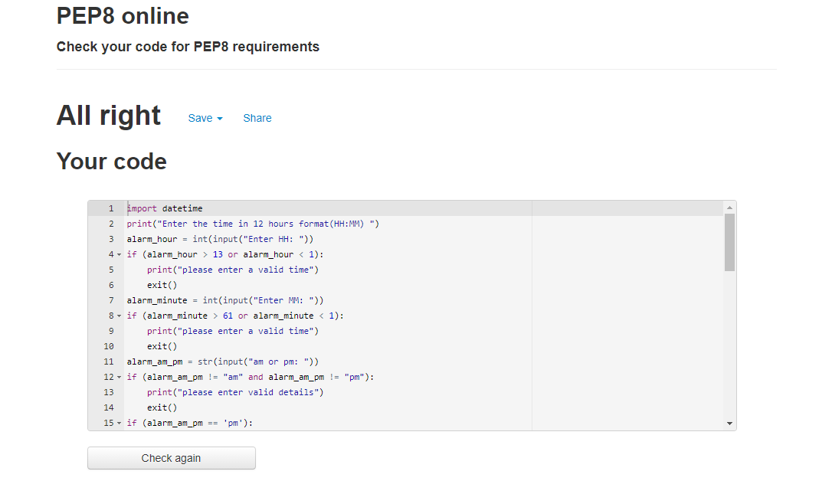

Figure :Code Quality

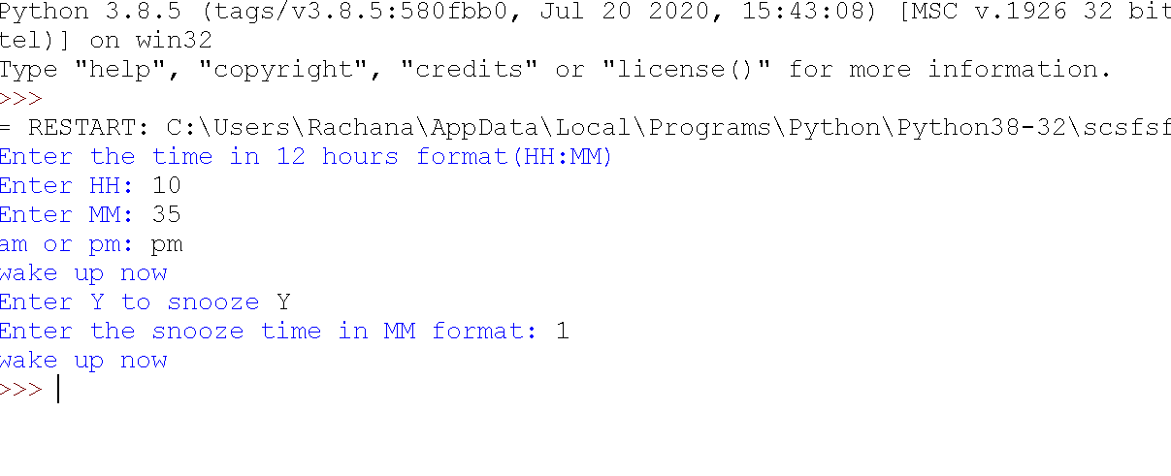

Figure : output of the project

## 

## 2: Python Code with OOPS

### 2.1: Source code

# import datetime module

import datetime

# import regular expression module

import re

# class for main setup alarm

class alarm():

print("Enter the time in 12 hours format(HH:MM) ")

# constructor to intialize variables required for function

def __init__(self, alarm_minute=0, alarm_hour=0, alarm_am_pm=0):

self.alarm_hour = int(input("Enter HH: "))

self.alarm_minute = int(input("Enter MM: "))

self.alarm_am_pm = str(input("am or pm: "))

self.lg = self.label()

# method for setup for alarm

def alarm_setup(self):

if (self.alarm_hour > 13 or self.alarm_hour < 1):

print("please enter a valid time")

exit()

if (self.alarm_minute > 61 or self.alarm_minute < 0):

print("please enter a valid time")

exit()

if (self.alarm_am_pm != "am" and self.alarm_am_pm != "pm"):

print("please enter valid details")

exit()

if (self.alarm_am_pm == 'pm'):

self.alarm_hour = self.alarm_hour+12

while(1):

if (self.alarm_hour == datetime.datetime.now().hour and

self.alarm_minute == datetime.datetime.now().minute):

print("wake up now")

break

# creating a class for label, which is used to note down important requirements

class label:

def label_show(self):

enter_label = str(input("Enter the label"))

# creating a class for snooze option

class snooze(alarm):

# creating a constructor for intializing the variables

def __init(self, alarm_minute1=0, alarm_hour1=0):

self.alarm_minute1 = self.alarm_minute

# creating a method called as snooze

def alarm_snooze(self):

miss_var1 = str(input("Enter Y to snooze "))

if (miss_var1 == "Y"):

alarm_snooze_min = int(input("Enter the snooze time in MM format"))

else:

exit()

self.alarm_minute = self.alarm_minute + alarm_snooze_min

if (alarm_snooze_min > 31 or alarm_snooze_min < 0):

print("Enter a valid time: ")

exit()

if(self.alarm_minute > 61):

self.alarm_hour = self.alarmhour+1

if (self.alarm_hour > 12):

self.alarm_hour = 1

self.alarm_minute = self.alarm_minute+alarm_snooze_min-60

# method to print after alarm

def alarm_snooze_function(self):

if (self.alarm_am_pm == 'pm'):

self.alarm_hour = self.alarm_hour+12

while(1):

if (self.alarm_hour == datetime.datetime.now().hour and

self.alarm_minute == datetime.datetime.now().minute):

print("wake up now")

break

# creating a class to display the final comments

class display(snooze):

def display_output(self):

print("Thank you for using alarm clock")

object1 = alarm()

object2 = snooze()

object3 = object2.lg

object4 = display()

object1.alarm_setup()

object3.label_show()

object2.alarm_snooze()

object2.alarm_snooze_function()

object4.display_output()

# regular expressions

print(re.search("[a-z]+[1-9][@][a-z]+[.][a-z]+", "prabhurithesh1@gmail.com"))

Github link: <https://github.com/99003188/pythonminiproject>

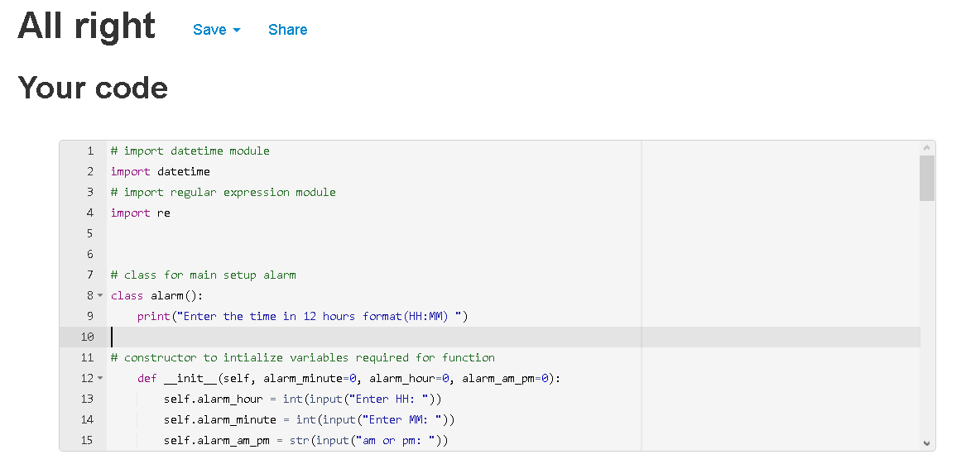

Figure :Code Quality (oops concept)

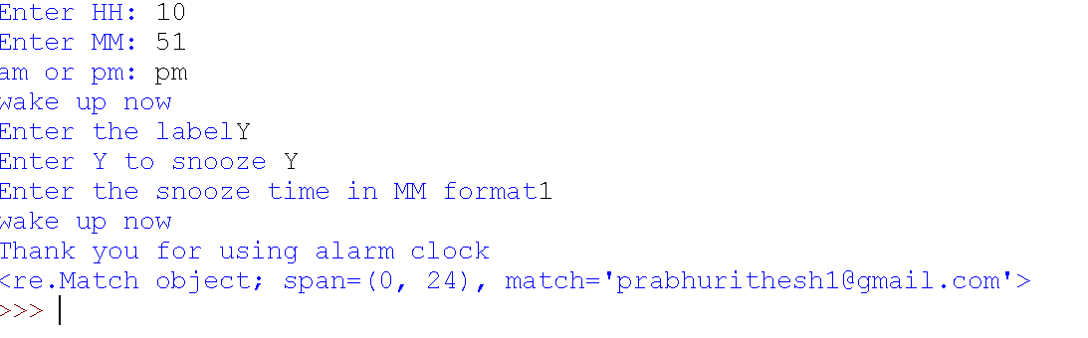

Figure :ouput(oops concept)