**./**

GENESIS – Embedded C Learning Report



|  |  |  |  |  |  |
| --- | --- | --- | --- | --- | --- |
| **Ver. Rel. No.** | **Release Date** | **Prepared. By** | **Reviewed By** | **To be Approved** | **Remarks/Revision Details** |
| 1.0 | 02/01/21 | Amaljith S |  |  |  |
|  |  |  |  |  |  |
|  |  |  |  |  |  |
|  |  |  |  |  |  |
|  |  |  |  |  |  |

**Details**

Contents

Contents 3

Activity 1 4

1.1 Build Using Git Bash 4

GREAT.C FILE 4

GREAT.H FILE 4

MAIN.C FILE 4

Build After Running in Git Bash 5

Activity 2 6

2.1 Linker Script 6

Activity 3 8

3.1 Startup Code 8

Activity 4 8

4.1 Build Using Makefile 8

4.2 Screenshot of Output after Running Make 9

4.3 Files Created 9

4.4 Github Link 9

Activity 5 10

5.1 Mini Project 10

5.1.1 Code Implementation 10

5.1.2 Hardware 12

5.1.3 Output 12

# Activity 1

## Build Using Git Bash

### GREAT.C FILE

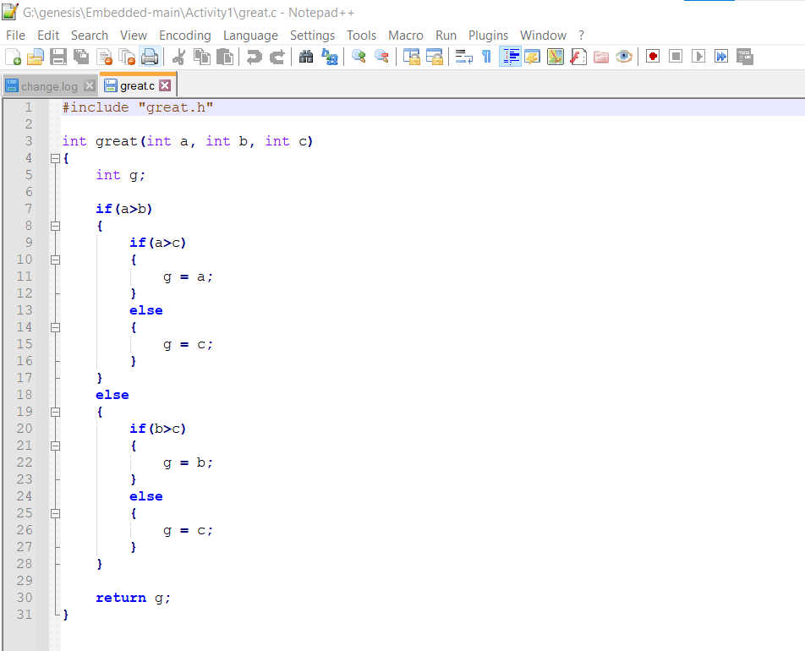

### GREAT.H FILE

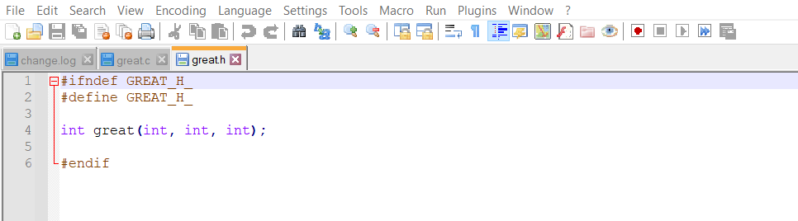

### 

### MAIN.C FILE

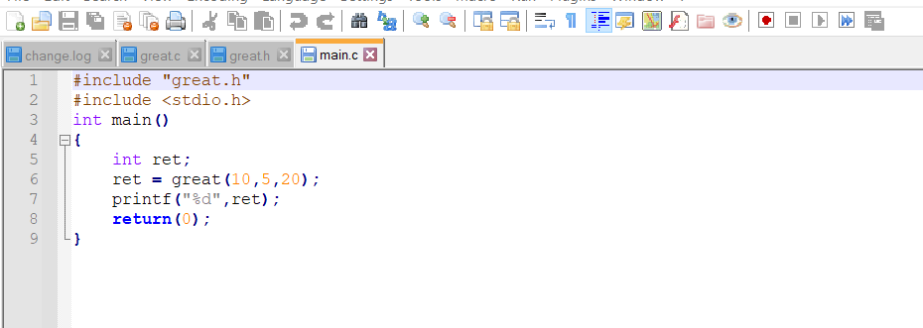

### Build After Running in Git Bash

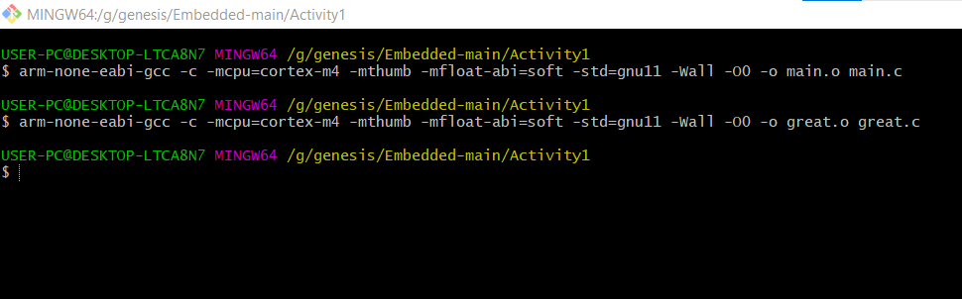

# Activity 2

## Linker Script

ENTRY(Reset_Handler)

MEMORY

{

FLASH(rx):ORIGIN =0x08000000,LENGTH =1024K

SRAM(rwx):ORIGIN =0x20000000,LENGTH =128K

}

SECTIONS

{

.text :

{

*(.isr_vector)

*(.text)

*(.text.*)

*(.init)

*(.fini)

*(.rodata)

*(.rodata.*)

. = ALIGN(4);

_etext = .;

}> FLASH

_la_data = LOADADDR(.data);

.data :

{

_sdata = .;

*(.data)

*(.data.*)

. = ALIGN(4);

_edata = .;

}> SRAM AT> FLASH

.bss :

{

_sbss = .;

__bss_start__ = _sbss;

*(.bss)

*(.bss.*)

*(COMMON)

. = ALIGN(4);

_ebss = .;

__bss_end__ = _ebss;

. = ALIGN(4);

end = .;

__end__ = .;

}> SRAM

}

# Activity 3

## 3.1 Startup Code

Git Link: <https://github.com/99003190/Embedded/blob/main/Activity1/stm32_startup.c>

# Activity 4

## Build Using Makefile

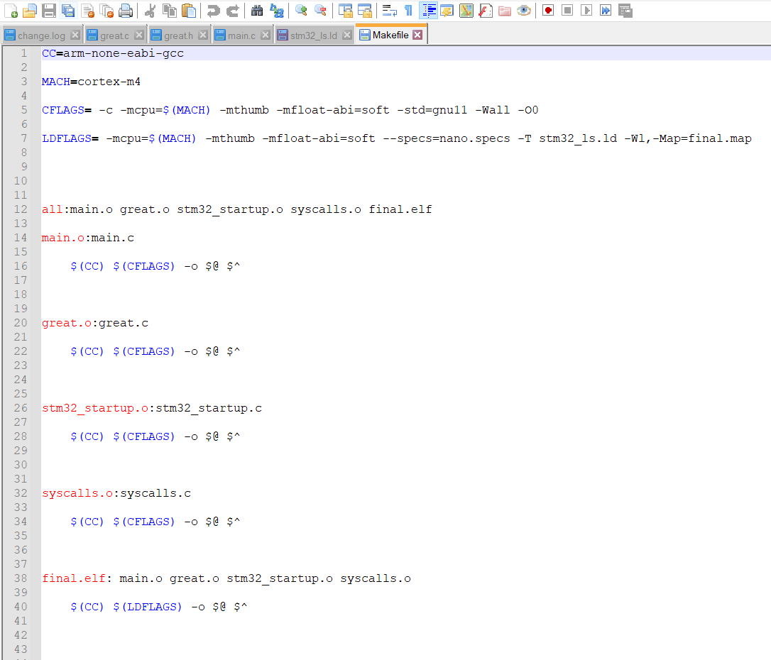

## Screenshot of Output after Running Make

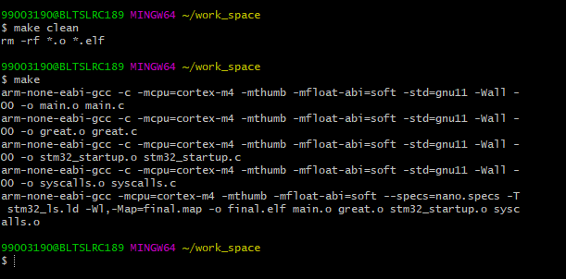

## Files Created

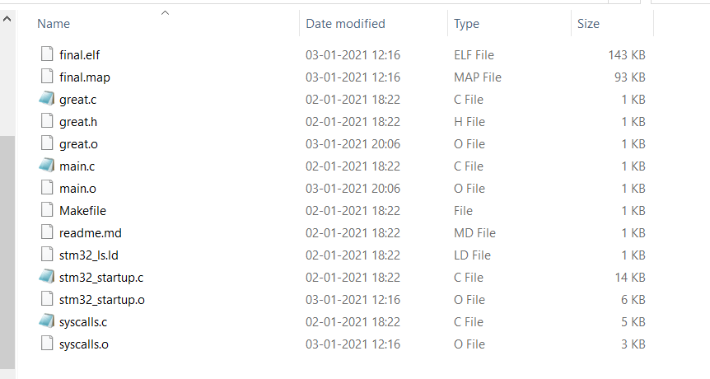

## Github Link

<https://github.com/99003190/Embedded/tree/main/Activity1>

# Activity 5

## 5.1 Mini Project

### 5.1.1 Code Implementation

##### **STM32**

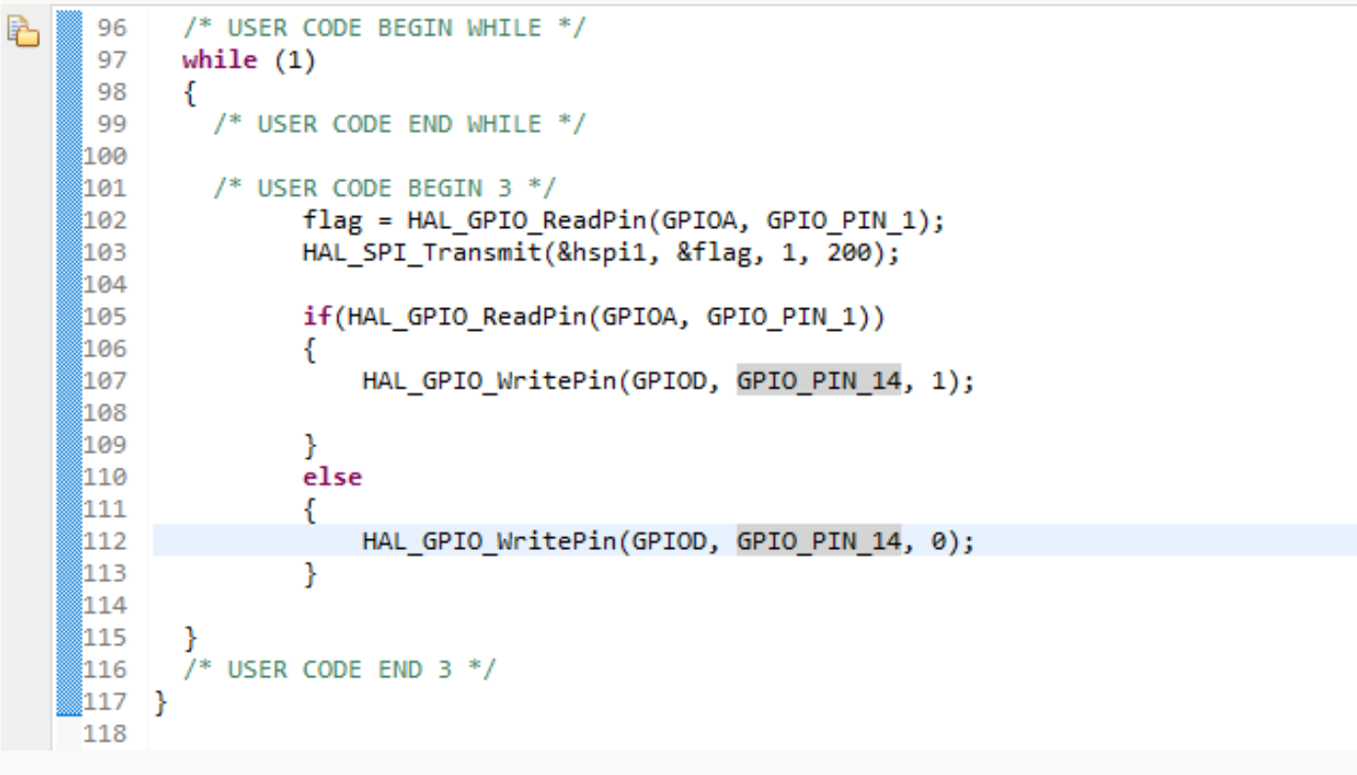

Github link:

<https://github.com/99003190/Embedded/tree/main/Project_Embedded/PIR>

SharePoint link:

<https://lnttsgroup.sharepoint.com/:f:/r/sites/GEA/Global%20Engineering%20Academy/GENESIS%20%20Nov%202020%20Submission/Nov%202020%20Submission/Bangalore/2011BLRGT01/99003190/Embedded_C/Embedded_Project/PIR?csf=1&web=1&e=nfuF2Z>

##### 

##### **Arduino**

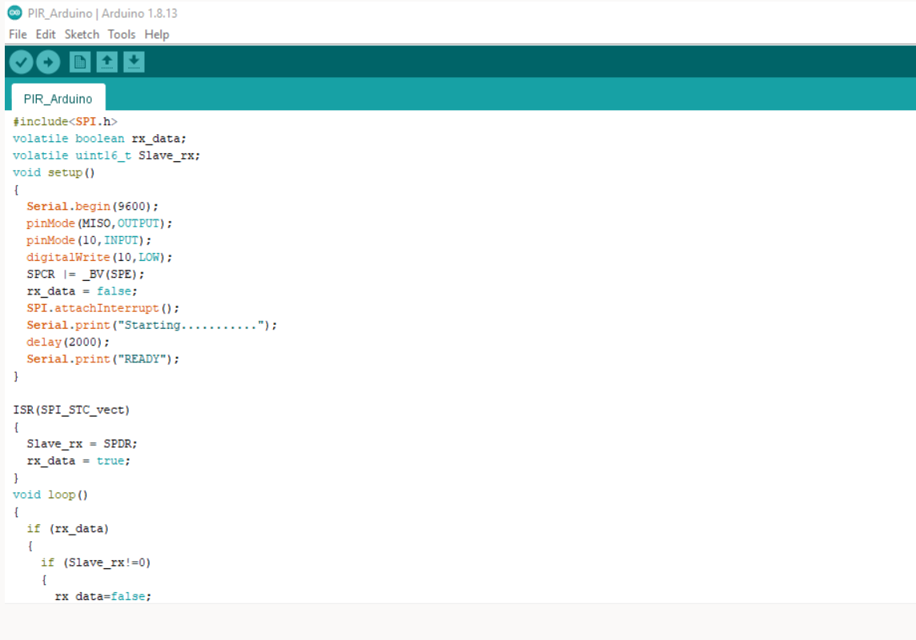

**Github link:**

<https://github.com/99003190/Embedded/tree/main/Project_Embedded/Arduino_Code>

### 5.1.2 Hardware

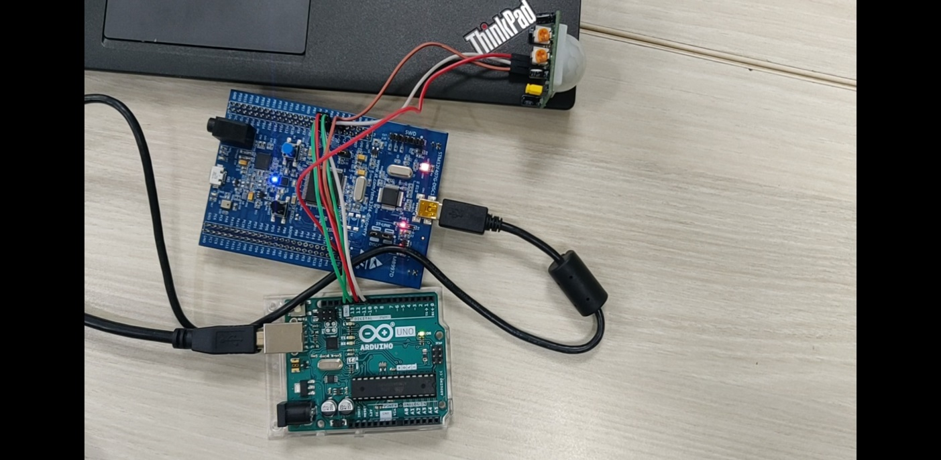

### 5.1.3 Output

##### **Output when no motion is detected**

Figure 1: LED OFF

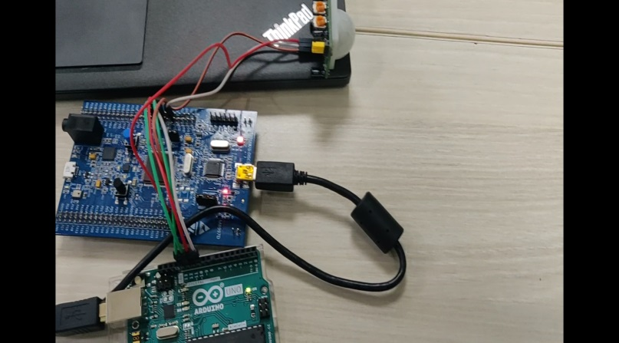 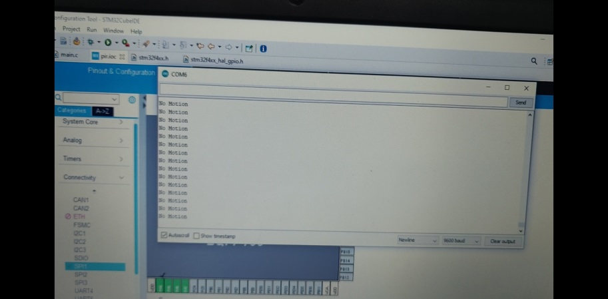

Figure 2: Serial Monitor showing no motion

##### 

##### **Output when motion is detected**

Figure 3: LED ON

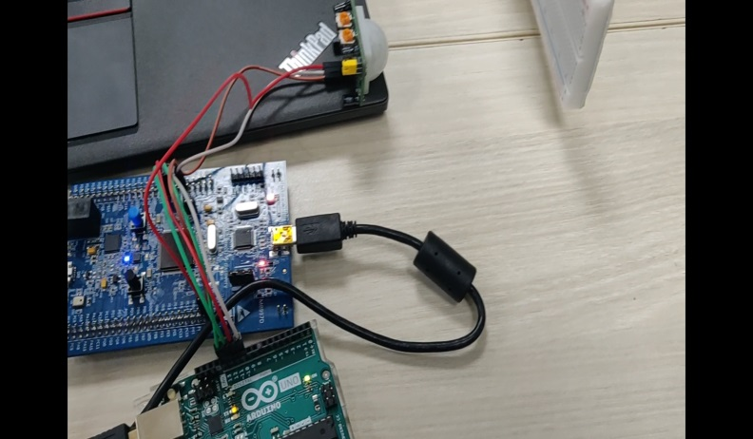 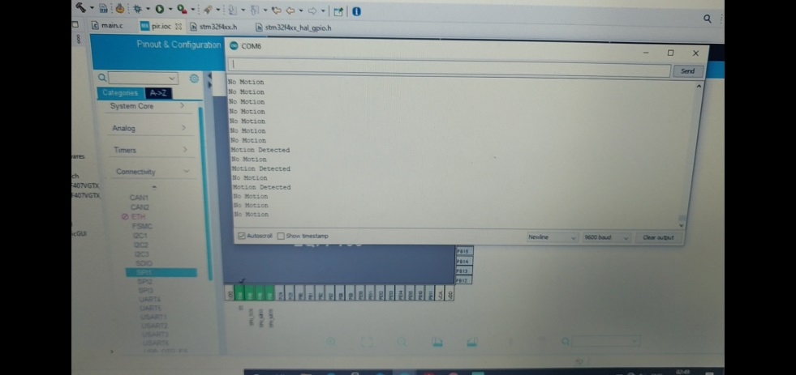

Figure 4: Serial Monitor Showing Motion Detected

### 5.1.4 Github Link

<https://github.com/99003190/Embedded/tree/main/Project_Embedded>