./

GENESIS – Embedded C Hardware Programming



|  |  |  |  |  |  |
| --- | --- | --- | --- | --- | --- |
| **Ver. Rel. No.** | **Release Date** | **Prepared. By** | **Reviewed By** | **To be Approved** | **Remarks/Revision Details** |
| 1.0 | 02/01/2021 | ANOOSHA CLARANCE |  |  |  |
|  |  |  |  |  |  |
|  |  |  |  |  |  |
|  |  |  |  |  |  |
|  |  |  |  |  |  |

**Details**

Contents

1 Contents 3

2 ACTIVITY 1: PERFORM BUILD USING GIT BASH 4

2.1 FIBONAACI.C FILE 4

2.2 FIBONAACI.H FILE 4

2.3 MAIN FILE 5

2.4 SCREENSHOT OF BUILD AFTER RUNNING IN GIT BASH 5

3 ACTIVITY 2: LINKER SCRIPT 6

4 ACTIVITY 3: STARTUP CODE 6

5 ACTIVITY 4: BUILD USING MAKEFILE 7

5.1 SCREENSHOT OF MAKEFILE 7

5.2 SCREENSHOT OF OUTPUT AFTER RUNNING MAKE 8

5.3 FILES CREATED 8

5.4 GITHUB LINK 8

6 MINIPROJECT 9

6.1 SCREENSHOT OF CODE IMPLEMENTATION 9

6.2 GITHUB LINK 10

# ACTIVITY 1: PERFORM BUILD USING GIT BASH

## FIBONAACI.C FILE

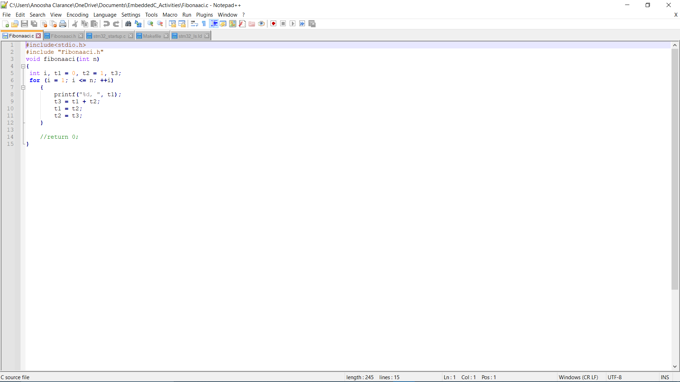

Figure 1: Fibonaaci.c file

## FIBONAACI.H FILE

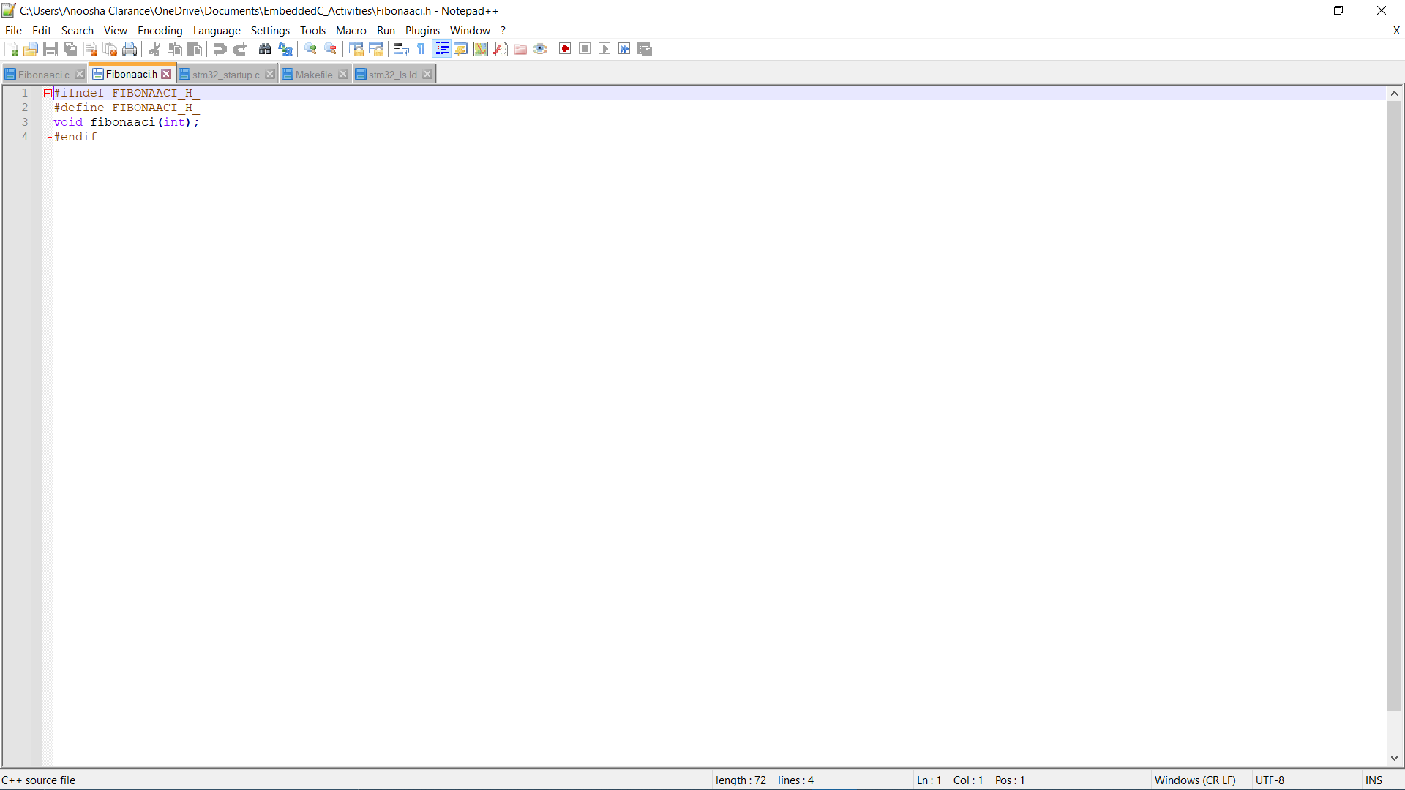

Figure : Fibonaaci.h

## MAIN FILE

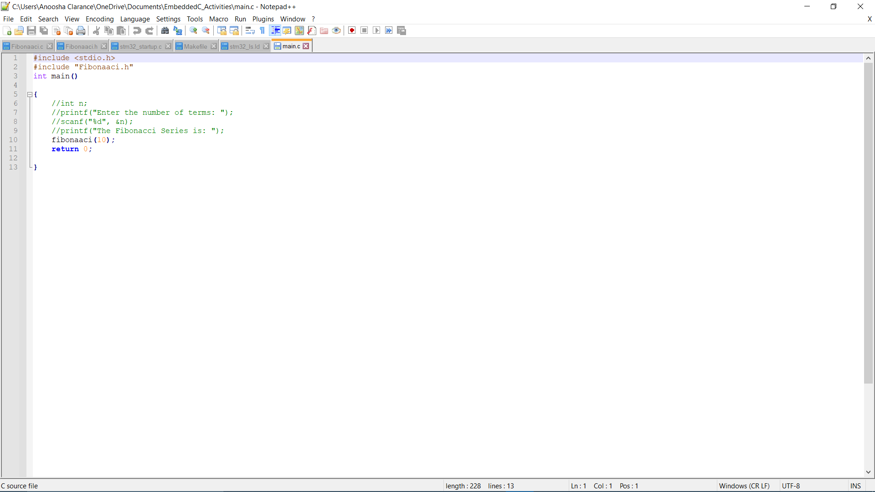

Figure : main.c file

## SCREENSHOT OF BUILD AFTER RUNNING IN GIT BASH

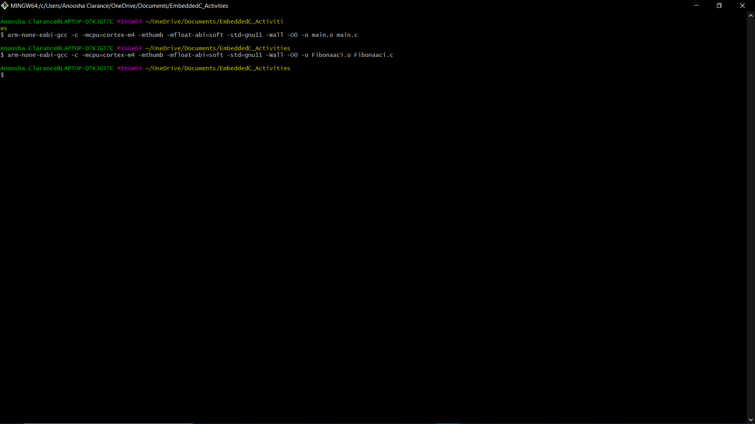

Figure : Git bash output

# ACTIVITY 2: LINKER SCRIPT

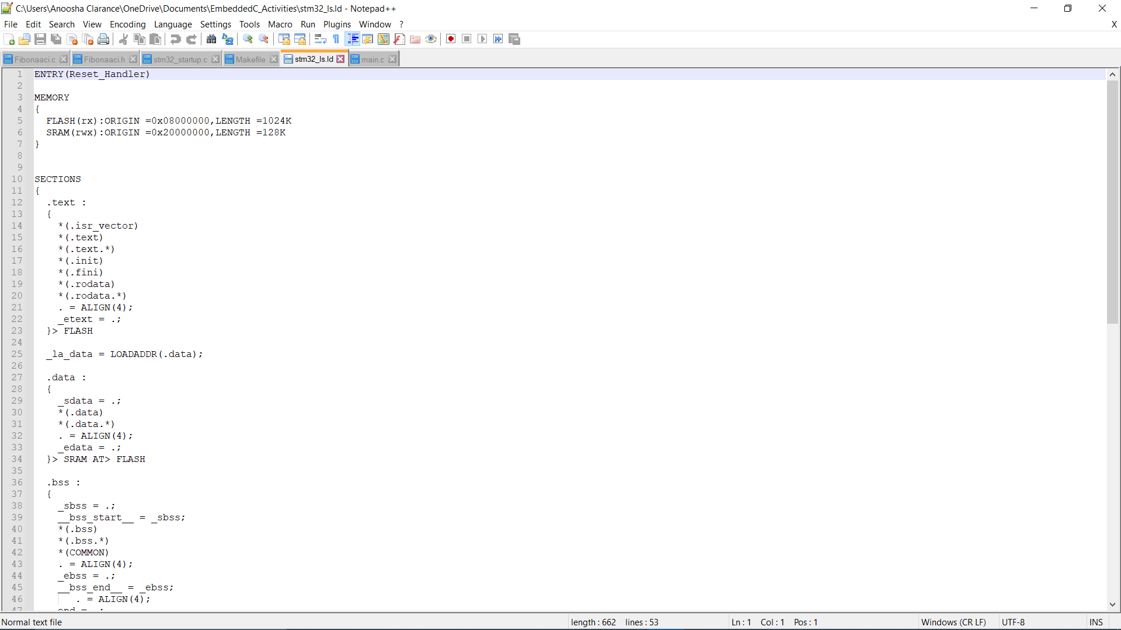

# ACTIVITY 3: STARTUP CODE

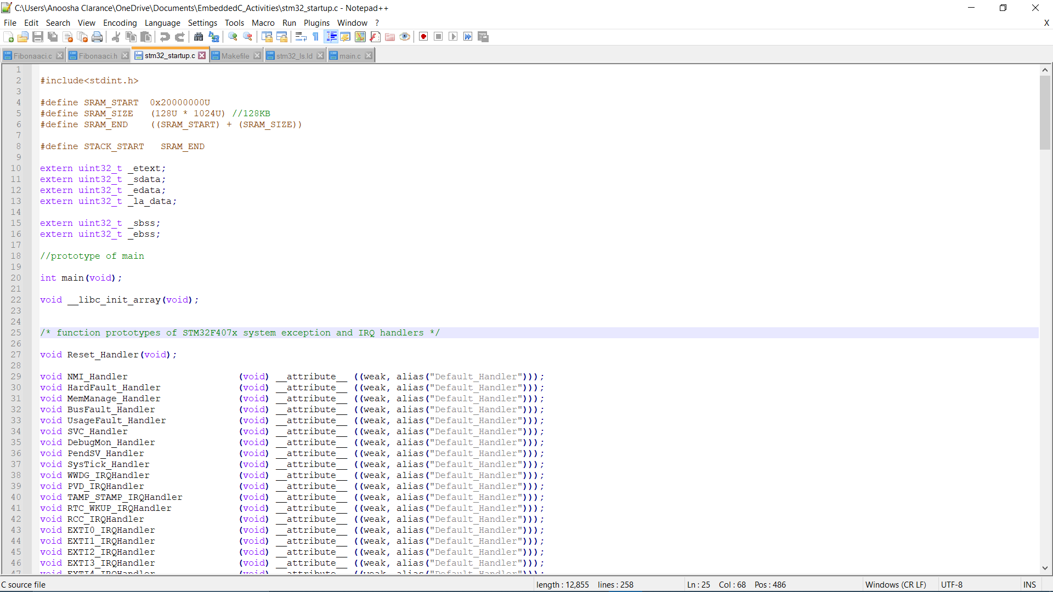

# 

# ACTIVITY 4: BUILD USING MAKEFILE

## SCREENSHOT OF MAKEFILE

Figure 5: Makefile

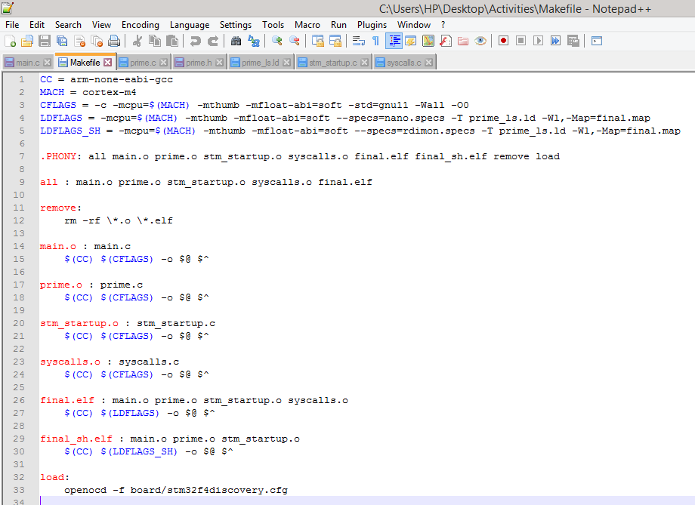

## SCREENSHOT OF OUTPUT AFTER RUNNING MAKE

Figure 6: Output in Git bash

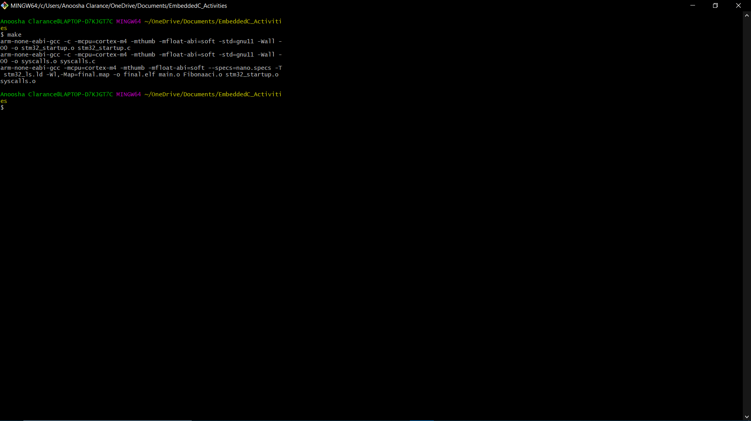

## FILES CREATED

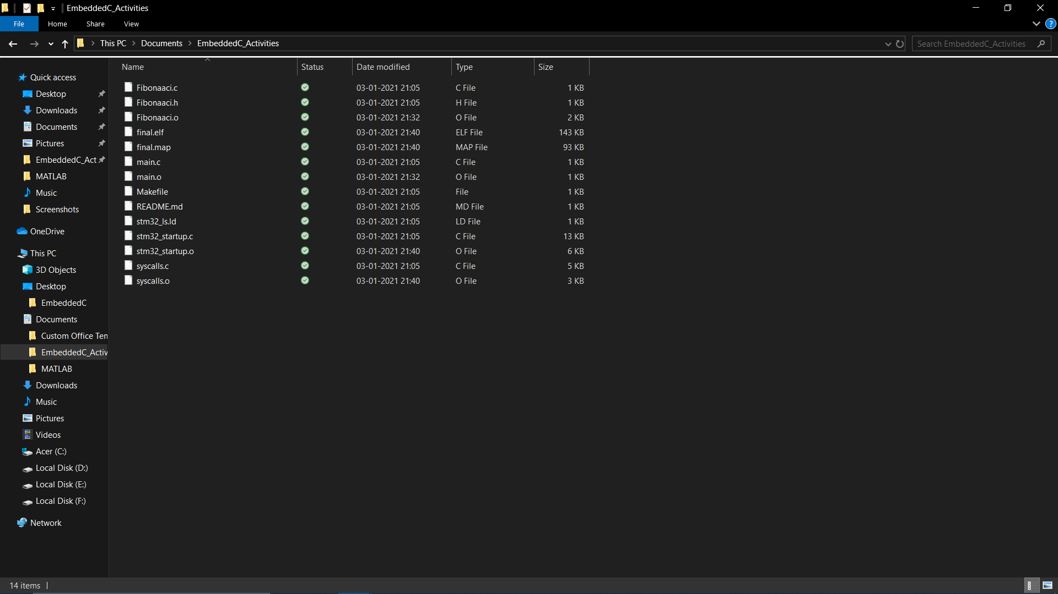

Figure :Files Created

## GITHUB LINK

[EmbeddedC/EmbeddedC_Activities at main · 99003191/EmbeddedC (github.com)](https://github.com/99003191/EmbeddedC/tree/main/EmbeddedC_Activities)

# MINIPROJECT

## SCREENSHOT OF CODE IMPLEMENTATION

Figure :Screenshot of code implementation (STM32)

Figure :Screenshot of code implementation (Arduino)

## GITHUB LINK

[EmbeddedC/Temprature_Sensor at main · 99003191/EmbeddedC (github.com)](https://github.com/99003191/EmbeddedC/tree/main/Temprature_Sensor)