**./**

GENESIS – Advanced Python Programming Project Report



|  |  |  |  |  |  |
| --- | --- | --- | --- | --- | --- |
| **Ver. Rel. No.** | **Release Date** | **Prepared. By** | **Reviewed By** | **To be Approved** | **Remarks/Revision Details** |
| **1.0** | **12/12/2020** | **Anoosha Clarance** |  |  |  |
|  |  |  |  |  |  |
|  |  |  |  |  |  |
|  |  |  |  |  |  |
|  |  |  |  |  |  |

**Details**

Contents

ACTIVITY 1 4

**1.1** **Code** 4

**1.2** **Pep8 Online Screenshot** 7

ACTIVITY 2 8

**2.1 Code** 8

**2.2 Pep8 Online Screenshot** 11

Activity3 12

**3.1.Code** 12

**3.2 Pep8 Online Screenshot** 15

**Table of Figures**

Figure 1: pep8 Activity1 7

Figure 2: pep8 Activity2 11

Figure 3:pep8 Activity3 15

# ACTIVITY 1

## **Code**

|  |
| --- |
| def menu(): |
|  | print("Choose an option from the following list:") |
|  | print("1.Add a new contact") |
|  | print("2.Remove an existing contact") |
|  | print("3.Delete all contacts") |
|  | print("4.Search for a contact") |
|  | print("5.Display all contact") |
|  | print("6.Exit Contact Book") |
|  | opt = int(input("Enter an option:")) |
|  | return opt |
|  |  |
|  |  |
|  | class allfunct: |
|  | def add_contact(self, contbook): |
|  | book = [] |
|  | for i in range(0, 4): |
|  | if i == 0: |
|  | book.append(str(input("Name:"))) |
|  | if i == 1: |
|  | book.append(str(input("Address:"))) |
|  | if i == 2: |
|  | book.append(int(input("Contact Number:"))) |
|  | if i == 3: |
|  | book.append(str(input("Email:"))) |
|  | if i == 4: |
|  | book.append(str(input("(Family/Friends/Work/Others):"))) |
|  | contbook.append(book) |
|  | return contbook |
|  |  |
|  | def display_all(self, contbook): |
|  | if not contbook: |
|  | print("\nContact book is empty") |
|  | else: |
|  | for i in range(len(contbook)): |
|  | print(contbook[i]) |
|  |  |
|  | def delete_all(self, contbook): |
|  | return contbook.clear() |
|  |  |
|  | def delete(self, contbook): |
|  | name = str(input("Enter the name of person to delete from the book:")) |
|  | temp = 0 |
|  | for i in range(len(contbook)): |
|  | if name == contbook[i][0]: |
|  | temp += 1 |
|  | print("The contact details of ", contbook[i][0], "is removed") |
|  | contbook.pop(i) |
|  | return contbook |
|  | if temp == 0: |
|  | print("Entered name is not found") |
|  | return contbook |
|  |  |
|  | def search(self, contbook): |
|  | print("1.Name") |
|  | print("2.Address") |
|  | print("3.Number") |
|  | print("4.Email") |
|  | print("5.Category") |
|  | opt = int(input("Enter search criteria")) |
|  | temp = [] |
|  | if opt == 1: |
|  | option = str(input("Enter the name")) |
|  | for i in range(len(contbook)): |
|  | if option == contbook[i][0]: |
|  | temp.append(contbook[i]) |
|  | elif opt == 2: |
|  | option = str(input("Enter the Address")) |
|  | for i in range(len(contbook)): |
|  | if option == contbook[i][1]: |
|  | temp.append(contbook[i]) |
|  | elif opt == 3: |
|  | option = int(input("Enter the number")) |
|  | for i in range(len(contbook)): |
|  | if option == int(contbook[i][2]): |
|  | temp.append(contbook[i]) |
|  | elif opt == 4: |
|  | option = str(input("Enter the email")) |
|  | for i in range(len(contbook)): |
|  | if option == contbook[i][3]: |
|  | temp.append(contbook[i]) |
|  | elif opt == 5: |
|  | option = str(input("Enter the category")) |
|  | for i in range(len(contbook)): |
|  | if option == contbook[i][4]: |
|  | temp.append(contbook[i]) |
|  | else: |
|  | print("Invalid input") |
|  | print(temp) |
|  |  |
|  |  |
|  | def primaryphone_book(): |
|  | phone_book = [] |
|  | rows = int(input("Enter intial number of contacts in contact book")) |
|  | cols = 5 |
|  | for i in range(rows): |
|  | temp_list = [] |
|  | for j in range(cols): |
|  | if j == 0: |
|  | temp_list.append(str(input("Name:"))) |
|  | if j == 1: |
|  | temp_list.append(str(input("Address:"))) |
|  | if j == 2: |
|  | temp_list.append(int(input("Contact Number:"))) |
|  | if j == 3: |
|  | temp_list.append(str(input("Email:"))) |
|  | if j == 4: |
|  | temp_list.append(str(input("(Family/Friends/Work/Others):"))) |
|  | phone_book.append(temp_list) |
|  | return phone_book |
|  | contbook = primaryphone_book() |
|  | cont1 = allfunct() |
|  | opt = menu() |
|  | val = 0 |
|  | if val == 1: |
|  | menu() |
|  | val == 1 |
|  | if opt == 1: |
|  | contbook = cont1.add_contact(contbook) |
|  | if opt == 2: |
|  | contbook = cont1.delete(contbook) |
|  | if opt == 3: |
|  | contbook = cont1.delete_all(contbook) |
|  | if opt == 4: |
|  | print(cont1.search(contbook)) |
|  | if opt == 5: |
|  | cont1.display_all(contbook) |

## **Pep8 Online Screenshot**

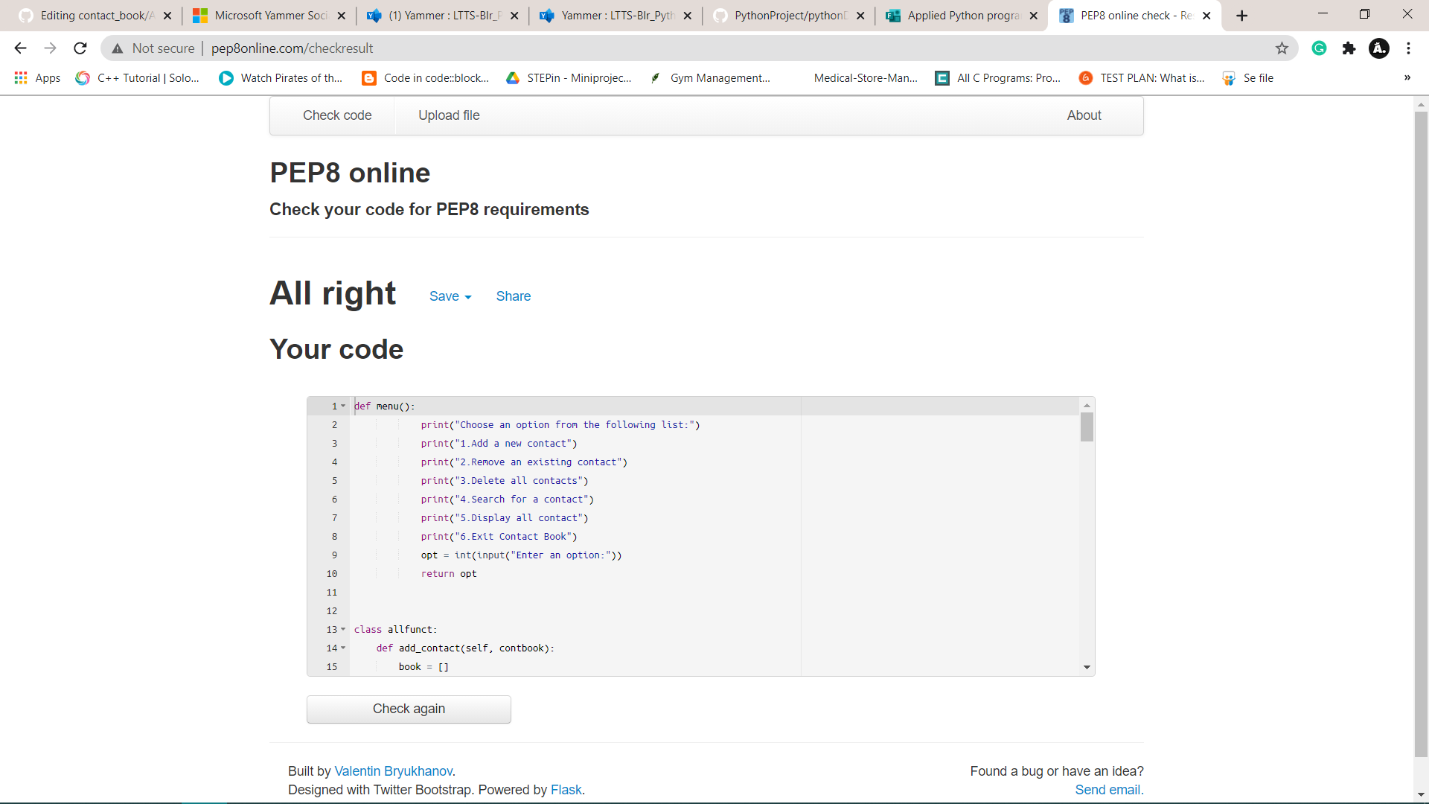

Figure 1: pep8 Activity1

# ACTIVITY 2

## **2.1 Code**

|  |
| --- |
| class contact_menu: |
|  | opt = 0 |
|  |  |
|  | def __init__(self, opt): |
|  | self.opt = opt |
|  |  |
|  | # Menu function |
|  | def menu(self): # instance method |
|  | print("*******Contact Book********") |
|  | print("Choose an option from the following list:") |
|  | print("1.Add a new contact") |
|  | print("2.Remove an existing contact") |
|  | print("3.Delete all contacts") |
|  | print("4.Search for a contact") |
|  | print("5.Display all contact") |
|  | print("6.Exit Contact Book") |
|  | self.opt = int(input("Enter an option:")) |
|  | return self.opt |
|  |  |
|  |  |
|  | # Single Inheritance |
|  | class allfunct(contact_menu): |
|  | def add_contact(self, contbook): |
|  | book = [] |
|  | for i in range(0, 5): |
|  | if i == 0: |
|  | book.append(str(input("Name:"))) |
|  | if i == 1: |
|  | book.append(str(input("Address:"))) |
|  | if i == 2: |
|  | book.append(int(input("Contact Number:"))) |
|  | if i == 3: |
|  | book.append(str(input("Email:"))) |
|  | if i == 4: |
|  | book.append(str(input("(Family/Friends/Work/Others):"))) |
|  | contbook.append(book) |
|  | return contbook |
|  |  |
|  | def display_all(self, contbook): |
|  | if not contbook: |
|  | print("\nContact book is empty") |
|  | else: |
|  | for i in range(len(contbook)): |
|  | print(contbook[i]) |
|  |  |
|  | def delete_all(self, contbook): |
|  | return contbook.clear() |
|  |  |
|  | def delete(self, contbook): |
|  | name = str(input("Enter the name of person to delete from the book:")) |
|  | temp = 0 |
|  | for i in range(len(contbook)): |
|  | if name == contbook[i][0]: |
|  | temp += 1 |
|  | print("The contact details of ", contbook[i][0], "is removed") |
|  | contbook.pop(i) |
|  | return contbook |
|  | if temp == 0: |
|  | print("Entered name is not found") |
|  | return contbook |
|  |  |
|  | def search(self, contbook): |
|  | print("1.Name") |
|  | print("2.Address") |
|  | print("3.Number") |
|  | print("4.Email") |
|  | print("5.Category") |
|  | optn = int(input("Enter search criteria")) |
|  | temp = [] |
|  | if optn == 1: |
|  | option = str(input("Enter the name")) |
|  | for i in range(len(contbook)): |
|  | if option == contbook[i][0]: |
|  | temp.append(contbook[i]) |
|  | elif optn == 2: |
|  | option = str(input("Enter the Address")) |
|  | for i in range(len(contbook)): |
|  | if option == contbook[i][1]: |
|  | temp.append(contbook[i]) |
|  | elif optn == 3: |
|  | option = int(input("Enter the number")) |
|  | for i in range(len(contbook)): |
|  | if option == int(contbook[i][2]): |
|  | temp.append(contbook[i]) |
|  | elif optn == 4: |
|  | option = str(input("Enter the email")) |
|  | for i in range(len(contbook)): |
|  | if option == contbook[i][3]: |
|  | temp.append(contbook[i]) |
|  | elif optn == 5: |
|  | option = str(input("Enter the category")) |
|  | for i in range(len(contbook)): |
|  | if option == contbook[i][4]: |
|  | temp.append(contbook[i]) |
|  | else: |
|  | print("Invalid input") |
|  | print(temp) |
|  |  |
|  |  |
|  | def primaryphone_book(): |
|  | phone_book = [] |
|  | rows = int(input("Enter intial number of contacts in contact book")) |
|  | cols = 5 |
|  | for i in range(rows): |
|  | temp_list = [] |
|  | for j in range(cols): |
|  | if j == 0: |
|  | temp_list.append(str(input("Name:"))) |
|  | if j == 1: |
|  | temp_list.append(str(input("Address:"))) |
|  | if j == 2: |
|  | temp_list.append(int(input("Contact Number:"))) |
|  | if j == 3: |
|  | temp_list.append(str(input("Email:"))) |
|  | if j == 4: |
|  | temp_list.append(str(input("(Family/Friends/Work/Others):"))) |
|  | phone_book.append(temp_list) |
|  | return phone_book |
|  | contbook = primaryphone_book() |
|  | cont1 = allfunct(contbook) |
|  | var = 0 |
|  | ch = cont1.menu() |
|  |  |
|  | while ch < 6: |
|  |  |
|  | if(var == 1): |
|  | cont1.menu() |
|  | var = 1 |
|  | cont1.opt |
|  | if cont1.opt == 1: |
|  | contbook = cont1.add_contact(contbook) |
|  | elif cont1.opt == 2: |
|  | contbook = cont1.delete(contbook) |
|  | elif cont1.opt == 3: |
|  | contbook = cont1.delete_all(contbook) |
|  | elif cont1.opt == 4: |
|  | print(cont1.search(contbook)) |
|  | elif cont1.opt == 5: |
|  | print(cont1.display_all(contbook)) |
|  | else: |
|  | print("Enter correct option") |

## **2.2 Pep8 Online Screenshot**

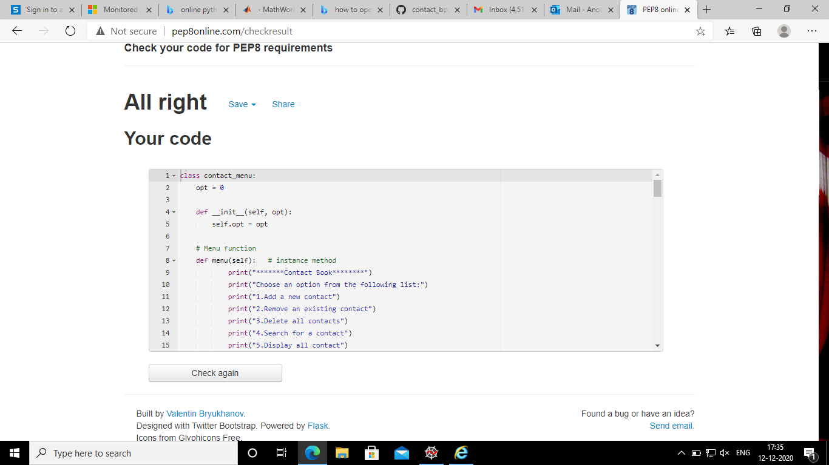

Figure 2: pep8 Activity2

|  |
| --- |
| Activity3**3.1.Code** import re |
|  |  |
|  |  |
|  | class contact_menu: |
|  | opt = 0 |
|  |  |
|  | def __init__(self, opt): |
|  | self.opt = opt |
|  |  |
|  | # Menu function |
|  | def menu(self): # instance method |
|  | print("*******Contact Book********") |
|  | print("Choose an option from the following list:") |
|  | print("1.Add a new contact") |
|  | print("2.Remove an existing contact") |
|  | print("3.Delete all contacts") |
|  | print("4.Search for a contact") |
|  | print("5.Display all contact") |
|  | print("6.Exit Contact Book") |
|  | self.opt = int(input("Enter an option:")) |
|  | return self.opt |
|  |  |
|  |  |
|  | # Single Inheritance |
|  | class allfunct(contact_menu): |
|  | def add_contact(self, contbook): |
|  | book = [] |
|  | for i in range(0, 5): |
|  | if i == 0: |
|  | book.append(str(input("Name:"))) |
|  | if i == 1: |
|  | book.append(str(input("Address:"))) |
|  | if i == 2: |
|  | # Regular expression |
|  | book.append(str(input("Contact Number:"))) |
|  | while re.match("[0-9]{10}", book[2]) is None: |
|  | book[2] = str(input("Enter correct input format")) |
|  | if i == 3: |
|  | # Regular Expression |
|  | book.append(str(input("Email:"))) |
|  | while re.match(r"[a-z]+@[a-z]+\.[a-z]{3}", book[3]) is None: |
|  | book[3] = str(input("Enter correct input format")) |
|  | if i == 4: |
|  | book.append(str(input("(Family/Friends/Work/Others):"))) |
|  | contbook.append(book) |
|  | return contbook |
|  |  |
|  | def display_all(self, contbook): |
|  | if not contbook: |
|  | print("\nContact book is empty") |
|  | else: |
|  | for i in range(len(contbook)): |
|  | print(contbook[i]) |
|  |  |
|  | def delete_all(self, contbook): |
|  | return contbook.clear() |
|  |  |
|  | def delete(self, contbook): |
|  | name = str(input("Enter the name of person to delete from the book:")) |
|  | temp = 0 |
|  | for i in range(len(contbook)): |
|  | if name == contbook[i][0]: |
|  | temp += 1 |
|  | print("The contact details of ", contbook[i][0], "is removed") |
|  | contbook.pop(i) |
|  | return contbook |
|  | if temp == 0: |
|  | print("Entered name is not found") |
|  | return contbook |
|  |  |
|  | def search(self, contbook): |
|  | print("1.Name") |
|  | print("2.Address") |
|  | print("3.Number") |
|  | print("4.Email") |
|  | print("5.Category") |
|  | optn = int(input("Enter search criteria")) |
|  | temp = [] |
|  | if optn == 1: |
|  | option = str(input("Enter the name")) |
|  | for i in range(len(contbook)): |
|  | if option == contbook[i][0]: |
|  | temp.append(contbook[i]) |
|  | elif optn == 2: |
|  | option = str(input("Enter the Address")) |
|  | for i in range(len(contbook)): |
|  | if option == contbook[i][1]: |
|  | temp.append(contbook[i]) |
|  | elif optn == 3: |
|  | option = int(input("Enter the number")) |
|  | for i in range(len(contbook)): |
|  | if option == int(contbook[i][2]): |
|  | temp.append(contbook[i]) |
|  | elif optn == 4: |
|  | option = str(input("Enter the email")) |
|  | for i in range(len(contbook)): |
|  | if option == contbook[i][3]: |
|  | temp.append(contbook[i]) |
|  | elif optn == 5: |
|  | option = str(input("Enter the category")) |
|  | for i in range(len(contbook)): |
|  | if option == contbook[i][4]: |
|  | temp.append(contbook[i]) |
|  | else: |
|  | print("Invalid input") |
|  | print(temp) |
|  |  |
|  |  |
|  | def primaryphone_book(): |
|  | phone_book = [] |
|  | rows = int(input("Enter intial number of contacts in contact book")) |
|  | cols = 5 |
|  | for i in range(rows): |
|  | temp_list = [] |
|  | for j in range(cols): |
|  | if j == 0: |
|  | temp_list.append(str(input("Name:"))) |
|  | if j == 1: |
|  | temp_list.append(str(input("Address:"))) |
|  | if j == 2: |
|  | temp_list.append(str(input("Contact Number:"))) |
|  | # Regular expression |
|  | while re.match("[0-9]{10}", temp_list[2]) is None: |
|  | temp_list[2] = str(input("Enter correct input format")) |
|  | if j == 3: |
|  | temp_list.append(str(input("Email:"))) |
|  | # Regular expression |
|  | while re.match(r"[a-z]+@[a-z]+\.[a-z]{3}", |
|  | temp_list[3]) is None: |
|  | temp_list[3] = str(input("Enter correct input format")) |
|  | if j == 4: |
|  | temp_list.append(str(input("(Family/Friends/Work/Others):"))) |
|  | phone_book.append(temp_list) |
|  | return phone_book |
|  | contbook = primaryphone_book() |
|  | cont1 = allfunct(contbook) |
|  | var = 0 |
|  | ch = cont1.menu() |
|  |  |
|  | while ch < 6: |
|  |  |
|  | if(var == 1): |
|  | cont1.menu() |
|  | var = 1 |
|  | cont1.opt |
|  | if cont1.opt == 1: |
|  | contbook = cont1.add_contact(contbook) |
|  | elif cont1.opt == 2: |
|  | contbook = cont1.delete(contbook) |
|  | elif cont1.opt == 3: |
|  | contbook = cont1.delete_all(contbook) |
|  | elif cont1.opt == 4: |
|  | print(cont1.search(contbook)) |
|  | elif cont1.opt == 5: |
|  | print(cont1.display_all(contbook)) |
|  | else: |
|  | print("Enter correct option") |

## **3.2 Pep8 Online Screenshot**

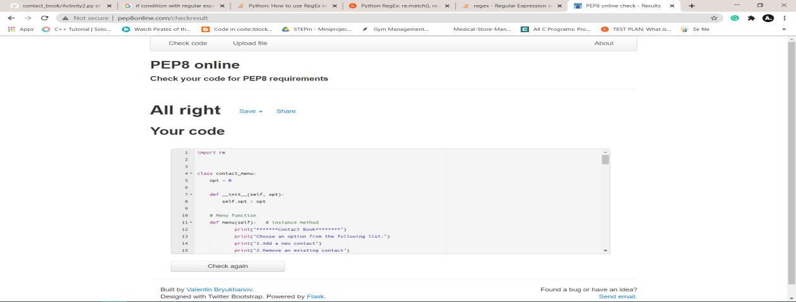

Figure 3:pep8 Activity3