**MINI PROJECT**

**ON**

**MEDICAL STORE MANAGEMENT SYSTEM**

**Submitted by: Anoosha Clarance**

**Candidate ID:104881**

**Table of Content**

Title Page 1

Table of Contents 2

Chapter 1: Introduction

1.1 Problem Statement 3

1.2 Project Description 3

Chapter 2: Requirements

2.1 Hardware Requirements 4

2.2 Software Requirements 4

2.3 Functional Requirements 5

Chapter 3: Design

3.1 Functional flow diagram 6

3.2 User case diagram 7

Chapter 4: Test Plan 8

Chapter 5: Test cases 9

Chapter 6: Expected Results 10

Chapter 7: Conclusion 11

# **Introduction**

## **1.1 Problem Statement**

The main objective of this project on the Medical Store Management System is to manage the details of medicines such as its quantity, manufacturing and expiry dates, company name, and some other information.

## **1.2 Project Description**

The purpose of the Medical Shop Management System is to automate the existing manual system with the help of computerized equipment and full-fledged computer software, fulfilling their requirements so that their valuable data/information can be stored for a longer period with easy accessing and manipulation of the same. The required software and hardware are easily available and easy to work with.

Medical Shop Management System can, as described above, can lead to error-free, secure, reliable, and fast management systems. It assists the user to concentrate on their other activities rather than to concentrate on record keeping. Thus it will help organizations in better utilization of resources.

The organization can maintain computerized records without redundant entries. That means that one need not be distracted by information that is not relevant while being able to reach the information. The project describes how to manage for good performance and better services for the clients.

The main features of this project include:

* Proper login system.
* Enter the information about the medicine.
* Allows knowing the information about the stock of medicine in the store.
* Medicine information can be obtained.
* Add and Delete medicine records.
* Change the quantity of medicine.

# 

# **2. Requirements**

## **2.1 Hardware requirements**

* Ram 512MB or higher.
* Minimum 10MB hard disk space.
* Intel/Pentium powered system.
* Processor speed 1.7 GHz

## **2.2 Software requirements**

* Windows 8 or higher versions.
* Visual Studio/CodeBlocks software.
* C language
* Mingw compiler

## 

## 

## **2.3 Functional requirements**

The management system must include the following features like:

* **Login system**

Using this module user enters the user name and password and the system checks whether it is valid. If it is the valid user can log in, otherwise invalid user name and password message is displayed

* **Add more Information about medicine**

Information on a particular medicine can be added

* **The stock of medicine in the store**

It shows the entire medicine available in the store and its details. Details of the medicine include its name, company name, manufacturing and expiry date, its quantity, and some other information about the medicine.

* **View information about medicine**

More information about each medicine is available by entering the name of medicine which we want.

* **Add and delete**

It helps to add and delete medicine details to the record

* **Change the quantity of medicine**

The number or quantity of medicine can be increased or decreased as required.

# 

# **3. Design**

## **3.1 Functional flow diagram**

# 

## **3.2 User Case diagram**

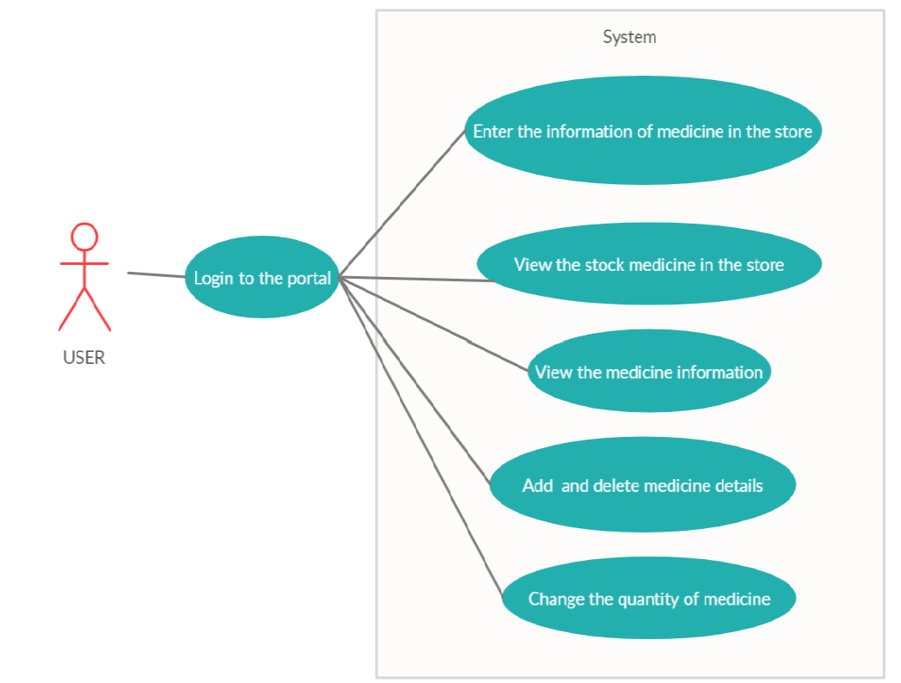

# **4.Test Plan**

## **4.1 Scope of testing**

### **4.1.1 In scope**

|  |  |
| --- | --- |
| **Module Name** | **Description** |
| Login | Authorized access is allowed here |
| Purchase medicine | It helps to know whether the required medicine |
| Add a medicine | The system allows adding the details of new medicine in the record. |
| Delete a medicine | The system allows deleting the details of existing medicine from the record. |
| Quantity of medicine | It displays the number of amount of medicine available in the store |
| Medicine information | It displays information about medicine in the store |
| Enter information of medicine | More information about the medicine can be entered by the user. |

### **4.1.1 Out of scope**

1. User interfaces
2. Hardware interfaces

## **4.2 Quality objectives**

* Ensure the Application under Test conforms to functional and non-functional requirements.
* Bugs/issues are identified and fixed before they go live.

## **4.3 Test Methodology**

The waterfall model is adopted as the test methodology here as it proceeds to the next phase only when the previous phase is completed.

## **4.4 Test Criteria**

### **4.4.1 Suspension Criteria**

If more than 45% of test cases are failed then the testing is suspended until all fail cases are fixed

### **4.4.2 Exit Criteria**

* 100% Test coverage.
* All manual test cases are executed.
* All open bugs are fixed or will be fixed in the next release.

## **4.5 Test Environment**

The test cases are executed in Code Blocks.

# 

# **5. Test Cases**

|  |  |  |  |
| --- | --- | --- | --- |
| **Test cases** | **Test scenario** | **Test Steps** | **Test Data** |
| 1 | To check if the user can log in using a valid username and password | Enter username and password | Username - medical_store  Password- password |
| 2 | To know if there is required quantity of medicine in the store and the cost of medicine | Choose option 1 | Enter 1 and enter the quantity of medicine require. |
| 3 | To check whether able to add more info about a particular medicine | Choose option 2 | Enter 2 and enter the name of the medicine into which we need to add more info. |
| 4 | To know the info about the stock of medicine in the store | Choose option 3 | Enter 3 |
| 5 | To know the info about a particular medicine | Choose option 4 | Enter 4 and enter the name of the medicine of which we need to know the information. |
| 6 | To add a new medicine’s details into the record | Choose option 5 | Enter 5 and enter the details of new medicine into the list. |
| 7 | To delete a medicine from the record | Choose option 6 | Enter 6 and enter the name of the medicine which we need to delete. |
| 8 | To change the quantity of medicine | Choose option 7 | Enter 7 and enter the name of the medicine of which we need to change the quantity. |
| 9 | To exit |  | Enter any other numbers of keys |

# 

# 

# **6. Expected Results**

|  |  |  |
| --- | --- | --- |
| **Test cases** | **Test scenario** | **Expected Results** |
| 1 | To check if the user can log in using a valid username and password | Successful login |
| 2 | To check if there is required quantity of medicine available and to know the price of medicine. | It asks to enter the name of medicine which is needed to be purchased and enter the quantity. It displays whether the quantity we mentioned is available or not and also displays the cost of medicine of the quantity we require. |
| 3 | To check whether able to add more info about a particular medicine | It asks to enter the name of medicine so that it displays its details and we can add more details of that medicine. |
| 4 | To know the info about the stock of medicine in the store | Displays the details of all the medicine in the store. The details include name, price, availability, company name, manufacturing date, expiry date, etc. |
| 5 | To know the info about a particular medicine | It asks to enter the name of the medicine we want so that it displays its details. |
| 6 | To add a new medicine’s details into the record | It allows us to add the details of a new medicine into the record. |
| 7 | To delete a medicine from the record | The deletion of medicine’s details can be performed. |
| 8 | To change the quantity of medicine | The quantity of medicine can be changed. |
| 9 | To continue with other options | Helps to continue with other options |
| 10 | To exit | It exits from the program |

# **7. Conclusion**

Medical Store Management System is very useful for handling the records of all medicine in the medical store. The application is reduced as much as possible to avoid errors while entering the data. It also provides error message while entering invalid data. No formal knowledge is needed for the user to use this system. Thus by this all, it proves it is user-friendly. Medical Shop Management System, as described above, can lead to an error-free, secure, reliable, and fast management system. It can assist the user to concentrate on their other activities rather than concentrate on the record-keeping. Thus it will help the organization in better utilization of resources.