### Design

**Component diagram**

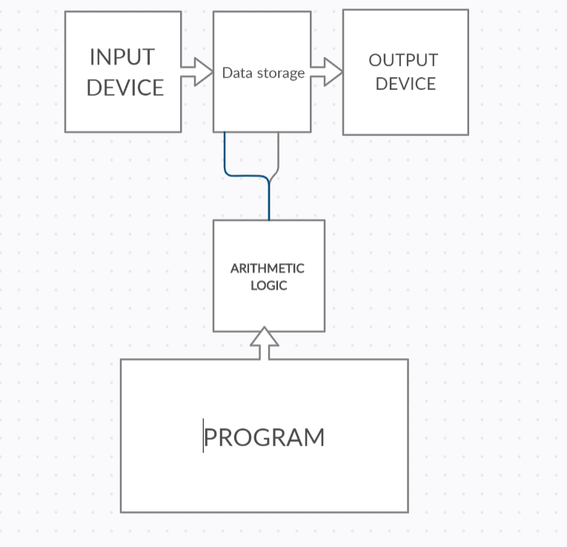

Figure 3. Component diagram for calculator

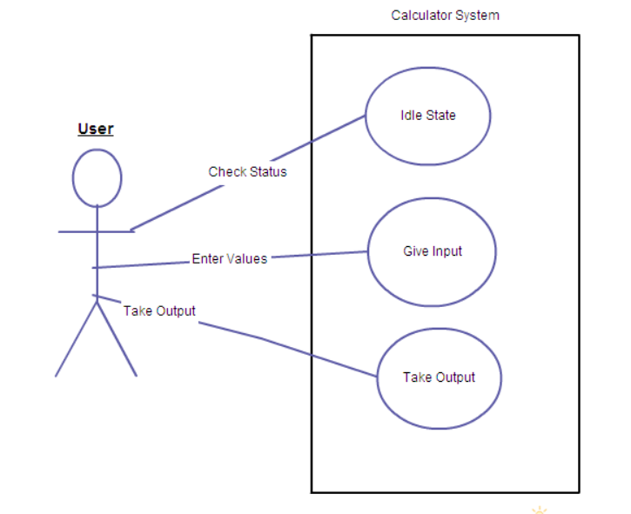

Figure 4. Use case diagram for calculator

**Use case diagram**

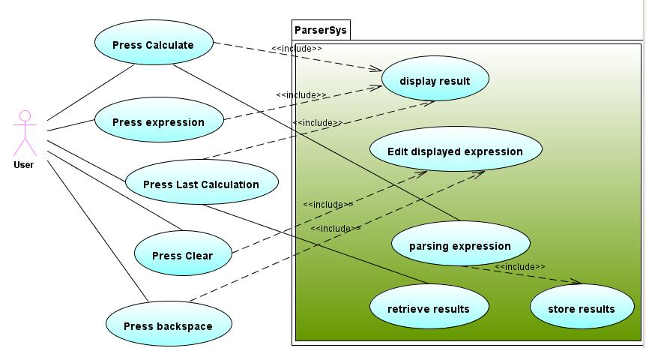

Figure 5. Use case Diagram for calculator

**UML diagram**

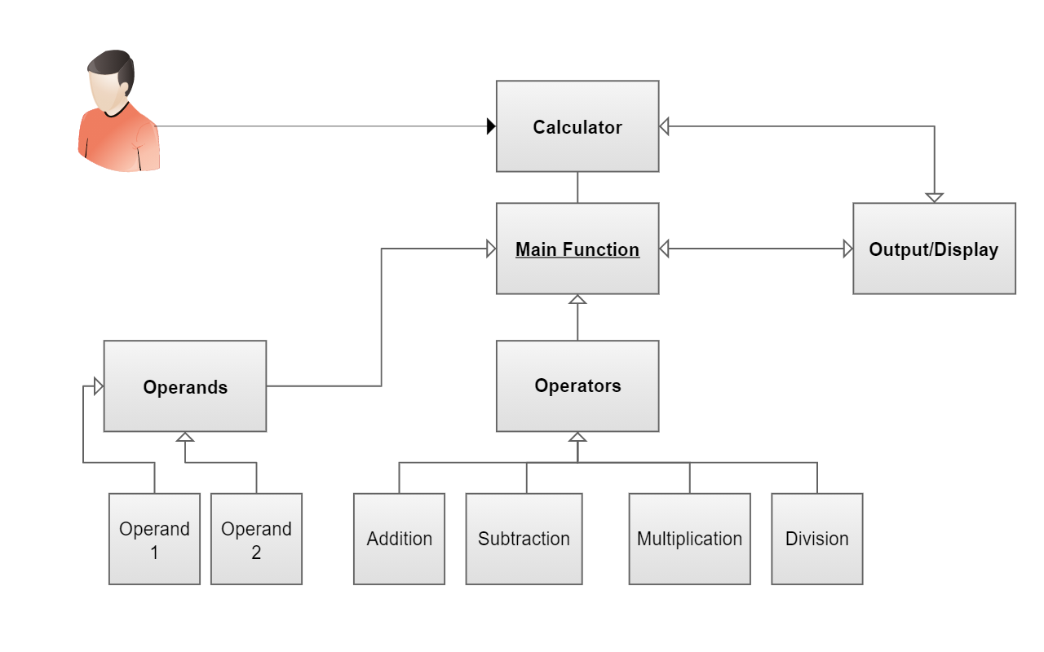

Figure 6. UML diagram for calculator

**Sequence diagram**

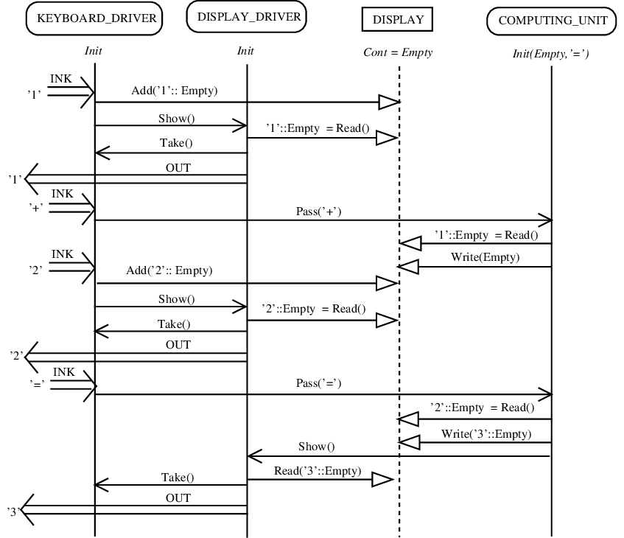

Figure 7. Sequence diagram for calculator

**State diagram**

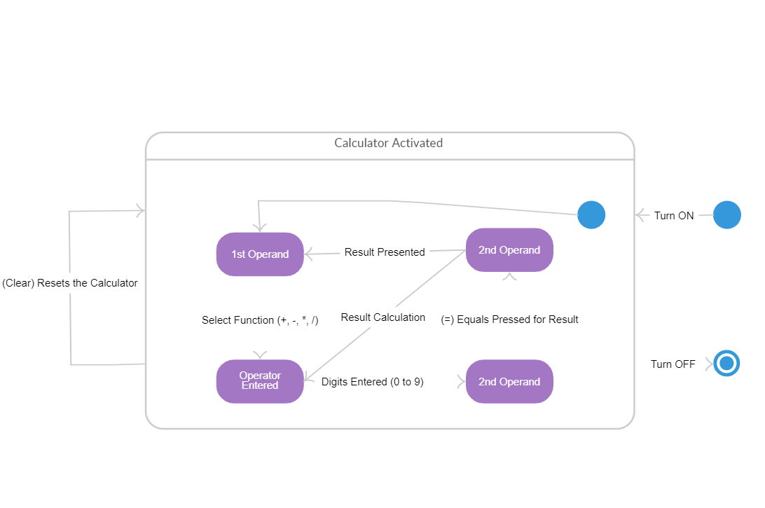

Figure 8. State diagram for calculator