./

**Report – Calculator**

Course Code: <CODE>



Ps .No: 99003196

Ps .No: 99003197

Ps .No: 99003198

Version Number:

Team Members :

Team No:

Module: Model Based System Engineering

|  |  |  |  |  |  |
| --- | --- | --- | --- | --- | --- |
| **Ver. Rel. No.** | **Release Date** | **Prepared. By** | **Reviewed By** | **Approved By** | **Remarks/Revision Details** |
| 01 | 07/12/2020 | Srinidhi Manda |  |  |  |
|  |  | Siddi Ahalya |  |  |  |
|  |  | Sappa Swarna Durga |  |  |  |
|  |  |  |  |  |  |
|  |  |  |  |  |  |

**Document History**

# 

Table of Contents

ACTIVITY 5 4

CALCULATOR 4

**INTRODUCTION** 4

**SWOT ANALYSIS** 5

**HIGH LEVEL REQUIREMENTS** 5

**LOW LEVEL REQUIREMENTS** 6

**SYSTEM DESIGN** 6

**UML DIAGRAMS** 6

Fig 1: State Diagram 6

Fig 2: Activity Diagram 7

Fig 3: Deployment Diagram 7

Fig 4: Component Diagram 8

Fig 5: Use Case Diagram 8

Fig: 6 Sequence Diagram 9

**TEST PLAN** 9

**Snapshots of Results** 10

**References** 10

# ACTIVITY 5

# CALCULATOR

## **INTRODUCTION**

A calculator is an electronic hand-held device that performs various mathematical operations. Modern electronic calculators vary from cheap, credit card sized models to sturdy desktop models. Various arithmetic operations, unit conversions and complex operations can be implemented using a simple calculator. Computations made using a calculator are more accurate and faster than humans do.

**COST VS AGEING**

**COST**

All Transistor Electronic

Calculator Calculator

**AGE**

Handheld Graphical

Calculator Calculator

## **Screenshot (12).pngSWOT ANALYSIS**

## **HIGH LEVEL REQUIREMENTS**

|  |  |
| --- | --- |
| **ID** | **Requirements** |
| HL_01 | Algebraic operations |
| HL_02 | Logarithmic operations |
| HL_03 | Unit Conversions |

## **LOW LEVEL REQUIREMENTS**

|  |  |
| --- | --- |
| **ID** | **Requirements** |
| LL_01 | Functions like add, subtract, multiply are necessary |
| LL_02 | A log function including the math header file |
| LL_03 | Various conversion factors for corresponding unit conversions. |

## **SYSTEM DESIGN**

## **UML DIAGRAMS**

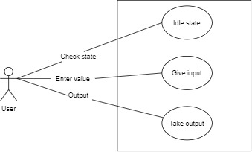

## Fig 1: State Diagram

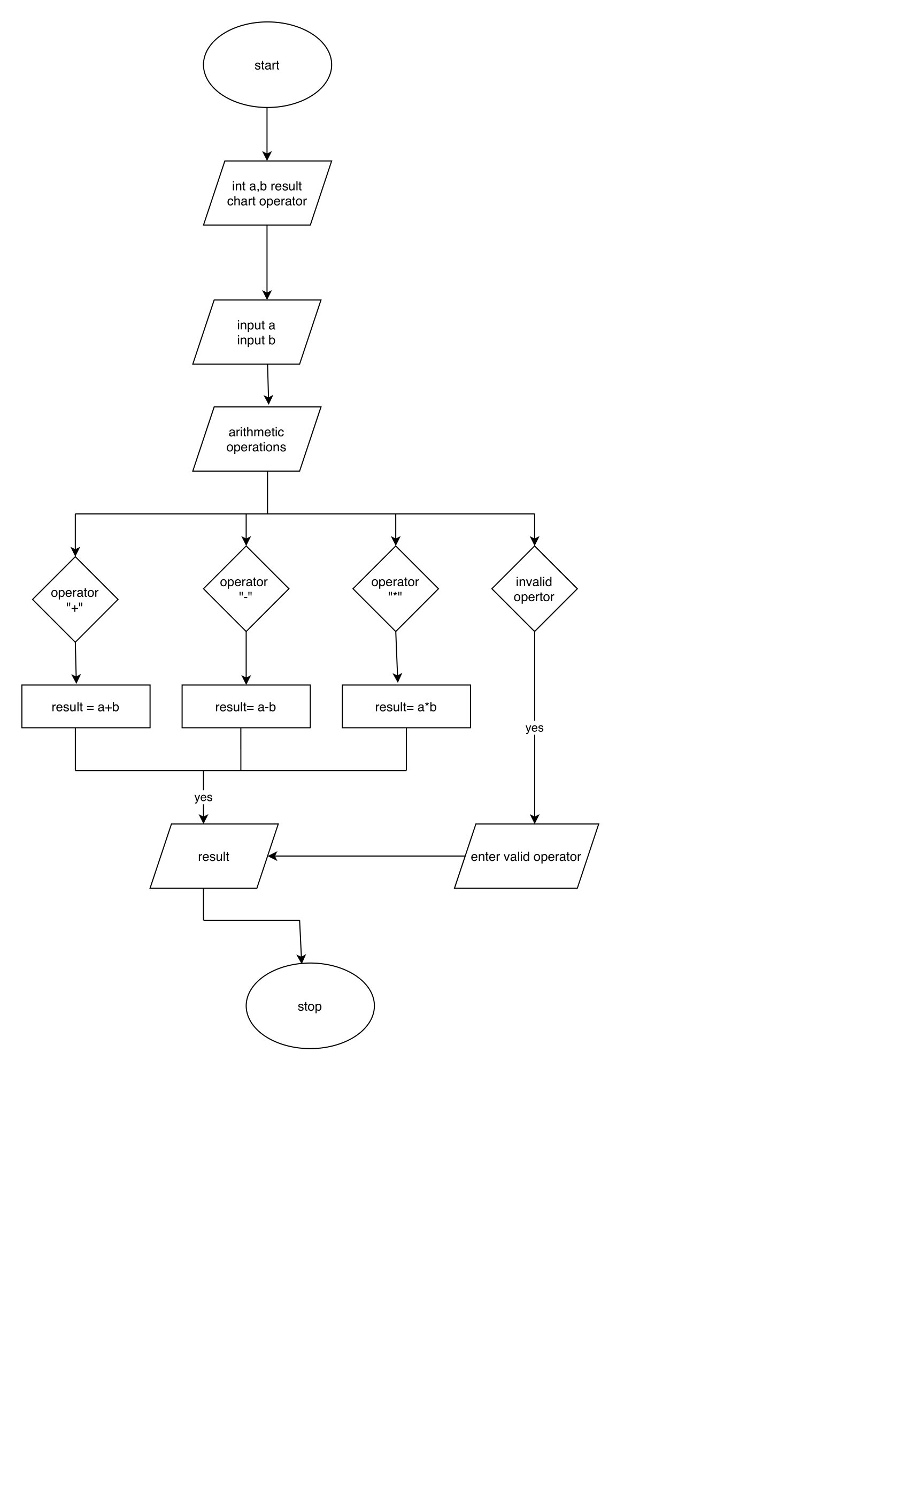

## Fig 2: Activity Diagram

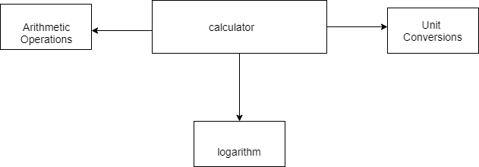

## Fig 3: Deployment Diagram

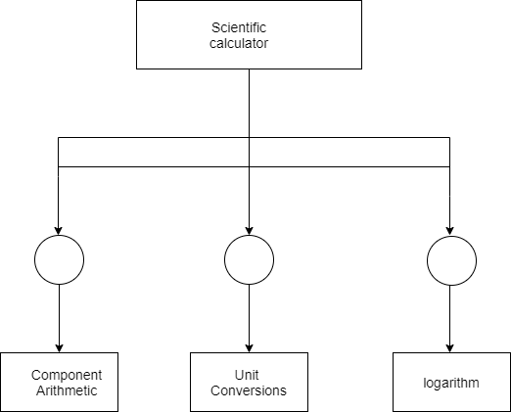

## Fig 4: Component Diagram

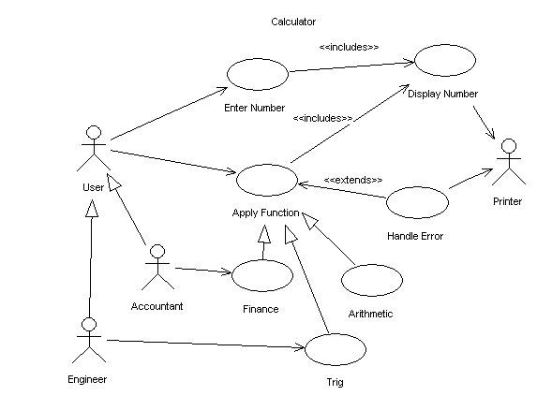

## Fig 5: Use Case Diagram

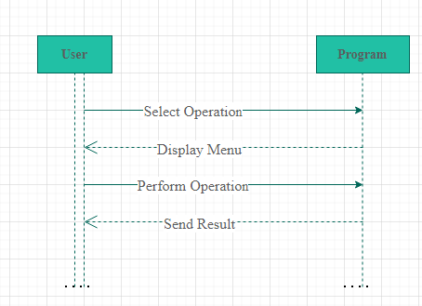

## Fig: 6 Sequence Diagram

## **TEST PLAN**

|  |  |  |  |  |
| --- | --- | --- | --- | --- |
| **Test**  **ID** | **Description** | **Input** | **Expected**  **output** | **Actual output** |
| 1 | Addition of two numbers | a=1, b=2 | 3 |  |
| 2 | Subtraction of two numbers | a=2, b=2 | 0 |  |
| 3 | Multiplication | a=1, b=2 | 2 |  |
| 4 | Square root | a=25 | 5 |  |
| 5 | power | a=2, b=5 | 32 |  |
| 6 | log | 2 | 0.693 |  |
| 7 | Fahrenheit to Celsius | 30 | -1.111 |  |
| 8 | Celsius to Fahrenheit | 100 | 212 |  |
| 9 | Celsius to kelvin | 50 | 323.15 |  |
| 10 | Kelvin to Celsius | 300 | 26.85 |  |
| 11 | Km to m | 1 | 1000 |  |
| 12 | m to km | 10 | 0.01 |  |
| 13 | Foot to inches | 3 | 36 |  |
| 14 | Yard to m | 1 | 0.9144 |  |
| 15 | Prime or composite | 2 | prime |  |
| 16 | Prime or composite | 1 | composite |  |

## **Snapshots of Results**

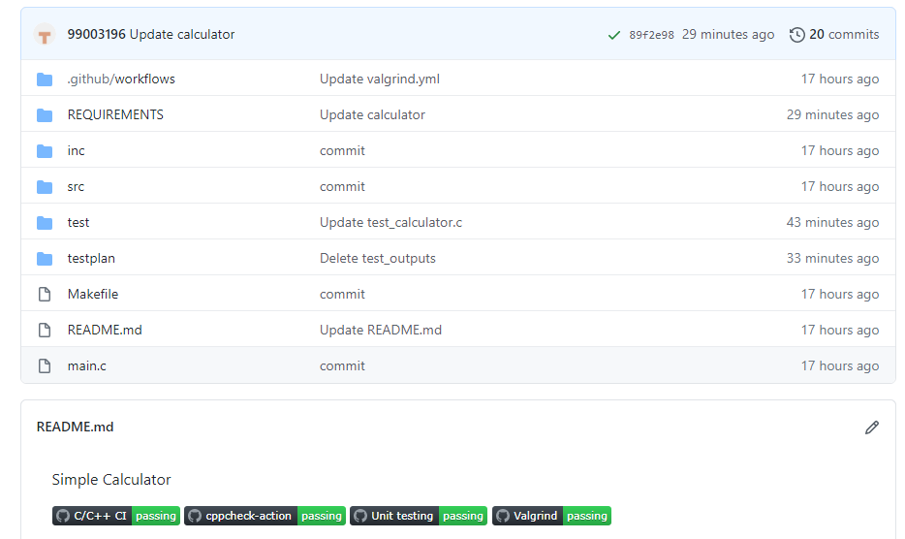

## **References**

* <https://github.com/99003198/calculator>
* <https://creately.com/blog/diagrams/uml-diagram-types-examples/#UseCaseDiagram>
* <https://app.diagrams.net/>