**OUTPUT_WITHOUT_OOPS:**

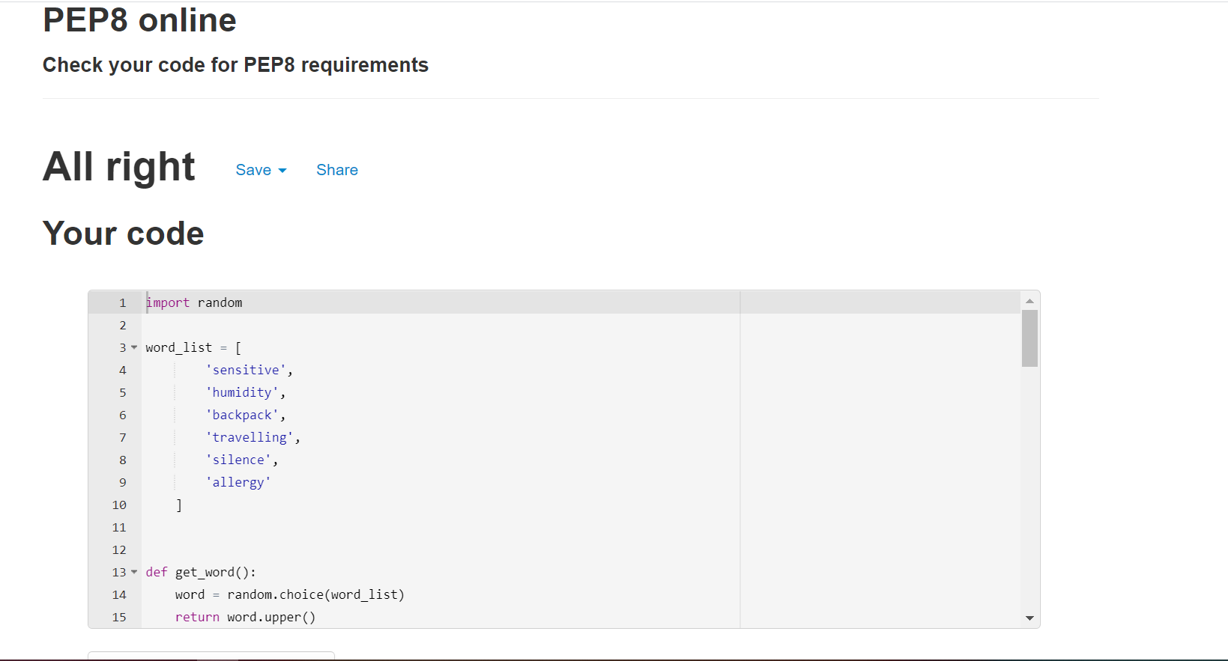

**OUTPUT_WITH_OOPS:**

